Coding practice submission

Section 1: importing CSV data - Hospital

Step 0 to 5
LOAD CSV WITH HEADERS FROM 'file:///HospitalGeneralInformation.csv' AS row
RETURN row LIMIT 5;

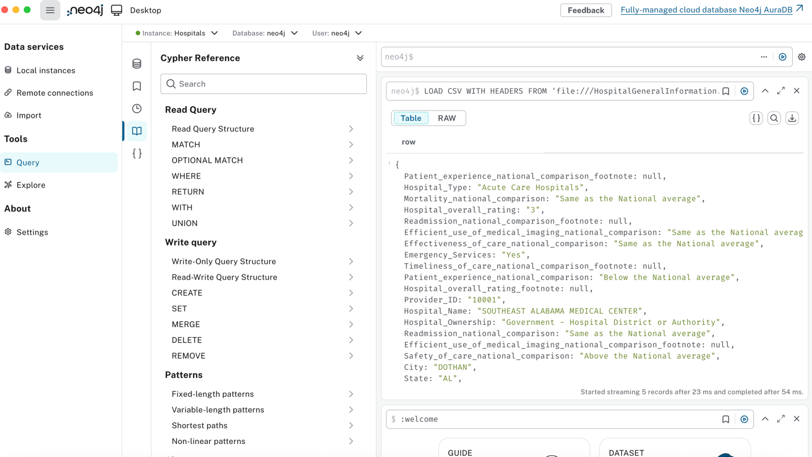

Step 6. Execute queries from week10_codingpractice_part1_cypher.txt
Test CSV:

LOAD CSV WITH HEADERS FROM 'file:///HospitalGeneralInformation.csv' AS row RETURN row LIMIT 5;
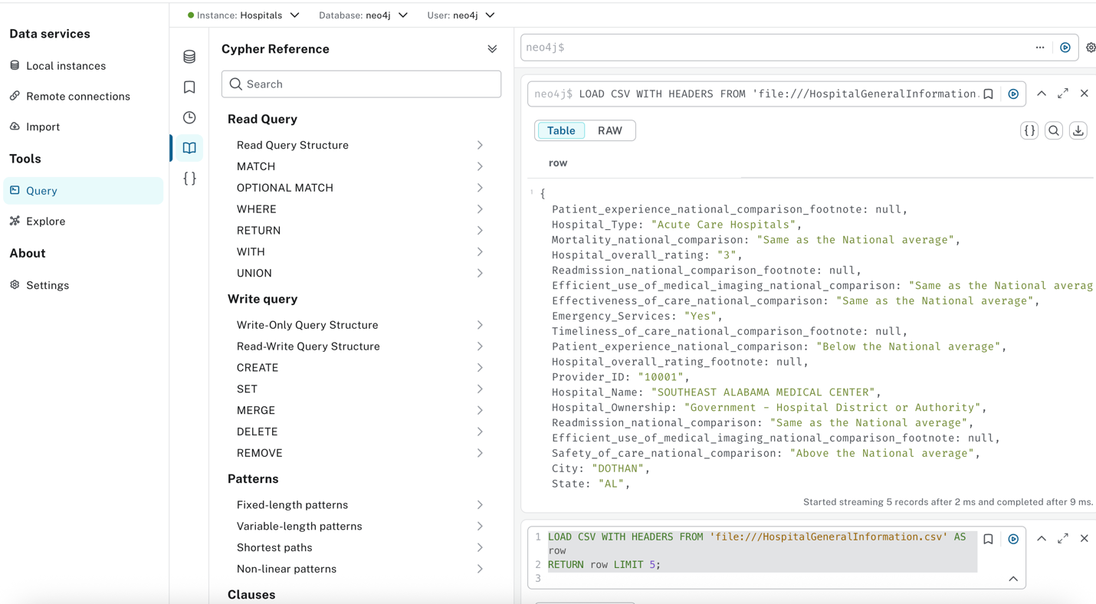

Q1: Create indexes:
CREATE INDEX county_name_index FOR (n:County) ON (n.name);
CREATE INDEX city_name_index FOR (n:City) ON (n.name);
CREATE INDEX zip_name_index FOR (n:ZipCode) ON (n.name);
CREATE INDEX address_name_index FOR (n:Address) ON (n.name);
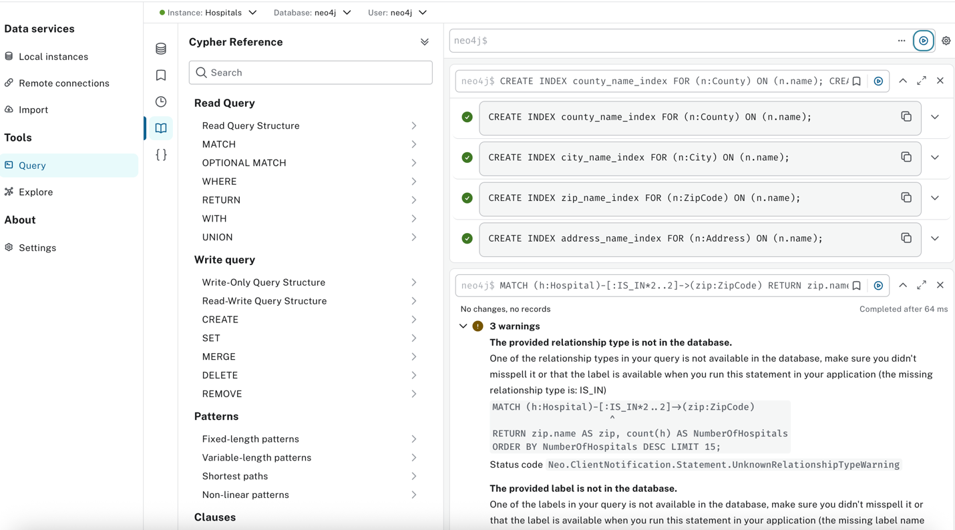

Q2: Create Constraints

CREATE CONSTRAINT FOR (h:Hospital) REQUIRE h.id IS UNIQUE;
CREATE CONSTRAINT FOR (s:State) REQUIRE s.name IS UNIQUE;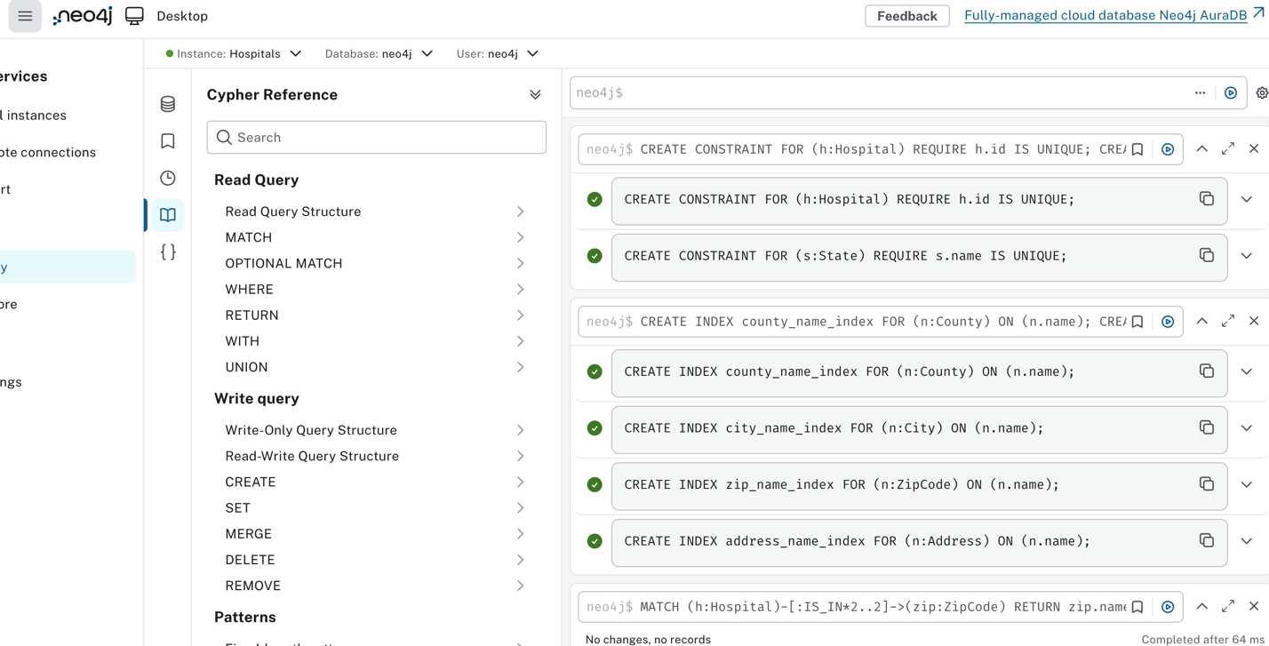

Q3: Main Data Load (only NY hospitals)
:auto LOAD CSV WITH HEADERS FROM 'file:///HospitalGeneralInformation.csv' AS row
WITH row
WHERE row.State = 'NY'
MERGE (state:State {name: row.State})
MERGE (state)<-[:IS_IN]-(county:County {name: row.County_Name})
MERGE (county)<-[:IS_IN]-(city:City {name: row.City})
MERGE (city)<-[:IS_IN]-(zip:ZipCode {name: row.ZIPCode})
MERGE (zip)<-[:IS_IN]-(address:Address {name: row.Address})
MERGE (h:Hospital {id: row.Provider_ID})
MERGE (h)-[:IS_IN]->(address);
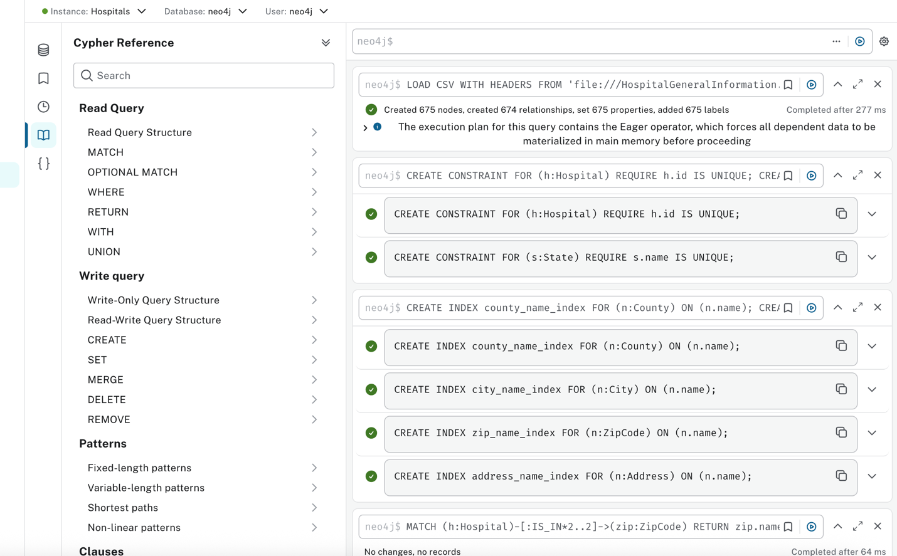

Q4: Additional Hospital Info
:auto LOAD CSV WITH HEADERS FROM 'file:///HospitalGeneralInformation.csv' AS row
WITH row
WHERE row.State = 'NY'
MATCH (h:Hospital {id: row.Provider_ID})
SET h.phone = row.Phone_Number,
h.emergency_services = row.Emergency_Services,
h.name = row.Hospital_Name,
h.mortality = row.Mortality_national_comparison,
h.safety = row.Safety_of_care_national_comparison,
h.timeliness = row.Timeliness_of_care_national_comparison,
h.experience = row.Patient_experience_national_comparison,
h.effectiveness = row.Effectiveness_of_care_national_comparison
MERGE (type:HospitalType {name: row.Hospital_Type})
MERGE (h)-[:HAS_TYPE]->(type)
MERGE (ownership:Ownership {name: row.Hospital_Ownership})
MERGE (h)-[:HAS_OWNERSHIP]->(ownership)
MERGE (rating:Rating {name: row.Hospital_overall_rating})
MERGE (h)-[:HAS_RATING]->(rating);

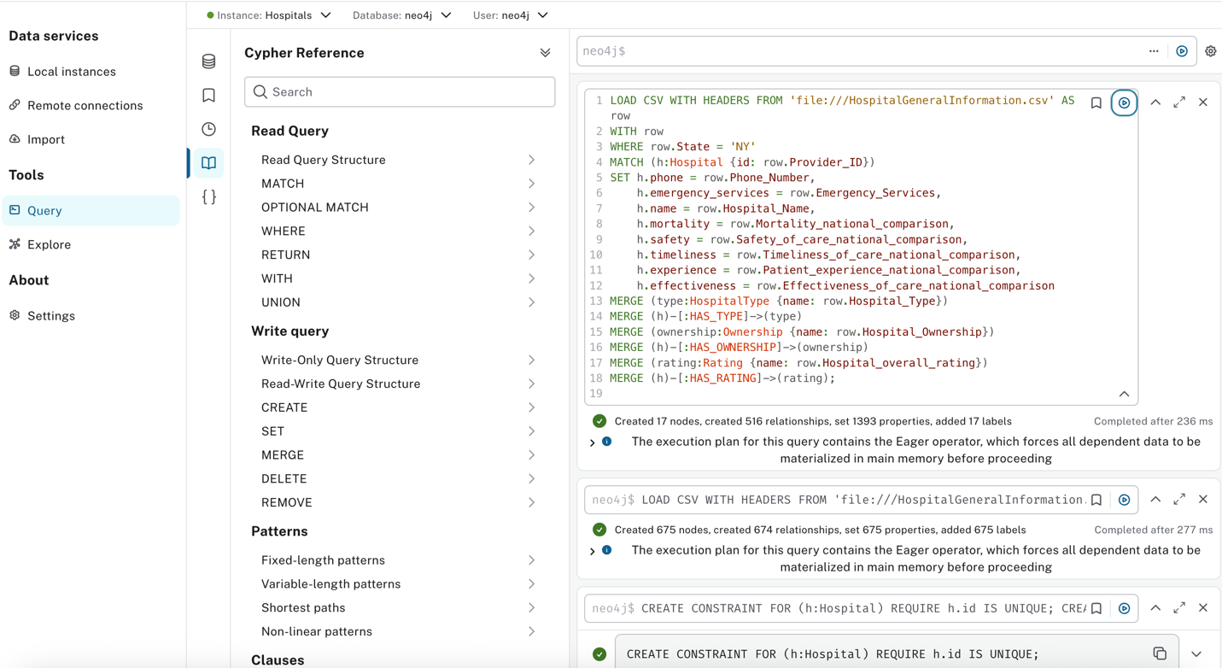

Q5: Load GPS Coordinates

LOAD CSV WITH HEADERS FROM 'file:///gpsinfo.csv' AS row
WITH row
MATCH (hospital:Hospital {id: row.id})
SET hospital.latitude = toFloat(row.latitude),
hospital.longitude = toFloat(row.longitude);
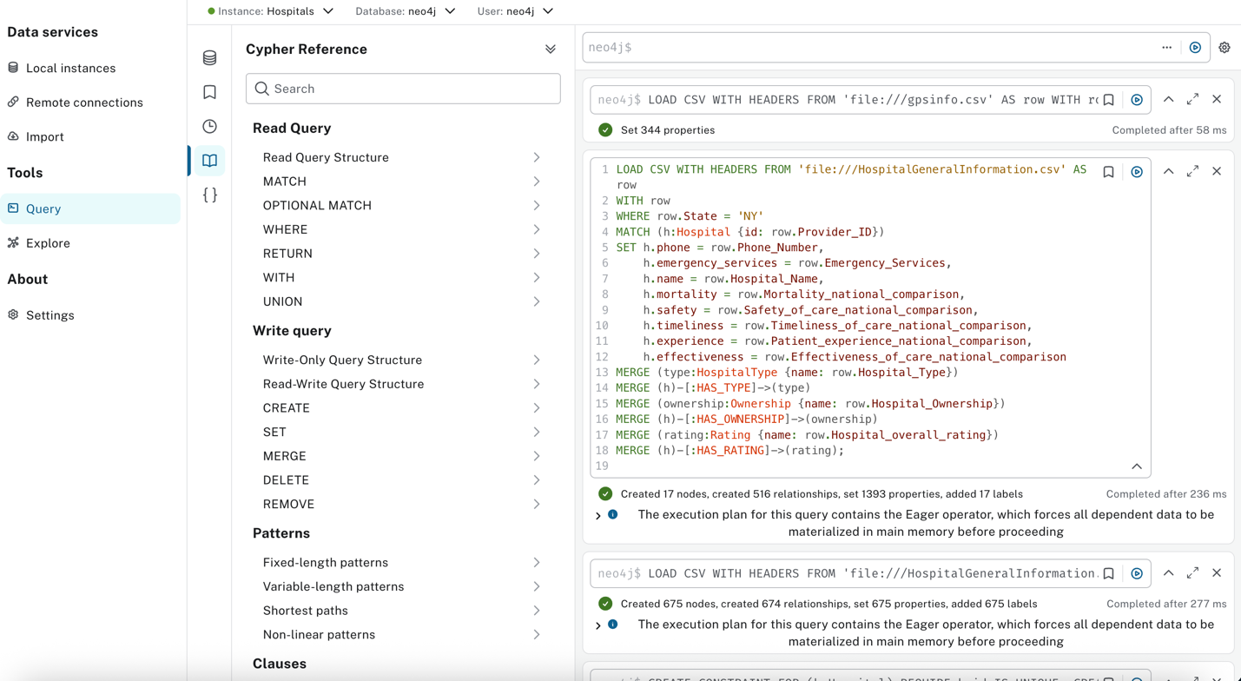

Q6: Schema Visualization

CALL db.schema.visualization();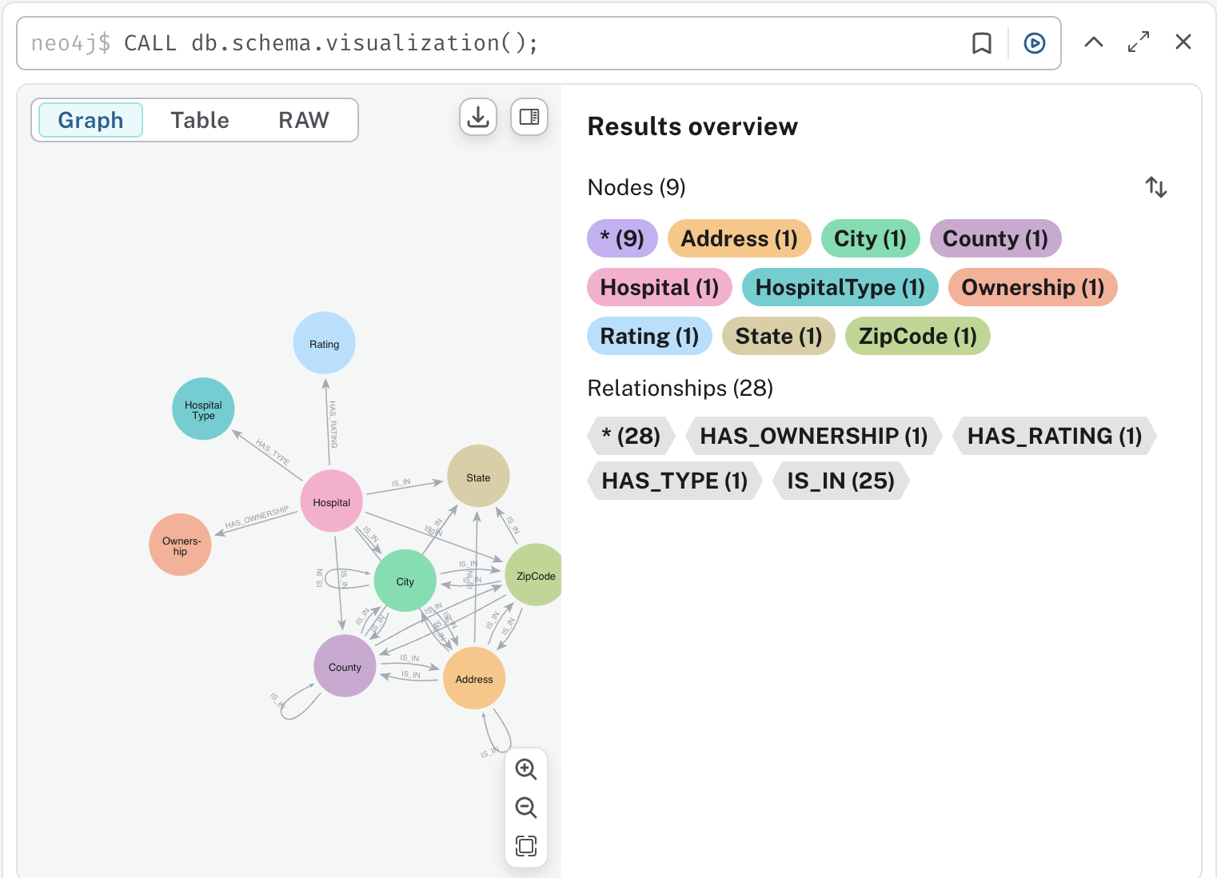

Q7: Sample Queries
Query 1: Number of hospitals per city

MATCH (h:Hospital)-[:IS_IN*3..3]->(city:City)
RETURN city.name AS city, count(h) AS NumberOfHospitals
ORDER BY NumberOfHospitals DESC LIMIT 15;

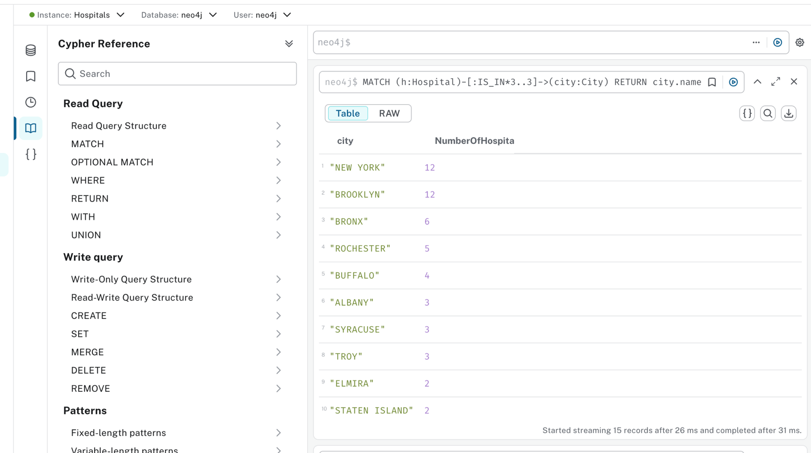

Query 2: Number of hospitals per ZIP
MATCH (h:Hospital)-[:IS_IN*2..2]->(zip:ZipCode)
RETURN zip.name AS zip, count(h) AS NumberOfHospitals
ORDER BY NumberOfHospitals DESC LIMIT 15;
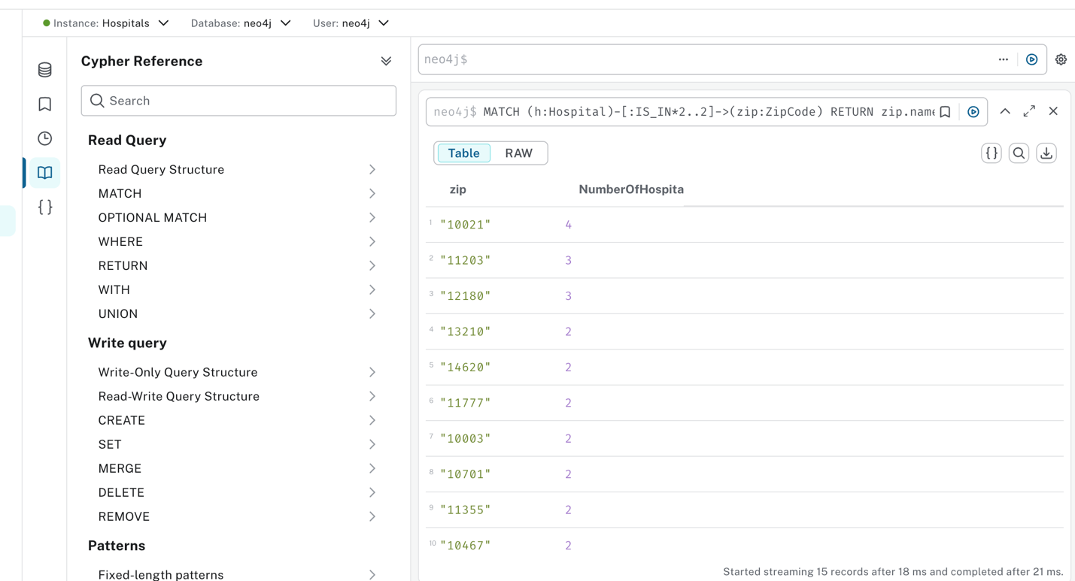

Query 3: Number of hospitals per street (Address)

MATCH (h:Hospital)-[:IS_IN]->(address:Address)
RETURN address.name AS street, count(h) AS NumberOfHospitals
ORDER BY NumberOfHospitals DESC LIMIT 15;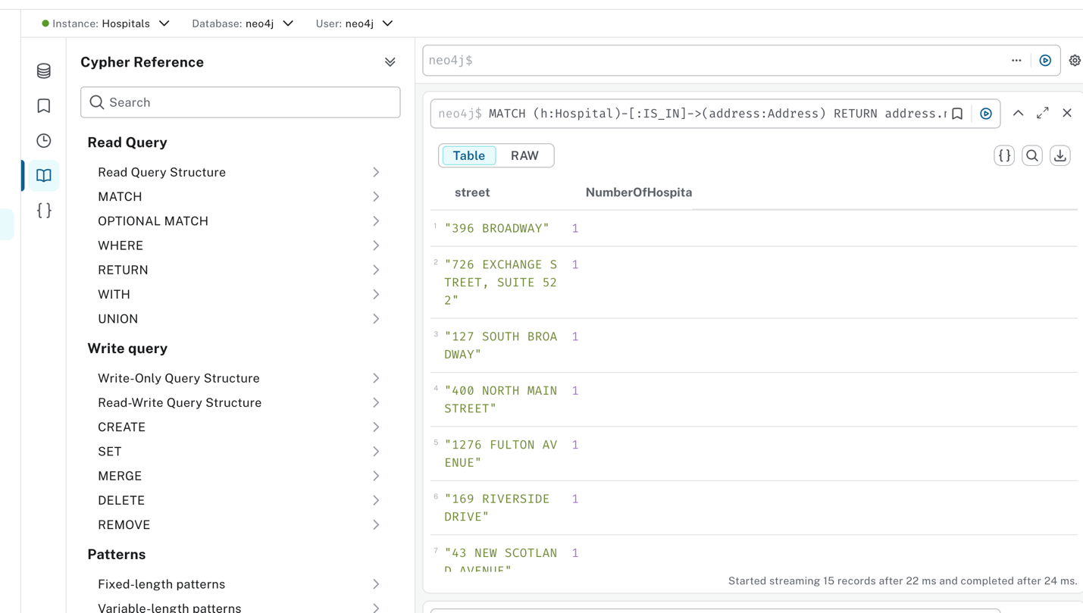

Query 4: Hospitals with below average mortality
MATCH (h:Hospital)-[:IS_IN*3..3]->(c:City)
WHERE h.mortality = 'Below the National average'
RETURN c.name AS city, count(h) AS NumberOfHospitals
ORDER BY NumberOfHospitals DESC LIMIT 15;
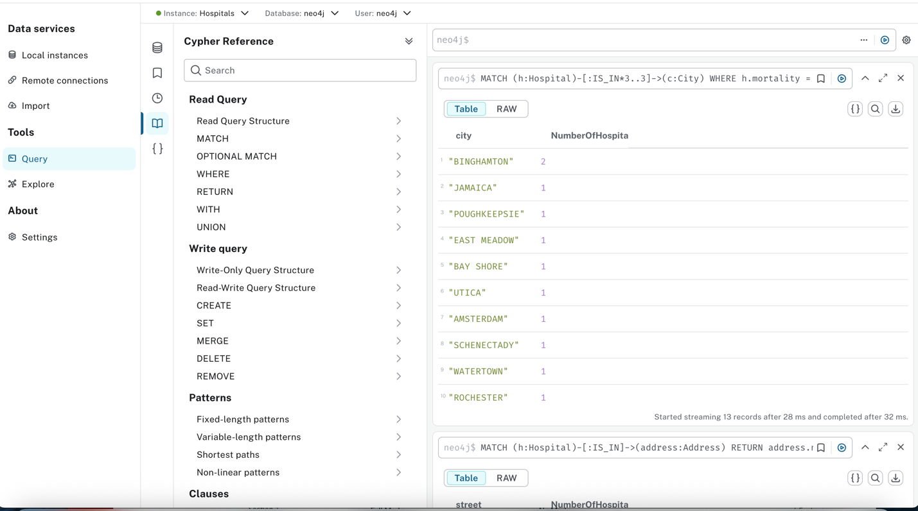

Query 5: Hospitals with emergency services
MATCH (h:Hospital)
WHERE h.emergency_services = 'Yes'
RETURN h.name, h.phone, h.latitude, h.longitude
LIMIT 10;
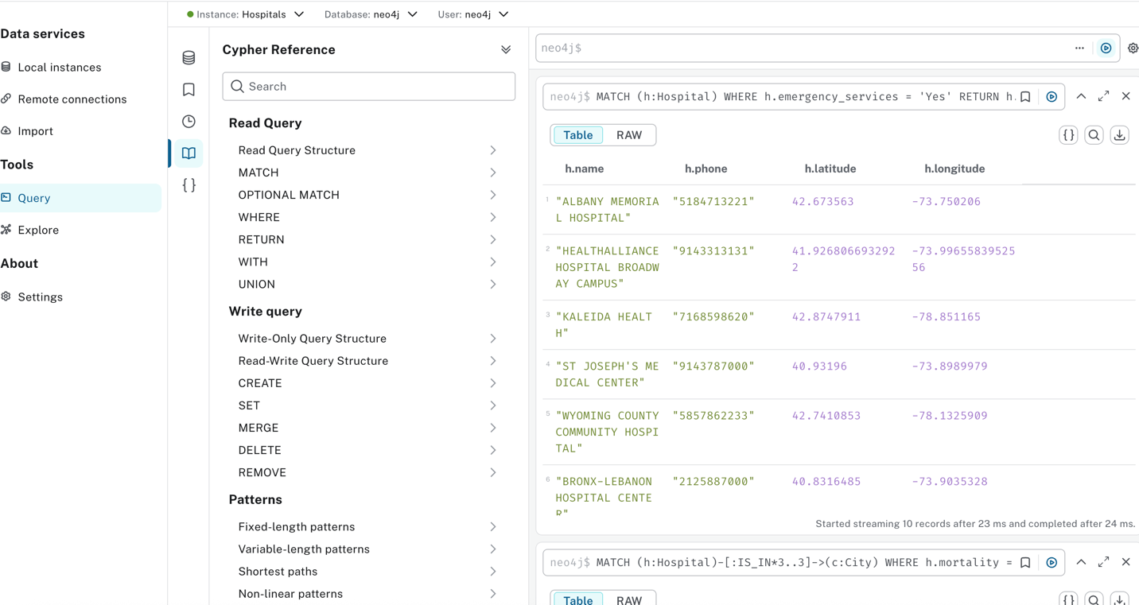

Section2

# the line
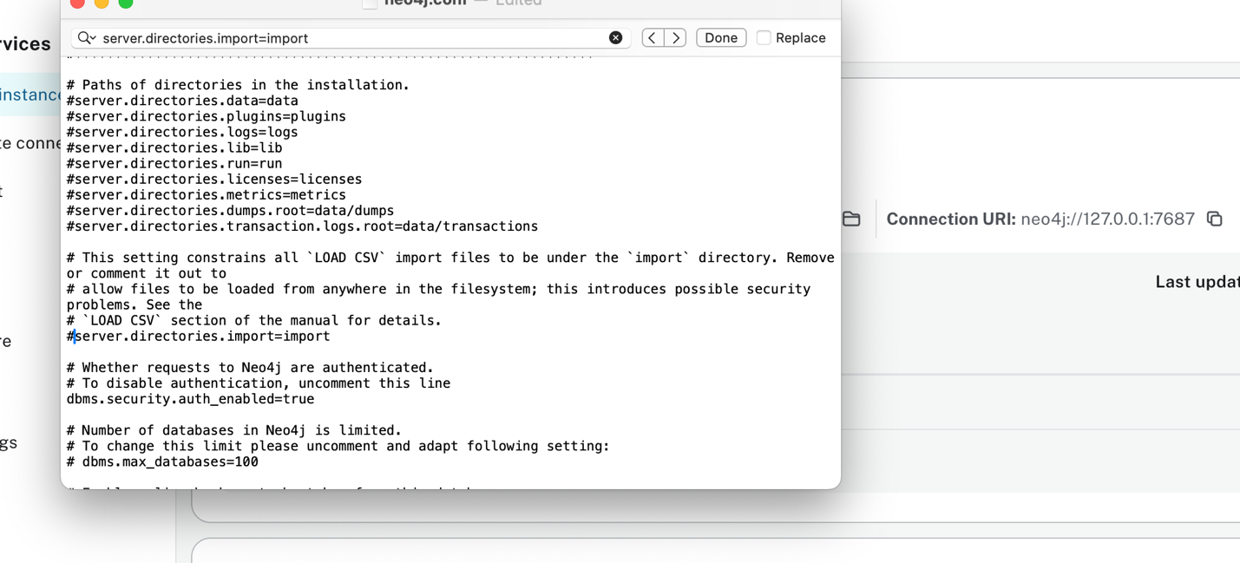

Successfully installed APOC
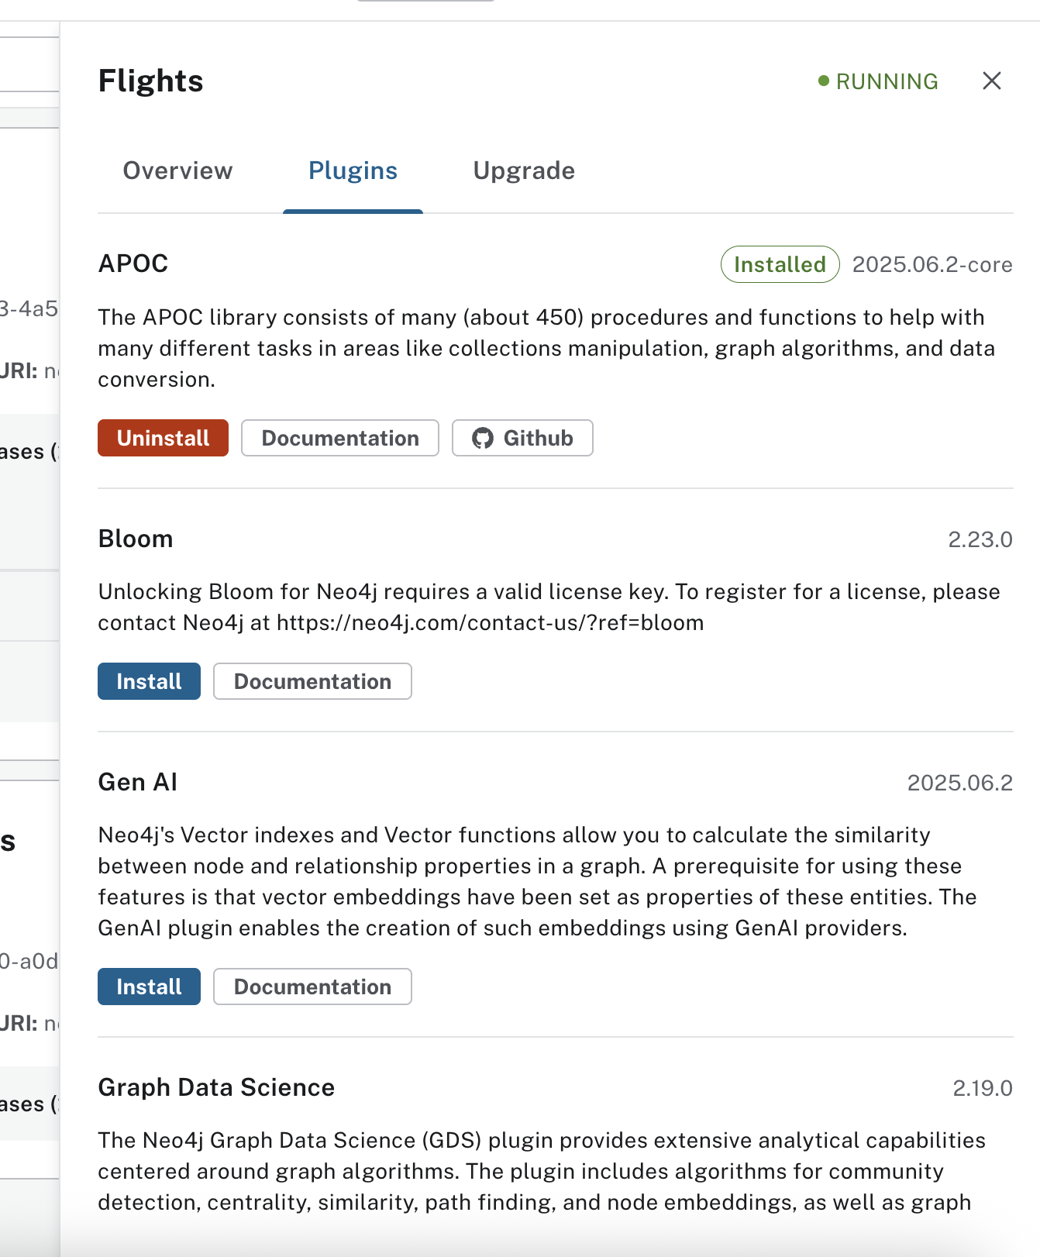

Connection URL: neo4j://127.0.1:7687

Check import directory
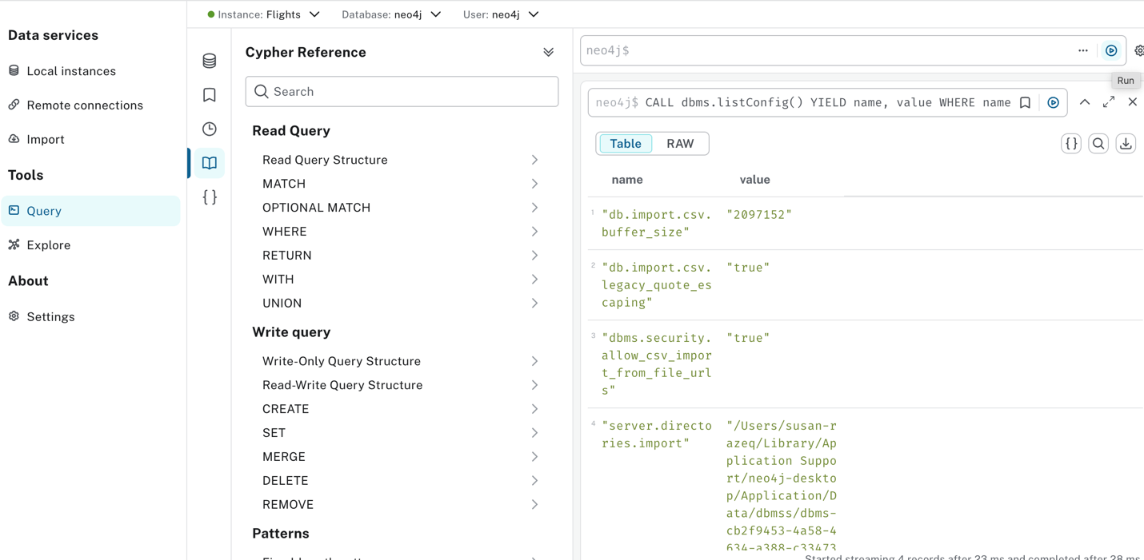

Step1 Add your full path: Load First 5 Lines
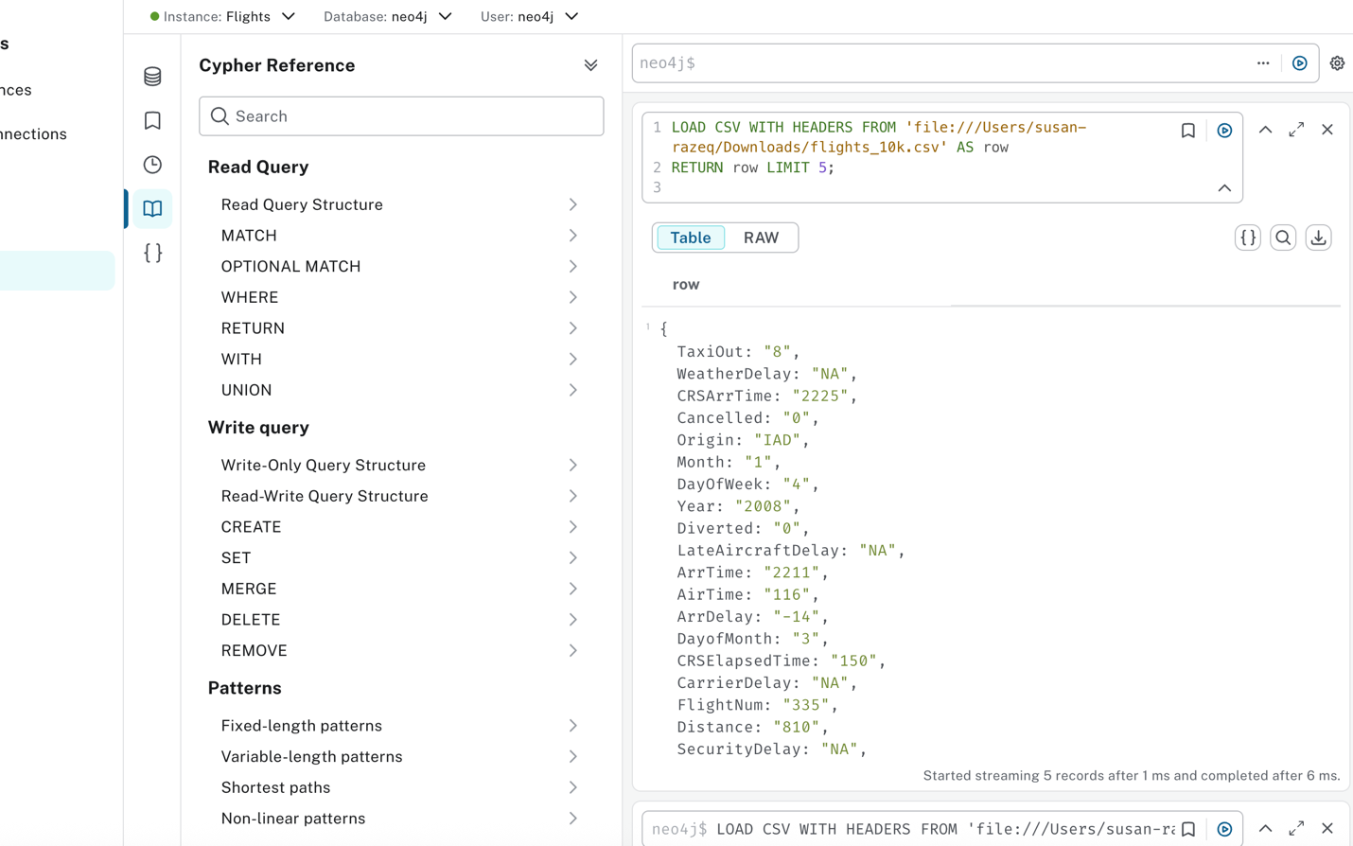

Step 2: Create Nodes & Constraints
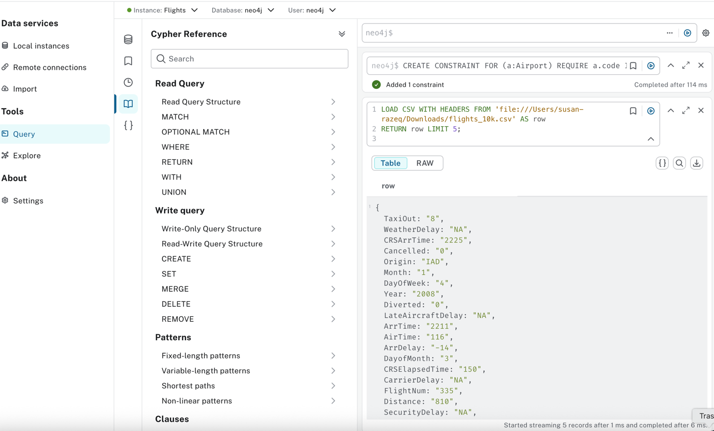
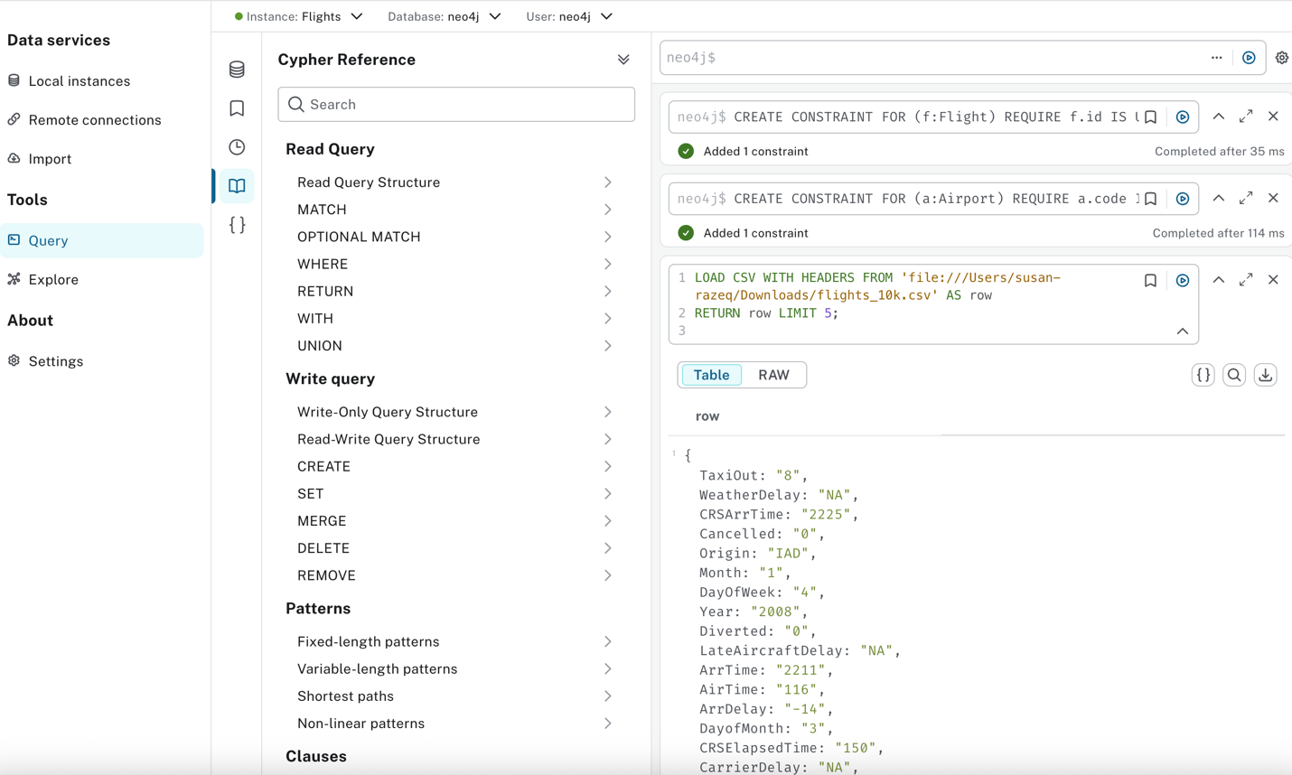

Step 3: Import Nodes & Relationships
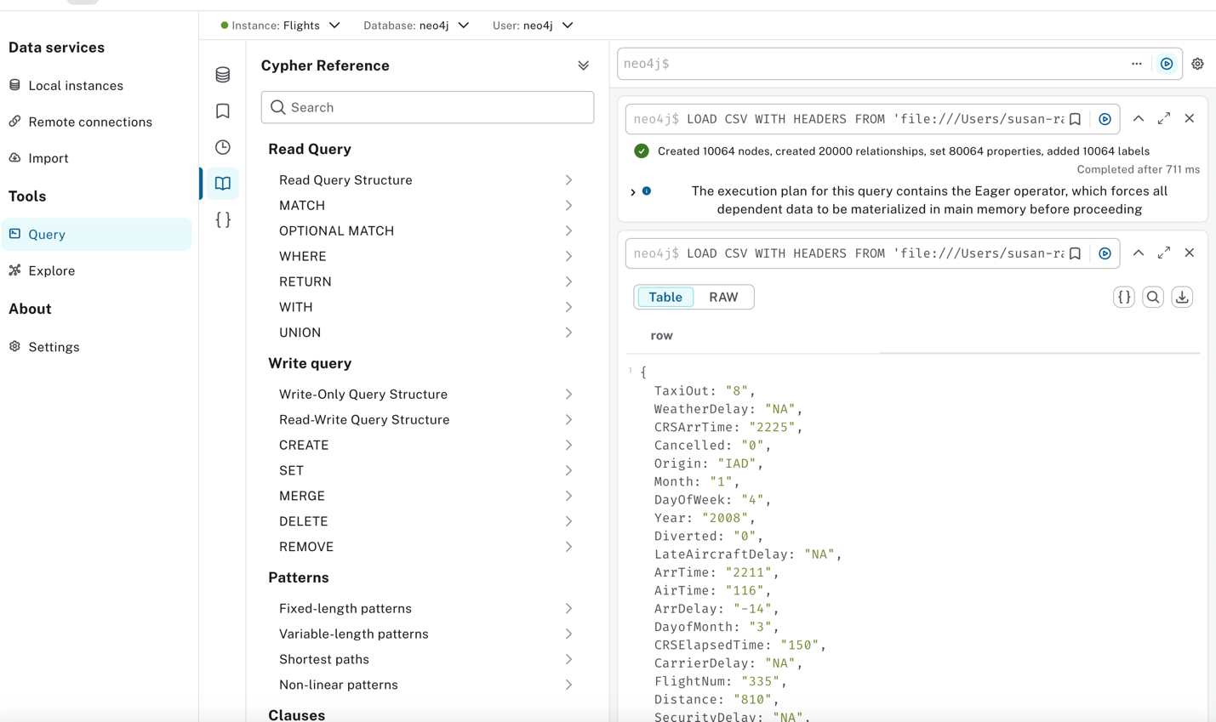

Step 4: Check Your Import
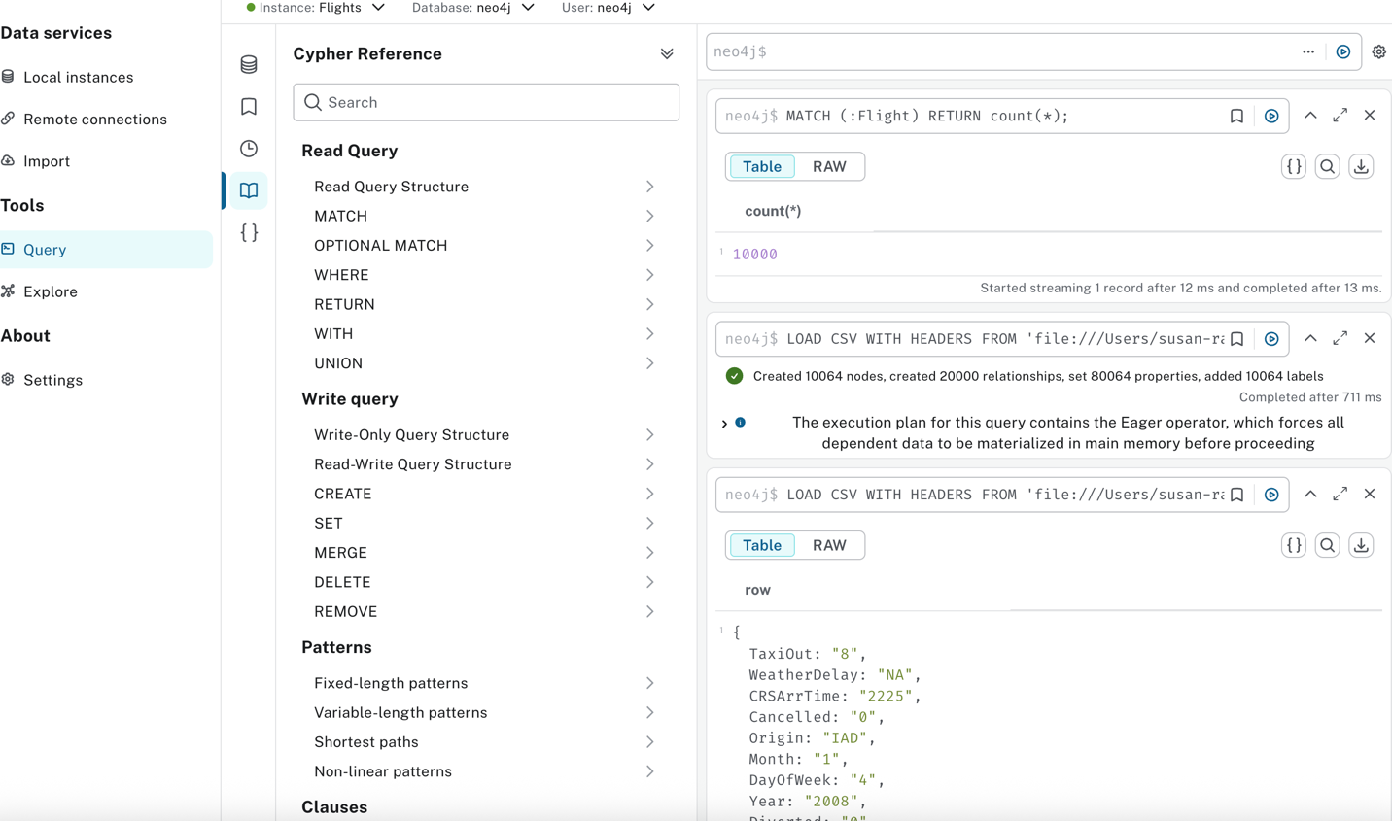

Visualize schema:
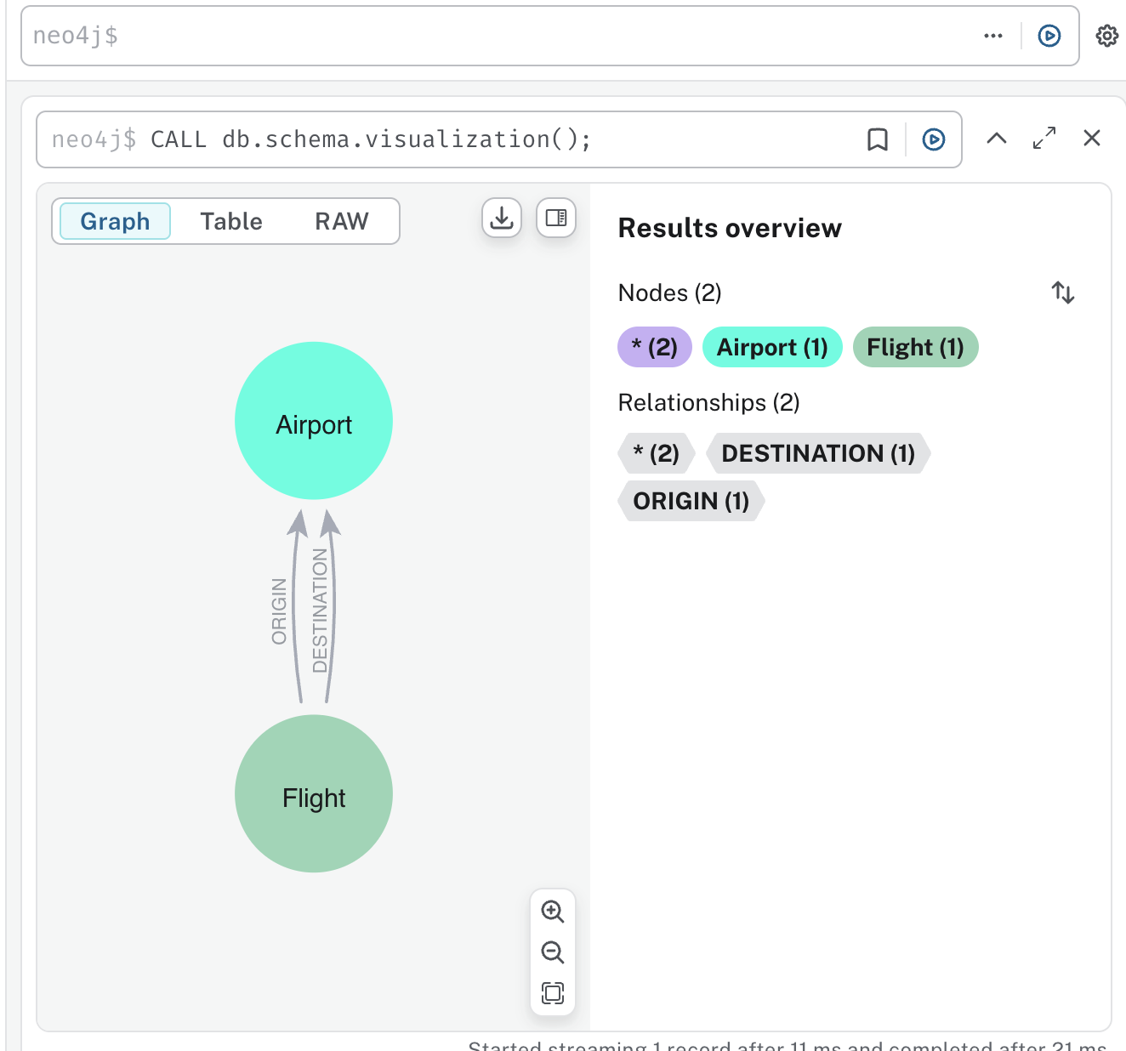

Step 5: Coerce Strings to Integers
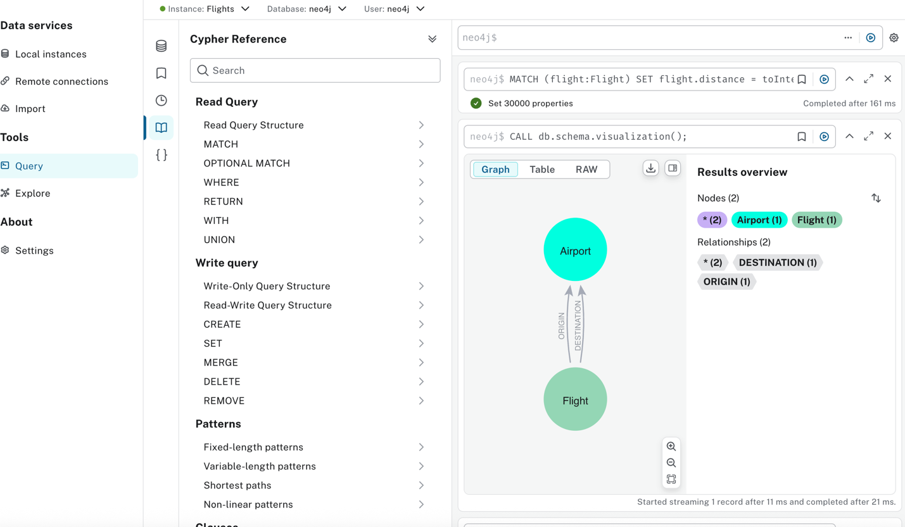

Test integer conversion:

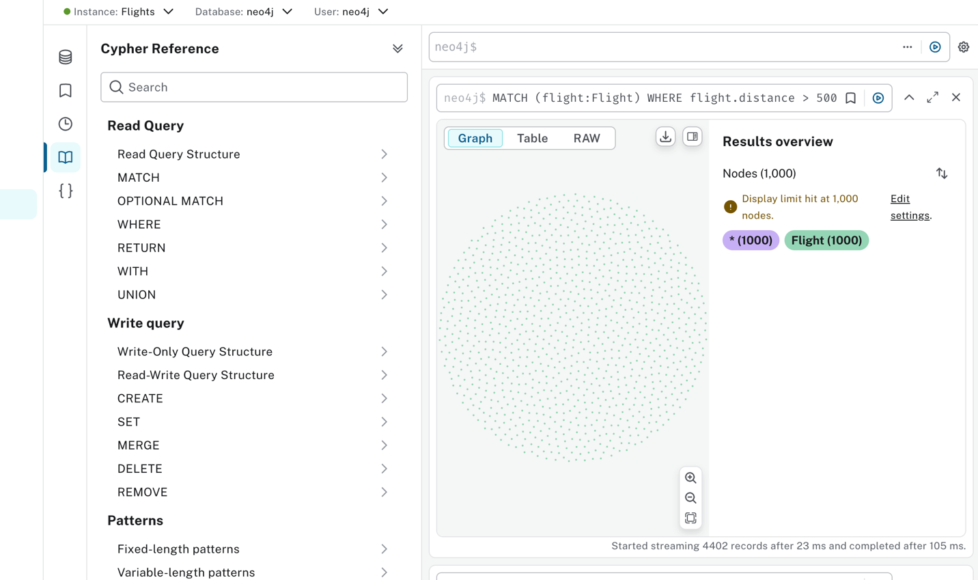

Step 6: Coerce Cancelled to Boolean
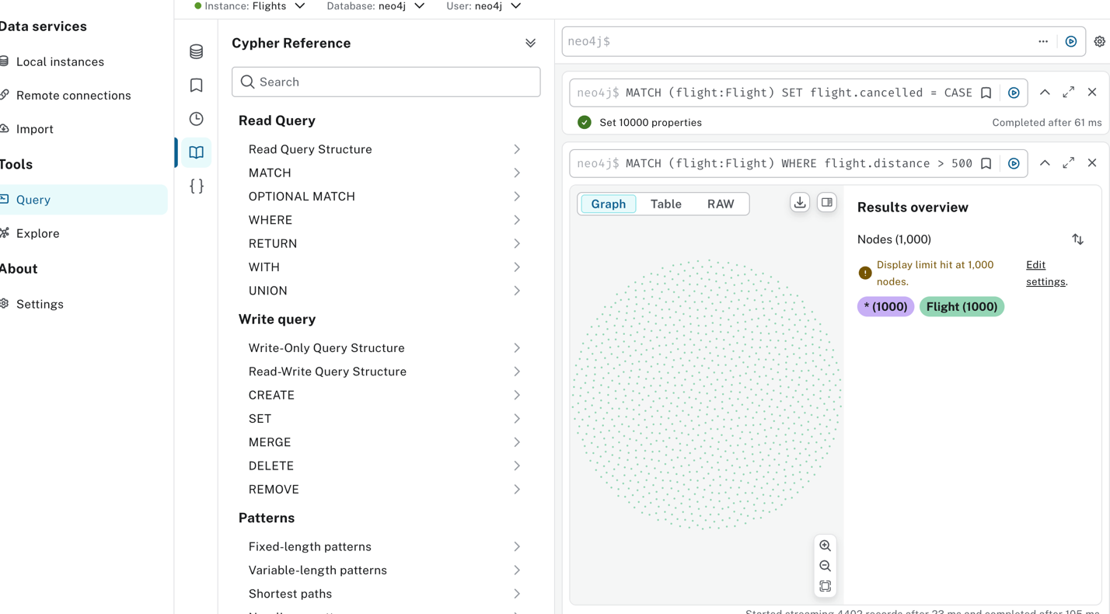

Test boolean: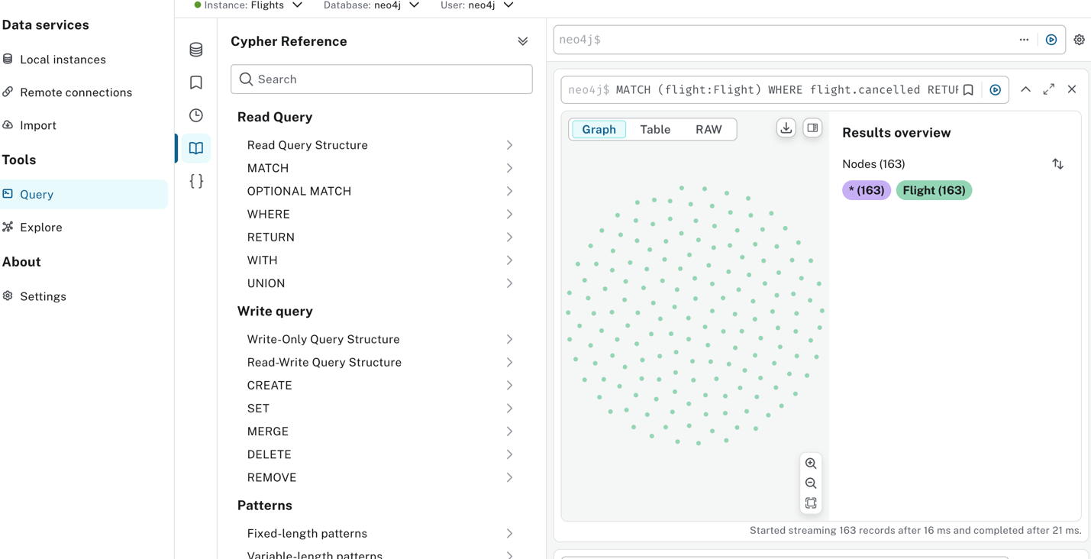

Step 1: Profiling the Query

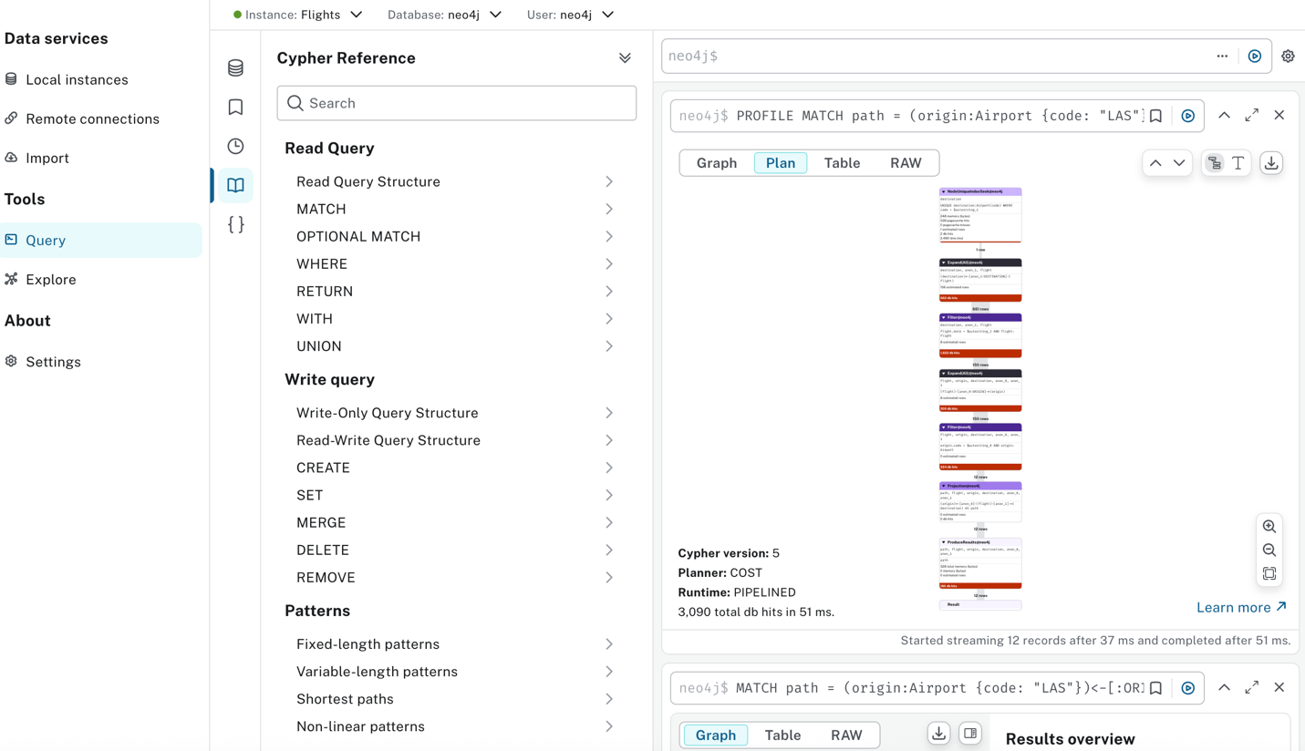
Step 2: Add CONNECTED_TO Relationships and add a new relationship
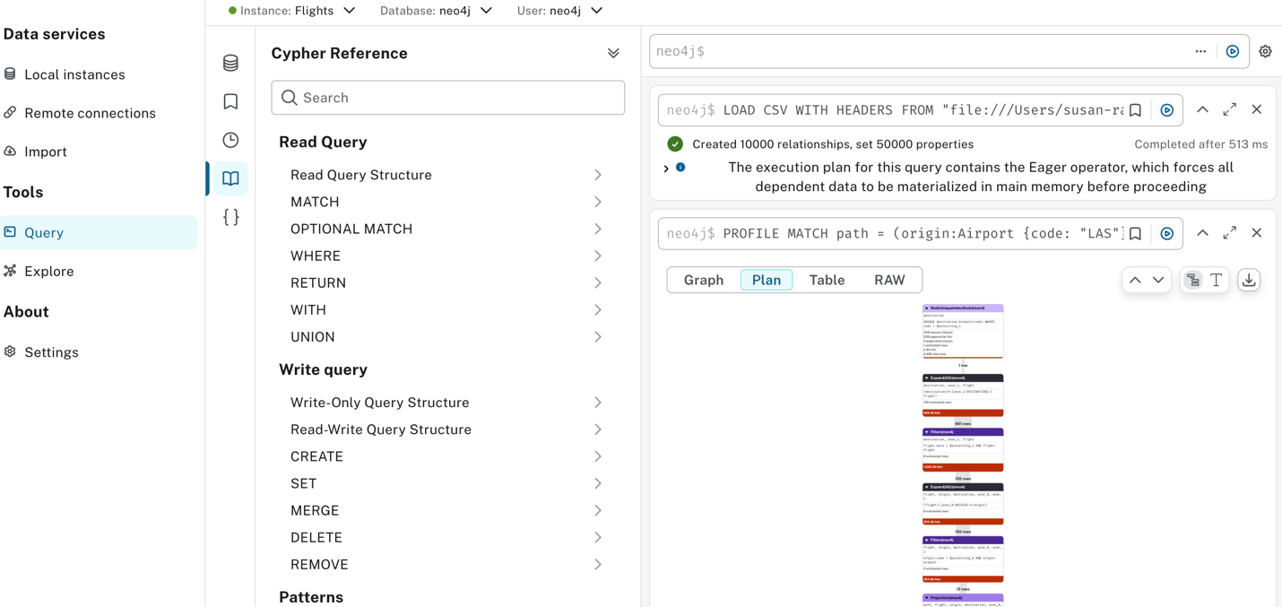

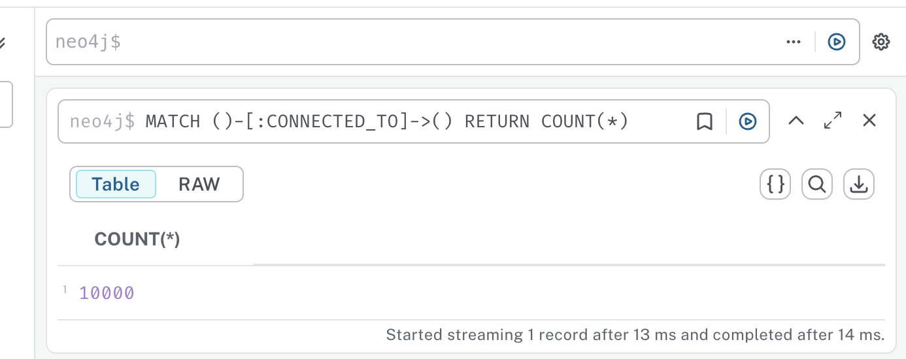

Count how many CONNECTED_TO relationships were created:
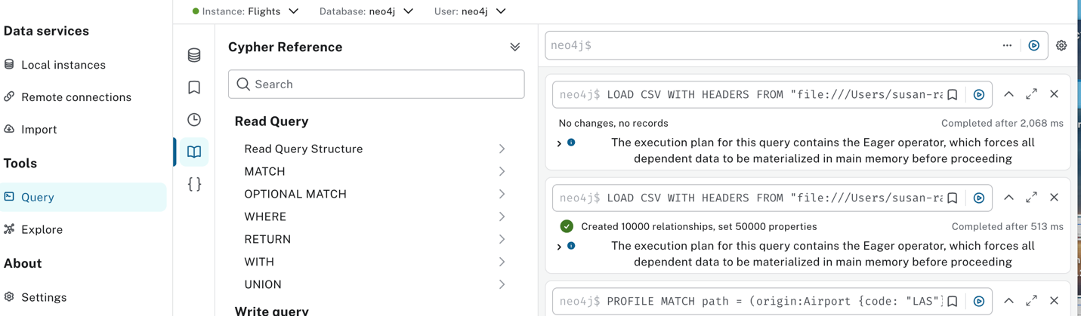

Step 3: Search Specific Flights
query: Flights between Los Angeles (LAS) and Chicago Midway (MDW) on "2008-1-3"
