
COLLEGE OF NATURAL AND COMPUTATIONAL SCIENCE
SCHOOL OF INFORMATION SCIENCE
Integrated Information System for Disaster Response and Emergency Management (ISDREM)
Submitted in partial fulfillment of Bachelor’s Degree in Information Systems (Industrial Project Phase-II)
 | GROUP MEMBERS | ID
 | Daniel Yohannes | UGR/7453/15
 | Hailemariam Kifleyohannes | UGR/1407/15
 | Mariamawit Tewodros | UGR/7952/15
 | Meti Abera | UGR/9108/15
 | Yeabsira Moges | UGR/8254/15
 | Yeabtsega Mekonnen | UGR/2291/15

Submitted to: Mr. Andaregachew
Submission Date: Mar 12 , 2026

Examination Board

Advisor Name: __________Andargachew Asfaw_______________

Signature: _____________________________________________

Date: _________________________________________________

Examiner Name: ________________________________________

Signature: ______________________________________________

Date: _________________________________________________

Examiner Name: ________________________________________

Signature: ______________________________________________

Date: _________________________________________________

Acknowledgement
We would like to extend our greatest gratitude to God for giving us the time, strength and wisdom to carry out the first half of the industrial project.
We are indebted to our parents as they have been our greatest support system in our academic journey by giving us emotional and financial support.
We would also like to thank our adviser. Mr. Andargachew Asfaw for giving us his unwavering support, advice and guidance throughout the project. His extraordinary ability to view things from different perspectives has been the light for our project's success.
Finally, we thank the F/D/R/E Disaster Risk Management Commission for being cooperative in answering all our questions and giving us all the necessary data to support the project.

Table of Contents

Acknowledgement 1
Table of Contents 2
List of Tables 4
List of Figures 5
Chapter Five 6
5. Object-oriented design 6
5.1. Previous Chapters Overview 6
5.2. Introduction to the Chapter 6
5.3. System Architecture 6
5.3.1. Strategic Design: Bounded Contexts 7
5.3.2. Tactical Design: The Onion (Hexagonal) Architecture 7
5.3.3. Ubiquitous Language and Communication 8
5.3.4. Reliability and Data Integrity 8
5.4. Design Class Modelling 9
Class Diagram 9
5.4.1.Description of classes 10
5.5. Relational Persistent Model 16
5.6. Component Diagram / Sub-System Decomposition 17
5.7. Deployment Diagram 19
5.8. User Interface 20
5.8.1. User Interface Flow Diagram 20
5.9. User Interface Design(selected sample ) 23
Chapter 6 27
6. Object-Oriented Implementation 27
6.1. Introduction 27
6.2. Testing and Testing Procedure 28
6.2.1. Unit Testing 28
6.3. End-to-End (E2E) and Integration Testing 31
6.2.3. System Testing 32
6.2.3 Critical Test Validations 40
6.2.4 Limitations and Future Test Coverage 41
6.4. Deployment and Installation Process 41
6.3.1 Server Deployment 41
6.3.2 Web Application Deployment 42
6.3.3 Mobile Application Deployment 42
6.3.4 Post Deployment Activities 42
Chapter 7 44
7. Conclusion and Recommendation 44
7.1. Conclusion 44
7.2. Recommendation 45
8. Reference 47
9. Appendix 48

List of Tables
Table 5.1 Disaster Class Description 10
Table 5.2 Incident Class Description 11
Table 5.3 ErtUnit Class Description 12
Table 5.4 Location Class Description 12
Table 5.5 User Class Description 12
Table 5.6 ResourceNeed Class Description 13
Table 5.7 Resource Class Description 13
Table 5.8 InventoryItem Class Description 14
Table 5.9 DonationCampaign Class Description 14
Table 5.10 Donation Class Description 15
Table 5.11 Comments Class Description 15
Table 5.12 AuditLogs Class Description 16
Table 6.1 Auth & User Module Unit Tests 29
Table 6.2 Donation Module Unit Tests 30
Table 6.3 Shared Infrastructure Unit Tests 30
Table 6.4 Authentication & User E2E Tests 32
Table 6.5 Donation Workflow E2E Tests 32
Table 6.6 Disaster Declaration Test Table 34
Table 6.7 Incident Reporting & Validation Test Table 35
Table 6.8 Emergency Resource Allocation Test Table 36
Table 6.9 Alert Notification Queue Test Table 37
Table 6.10 Disaster log comments and collaboration test table 38
Table 6.11 Emergency Response Team (ERT) Unit Deployment Test Table 39
Table 6.12 Master Resource Catalog & Inventory Stock Test Table 40

List of Figures
Figure 5.1 Domain Driven Data Model Architecture 8
Figure 5.2 Class diagram 9
Figure 5.3 Relational Persistence Diagram 17
Figure 5.4 Component Diagram Notations 18
Figure 5.5 Component Diagram 19
Figure 5.6 Deployment Diagram 20
Figure 5.7 Web UI Flow 21
Figure 5.8 Mobile UI Flow 22
Figure 5.9 Sign in Page UI 23
Figure 5.10 Sign up Page UI 23
Figure 5.11 Incident Validator Dashboard 24
Figure 5.12 Lists of Reported Incidents Page 24
Figure 5.13 Disaster Managers Dashboard 25
Figure 5.14 Active Disaster Page 25
Figure 5.15 Emergency Response Team Dashboard 26
Figure 5.16 Resource Inventory Page 26
Figure 6.1 Unit Testing Result 31

Chapter Five

Object-oriented design

Previous Chapters Overview
In the previous chapters we have outlined the requirements and the initial object-oriented analysis of the Integrated Information System for Disaster Response and Emergency Management (ISDREM). As a result, we have delivered the scope, significance of the project, project schedule, functional and non-functional requirements, use case diagram, sequence diagram, class diagram and the prototype of our system.

Introduction to the Chapter
This chapter describes the transition from "what" the system does which is the analysis to "how" it will be built. Using Object-Oriented Design (OOD) principles, we define the system architecture, classes, relational persistence model, components, deployment diagram, tests used and recommendations of the ISDREM platform. The goal is to ensure the system is modular, scalable, and capable of handling real-time data in an efficient manner.

System Architecture
The ISDREM system is developed using a Domain-Driven Design (DDD) architectural approach. This methodology prioritizes the core business logic—the "domain"—of disaster response, ensuring that the software's structure directly mirrors the operational complexities and hierarchical workflows of the Ethiopian Disaster Risk Management Commission (EDRMC) (Evans, 2003).

5.3.1. Strategic Design: Bounded Contexts
To manage complexity, the system is decomposed into several Bounded Contexts. Each context represents a specific sub-domain of disaster management with its own independent models and rules:
- Incident Management Context: Focuses on the lifecycle of a incident report, from initial field submission (using mobile offline-first capabilities) to verification by authorized validators.
- Early Warning & Alerting Context: Manages the logic for geo-targeted public notifications and the multi-hazard impact thresholds required for different alert levels (EDRMC, 2023b).
- Resource & Logistics Context: Oversees the inventory tracking, and allocation of life-saving supplies (e.g., food, medicine) based on prioritized needs from affected Woredas (EDRMC, 2023b).
- Donor & Humanitarian Context: Facilitates the integration of external NGO contributions and donation campaigns into the active response effort (OCHA, 2024a).

5.3.2. Tactical Design: The Onion (Hexagonal) Architecture
Each Bounded Context follows an Onion Architecture (also known as Hexagonal Architecture), which places the domain model at the center and keeps it independent of external technologies:
- Domain Model (Core): Contains the "Entities" (e.g., Active Incident, Resource Need) and "Value Objects" (e.g., Geo-Coordinates) that represent the business rules of disaster response (Booch, 1994).
- Domain Services: Handles logic that doesn't belong to a single entity, such as the automated logic for determining if a verified incident warrants a "Federal Disaster Declaration" (Vernon, 2013).
- Application Services: Acts as the orchestrator, receiving requests from the user interfaces and coordinating the domain objects to fulfill a use case, such as "Process Donation" or "Update Incident Status" (Cockburn, 2000).
- Infrastructure Layer (Adapters): Contains technical implementations, such as the PostgreSQL/PostGIS database adapters, SMS Gateway integrations for alerts, and React/React Native frontend interfaces.

5.3.3. Ubiquitous Language and Communication
A core component of this architecture is the Ubiquitous Language, a shared vocabulary between developers and EDRMC stakeholders (Evans, 2003). (e.g., using terms like "Woreda-level validation" or "Resource-paralysis" consistently in the code and the UI). Communication between different bounded contexts is handled via Domain Events. For example, when an Incident is marked as "Verified" in the Incident Management Context, it triggers a domain event that notifies the Early Warning Context to prepare a public alert.

5.3.4. Reliability and Data Integrity
By isolating the domain logic, the DDD approach ensures that the system remains stable during high-stress disaster events (ALazzawi et al., 2023). The use of Aggregates within the data layer ensures that complex operations—such as updating a regional resource inventory while processing multiple aid requests—maintain strict data integrity and consistency.
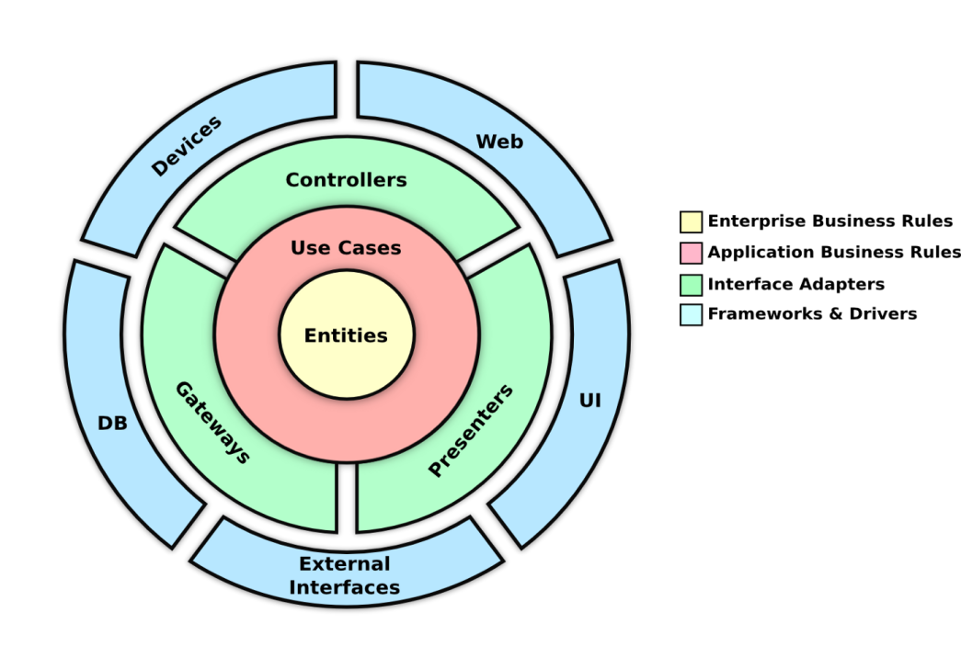
Figure 5.1 Domain Driven Data Model Architecture

Design Class Modelling
A class diagram is a fundamental component of object-oriented modeling, used to represent the static structure of a system by illustrating the system’s classes, their attributes, methods, and the relationships between the classes (Booch, 1994).

Class Diagram
The image below shows the class diagram of our system:
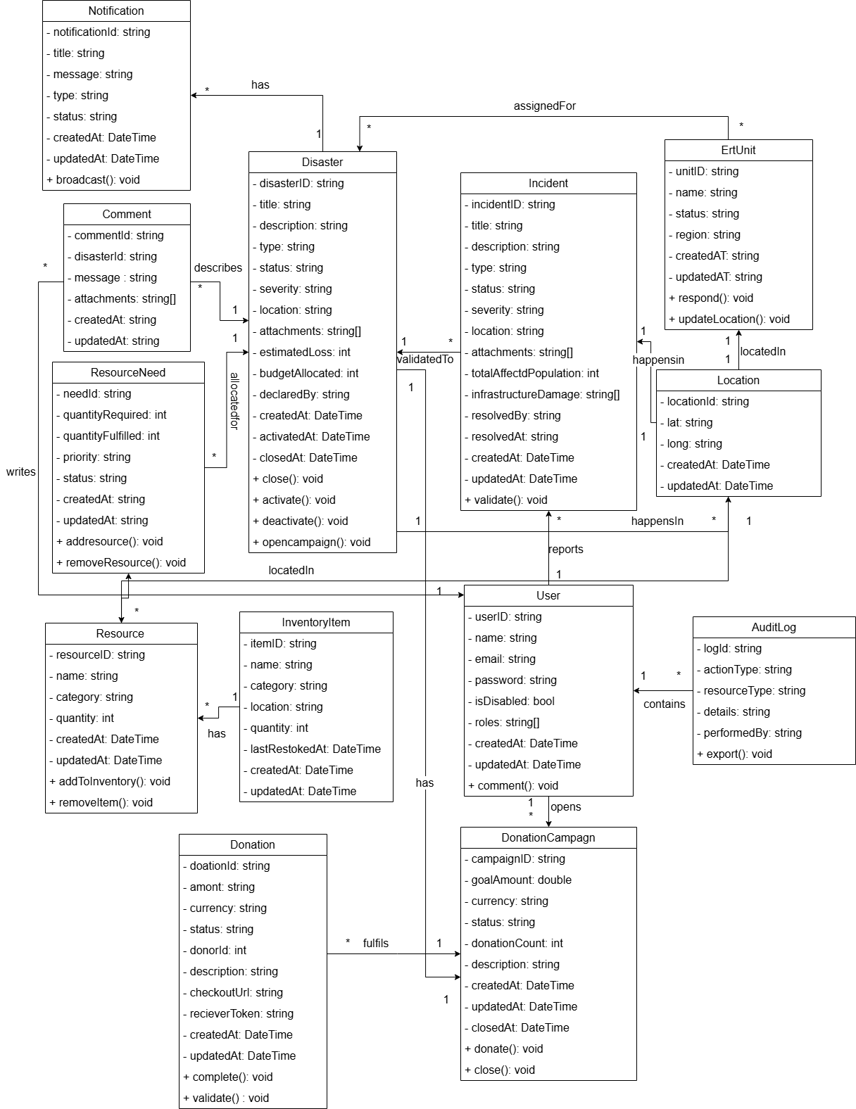
Figure 5.2 Class diagram

5.4.1.Description of classes
A class description provides a detailed specification of the properties and behaviors of a class within object-oriented design. It typically includes the class’s attributes, methods, and the relationships it has with other classes, offering a clear understanding of its functionality within the system (Booch, 1994).
Below we have provided the detailed class description with each attribute name and description:

Disaster
Attributes
Name | Descriptions
disasterId | Unique identifier for the disaster
title | The name or title of the disaster event.
description | Detailed explanation of the disaster.
type | The category of disaster (e.g., Earthquake, Flood).
status | Current state of the disaster (e.g., Active, Closed).
severity | Scale of impact (e.g., High, Medium, Low).
location | Geographic text description of the affected area.
attachments | Array of links/paths to related media or documents.
estimatedLoss | Projected financial or structural loss.
budgetAllocated | Funds assigned to manage this specific disaster.
declaredBy | The authority figure or system user who declared the disaster.
createdAt | Timestamp when the disaster record was created.
activatedAt | Timestamp when response actions were activated.
closedAt | Timestamp when the disaster case was officially resolved/closed.
Methods
Name | Description
close(): void | Sets the disaster status to closed and handles wrap-up logic.
activate(): void | Changes the status to active to initiate relief operations.
deactivate(): void | Temporarily halts or stands down active responses.
opencampaign(): void | Launches a connected donation campaign for fundraising.
Table 5.1 Disaster Class Description

Incident
Attributes
Name | Descriptions
incidentID | Unique identifier for the incident
title | The name or title of the incident event.
description | Detailed explanation of the incident.
type | The category of incident (e.g., Earthquake, Flood).
status | Current tracking status (e.g., Pending, Validated).
severity | Preliminary assessment of severity.
location | Text description or reference for where it happened.
attachments | Supporting files or photos uploaded by the reporter.
totalAffectedPopulation | Estimated number of people impacted.
infrastructureDamage | List or descriptions of affected infrastructure (roads, power lines, etc.).
resolvedBy | Identity of the user who resolved the incident
resolvedAt | Timestamp when the incident was marked as resolved.
createdAt | Timestamp when the incident was first reported.
updatedAt | Timestamp of the most recent modification.
Methods
Name | Description
validate(): void | Validates the legitimacy of an incident
Table 5.2 Incident Class Description

Ert Unit
Attributes
Name | Description
unitID | Unique identifier for the emergency response unit.
name | Call sign or name of the unit.
status | Current operational status
region | Geographic region assigned to the unit
createdAt | Timestamp when the unit record was added.
updatedAt | Timestamp when unit details were last updated.
Method
Name | Description
respond(): void | Mobilizes the unit to respond to an assignment.
updateLocation(): void | Refreshes the unit's current geographical location coordinate data.
Table 5.3 ErtUnit Class Description

Location
Attributes
Name | Description
locationId | Unique identifier for the location entry.
lat | Latitude coordinate
long | Longtiude Coordinate
createdAt | Timestamp when the coordinate were logged
updatedAt | Timestamp when the coordinate were last changed
Methods
Name | Description
Table 5.4 Location Class Description

User
Attributes
Name | Description
userID | Unique identifier for the user account
name | Full name of the user
email | Electronic mail address used for communication and login
password | Hashed security password credential.
isDisabled | Flag indicating if the account is deactivated.
roles | Array of assigned authorization roles (e.g., Admin, ERT_Member)
createdAt | Timestamp when account was registered.
updatedAt | Timestamp when account info changed.
Methods
Name | Description
comment(): void | Allows the user to leave a comment on a disaster
Table 5.5 User Class Description

ResourceNeed
Attributes
Name | Description
needId | Unique identifier for the specific need request.
quantityRequired | Total amount of items/resources needed.
quantityFulfilled | Total amount of items/resources successfully supplied so far
priority | Urgency level of the request (e.g., Critical, Normal).
status | Lifecycle state of the request (e.g., Pending, Fully Met).
createdAt | Timestamp when the resource need was created.
updatedAt | Timestamp when the request was modified.
Methods
Name | Description
addresource(): void | Allocates or adds a concrete resource toward fulfilling this need.
removeresource(): void | Allocates or adds a concrete resource toward fulfilling this need.
Table 5.6 ResourceNeed Class Description

Resource
Attribute
Name | Description
resourceID | Unique identifier for the resource catalog archetype.
name | Descriptive name of the resource (e.g., "Water Purification Kit")
category | Group type (e.g., Medical, Food, Logistics).
quantity | Available total volume or stock count.
createdAt | Timestamp when the resource entity was registered.
updatedAt | Timestamp when the resource entity was registered.
Methods
Name | Description
addToInventory(): void | Moves or registers this resource type into the live trackable inventory.
removeItem(): void | Moves or registers this resource type into the live trackable inventory.
Table 5.7 Resource Class Description

InventoryItem
Attributes
Name | Description
itemID | Unique identifier for the inventory item.
Name | Name of the inventory item.
Category | Classification group of the item.
Location | Storage facility or warehouse name where the item sits.
Quantity | Instock volume at this location
lastRestockedAt | Timestamp of the most recent delivery update.
createdAt | Timestamp of initial inventory initialization.
updatedAt | Timestamp of the latest item count edit.
Methods
Name | Description
Table 5.8 InventoryItem Class Description

DonationCampaign
Attributes
Name | Description
campaignId | Unique identifier for the donation campaign.
goalAmount | Financial target amount to be raised.
currency | Currency denomination code (e.g., USD, EUR).
status | State of fundraising (e.g., Ongoing, Paused, Completed).
donationCount | Running tally of how many individual donations have been processed.
Description | Narrative text explaining the goal of the campaign
createdAt | Timestamp of campaign launch.
updatedAt | Timestamp of campaign modification.
closedAt | Timestamp of when the campaign formally ended.
Methods
Donate(): void | Process an incoming donor contribution
Close(): void | Closes the current donation campaign
Table 5.9 DonationCampaign Class Description

Donation
Attributes
Name | Description
doationId | Unique identifier for the transaction record. (Note: Typo in diagram as "doationId")
Amont | Value amount contributed. (Note: Typo in diagram as "amont")
Currency | Currency format utilized for the transaction
Status | Payment state (e.g., Pending, Cleared, Failed).
donorId | Identifier referencing the donor profile.
Description | Optional note written by the donor.
checkoutUrl | Secure payment gateway processing web address.
recieverToken | Secure transactional handshake validation token. (Note: Typo in diagram as "recieverToken")
createdAt | Timestamp of when payment was initiated.
updatedAt | Timestamp of final transaction status change.
Methods
Name | Description
Complete(): void | Finalizes the payment as fully processed.
validate(): void | Verifies with banking gateways to ensure funds are authentic.
Table 5.10 Donation Class Description

Comment
Attributes
Name | Description
commentId | Unique identifier for the comment entry.
message | Main text context written by the user.
attachments | Media attachments linked inside the message post
createdAt | Timestamp if the text block was published.
updatedAt | Timestamp if the text block was later edited.
Table 5.11 Comments Class Description

AuditLog
Attributes
Name | Description
logId | Unique database entry row token identifier
actionType | CRUD operation classification (e.g., Create, Modify, Delete).
resourceType | System table target impacted (e.g., InventoryItem, User).
Details | Technical breakdown text of exactly what was modified
performedBy | Account identifier of who executed the transaction action.
performedAt | Time of the action that was performed
Methods
Name | Description
Export(): void | Compiles log entries into standard CSV/PDF files for offline review.
Table 5.12 AuditLogs Class Description

Relational Persistent Model
A Relational Persistent Model is the physical representation of the data schema that ensures data survives after the application process terminates (Ambler, 2003). According to Ambler, this model must address three critical mapping challenges:
- Attribute Mapping: Simple attributes (strings, integers) map directly to table columns.
- Association Mapping: Relationships between classes (like a User reporting an Incident) are maintained through Foreign Keys ($FK$) or associative tables for many-to-many relationships.
- Inheritance Mapping: This is Ambler's specialty. Since databases don't "inherit," he suggests strategies like Single Table Inheritance (putting all actor data in one Users table with a type discriminator) to map Class hierarchies to the relational world.
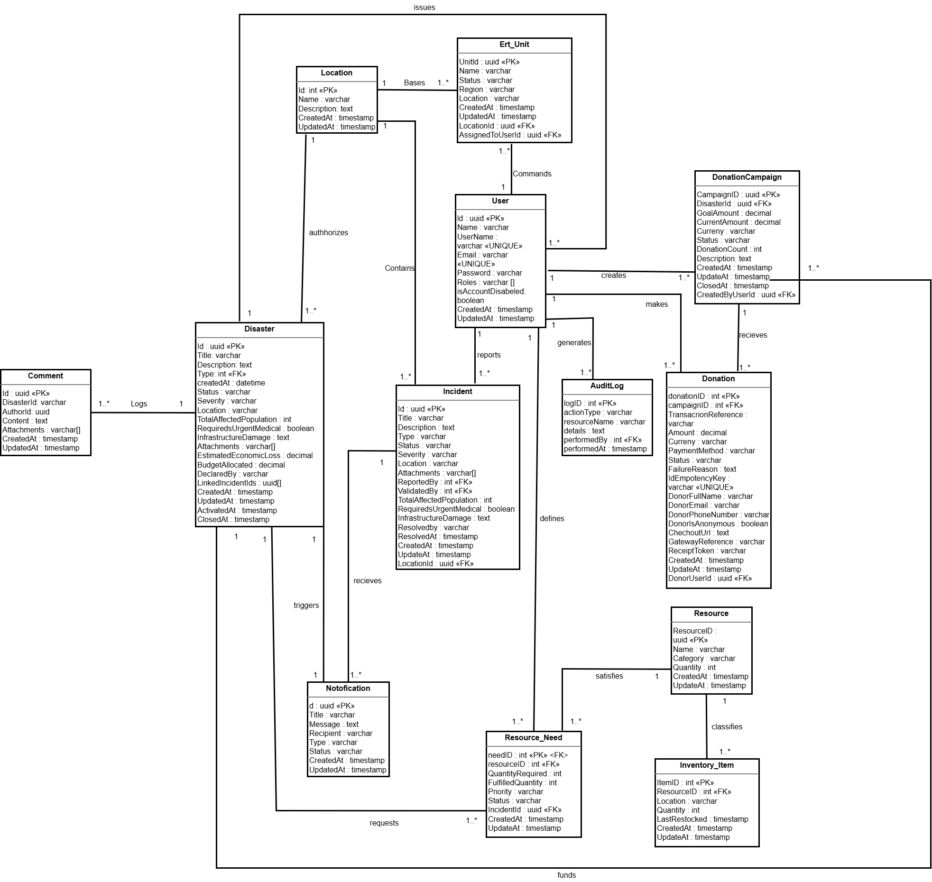
Figure 5.3 Relational Persistence Diagram

Component Diagram / Sub-System Decomposition
A component diagram illustrates the high-level structural organization of a system by focusing on its modular parts and their dependencies. Within the Unified Modeling Language (UML) framework, components are defined as modular, replaceable, and encapsulated units of a system that groups related behaviors and data into a single entity. These building blocks are intended to be independent of their environment, allowing them to be developed, tested, and deployed as standalone pieces of the architecture (Miles & Hamilton, 2006). By utilizing component diagrams, developers can effectively partition a complex system into manageable subsystems, emphasizing the "black-box" nature of each module and highlighting how services are orchestrated through formal interfaces (Arlow & Neustadt, 2005).
Notations
To effectively model the system’s architecture using component diagrams, the following standard UML notations are employed:
- Component: Represents a logical, autonomous unit of the system that encapsulates related functionalities. It is visually represented as a rectangle with a specific component icon (a small box with two smaller rectangles protruding from its side) or "tabs" placed in the upper right corner (Larman, 2004).
- Provided Interface: Denotes the specific set of services or operations that a component makes available to other components. This is represented by a "lollipop" symbol, consisting of a full circle connected to the component by a straight line.
- Required Interface: Denotes a dependency where a component needs services from an external source to fulfill its responsibilities. This is illustrated with a "socket" symbol, shown as a semi-circle or arc that conceptually "plugs into" a provided interface.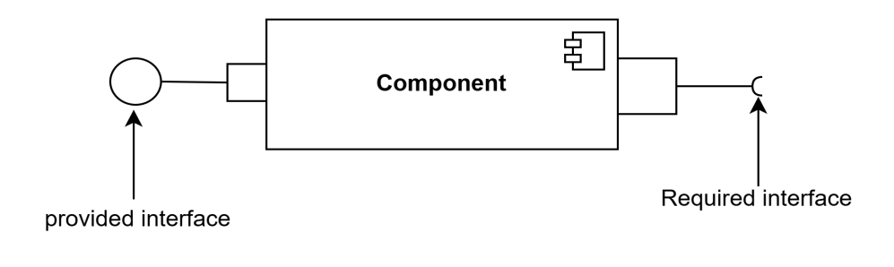
Figure 5.4 Component Diagram Notations
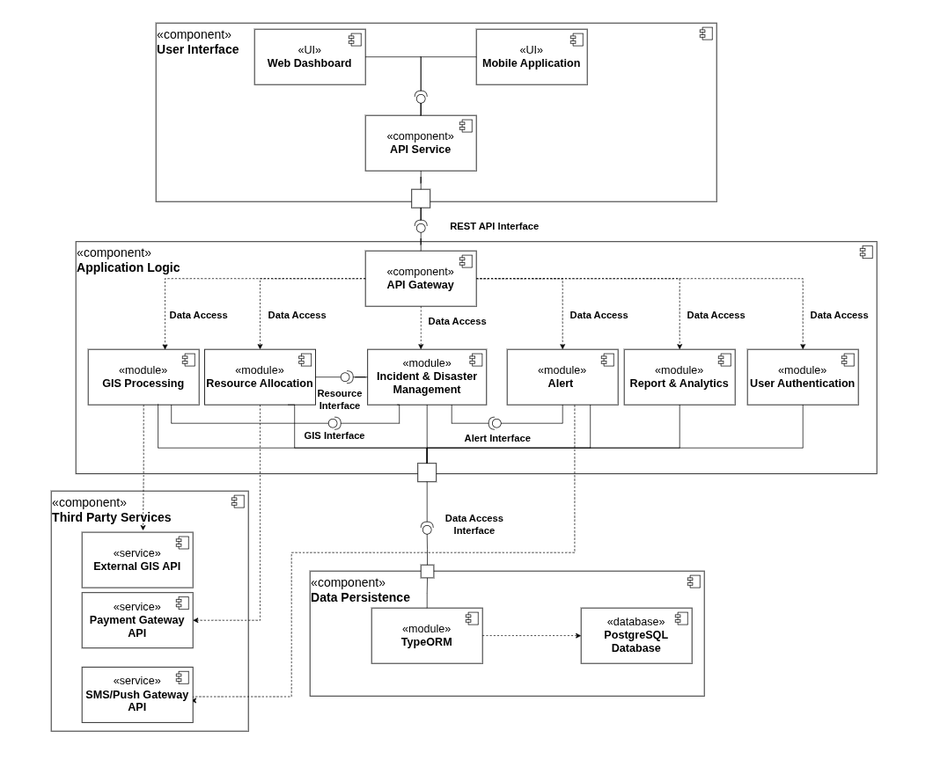
Figure 5.5 Component Diagram

Deployment Diagram
UML deployment diagrams show the hardware for your system, the software that is installed on that hardware, and the middleware used to connect the disparate machines to one another (Ambler, 2005).
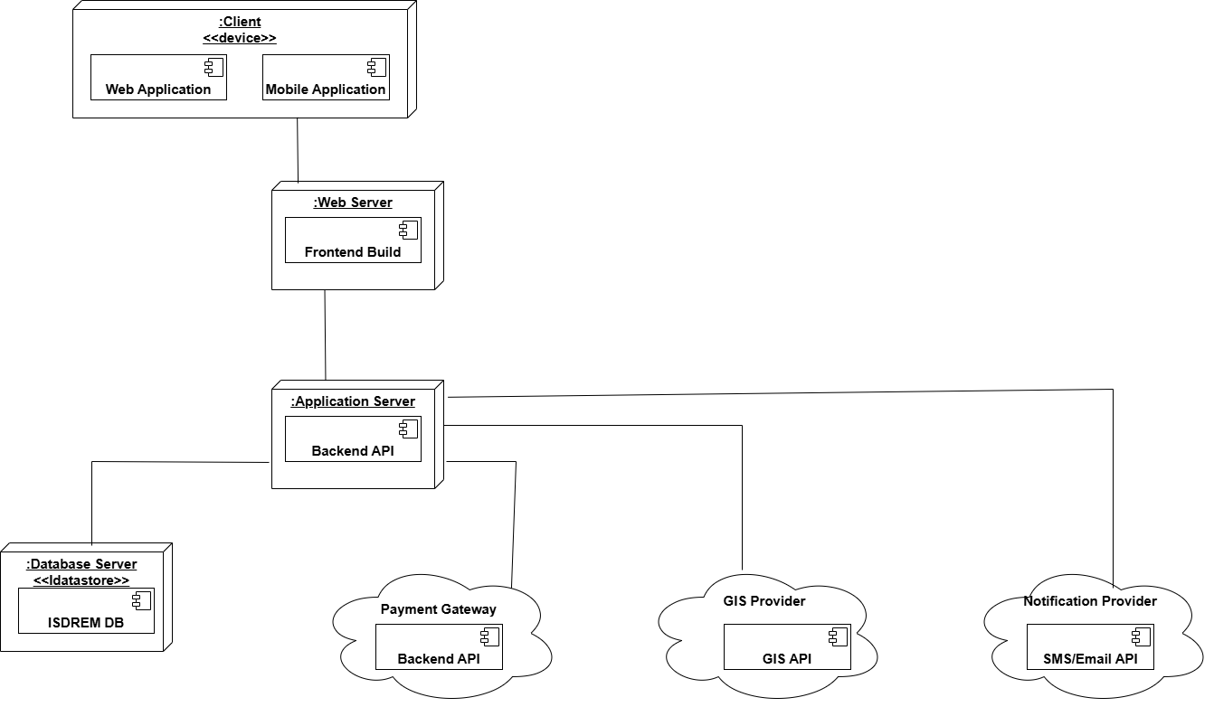
Figure 5.6 Deployment Diagram

User Interface
A user interface (UI) is the point of interaction between a user and a computer system. It is the graphical, textual, or auditory representation of a software application, website, or device that allows users to perform tasks, navigate, and communicate with the system.

User Interface Flow Diagram
A user interface flow diagram is a graphical representation of the steps a user takes to complete a task or accomplish a goal within a software application. The diagram maps the user's interactions with the interface and the system's responses, including any decisions or branching paths that may occur during the process.
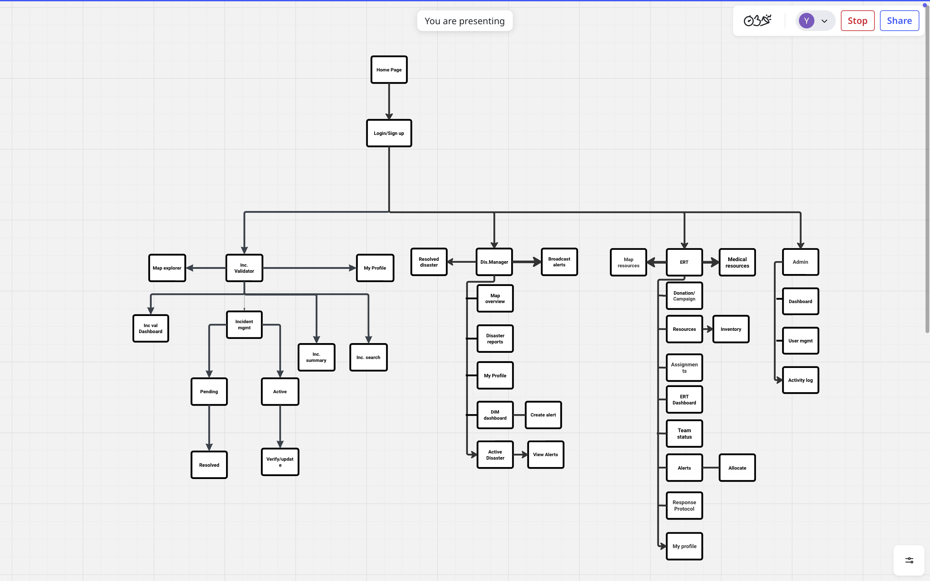
Figure 5.7 Web UI Flow

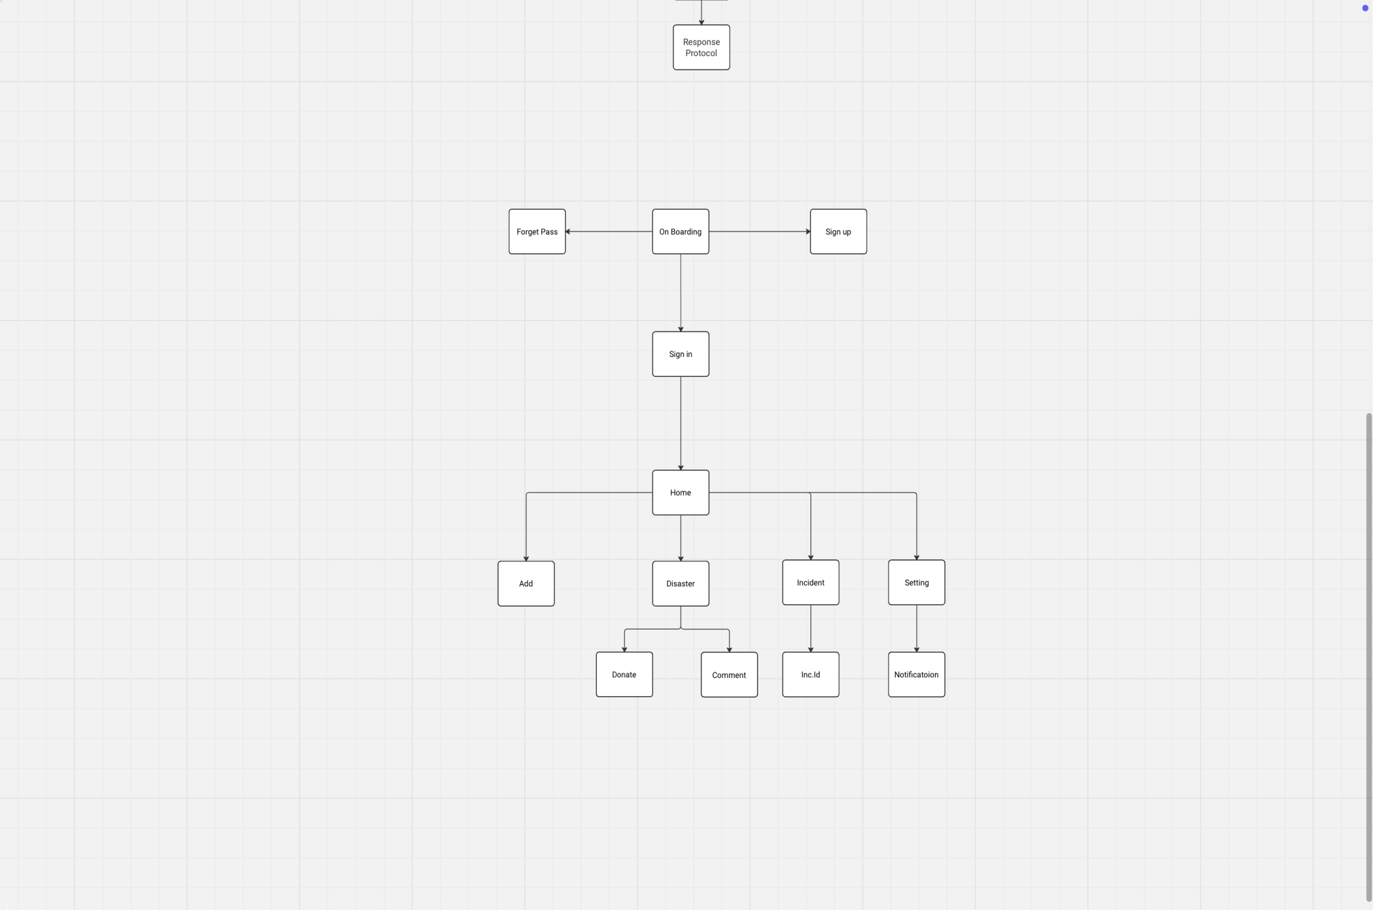
Figure 5.8 Mobile UI Flow

User Interface Design(selected sample )

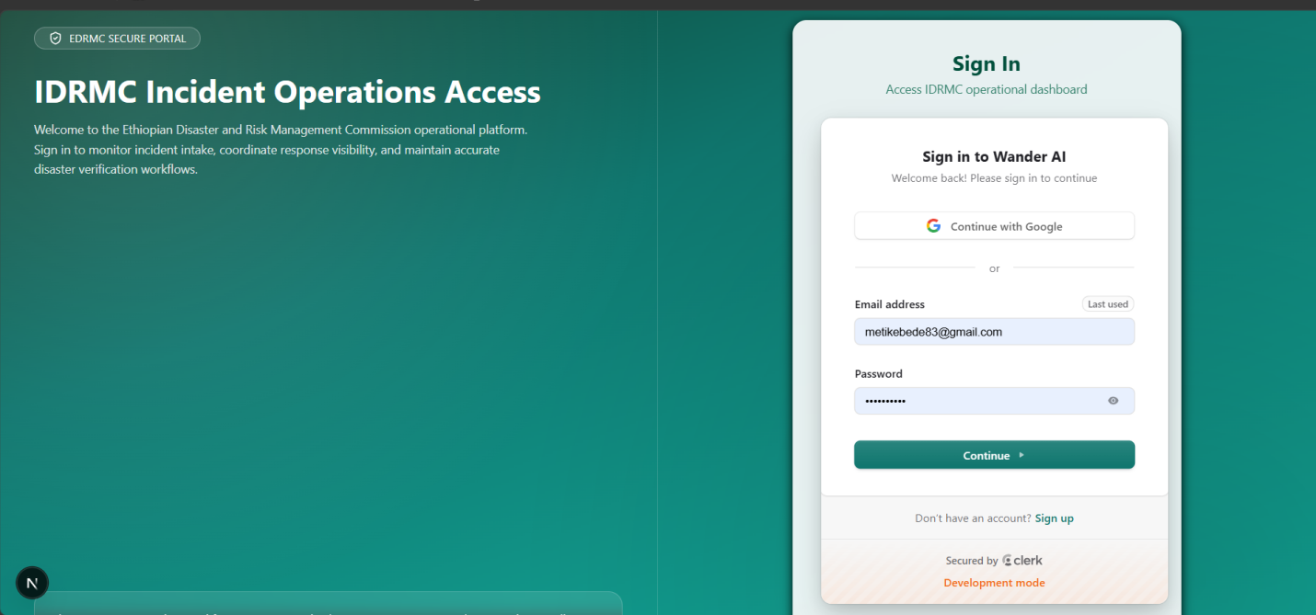
Figure 5.9 Sign in Page UI

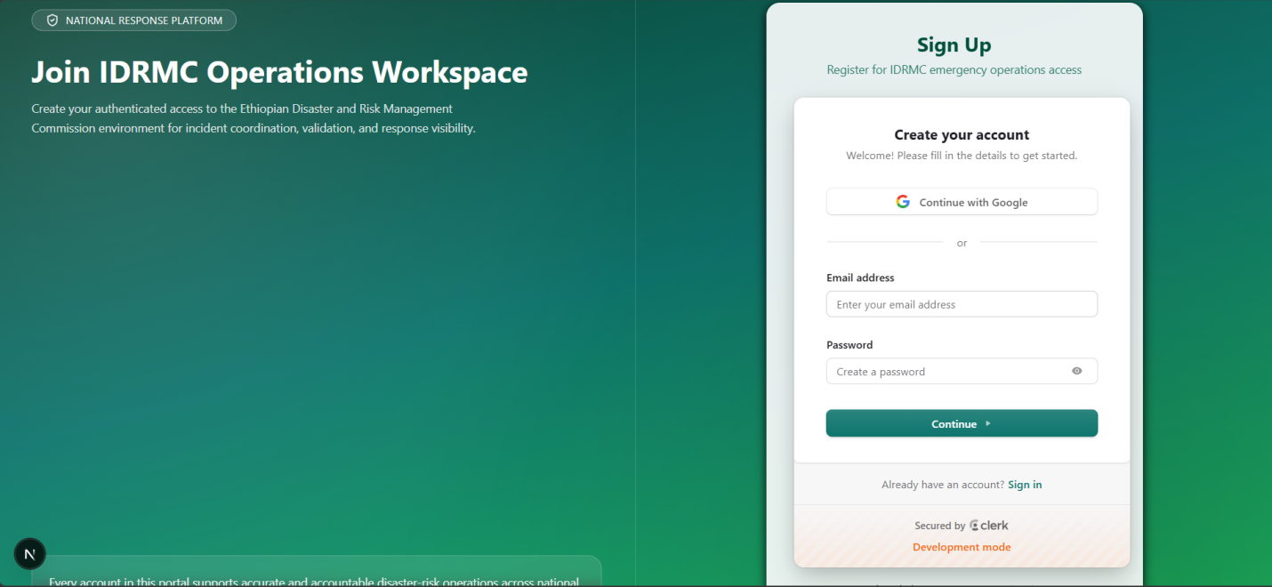
Figure 5.10 Sign up Page UI
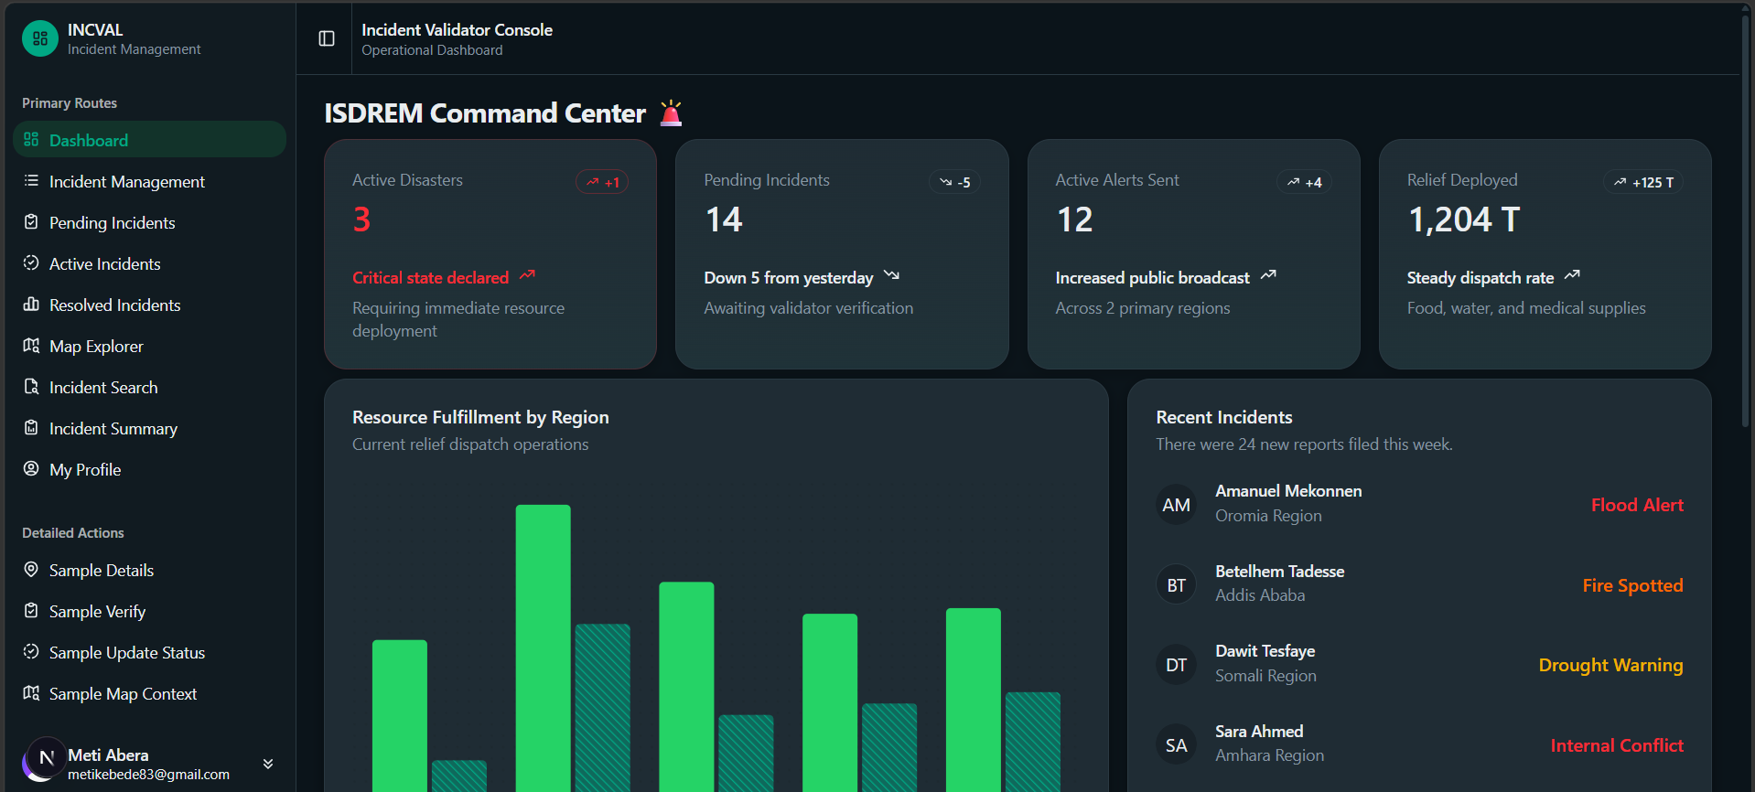
Figure 5.11 Incident Validator Dashboard

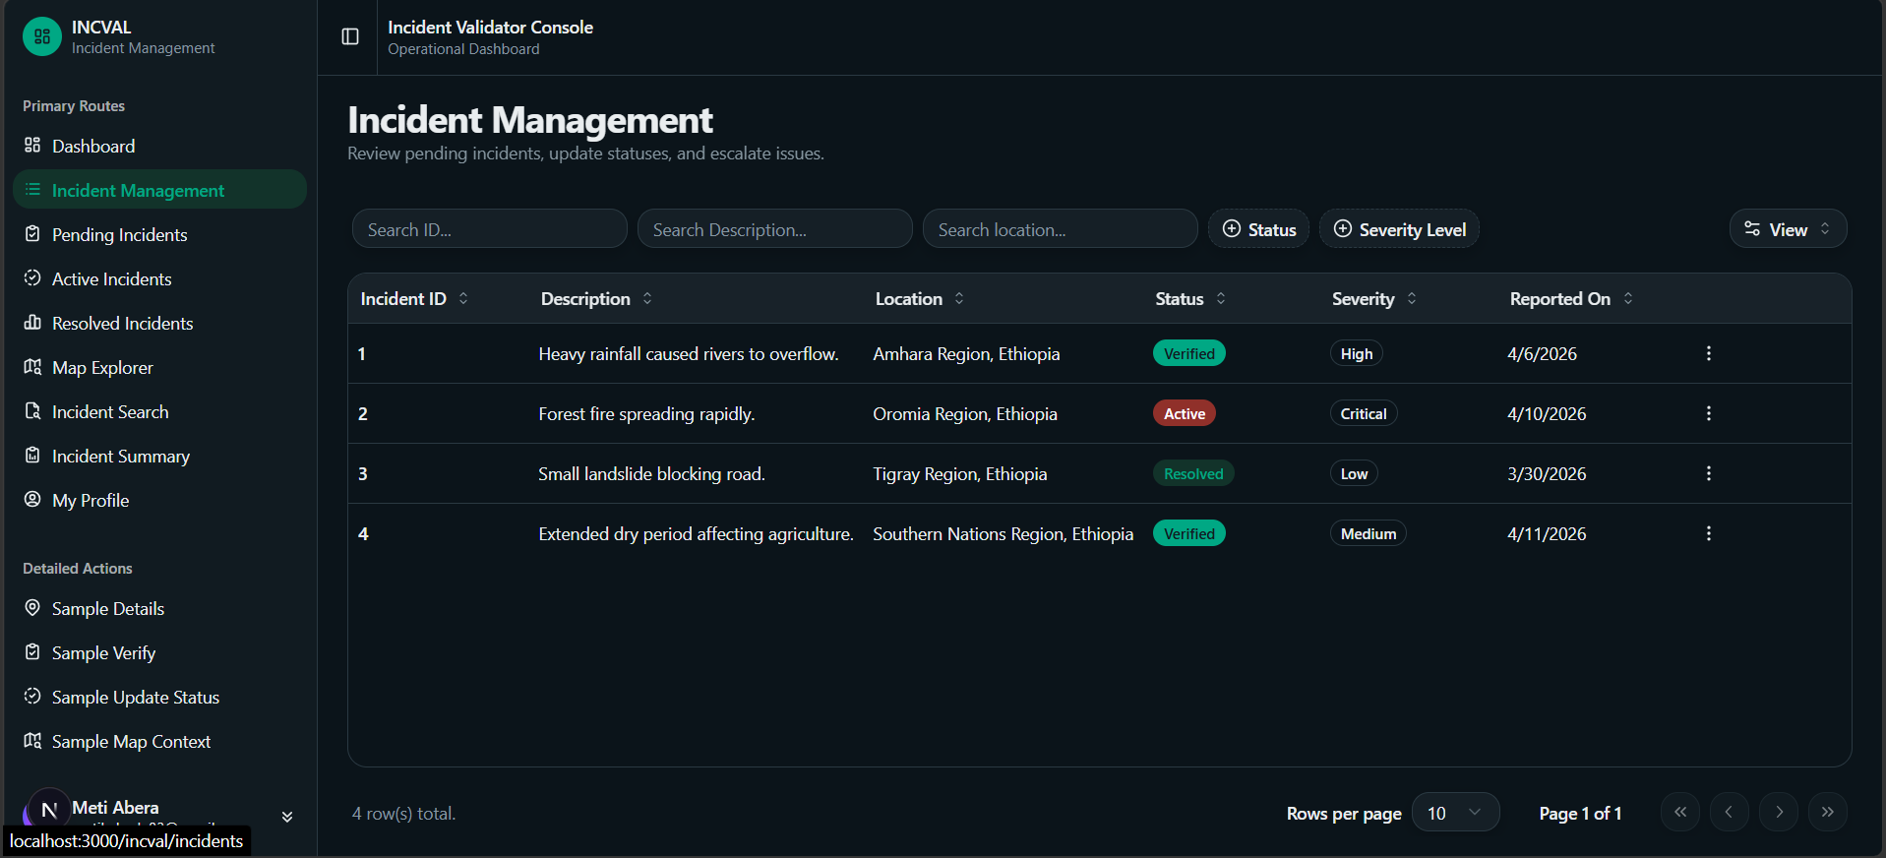
Figure 5.12 Lists of Reported Incidents Page

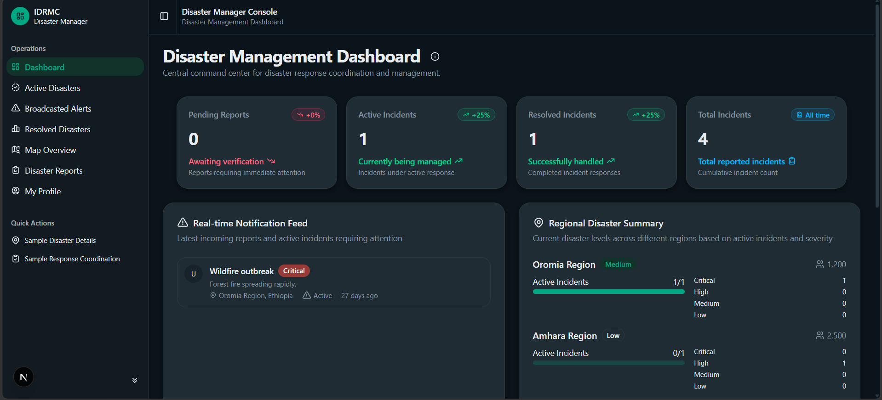
Figure 5.13 Disaster Managers Dashboard

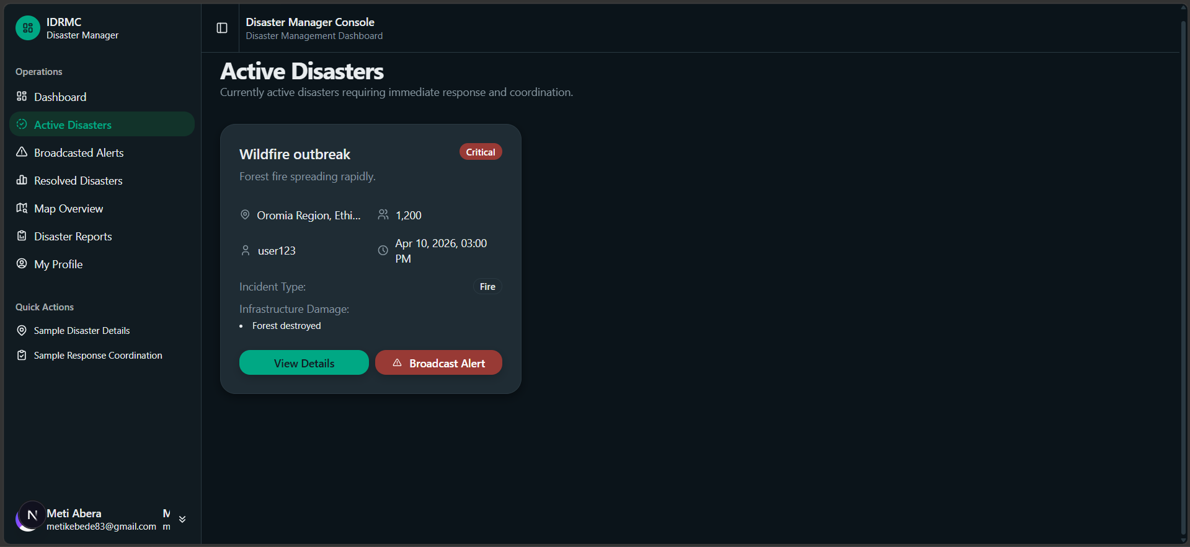
Figure 5.14 Active Disaster Page
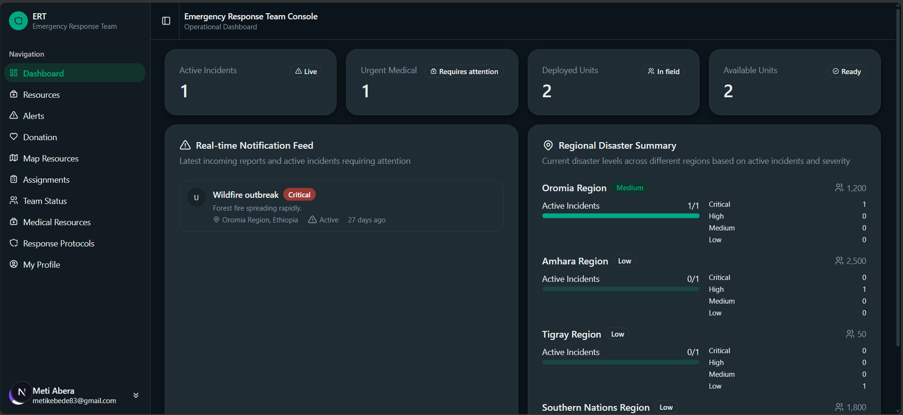
Figure 5.15 Emergency Response Team Dashboard

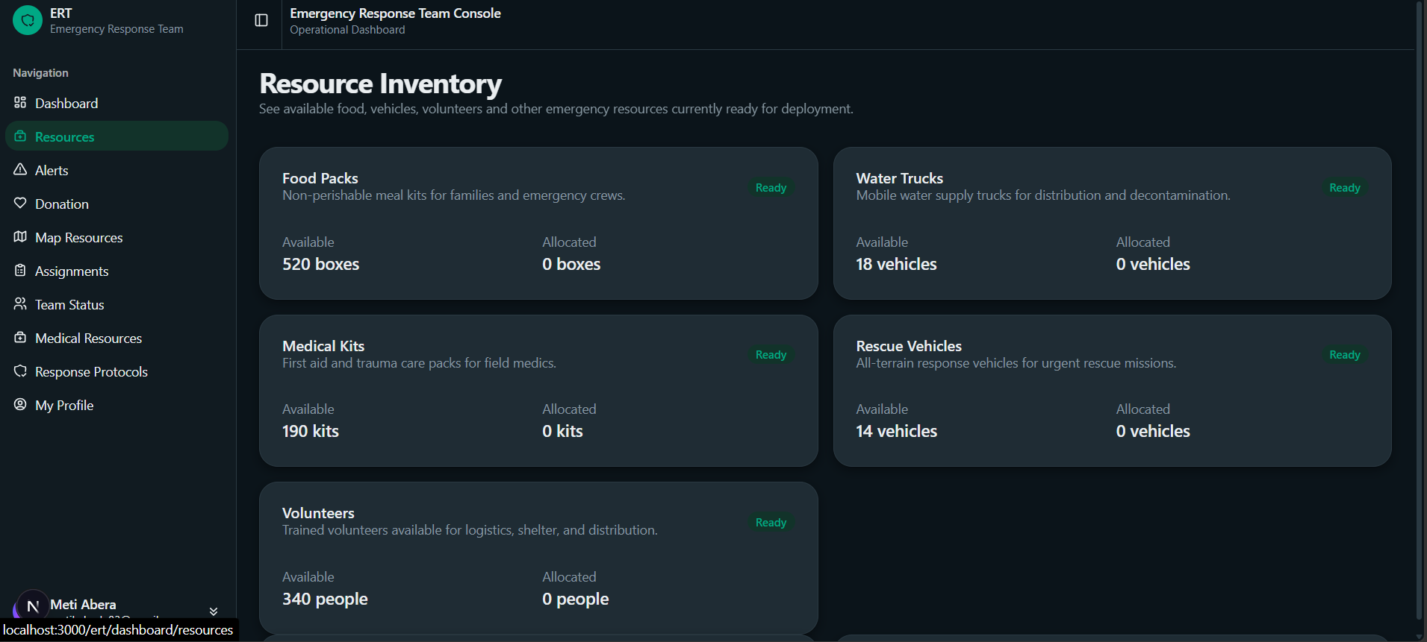
Figure 5.16 Resource Inventory Page

Chapter 6

Object-Oriented Implementation
This Chapter discusses the testing processes that are going to be implemented to test ISDREM. This is necessary to make sure the functionality of the system. The testing process includes unit, integration and system testing and deploying the system to the appropriate platform.

Introduction
The Integrated System for Disaster Response and Emergency Management (ISDREM) was implemented using an object-oriented approach to ensure modularity, scalability, maintainability, and reusability of system components. Object-oriented implementation promotes encapsulation, abstraction, inheritance, and polymorphism, which are essential for managing complex disaster management workflows involving multiple actors and real-time operations.
The overall architecture follows a Domain-Driven layered approach:
- Presentation Layer: Developed using React.js (Web) and React Native (Mobile) to handle user interfaces and offline-first capabilities.
- Application/Service Layer: Implemented with Node.js and Express/NestJS, acting as the orchestrator for incoming requests and coordinating domain objects.
- Domain Model Layer: Contains the core business logic, entities (e.g., Active Incident, Resource Need), and validation rules.
- Data Access Layer: Utilizes PostgreSQL with PostGIS extensions to manage relational and geospatial data persistence.
This separation of concerns enhances maintainability and supports incremental system evolution, ensuring the system remains stable during high-stress disaster events.

Testing and Testing Procedure
Testing was conducted systematically to ensure the correctness, reliability, and security of the ISDREM system. The testing strategy integrates both Unit Testing and End-to-End (E2E) Testing to validate the application across all layers.
Test Technology Stack:
- Jest: The primary JavaScript testing framework used for test structuring, mocking, and assertions.
- @nestjs/testing: Utilized for dependency injection and creating isolated execution contexts.
- Supertest: Employed for executing HTTP assertions against the application during E2E tests.
- TypeORM: Used to manage test database connections, migrations, and entity verification.
Overall Test Statistics: The testing suite currently comprises 20 total test files (15 Unit Test files and 5 E2E Test files), encompassing over 107 individual tests spanning more than 1,000 lines of test code. All 107+ active tests are currently passing, with one module (Article) marked as skipped.

6.2.1. Unit Testing
Unit testing evaluates individual components of the software application in isolation to ensure they operate in accordance with their specified design. The primary objective is to facilitate the early detection of defects and safeguard against regression errors.
Within the ISDREM system, unit testing heavily utilizes a Mocking Pattern, where services are mocked using jest.fn(), dependencies are injected via Test.createTestingModule(), and provider overrides are used for strict isolation.
Key Tested Components & Results Over 82 unit tests were executed across 15 files with a 100% pass rate. The following tables highlight key functionalities verified:

Component | Tested Functionality | Expected Behavior | Status
AuthController | User Registration | Validates inputs and returns { data: null, meta: {} } upon successful registration. | PASS
AuthService | Credential Validation | Returns a valid User Output object and Access Token claim when provided with correct username/password. | PASS
UserController | CRUD Operations | Successfully calls getUserById and updateUser with correct IDs and parameters. | PASS
UserAclService | Admin Permissions | Admin role is authorized to Create, Read, Update, Delete, and List all user resources. | PASS
UserAclService | User Permissions | User role can Read/Update themselves but is restricted from Deleting themselves or Updating/Deleting other users. | PASS
Table 6.1 Auth & User Module Unit Tests

Component | Tested Functionality | Expected Behavior | Status
DonationTransactionService | Transaction Initialization | Caches duplicate requests via Idempotency Key; rejects donations for non-active campaigns; returns checkoutUrl. | PASS
DonationCampaignService | Campaign State Transitions | Successfully activates campaigns; rejects transitions back to DRAFT; wraps domain errors as BadRequestException. | PASS
DonationEntity | Value Validation & State | Throws error if donation amount is ≤ 0; marks donation as PENDING_GATEWAY; prevents invalid transitions. | PASS
CampaignEntity | Goal & Funds Logic | Rejects currency mismatches; adds funds only when ACTIVE; accurately rounds progress percentage to 2 decimals. | PASS
Table 6.2 Donation Module Unit Tests

Component | Tested Functionality | Expected Behavior | Status
AllExceptionsFilter | Global Error Handling | Captures 404/400 HttpExceptions and unhandled 500 errors; suppresses detailed error messages in production mode. | PASS
RequestContext | Request Utility Tracking | Correctly sets URL, RequestID, and captures IP addresses from forwarded headers. | PASS
Table 6.3 Shared Infrastructure Unit Tests

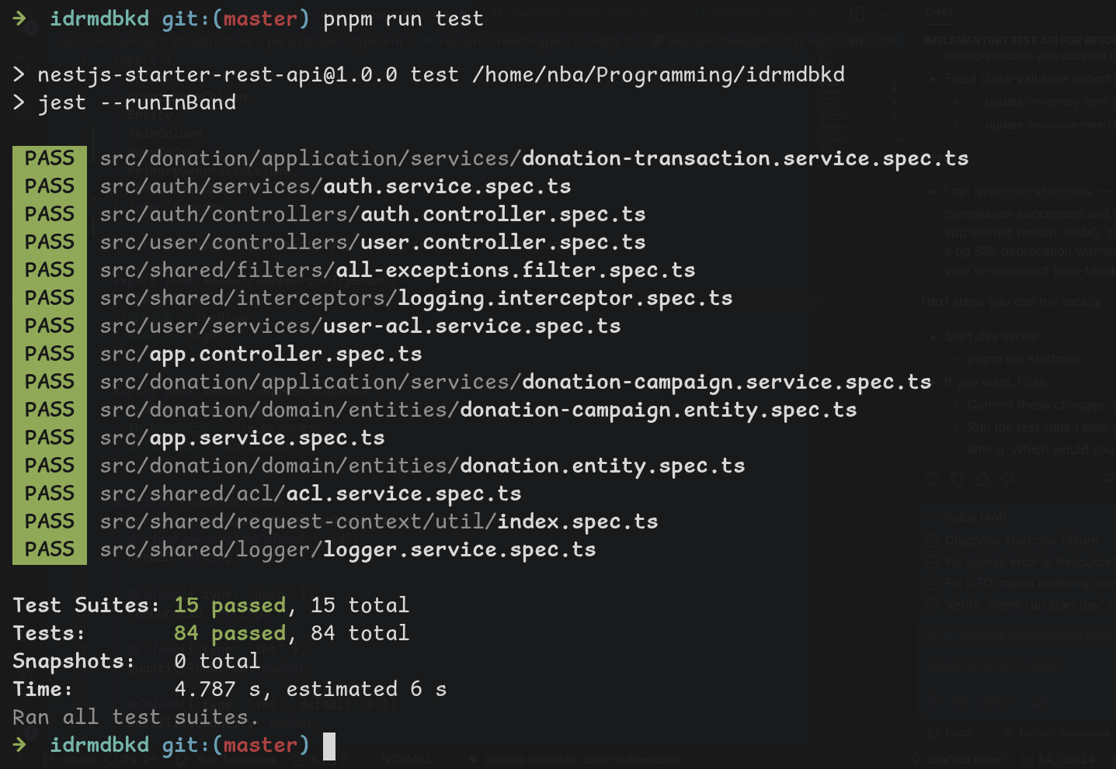
Figure 6.1 Unit Testing Result

End-to-End (E2E) and Integration Testing
End-to-End testing evaluates the interactions between controllers, routes, middleware, and the database to ensure the system functions correctly as a unified ecosystem.
Database Testing Pattern: E2E tests utilize a strict database testing pattern to prevent data leaks. Pre-test setups run resetDBBeforeTest(), followed by createDBEntities(), and conclude with closeDBAfterTest().
Over 25 E2E tests were executed across 5 files with a 100% pass rate.

Endpoint | Method | Input / Condition | Expected Status / Assertion | Result
/auth/register | POST | Valid RegisterInput | 201 - Returns user object with ID. | PASS
/auth/login | POST | Wrong credentials | 401 - Unauthorized. | PASS
/auth/refresh-token | POST | Valid refreshToken | 200 - Returns new token pair. | PASS
/users/me | GET | No Bearer Token | 401 - Unauthorized. | PASS
/users/:id | PATCH | Incorrect password type (Number) | 400 - Bad Request. | PASS
Table 6.4 Authentication & User E2E Tests

Step | Endpoint | Method | Expected Status / Assertion | Result
1. Create | /donations/campaigns | POST | 201 - Campaign created in database. | PASS
2.Activate | /donations/campaigns/{id}/status | PATCH | 200 - Campaign status updated to ACTIVE. | PASS
3. Initialize | /donations/initialize | POST | 201 - checkoutUrl returned for payment. | PASS
4. Webhook | /donations/webhooks/chapa | POST | 200 - Payment callback processed successfully. | PASS
5. Receipt | /donations/{id}/receipt | GET | 200 - PDF generated using receiptToken. | PASS
Table 6.5 Donation Workflow E2E Tests

6.2.3. System Testing
System testing is used to test the full functioning of the system. This is to ensure that all the features are working seamlessly. During this test we will use different test cases and then check whether the feature works or not.
The below tables will display the test cases used:
Field | Details
Test Case Identifier | Disaster Declaration Test
Location | Disaster Management Dashboard Page
Features to be Tested | Disaster Proclamation, Input Field Validations, Geospatial Reference Mapping, Automated Notification Cascading
Data | - Disaster Title (e.g., "Awash River Basin Flood")
 | - Severity Level (CRITICAL, HIGH, MEDIUM, LOW)
 | - Spatial Scope / Location ID (Geographic Region Reference)
 | - Description / Timeline Notes
Test Cases | - Verify if the page displays all mandatory entry fields and correctly binds selection dropdowns for Location ID and Severity Level
 | - Verify if a DisasterManager can input valid information and submit the form successfully.
 | - Verify if the system handles missing entries or invalid coordinate formats by prompting appropriate error corrections.
 | - Verify if an auto-generated unique identifier is created and stored properly in the database with status set to ACTIVE.
 | - Verify if declaring a disaster automatically creates a broadcast entry in the notifications table linking directly back to the new disasterId.
Expected Result | - The disaster record is saved with a unique primary key and an accurate severity state.
 | - The system flags incomplete fields and blocks submission.
 | - Dependent system actions trigger immediate, unread notifications for all personnel stationed within the impacted location radius
Table 6.6 Disaster Declaration Test Table

Field | Details
Test Case Identifier | Incident Reporting and Validation Test
Location | Field Reporting Mobile Module / Regional Dispatch View
Features to be Tested | Field Report Submission, Media/Attachment Handling, Validation State Machine Transitions, Auditor Logs
Data | - Incident Description (e.g., "Landslide blocking main route")
 | - Incident Category (Infrastructure, Medical, Fire, Flood)
 | - Reporting User ID
 | - Validator Comments / Status Choice (VALIDATED, REJECTED)
Test Cases | - Verify if field agents can successfully drop location pins, add details, and submit a report.
 | - erify if a new submission defaults to a state of PENDING and appends an action row to the system's AuditLogs.
 | - Verify if an authorized IncidentValidator can review pending incidents and update the status to VALIDATED or REJECTED.
 | - Verify if the validation transition automatically triggers an assessment hook for the early warning system cluster.
 | - Verify if unauthorized users are blocked from executing validation state patches.
Expected Result | - Field reports are successfully logged with timestamps and associated reporter IDs.
 | - State changes flow properly; changing an incident status updates the dispatch board dynamically.
 | - Permission violations generate a 403 Forbidden response and log a security alert.
Table 6.7 Incident Reporting & Validation Test Table

Field | Details
Test Case Identifier | Emergency Resource Allocation Test
Location | Resource Management and Logistics Dashboard
Features to be Tested | Resource Need Creation, Inventory Availability Inquiries, Atomic Quantity Updates, Transaction Safety
Data | - Target Incident ID
 | - Master Resource Catalog Item ID
 | - Quantity Requested
 | - Warehouse Stock Balances
Test Cases | - Verify if response teams can declare material requirements for a validated incident zone, setting a state of PENDING_FULFILLMENT.
 | - Verify if warehouse coordinators can query stock availability matching the catalog profile item.
 | - Verify if executing a fulfillment transaction successfully decreases the physical stock balance in the database.
 | - Verify if the system blocks allocation requests when the requested quantity exceeds available stock levels.
 | - Verify if concurrent allocation updates on a single warehouse item are handled atomically without causing race conditions.
Expected Result | - Resource requests link to an active disaster ID and transition cleanly from pending to fulfilled.
 | - Database inventory row values update automatically to match distributed supplies.
 | - The system prevents over-allocation by displaying error messages when inventory levels are insufficient.
Table 6.8 Emergency Resource Allocation Test Table

Field | Detail
Test Case Identifier | Alert Notification Queue Test
Location | Notification Center / User Alert Hub
Features to be Tested | Broadcast Filter Compilation, Asynchronous Queue Processing, Delivery Status Tracking, Access Rules
Data | - Notification ID
 | - Recipient Endpoint / User Token
 | - Message Payload & Type (DISASTER_BROADCAST, INCIDENT_ALERT)
 | - Status State (PENDING, SENT, READ)
Test Cases | - Verify if the alerting mechanism compiles a list of eligible target user profiles inside an impact radius without missing active accounts.
 | - Verify if notifications are written cleanly to the database with a reference to the triggering event identifier.
 | - Verify if the message status updates to SENT after processing and to READ once clicked by an end user.
 | - Verify if users can access their notification lists without experiencing system lag during bulk broadcast dispatches.
 | - Verify if system alerts are delivered across multiple integrated channels (such as E-mail or mobile push tokens) based on profile preferences.
Expected Result | - Broadcast loops successfully isolate target user groupings and distribute alerts dynamically.
 | - The asynchronous queue processes messages without blocking main operational tables.
 | - Status tracking states update accurately, providing reliable audit logs for emergency response timelines.
Table 6.9 Alert Notification Queue Test Table

Field | Detail
Test Case Identifier | Disaster Log Comments & Collaboration Test
Location | Disaster Feed Timeline / Situation Update Section
Features to be Tested | Situational Log Appending, Character Limit Enforcement, Media/Document Attachment Handling, Multi-User Thread Concurrency
Data | - Target Disaster ID (Valid active UUID)
 | - Author User ID (Authenticated Responder)
 | - Plain Text Content (e.g., "Bridge clear for logistics units as of 09:00 EAT.")
 | - File Payload (Image/PDF status reports)
Test Cases | - Verify if an authenticated responder can successfully publish a text update to a specific disaster log.
 | - Verify if the system allows valid file extensions (PNG, JPG, PDF) as attachments and blocks executable or dangerous file types.
 | - Verify if the feed rejects completely blank updates or submissions that exceed the max text length limit.
 | - Verify if multiple users posting to the same disaster thread simultaneously experience lag or out-of-order timeline syncing.
 | - Verify if unauthorized guest accounts are explicitly blocked from modifying or creating situational logs.
Expected Result | - New updates append immediately to the targeted disasterId feed with correct author references and timestamps.
 | - Invalid inputs are rejected with front-end validation prompts, while valid binary files save to protected cloud storage buckets.
 | - Timeline consistency is strictly maintained using incremental database sequence sorting.
Table 6.10 Disaster log comments and collaboration test table

Field | Detail
Test Case Identifier | Emergency Response Team (ERT) Unit Deployment Test
Location | ERT Logistics and Fleet Management Screen
Features to be Tested | Team Record Initialization, Sector/Staging Location Assignments, Commander Accountability Mapping, Status State Transitions
Data | - ERT Unit Name (e.g., "Alpha Search & Rescue")
 | - Assigned User ID (Commander Level)
 | - Target Location ID (Staging Zone)
 | - Unit Status (AVAILABLE, DEPLOYED, OOS)
Test Cases | - Verify if the system allows assigning a valid user account as the Unit Commander while enforcing that the user possesses the necessary operational permissions.
 | - Verify if changing the Unit Status to DEPLOYED triggers a cascading update that flags the team's designated locationId as actively covered on the global map.
 | - Verify if the schema successfully blocks assigning a single commander to two active units simultaneously if business rules dictate unique assignment.
 | - Verify if deleting a staging sector (locations) is blocked (RESTRICT) while an ERT unit is currently assigned to it.
Expected Result | - Unit rows are saved successfully with integrated foreign keys validating data integrity.
 | - Status updates flow into the application layers smoothly, altering state machine records in real time.
 | - Relational safety triggers reject cascading deletions that would leave active operational teams without an assigned base.
Table 6.11 Emergency Response Team (ERT) Unit Deployment Test Table

Field | Detail
Test Case Identifier | Master Resource Catalog & Inventory Stock Test
Location | Supply Chain Catalog Configuration Screen / Inventory Warehouse Triage
Features to be Tested | Global Catalog Definition, Inventory Item Batch Ingestion, Restock Timestamp Updates, Data Integrity on Discrepancies
Data | - Resource ID (Master Catalog Reference Key)
 | - Supply Item Name & Category (e.g., "High-Capacity Water Purifier")
 | - Local Item Batch Quantity
 | - Last Restocked Timestamp
Test Cases | - Verify if catalog managers can define global baseline items in the master resources table with a unique category profile.
 | - Verify if warehouse personnel can initialize physical stock entries in the inventory_items table that pull structural item details from the parent resourceID.
 | - Verify if updating an inventory balance automatically refreshes the lastRestocked timestamp field to the current database transaction time.
 | - Verify if inputting a negative stock or restock quantity is blocked by database-level column constraints.
 | - Verify if deleting a master template from the global catalog is completely prevented if live warehouses still track physical batches of that resource type in stock.
Expected Result | - Core supply definitions decouple efficiently from physical local stockpiles, minimizing structural redundancy.
 | - System fields enforce strict verification rules, keeping negative balances or orphan inventory rows from breaking transactional accounting models.
 | - Automated temporal updates offer reliable system metrics for supply chain audits.
Table 6.12 Master Resource Catalog & Inventory Stock Test Table

6.2.3 Critical Test Validations
The testing suite rigorously enforced Domain-Driven Design (DDD) rules, focusing on the following critical scenarios:
- Security: Validated that standard users cannot delete other users, and that administrators have comprehensive operational access. Missing authorization tokens strictly return 401 errors.
- Business Logic: Enforced rules stating that donation amounts must strictly be greater than 0, and that campaigns must be in an ACTIVE state to receive funds.
- State Machines: Validated exact entity state transitions for donations to prevent fraudulent updates.
- Idempotency: Confirmed that duplicate donation requests are properly cached, preventing double-billing or overlapping database entries.

6.2.4 Limitations and Future Test Coverage
While the core functionality (App, Auth, User, Donation, Shared) achieved high test coverage, system audits identified specific areas requiring future implementation. The test/article/article.e2e-spec.ts suite was skipped as the module is currently unimplemented.
Recommendations for Future Enhancements:
- Coverage Expansion: Implement comprehensive Unit and E2E tests for the currently untested modules, specifically: Comment, Incident, Location, Notification, and Disaster modules.
- Integration Workflows: Add cross-module integration tests to ensure seamless data flow between the Incident reporting mechanics and the Disaster Management modules.
- Performance & Security Testing: Integrate performance benchmarks to simulate peak disaster loads and conduct formal penetration tests to reinforce the platform's security posture.

Deployment and Installation Process
The deployment strategy agile deployment philosophy, emphasizing incremental release, automation, and continuous improvement.

6.3.1 Server Deployment
The production environment consists of:
- Application Server
- Database Server
- Secure communication layer
Deployment steps included:
- Installation of runtime environment
- Database schema creation and migration
- Configuration of environment variables
- Secure HTTPS setup
- Initial administrative account configuration
Database evolution followed controlled migration procedures to maintain backward compatibility.

6.3.2 Web Application Deployment
The web application was built and deployed to the production server. Configuration settings were adjusted for production mode, and smoke testing was performed to verify core functionalities such as authentication, incident reporting, and alert broadcasting.

6.3.3 Mobile Application Deployment
The mobile application was compiled into a production build. Backend API endpoints were configured to connect to the production server. The application was tested on multiple devices before distribution.

6.3.4 Post Deployment Activities
Post deployment activities include:
- Continuous monitoring
- Periodic database backup
- Security patch updates
- Performance optimization
- Audit log monitoring
Consistent with agile principles, deployment is not considered a final stage but part of a continuous improvement cycle.

Chapter 7

Conclusion and Recommendation

Conclusion
The Integrated Information System for Disaster Response and Emergency Management (ISDREM) overcomes the historical weakness of the emergency response ecosystem, such as siloed communications, manual tracking and delayed mobilization. For this industrial project, phase II has made the system production ready by implementing the architecture that has been planned.
The Integrated Information System for Disaster Response and Emergency Management (ISDREM) overcomes the historical weaknesses of the emergency response ecosystem, such as siloed communications, manual tracking and delayed mobilization. For this industrial project, phase-II has pushed the system out of the abstract architectural sketch phase and made it into a working production-ready enterprise application that can synchronize disaster workflows from multiple agencies in real-time. On the architectural side, this project demonstrates the effectiveness of using Strategic Domain-Driven Design (DDD) together with a Tactical Hexagonal (Onion) Architecture. By breaking down the complex real-world operations into distinct, highly cohesive bounded contexts (Core User Management, Disaster Proclamation, Field Incident Reporting, Public Relief Donations), each module could scale independently from others without causing regressions across the entire system. A strong distinction between the core business logic and external infrastructures (such as database drivers and payment gateways) ensures that ISDREM will be very flexible and maintainable throughout the software's entire lifecycle. On an operational level, the system is required to fill the critical gap between availability of resources and real-time demand. Centralizing the supply catalog as a relational database and localizing the tracking of stock in the warehouses enables the response units to distribute material aid with the utmost atomic precision. At the same time, the adoption of the public crowdfunding models gives the private banks and public funders an accountable register of the funding for disasters as they are declared, promoting transparency in disaster funding. Lastly, verification and system testing ensured the platform's reliability in high-stress environments. Isolated unit testing with Jest and end-to-end API lifecycle assertions with Supertest provided the confidence that critical business invariants like automated cascading notification dispatch on disaster declaration, resource distribution and atomic stock deduction are safely and predictably handled. In conclusion, ISDREM is a powerful framework that effectively employs current information systems architecture to save lives, protect infrastructure and supports coordinated, common aid in crisis situations.

Recommendation
The recommendation that we suggest for the future enhancement of the system’s efficiency, reach and resilience are listed as follows:
- AI integration for automated validation of incidents: It is recommended to implement Machine Learning (ML) algorithms and Natural Language Processing (NLP) to automatically categorize and prioritize incoming reports. By analyzing historical data and cross-referencing multiple reports from the same geographic area, the system can filter out duplicates or "fake" reports and instantly flag life-threatening situations for immediate human intervention. This ensures that the objective of "timely information" is met even during high-volume periods.
- Establishing standardized APIs for inter-agency collaboration: We recommend the development of a Public API Layer following international standards such as the Common Alerting Protocol (CAP). This would allow the ISDREM platform to act as a central data hub, enabling external agencies to pull real-time GIS data and incident updates into their own proprietary systems. Standardizing these interfaces will reduce communication silos and ensure a synchronized national response to emergencies.
- Distributing the system to a cloud-native platforms: Future iterations of ISDREM should utilize Microservices and Serverless Computing. This transition would allow the system to benefit from Auto-Scaling, where server capacity automatically expands to meet sudden surges in user traffic during a disaster and shrinks during quiet periods to save costs. Additionally, cloud-native storage would provide geographically redundant backups, ensuring that the system remains online even if local infrastructure in one region is destroyed.

Reference
  - Ambler, S. W. (2003). Agile Database Techniques: Effective Strategies for the Agile Software Developer. Wiley.
  - Booch, G. (1994). Object-oriented analysis and design with applications (2nd ed.). Addison-Wesley.
  - Ambler, S. W. (2005). The elements of UML 2.0 style. Cambridge University Press.
  - Arlow, J., & Neustadt, I. (2005). UML 2 and the unified process: Practical object-oriented analysis and design (2nd ed.). Addison-Wesley Professional.
  - Larman, C. (2004). Applying UML and patterns: An introduction to object-oriented analysis and design and iterative development (3rd ed.). Prentice Hall.
  - Miles, R., & Hamilton, K. (2006). Learning UML 2.0. O'Reilly Media, Inc.

Appendix
Sample code

