Building a Transmission-mode Laser Scanning Microscope for Free

Joseph R. Freeston
Department of English, Windham High School
Freshman Writing
June 8, 2020

Abstract
Scientific equipment can often be produced with parts that can be found in old electronics. This paper is intended to inform about how a transmission-mode laser scanning microscope (TLSM) can be constructed for very little monetary cost. A TLSM shines a collimated laser beam into optics which focus it into a small area along the focal plane (which is on the specimen). A TLSM measures the light transmitted through an object, sometimes revealing interesting details about its structure. This reflected light is measured as the beam is scanned along the object in order to capture a grayscale image. Although most laser scanning microscopes are confocal, meaning that the light reflected off of an object goes backward through the objective lens, and is then measured, this one operates only in transmission-mode. This functional piece of equipment is capable of obtaining three-dimensional slices of almost any small, translucent object, and can be built with parts commonly found in old and broken electronics.
Keywords: arduino, laser, microscope, optics

Glossary
- Actuator
  - A device that actuates, or moves, something.
- Beam waist
  - The diameter of a beam at its focal point (Hinton, 2019).
- Bipolar Junction Transistor (BJT)
  - A type of transistor that allows controlling the amount of electric current going from its collector to its emitter by altering the current from its base to its emitter (See “Transistor”).
- Cadmium-sulfide
  - A carcinogenic material commonly found in older photoresistors (See “Photoresistor”).
- Collimation
  - The process of forming a beam into a straight, column-shaped one by lowering its angle of divergence.
- Confocal
  - Meaning that a laser will be focused onto something and in the same manner (through the same optics) be reflected backward to end up in the same place it originated from. The returning beam may also be split off into a detector at the same optical distance from the objective lens as the laser.
- Current Source
  - A current source is capable of maintaining a constant current output, even with varying loads, by altering its voltage output.
- Diaphragm
  - (In a speaker) The part of a speaker which is actuated back and forth by the coil repelling or attracting a magnet. Normally, the diaphragm turns the mechanical motion into a longitudinal wave going through the air.
- Duty cycle
  - The percentage of time that a pulsed signal is in the high or “on” state. If the signal remains high for 90% of the time in between spiking low, it has a 90% duty cycle (See “Pulse-width Modulation”).
- Electromagnet
  - A magnet relying on the magnetic field produced around a wire with current flowing through it. These are generally just a coil of wire, often wrapped around a metal core. They may be turned on and off, and even varied, electronically.
- H-Bridge
  - An arrangement of transistors that allow reversing the polarity of a device, such as a motor or a coil. They are commonly used to control a motor’s direction.
- Kirchhoff's Current law
  - A law that allows multiple devices in series to draw the same amount of current.
- Microcontroller
  - A small computer capable of performing calculations and controlling electronics through input/output pins (i/o pins).
- Ohm
  - The unit used to measure resistance to the flow of electric current, named after Georg Ohm, the man that discovered Ohm’s Law.
- Ohm’s Law
  - The famous equation relating current, voltage, and resistance, stating that V=IR, with “V” being the voltage drop across something, “I” being the current going through it, and “R” being the resistance in ohms (See “Ohm”).
- Operational Amplifier (Op-Amp)
  - A device that amplifies a signal based upon the difference between its two inputs.
- Photodiode
  - A device that can be used to measure the intensity of light.
- Photoresistor
  - Similar to a photodiode, but with a much slower reaction time. It is essentially a resistor whose resistance changes based on light intensity (See “Resistor”).
- Power supply
  - A device which usually supplies (a) specific voltage(s) to an electronic circuit, generally converting the high voltage alternating current from an electrical outlet into low-voltage direct current.
- Pulse-width Modulation (PWM)
  - A method of synthesizing a nearly analog signal from a digital one by pulsing something and adjusting the duty cycle (See “Duty Cycle”).
- Resistor
  - An electronic component that resists the flow of electric current.
- Speaker
  - A device that transforms an analog (or almost analog) electrical signal into motion, used to create sound (but used only as an actuator in this project).
- Transistor
  - An electronic component which acts as an electronically controlled switch, controlling the flow of electricity with another electrical signal.
- Transmission
  - (In the context of optics) Occurs when light goes through a transparent or translucent object.

Building a Transmission-mode Laser Scanning Microscope for Free
Laser scanning microscopy is a widely used technique for observing microscopic structures, primarily in fields such as biology. A laser scanning microscope (LSM) can generate an image by scanning a laser across a surface and then capturing the intensity of the reflected and/or transmitted light through the substance. The primary advantage that an LSM has over a generic optical microscope exists because of the way that such a microscope operates: the size of a pixel in the captured image can be as small as the beam waist of the laser used. Because of the smaller lenses and supposedly higher optical quality present, with precision equipment, an LSM can have a much higher magnification than most optical microscopes. Furthermore, LSMs allow for 3-dimensional images to be captured by taking many frames with different focal distances. Because of this, laser scanning microscopy can reveal inner structures in translucent materials, including a substance’s crystalline structure. Laser scanning microscopes are relatively simple in their construction, compared to, for example, a scanning electron microscope (SEM). Despite the common preconception that such a topic may only be explored with industrial-grade lab equipment, an LSM is not overly complicated and can be made cheaply in a home workshop.
Interestingly enough, compact disc (CD) drives operate with the same principles as confocal laser scanning microscopes. A laser is reflected off of the surface of the disc and the returning beam’s intensity is measured. According to Woodford (2019), data is stored through the lands and pits on the CD, which reflect light differently, and they can be told apart from each other by the drive. In this manner, bits of data are encoded and stored physically in an optically read medium (Woodford, 2019).
In more detail, CD drives operate in a very similar way to LSMs. The collimated laser is focused down onto the disc by the objective lens. As the disc spins, the objective lens slowly scans across it, and a separate actuator exists for focusing and tracking the laser across the disc. This optical device, capable not only of focusing a laser to a microscopic point, but also steering the beam and focusing it automatically.
LSMs have previously been constructed in the past using parts from CD drives in addition to other parts (Williams, 2017; Venkes, 2017). After noticing this, I decided to build my own with an additional challenge: that no money would be spent on the project.
Prototypes and Revisions
Project Overview
I built this TLSM in over two years, although spread throughout this timeframe were three separate prototypes (and other projects). Some parts were reused across the prototypes, but each prototype had a unique method of operation. Due to effects of experimentation, three CD drives were required, but in replicating this project, only one would be required. Each prototype also had several different parts that were improved over its life (See Appendix A).
Prototype One
The first prototype had the primary purpose of a test: I wanted to see how feasible this project would be. The overall configuration was not confocal, nor was it transmission-mode. It had a cardboard enclosure, and a screw-driven focus mechanism made from an old bolt. The laser pointed down an aluminum rod, upon which was also the lens moving assembly from a CD drive. This allowed for a single line to be scanned, one pixel by 511 pixels, at any of 511 potential focal points. Instead of having a lens on the lens moving assembly, the specimen was moved directly instead of moving the beam’s position. The non-confocal reflected light was measured by a poor quality webcam, which attempted to measure the reflected beam’s intensity. To control the (specimen) lens-moving assembly, I used an H-bridge four-channel motor controller combined with a Trinket M0 microcontroller, which emulated a mouse to communicate with the computer and scanned the laser on its own.
Prototype Two
The second prototype consisted of the frame from an old optical microscope connected to a few metal boxes with wood. The laser was held on the optical microscope frame, where it shone into a beam splitter made from an old microscope slide at a 45-degree angle. Half of the beam was then split to the first cadmium-sulfide photoresistor, and the other half went forward into a metal box. Inside the metal box was the lens moving mechanism, using the same lens moving apparatus for the Y and Z-axis, and using a speaker for the x axis. This speaker was driven by a circuit to filter a pulse-width modulation (PWM) signal so that the deflection of the speaker’s diaphragm could be accurately controlled. The diaphragm was connected to a rod that (through linear bearings) pushed and pulled the entire lens moving piece back and forth. The lens moving piece controlled the y and z axis, while the speaker controlled the x axis. The laser was intended to shine through the lens (from which it could be redirected as well) and onto the specimen. The reflected light then went back through the objective lens to the beam splitter, where half of it went back into the laser, and half of it met another photoresistor. The intended operation of this prototype was confocal, however, it did not work properly for multiple reasons.
Its primary reason for failure was the fact that the laser was too dim to be received by the measuring photoresistor. In addition to the losses from the beam splitter and lens, for confocal operation to be ideal, the specimen must be perpendicular to the laser, and the sensors (photoresistors) must be aligned perfectly (which was tricky). Despite much experimentation, the signal received of the confocally reflected light was very little compared to the tiny amount of ambient light of the room, which was dark. Because of this, the scan measured the amount of light leakage throughout the scan, which was usually the brightness of the sunlight.
Figure 1
A Photograph of the Back of the Second Prototype
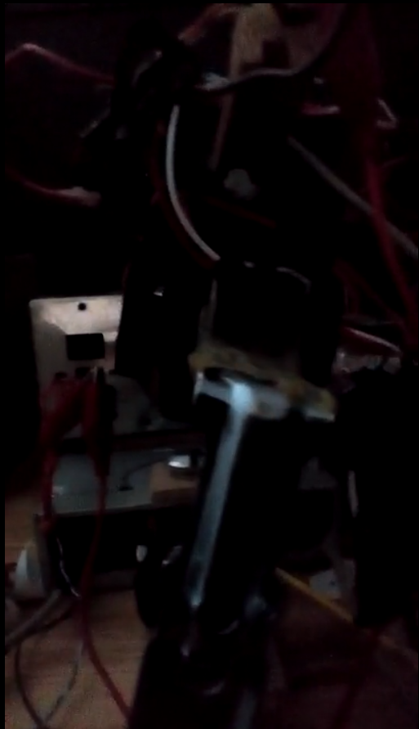
Another reason for the second prototype’s failure was that the beam quality present was unsatisfactory. Although it is sometimes taught that a convex lens can focus light to an infinitely small point (its focal point), this is very far from being true. According to Hinton (2019), a convex optical lens, depending on its quality, may focus a beam to have a finite cross-sectional area at its focal point, where the beam’s diameter at this point is its beam waist. Also, the smallest achievable beam waist (which produces a better resolution from the microscope) is related to the laser’s beam quality (Hinton, 2019). Beam quality is a ratio that measures this property of a beam. Higher beam qualities, depending on the method by which they are measured, often indicate a beam that is more similar to a gaussian beam, which a theoretically ideal laser beam is (Hinton, 2019). Beam quality appears to decrease as the beam propagates further, as well as from poor-quality lenses and other optical components. Due to the poor-quality laser pointer that was used, combined with impurities in the microscope slide and objective lens, and the large distance (about 16 inches) that the laser traveled because of its focal distance, the beam quality was extremely poor. This resulted in a limitation to the size of the beam waist at the specimen, meaning that the minimum pixel size for a clear scan was increased to nearly a quarter of the area it was capable of scanning. For these reasons, the second prototype served primarily as a learning experience, teaching me the skills necessary for building a third, and working, prototype.
Prototype Three
The third, and current, prototype consists of the same lens moving assembly from the second prototype, modified so that the entire laser module from a CD drive slides along the X-axis. This shines a beam directly onto the specimen (focused by the objective lens built-in to the laser module). The light that is transmitted through the specimen is focused into the optical sensor from a cheap USB webcam. As the laser is scanned across the specimen, the transmitted light’s intensity is measured through image processing and stored for display on a graph by a computer. The microscope is also housed within the case from an old personal computer (PC). Beam quality is acceptable, as the laser used should be capable of being focused small enough to read a CD, and general operation works well. A picture of this prototype is shown in Figure 2.

Figure 2
Prototype Three
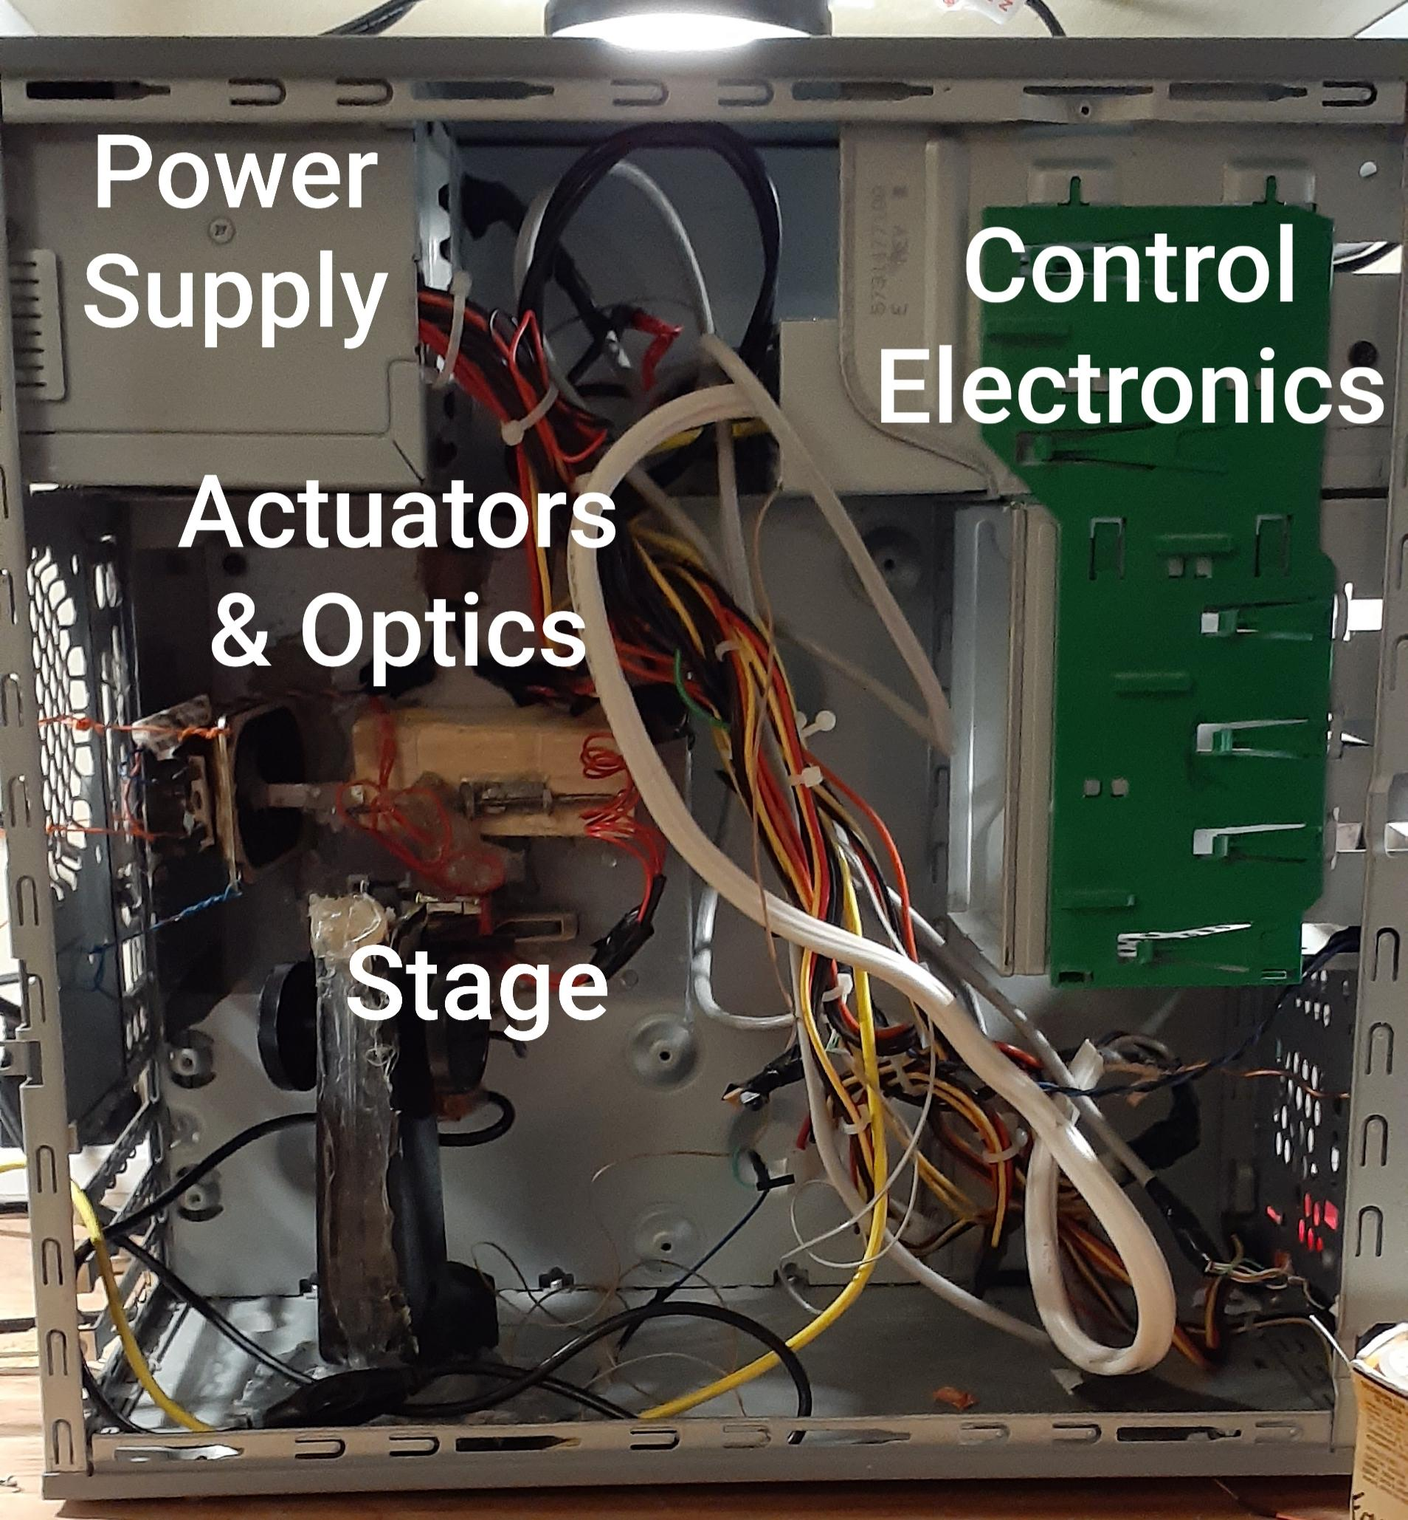
Note. The control electronics are housed within the case of a CD drive, the insides of which may be seen in Figure 4.
Theory of Operation and Usage
The microscope operates by scanning a focused laser beam in the X, Y, and Z directions across a translucent object. The transmitted light’s intensity is measured by a USB camera and put into an image with software, with each location measured by the laser representing a pixel. The electronics are easily explained by examining the schematic in Appendix B. Usage is demonstrated, in addition to an explanation of the microscope, in the following video: 20200604_213744.mp4.
Software
The software, written in Python, is operated through a graphical user interface (GUI) that I made with QT Designer. When a scan is initiated with a step size and a list of focus levels to use, the software initializes and begins the scan automatically. The laser is controlled and scanned across the specimen by sending commands to the Arduino Nano microcontroller acting as the interface between software and hardware. The transmitted laser’s intensity is measured by a USB camera. An image is taken and averaged to get the overall brightness, and essentially the intensity of the laser. Each of these values becomes a pixel. A screenshot of the software is given in Figure 3. A copy of the software is uploaded to https://drive.google.com/drive/folders/1klmBxgbNrT-C8QPAXFWqk-q2L1XAimAe?usp=sharing.

Figure 3
Screenshot of the Software GUI
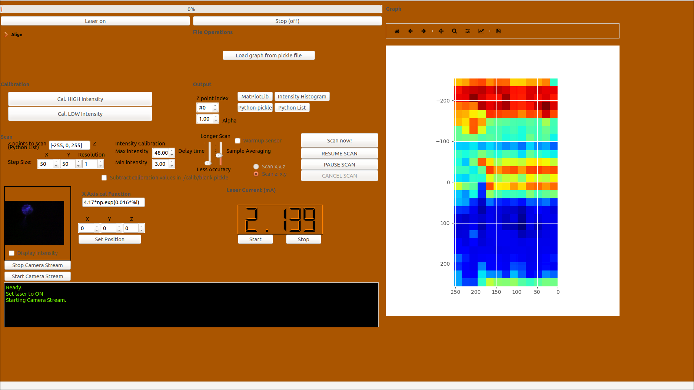
Hardware
Optics. The optical system of the microscope is relatively straightforward. It consists of a laser diode whose light is collimated (forced into a straight beam) and reflected downwards and into the objective lens. The moveable objective lens focuses the laser through the specimen and into another lens, which focuses the transmitted light into the image sensor of a USB webcam.
Electronics. The electrical system of the microscope is best defined and explained with the schematic in Appendix B. A picture of the electronics is displayed in Figure 4.

Figure 4
A Photograph of the Inside of the Control Electronics Box
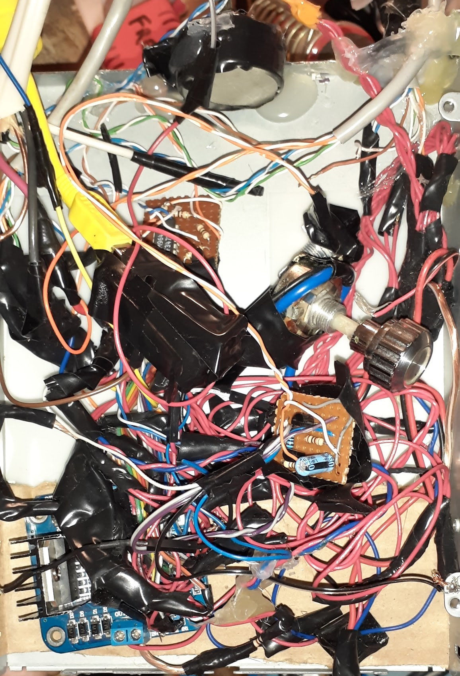

Safety
Safety precautions that should be taken while operating such a contraption are also important to note. The laser diodes found in laser pointers, such as the one used in the first two prototypes of this project, are generally Class II lasers. These are considered safe for “normal use,” while staring at them may still cause eye damage (“Laser Safety Facts”, 2013). The laser diodes found in CD players are Class 3R and Class 3B lasers. These can cause eye damage, and stronger Class 3B lasers can potentially cause fire and burns when focused (Kobrle, n.d.; “Laser Safety Facts”, 2013).
The laser in the third and current prototype of the TLSM has a very close focal distance (a few millimeters, depending on adjustment), and uses a generally low power. Because of this, the intensity of laser radiation is too small to do damage by the time it has passed through the specimen, and the laser (given very little power) is very safe.
The initial prototypes presented a much higher risk, as the laser, although of a lower class, was being driven with more power. There were also exposed lenses, which could have acted as partial mirrors and reflected part of the laser towards someone’s eyes. For this reason, great care must be taken when handling and operating almost any lasers.
Results
Though initial results were vague and sometimes quite poor, later results became increasingly better. Merely the vague outline of things was visible from earlier scans, and with incremental improvements, the captured images have become clearer.
While the microscope is theoretically capable of taking a 256 by 511-pixel image, each pixel being an estimated 17 microns across diagonally, lower-resolution scans have yielded far greater success. The greatest success has been observed in images with a step size of 20 (skipping all but every 20th pixel, basically), or a resolution of 12x25. Higher resolutions can be achieved, although to maintain accuracy, these can take upwards of 10 hours. Scans with resolutions higher than 15x34 tend to have issues regarding the X-axis’ movement being inconsistent, likely due to the small step size and potentially due to heat. This could likely be fixed by placing a small fan near the speaker which drives the X-axis, and/or increasing the delay between pixel measurements. Nonetheless, the clarity of the images produced by the TLSM is not hampered by low-resolution scans. Although many scans use a low resolution, they are only scanning an area somewhat smaller than the size of the cross-section of a pencil. Observing this, as well as the estimated minimum pixel size of 17 microns, the TLSM may be useful as a tool and piece of equipment. It can obtain three-dimensional slices of the inner structure of a translucent object and see what cannot be seen with the naked eye, therefore accomplishing its goal.
Figures 5-7 show a few of the best scans. The speaker grille from a cheap Baofeng handheld radio is shown in Figure 5. The cells of the mesh (the red/yellow areas) are approximately 60 mils (thousandths of an inch) across, and the wire in the mesh (the blue) has a diameter of 20 mils. Figure 7 shows a piece of plant lice, with one of its legs visible, and Figure 8 is of a slide with some bean starch on it. Towards the middle-left of Figure 8, a near individual grain is visible.
Figure 5
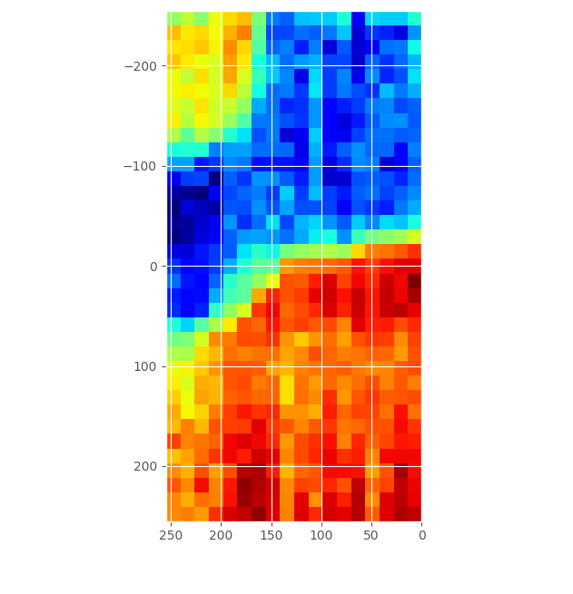
A Scan of a Cell of the Speaker Grille from a Handheld Radio
Note. Blue areas indicate low transparency, with red indicating the opposite. The yellow and red regions of the image are cells of the mesh.

Figure 6
A Scan Displaying Part of a Piece of Plant Lice
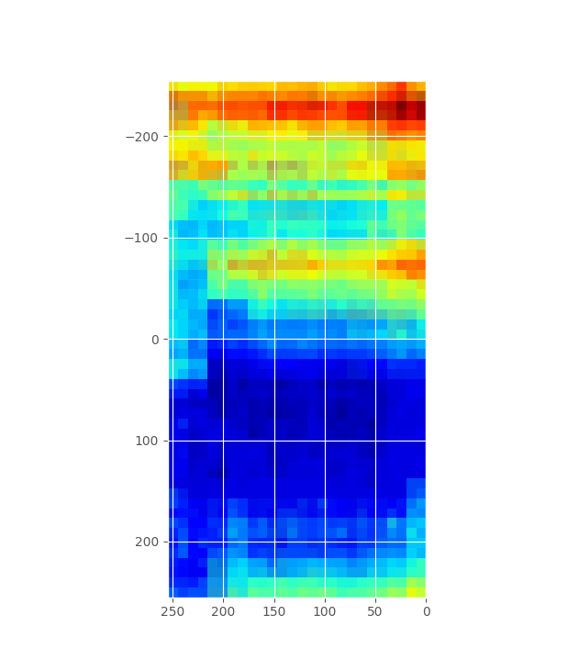

Figure 7
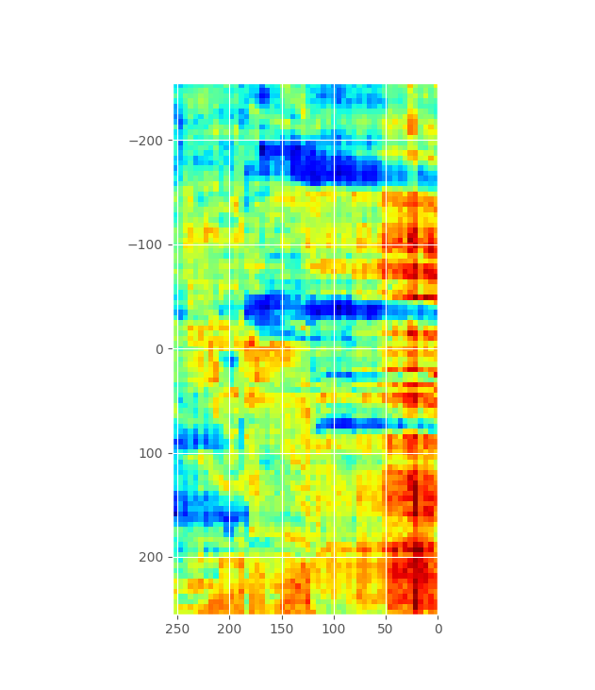
A Scan of Bean Starch
In conclusion, the microscope fulfills its purpose, and could even be used as equipment for help with other projects involving microscopic details. The effort that I put into it was well worth my time, and I may even continue to make it better. It will likely never have the same quality that some commercial industrial laser scanning microscopes offer, but it is a functional microscope, and hence achieves its goal.

References
Arduino. (2008). Arduino Nano (V2.3). Arduino - Home. https://www.arduino.cc/en/uploads/Main/ArduinoNanoManual23.pdf
(Arduino Nano Datasheet)
Bigelow, K. (n.d.). The basic current mirror. Play-Hookey. https://www.play-hookey.com/analog/current_mirrors/current_mirror_basic.html
Hinton, R. (2019, June 1). Beam propagation and quality factors: A primer. Laser Focus World. https://www.laserfocusworld.com/lasers-sources/article/14036821/beam-propagation-and-quality-factors-a-primer
Laser Safety Facts. (2013, November 23). https://www.lasersafetyfacts.com/
Jameco Electronics. (n.d.). Muscle wire FAQ. Jameco Electronics - Electronic Components Distributor. https://www.jameco.com/Jameco/robot/muscleqa.html
Keim, R. (2016, April 11). Low-pass filter a PWM signal into an analog voltage - Technical articles. All About Circuits - Electrical Engineering & Electronics Community. https://www.allaboutcircuits.com/technical-articles/low-pass-filter-a-pwm-signal-into-an-analog-voltage/
Kobrle, D. (n.d.). Laser diodes from CD-RW drives can cut and burn! DANYK.CZ - Elektrotechnika, shémata, návody. https://danyk.cz/laser_en.html
Koheron. (2018, October 16). Understanding the basics of laser diode drivers. https://www.koheron.com/blog/2018/10/16/understanding-the-basics-of-laser-diode-drivers
Venkes. (2017, February 5). Laser scanning microscope. Instructables. https://www.instructables.com/id/Laser-Scanning-Microscope/
Williams, A. (2017, February 15). Speakers make a LASER scanning microscope. Hackaday. https://hackaday.com/2017/02/15/speakers-make-a-laser-scanning-microscope/
Woodford, C. (2019, August 30). How do CD and DVD players work? Explain that Stuff. https://www.explainthatstuff.com/cdplayers.html

Appendix A
Hardware Revisions
Many revisions and iterations of nearly every part of the microscope have been made as features have improved. Later, subsequent iterations are generally either simplified or more advanced versions of a previous version of a part, depending on its use.
The Laser and its Driver
Given that, seemingly, the most important part of the microscope is the laser, it and its driver have a large impact on the success of the entire project. The laser, in the first two prototypes, was a simple diode laser that can be found in almost any handheld laser pointer. No driver was used. This laser had a poor beam quality, and also dimmed and brightened almost spontaneously upon changes in the current load on the power supply (which is also indicative of the power supply being somewhat overloaded). In the last prototype, a higher-quality diode laser from a CD drive was used, along with the collimating and focusing optics and the lens moving mechanism from one. Laser diodes must be used with care, not only for safety purposes, but to increase their longevity. Applying direct voltage can ruin a laser diode, as they have very little “forward resistance,” and they may easily be burned out (Kobrle, n.d.). The current going into a laser diode must be kept constant to ensure that its optical output is consistent. This is because laser diodes produce heat when on. As they heat, their resistance changes, meaning that more or less current will flow through them and their intensity will vary (Koheron, 2018). This must also be avoided.
In its simplest form, a laser diode driver is nothing but a current source. Although expensive industrial laser drivers can monitor (using the photodiode that is built in to many laser diodes) the laser’s output power and aim to keep that consistent, the one used here only monitors current.
The first revision used a current mirror, a device which uses bipolar junction transistors (BJTs) to mirror the current going through one device (usually a resistor) through another device. A current source can be made by having a fixed resistor with a “reference current” across it, and have the same amount of current be mirrored across a device (Bigelow, n.d.). Although this worked very well as an accurate current source, when the load (the laser) was disconnected, the transistors overheated in an attempt to push more current through the open load by increasing their base current to several milliamps. Because of this, combined with experimentation, a current mirror proved to be a poor choice for a laser diode driver.
Figure A1
One of the First Laser Driver Prototypes, Using a Current Mirror
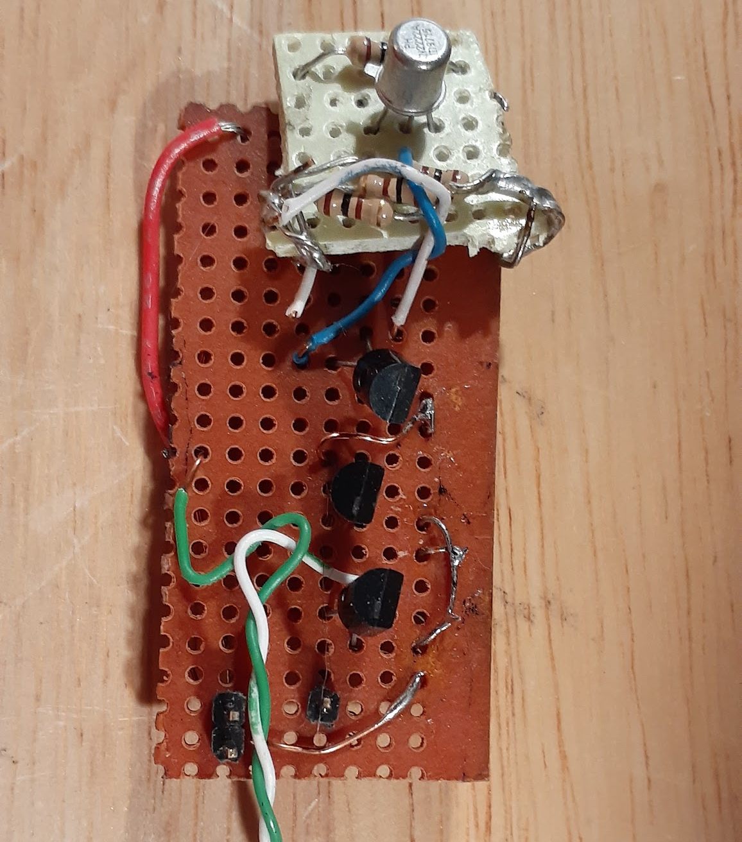
The second attempt repeated the first, but with a heatsink on the transistors to make them overheat less easily. This, for the same reason, failed, and I moved on to another idea. The circuit may well have worked with higher-power transistors, such as 2N2222a transistors, but this was never tested.
The third, and current, laser driver is a current source operating as follows: Current flows from the collector of an NPN BJT to its emitter, and then through the load (again, the laser diode). Current then flows through a resistor to ground. The resistor is current-limiting, as well as to separate the node between it and the load from ground (and, to some extent, acting as a current-sense resistor as well). An operational amplifier measures between power and the top of the resistor, and outputs this difference to the base of the transistor, forming a feedback loop which attempts to keep the voltage at the cathode of the laser diode constant. This keeps the current through the resistor constant due to Ohm’s law, and, because of Kirchhoff's Current Law, the current through the laser diode is the same.
Figure A2
Current Laser Driver
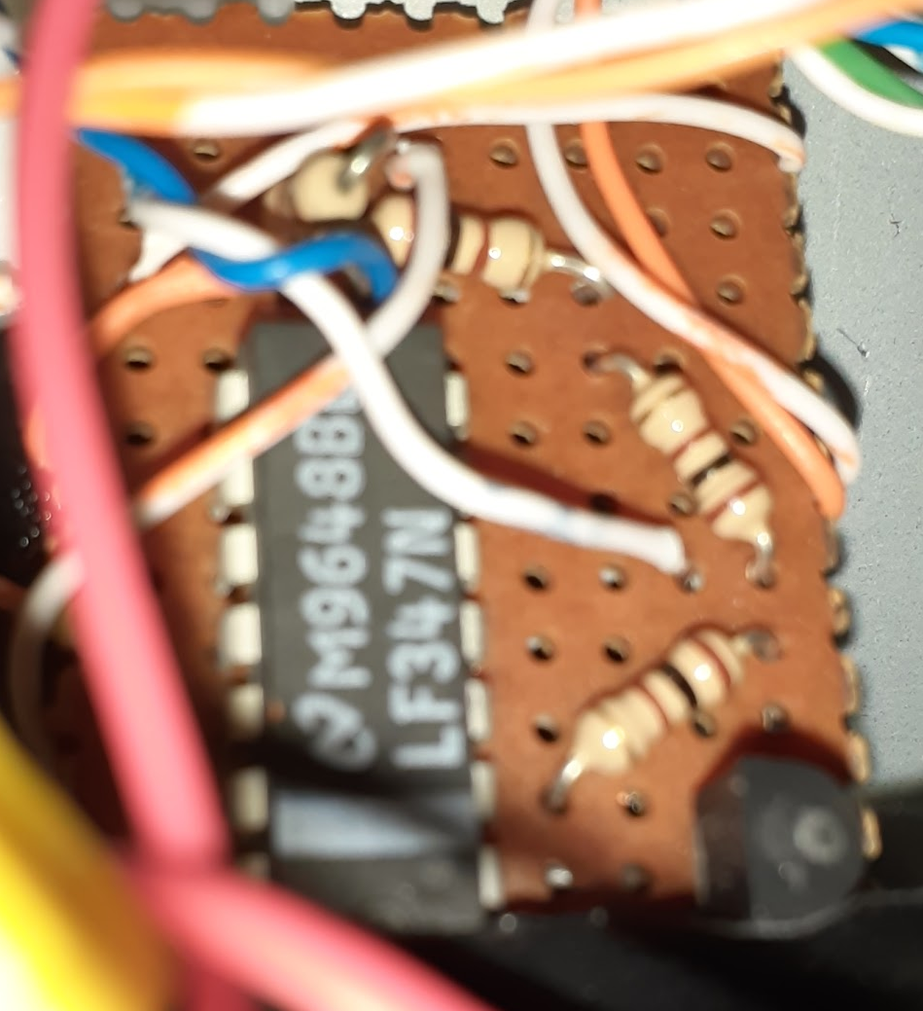
Lens Movement
The laser can scan because of the movement of the objective lens that directs it. In the first two prototypes, the same mechanism was used as that which is used in a CD drive to move the lens, although the third prototype includes the entire CD read/write head from a drive. This read/write head includes optics (to collimate the beam, reflect it downwards, and focus it), as well as a laser and lens-moving mechanism for the objective lens. This lens-moving mechanism is relatively simple: an objective lens with coils on each side of it is suspended in a cavity by its coils’ power wires. These coils act as electromagnets, producing a magnetic field when energized. These push/pull against the fixed magnets on the sides of the cavity, allowing the objective lens to move up and down (focus) as well as back and forth. The other axis is normally taken care of by the spinning of the disc.
Figure A3
A Lens Moving Mechanism
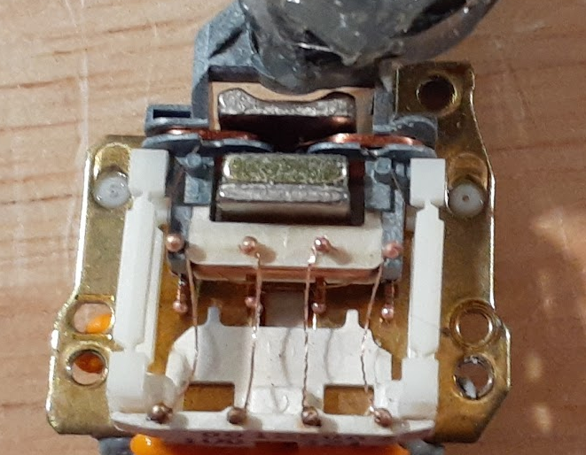
Note. This lens moving mechanism operates slightly differently from what is described because the one in the microscope is difficult to take a picture of and this one is unconventional.
In the second and third prototypes, a 1.5 watt, 8 ohm speaker was used to move the laser for its X-axis. To utilize the speaker as a precise actuator, a PWM signal is smoothed and averaged by a circuit that charges and discharges a capacitor, creating an analog output which is used to drive the speaker. A simple digital to analog converter (DAC) can be made in this manner, by filtering and smoothing the PWM signal (Keim, 2016). By adjusting the duty cycle of the PWM signal, the speaker can be moved back and forth. Unfortunately, the relationship between the duty cycle in and the current out across the speaker is logarithmic instead of linear, which would be ideal. This is because of the circuit that drives the speaker. To correct for this nonlinearity, the inverse of this logarithmic function (which is an exponential function) is used in the software to counteract it. Without correction, the captured image is stretched in its X-axis according to a logarithmic function, which makes it difficult to interpret.
I did experiment and think about alternatives to a speaker for the X-axis movement, however, the speaker appeared to accomplish the task in the best manner possible. I considered using muscle wire, a type of resistive wire which expands and contracts with heat, and, therefore, with current (Jameco Electronics, n.d.). It appeared as though it would be difficult to control with fine movements such as the ones that were needed. I also experimented with using a micro servo to actuate a lever arm slightly off-center from the axis of rotation, but that could not have produced the same potential resolution. Because of the factors limiting the alternatives, I settled on utilizing a speaker for the X-axis movement.

Figure A4
Speaker Driver, First Revision
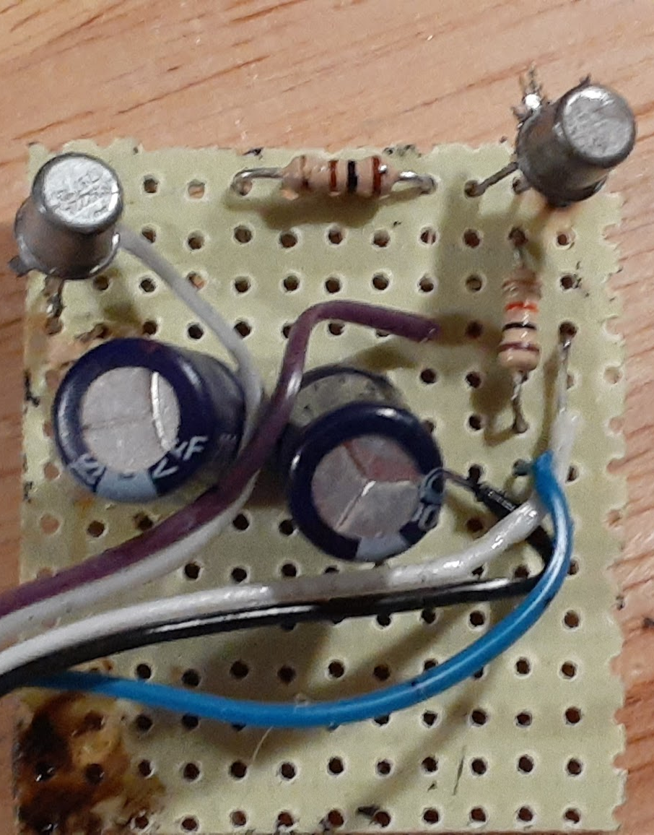
Figure A5
Speaker Driver, Second Revision
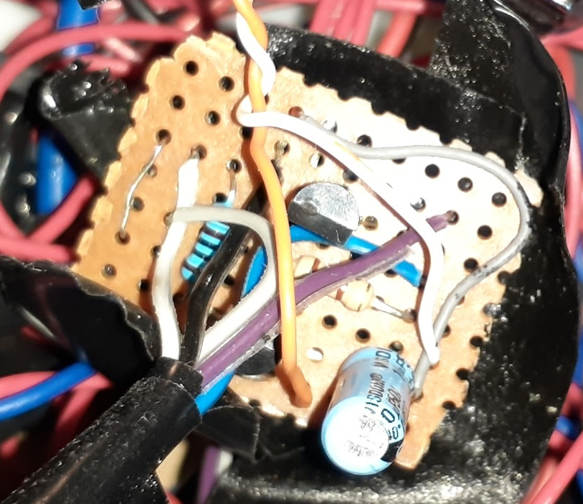
Detector
Once the laser is aimed through or at an object, the transmitted (or reflected) intensity of the laser must be measured. This was done initially with a Universal Serial Bus (USB) camera. This camera had issues with brightness correction mid-scan, removing a lot of consistency. The second prototype used photoresistors to measure the intensity of the laser before and after reflecting off of the specimen. These were highly susceptible to shifts in ambient lighting conditions, and were not sensitive enough to effectively measure the reflected laser off of an object other than a mirror. The third prototype employs a slightly higher-quality USB camera for a detector, which appears to have worked very well. Intensity is measured out of the camera simply by averaging together each of the channels of all of the pixels in the image to obtain the overall brightness. If the only thing visible in the image is the laser, this will calculate the laser’s brightness at that point.
Controller
The first microscope utilized an Adafruit Trinket M0 microcontroller to provide an interface between the computer software and the hardware. Due to its lacking number of input/output (i/o) pins, it was later replaced by an Arduino Nano microcontroller in the second and third prototypes. The Arduino Nano has eight analog inputs and 14 digital i/o pins (Arduino, 2008). These are useful for monitoring levels and getting input from photoresistors and other analog sensors, and for controlling many aspects of the microscope’s operation. Another advantage of this microcontroller is its support and documentation, as the Arduino has become a standard microcontroller platform for hobbyists around the world, as is clear through their website, https://www.arduino.cc.

Appendix B
Full Electrical Schematic of the Microscope
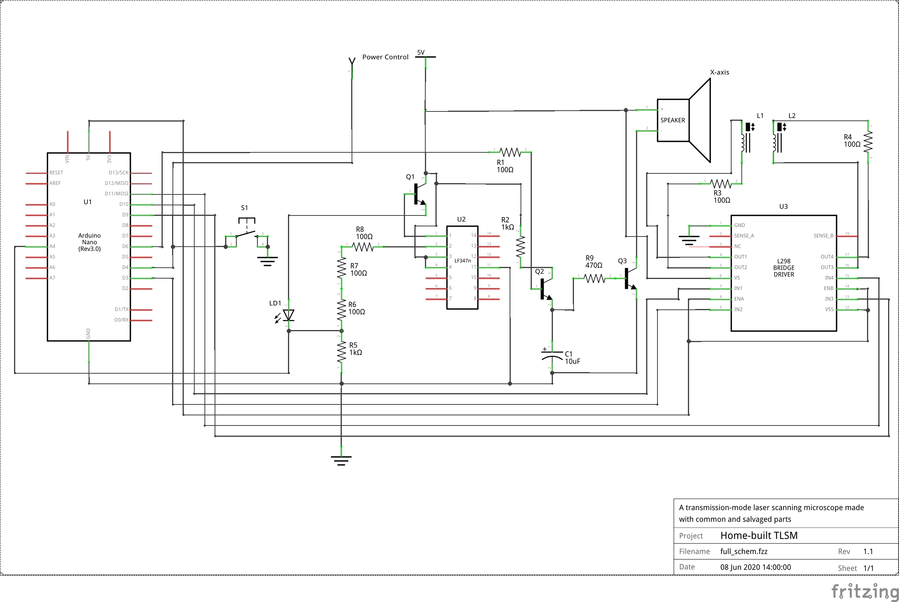
The Arduino Nano, U1, receives commands via USB from the software running on a computer. These commands allow it to turn on/off the laser and lens movement by pulling pin D4 low, providing a path between the (ATX) power supply control pin and ground and powering up the supply. Commands can also send the focused laser point to a specific (x,y,z) location by pulse-width modulating pins D3, D6, D9, D10, and D11 to control the speaker driver and H-bridge circuit.
The X-axis is moved to a specific location by pulse-width modulating pin D6. This turns transistor Q2 on and off, charging C1, which drains into Q3 through R9. This acts as a buffer, averaging the PWM signal to prevent the speaker from sounding too loud of a tone from the PWM. Q3 drives the speaker based on the current through R9 (due to Kirchhoff's Current Law), which is dependent on the voltage across C1, which is dependent on the duty cycle of the PWM signal which charges it. To keep the voltage across C1 at a relatively constant level, the capacitor is also constantly drained through R9 and Q3.
The laser is driven by a simple current source. U2, an Operational Amplifier, and Q1, along with the surrounding resistors form a feedback loop attempting to keep the voltage at the cathode of the laser diode constant (Koheron, 2018). The current across the laser diode LD1 is equal to the current across R5, because of Kirchhoff's Current Law and the fact that Operational Amplifiers (including this one) have high input impedances (As can be found in their datasheets). Because of this, the current across LD1 can be found by measuring the voltage at its cathode (which is the voltage across the resistor R5) and utilizing Ohm’s Law. By this method, the software (through the Arduino) can measure the current across the laser, which is a useful thing to know.
The Y/Z movement is accomplished with U3, a cheap L298 H-Bridge motor driver board to double the range. Because of this, the image is always at a 1:2 aspect ratio.
Appendix C
Parts used
I used many supplies and parts in this project through each iteration of each part. The following is a list of the parts and materials required to build the final prototype.
- An old computer case
- A computer power supply
- The case from a second computer power supply
- At least one CD drive
- CAT-5 wire (could be almost any wire of at least that thickness)
- Some other, bigger wire
- Female crimp-on connectors for connecting to the Arduino
- Arduino nano
- An assortment of resistors (See Appendix B)
- At least 3 2N2222A NPN transistors
- A momentary switch
- An LF347N quad op-amp chip (or a similar op-amp)
- A 10 μF capacitor
- A 1.5 or 2-watt speaker
- An L298 motor driver module
- USB to Mini USB cable
- USB webcam
- Some scrap wood
- Hot glue
- An assortment of fasteners and screws
- Rosin core lead solder
- Electrical tape
- Perf board or solder breadboard
Tools/Equipment Used
The following tools were used in the making of this project. They are not all necessary, but many of them facilitate the building process and make it much easier.
- Some sort of calipers or a micrometer
- Crimper
- Wire strippers
- Needle-nose pliers
- Vice-grips (locking pliers)
- Vice
- Some clamps
- Hacksaw
- Metal shears
- Handsaw
- Soldering pencil
- File
- Screwdrivers
- 2 Mhz Function generator
- Oscilloscope (x2)
- Digital multimeter (x2)
- Benchtop power supply
- Alligator clip leads (x5 at least)

