Chad Brown

CS485

Programming Assignment 4

Report

OpenCV's function calibrateCamera was used to calculate the intrinsic matrix, the distance coefficients, and the translation and rotation matrices for each image. The intrinsic matrix and distance coefficients are shown in Figure 1.

Figure 1: The intrinsic matrix and the distance coefficients are shown towards the bottom.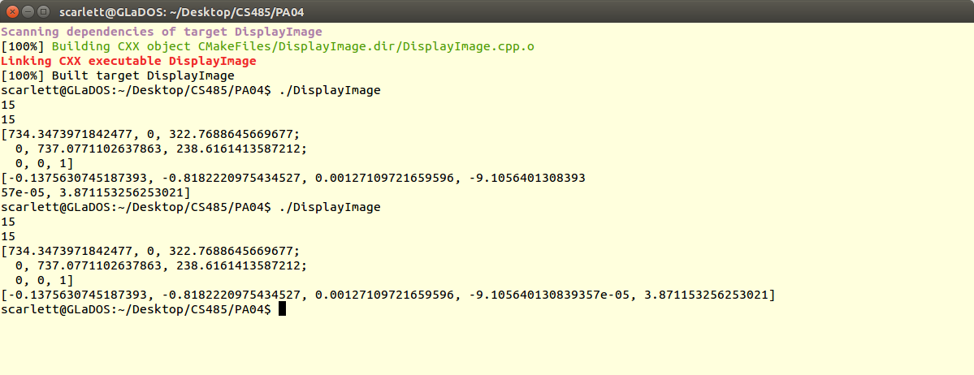

734.3473971842477 0 322.7688645669677;

0 737.0771102637863 238.6161413587212;

0 0 1

Figure 2: This is the intrinsic matrix in plain text.

Figure 2 shows the intrinsic matrix in better detail and shows that the fx and fy of the image are fairly large, being around 735 each. This seems to be near the width of the image, which is 640 pixels wide. The principal point, cx,cy seems to bearound the middle of the image at 322 and 238, which is nearly half of the image size of 640x480.

The results of recomputing the original pixel values from the world pixels were very similar to the original pixel values. The error rates are shown partly in Figure 3.



Figure 3: The average error rates per chessboard image are shown for the pixel coordinates after recalculating them.

The error rates are relatively small given how large the coordinates were originally, ranging up to the width and height of the images, 640x480. These error rates seem to come down to less than half a pixel per calculated pixel coordinate. This level of accuracy leads The error that is appearing is likely due to rounding errors in the testing computer and in OpenCV's calculations. Figure 4 shows a portion of the complete results.

Figure 4: Shown are the error rates for the first 34 points of the first 7 images used.