The world 10 largest companies yield the following data:

Page-38

x1 | x2 | x3
108.28 | 17.05 | 1,484.10
152.36 | 16.59 | 750.33
95.04 | 10.91 | 766.42
65.45 | 14.14 | 1,110.46
62.97 | 9.52 | 1,031.29
263.99 | 25.33 | 195.26
265.19 | 18.54 | 193.83
285.06 | 15.73 | 191.11
92.01 | 8.1 | 1,175.16
165.68 | 11.13 | 211.15

a) Plot the scatter diagram and comment
b) Compute 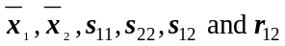. Interpret 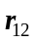.
c) Construct Q-Q plot. Do these data appear to be normally distributed? Explain.
d) Calculate the squared statistical distances 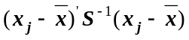.
e) Using the distances in part d), determine the proportion of observations falling within the estimated 50% probability contour of a bivariate normal distribution.
f) Construct a Chi-square plot. Are this data approximately bivariate normal? Explain

Problem3: Page-214

