BIT 4107 – Mobile Application Development
ENHANCED PROFESSIONAL STUDENT LOGBOOK
Student Name: Maina Kinya.
Admission Number: BIT/2024/74320.

Instructions
This logbook is used to document weekly learning activities, practical exercises, skills acquired, challenges encountered, solutions applied, and reflections. Students should complete all sections every week.
NOTE: In some of the weekly tasks I created separate apps and in others in added onto the main app but by the final week I will incorporate all aspects into a single application.

Week 1: Introduction to Mobile Application Development
Practical Activities Undertaken
Create a “hello world” flutter app
Tools/Software Used
- Android studio
- Flutter sdk
- Emulator
Personal Reflection
Environment configuration and building a basic "Hello World" mobile application. Transitioned from web-based environments to mobile IDEs, understanding the specific constraints of mobile rendering.
Visual Evidence
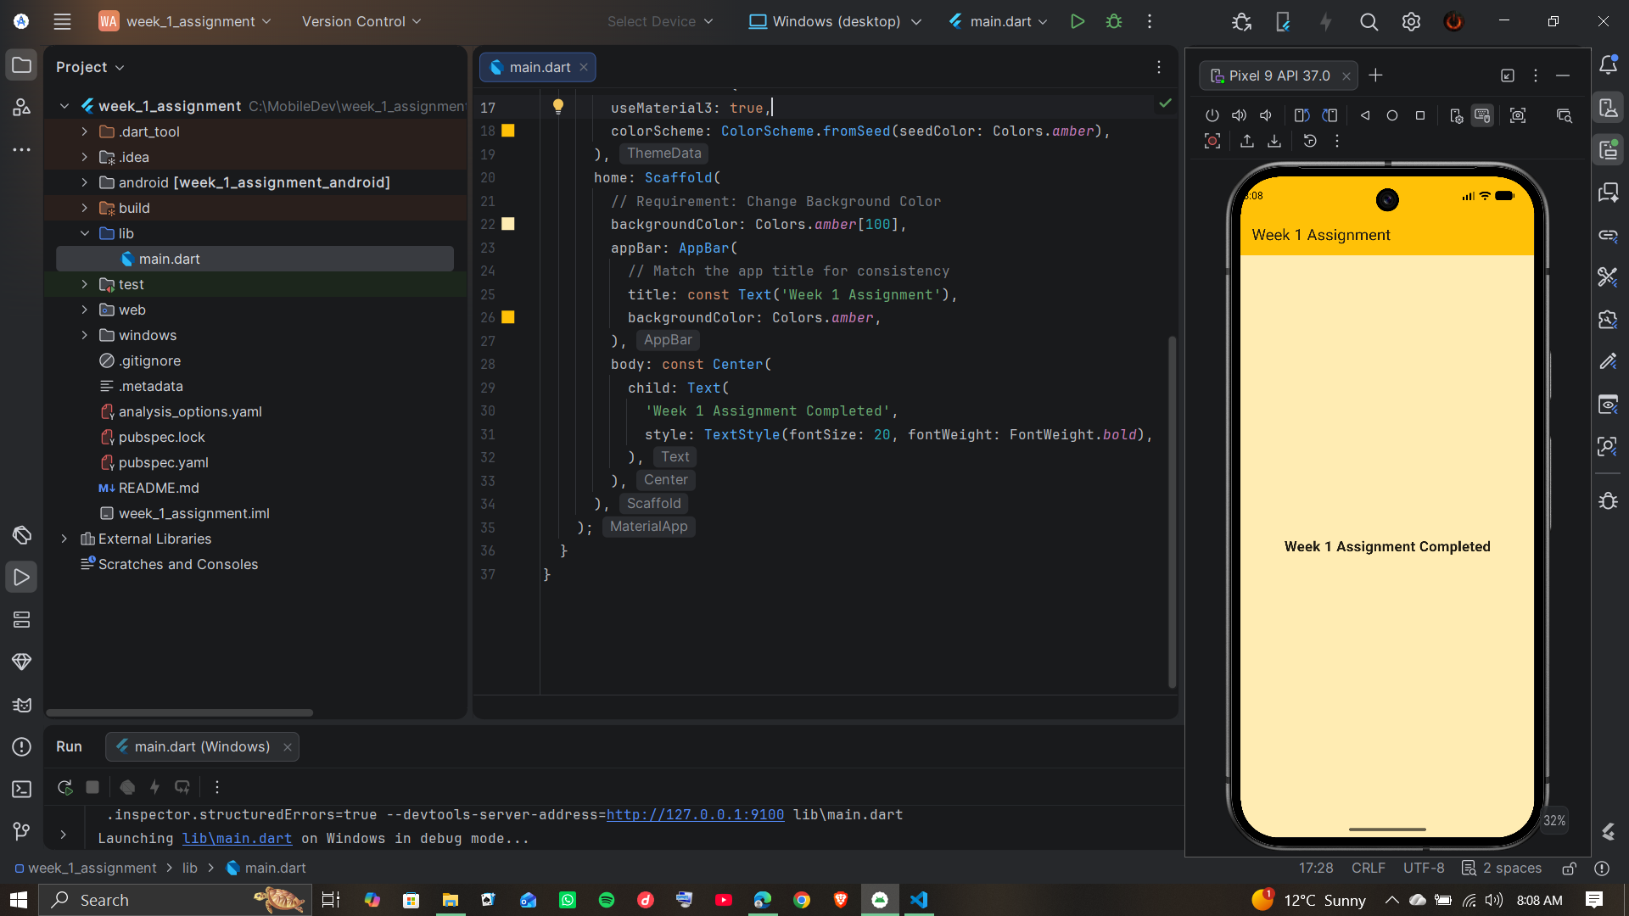
Week 2: Mobile Development Environment
Practical Activities Undertaken
Mini Student Management app
Personal Reflection
Mastering platform-specific syntax and implementing core user interface elements. I adapted to strict, strongly-typed syntax required for robust mobile application stability.
Visual Evidence
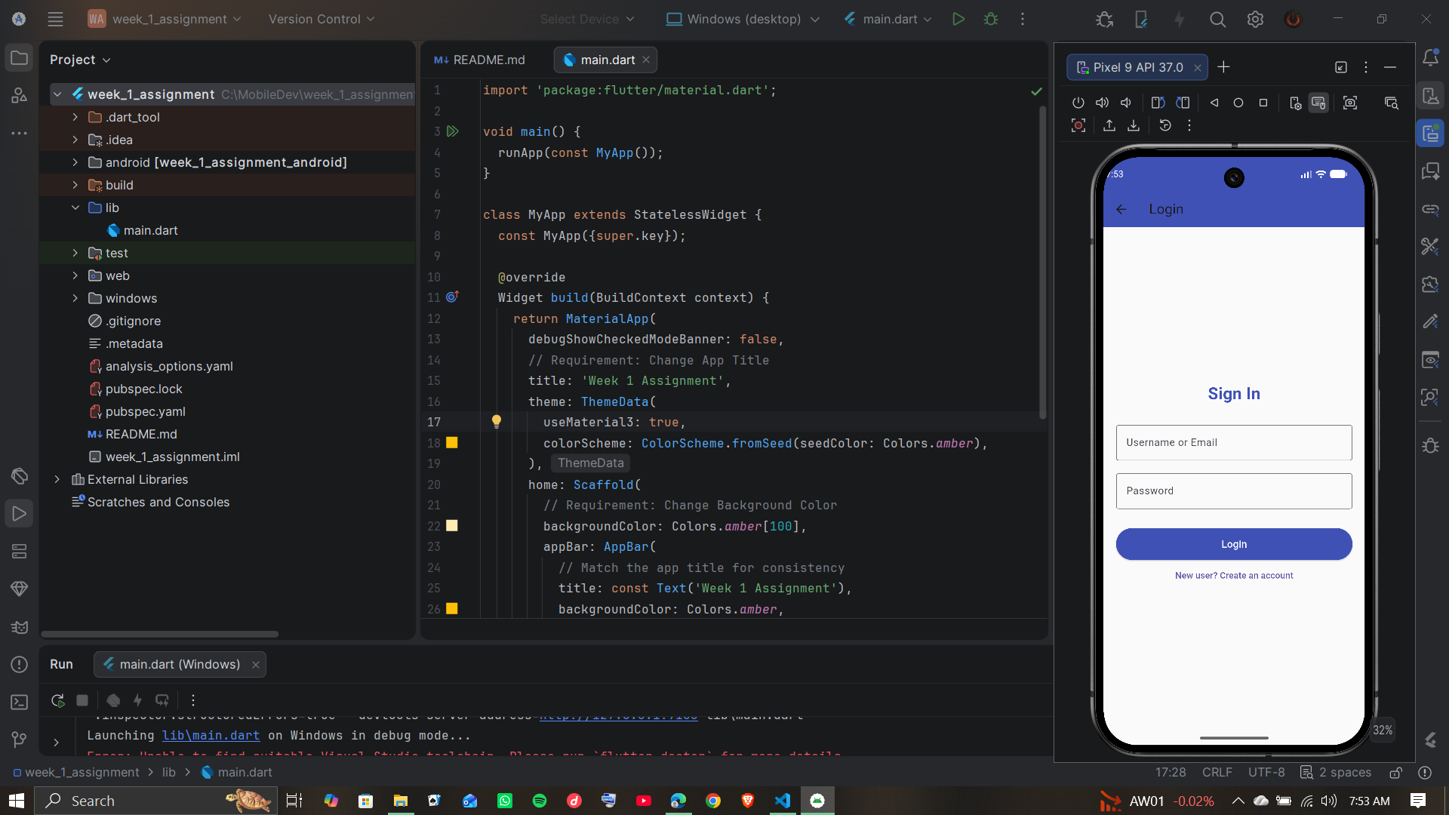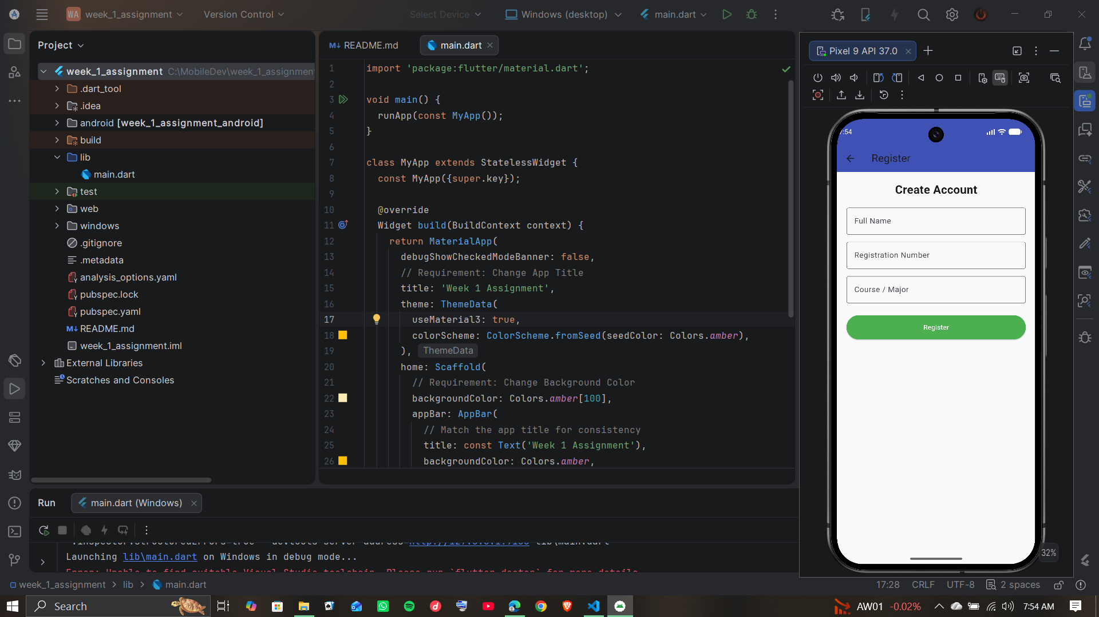
Week 3: User Interface Design
Practical Activities Undertaken
Building a Complete UI Prototype
Personal Reflection
Designed responsive layouts and establishing interactive front-end user components. Realized the importance of responsive, mobile-first layouts over desktop-oriented design frameworks.
Visual Evidence
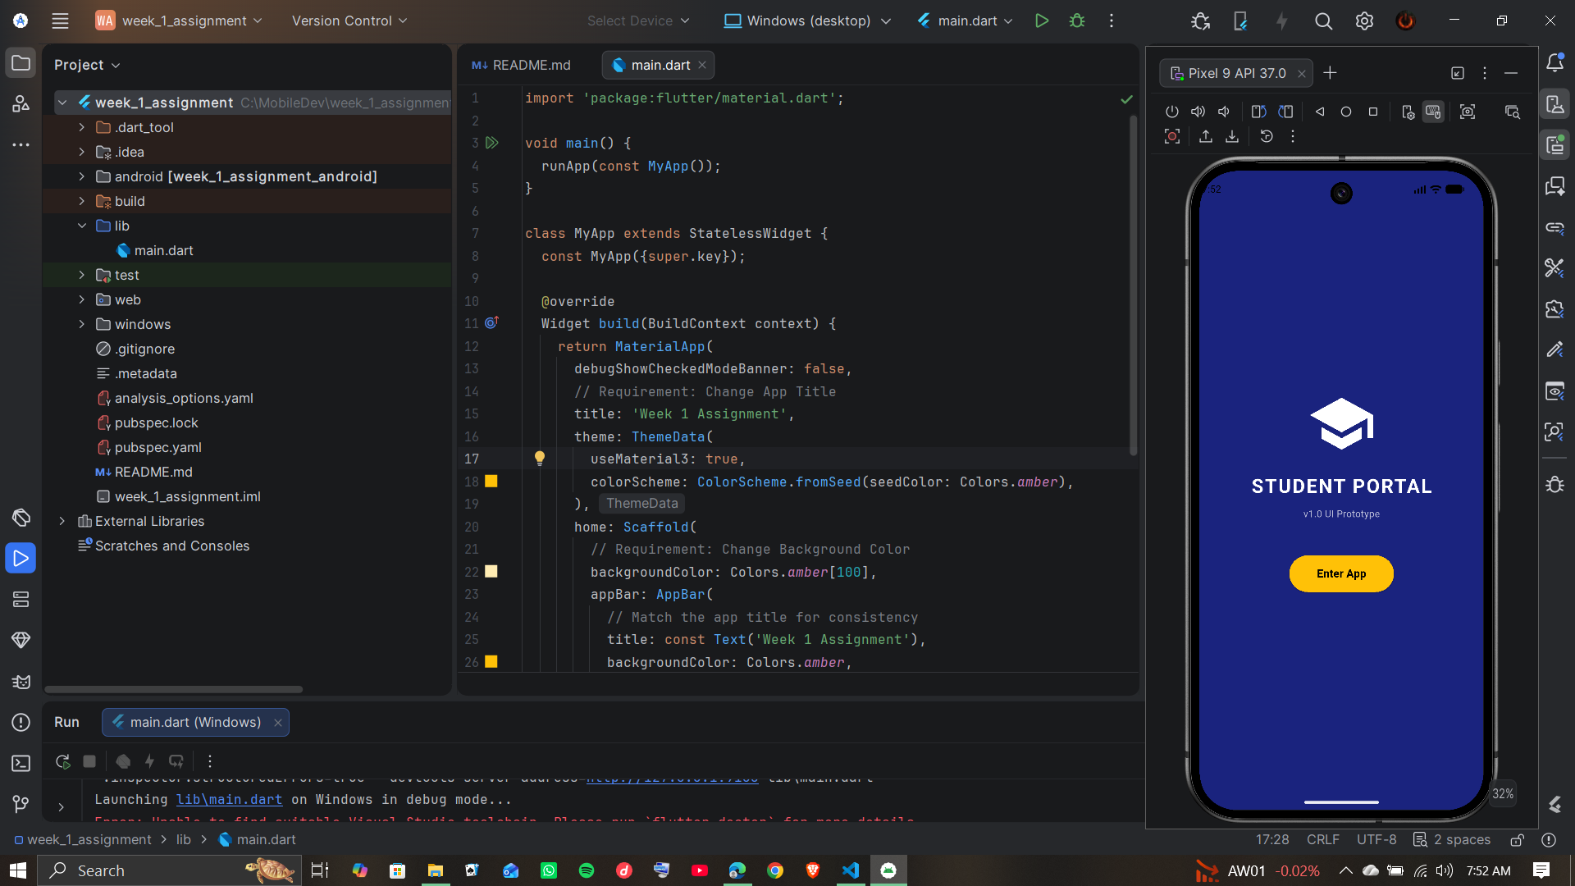

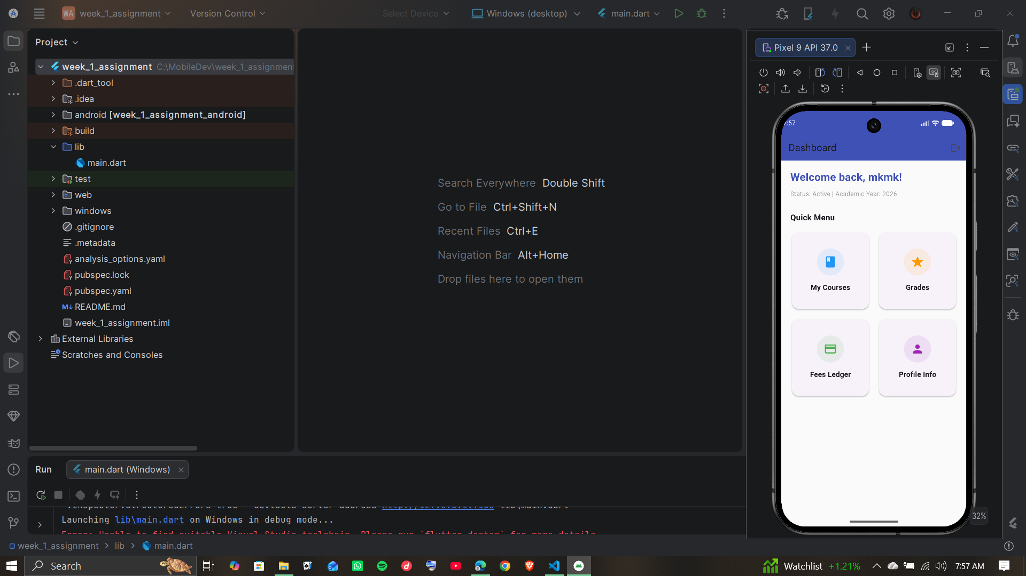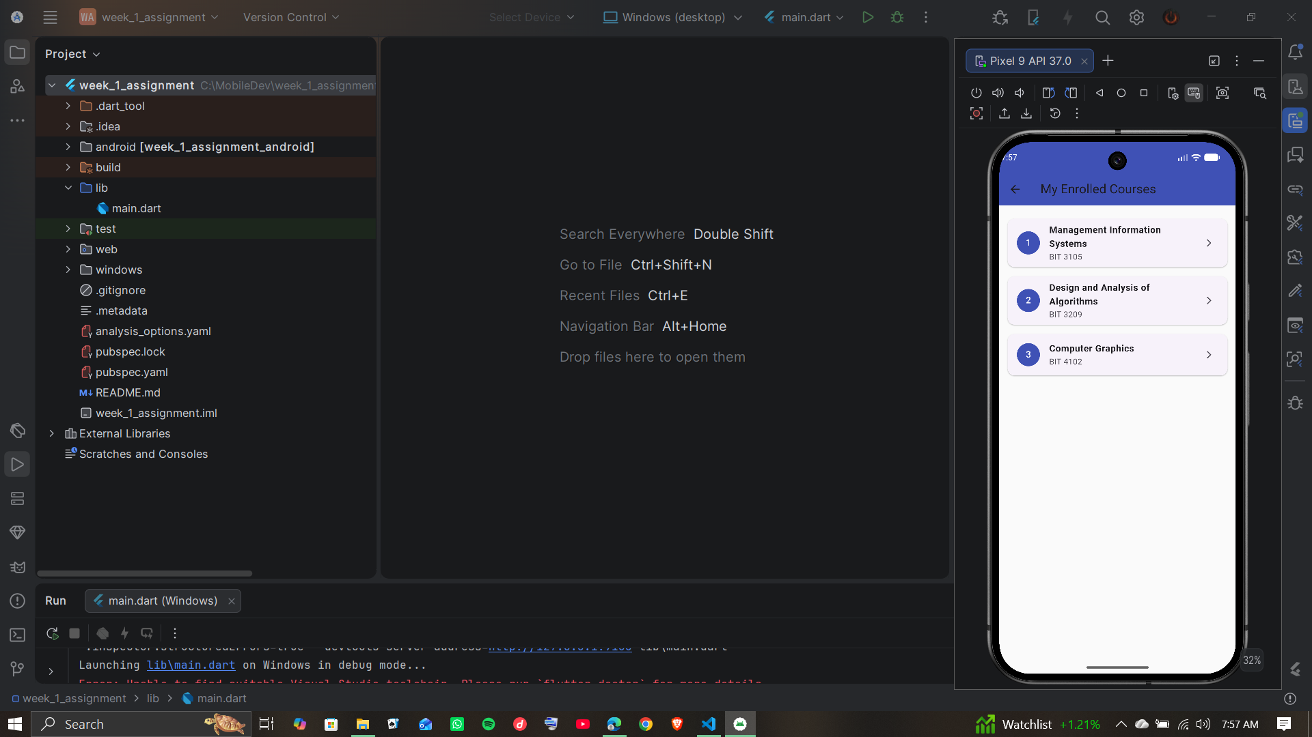

Week 4: Event Handling and User Interaction
NOTE: Week 4 work is similar to week 3 so I combined in the same app
Practical Activities Undertaken
Created interactive mobile app screens with buttons, forms, and navigation menus. Implemented event handling for user actions such as button clicks, text input, and form submissions. Added validation to ensure users enter correct information before submitting data. Built a simple mobile application that responds to user interactions and displays feedback messages.
Personal Reflection
I learned how event handling improves user experience by making mobile applications interactive and responsive. I understood the importance of connecting user actions to specific functions and ensuring applications provide immediate feedback. This week also helped me appreciate the need for intuitive and user-friendly interfaces in mobile application development.
Visual Evidence


Week 5: Data Management
Practical Activities Undertaken
Create a student registration app that stores and displays records
Personal Reflection
Data Management: Implementing local storage solutions to save, retrieve, and display data. Learned the critical need for lightweight, efficient local caching compared to heavy relational databases.
Visual Evidence
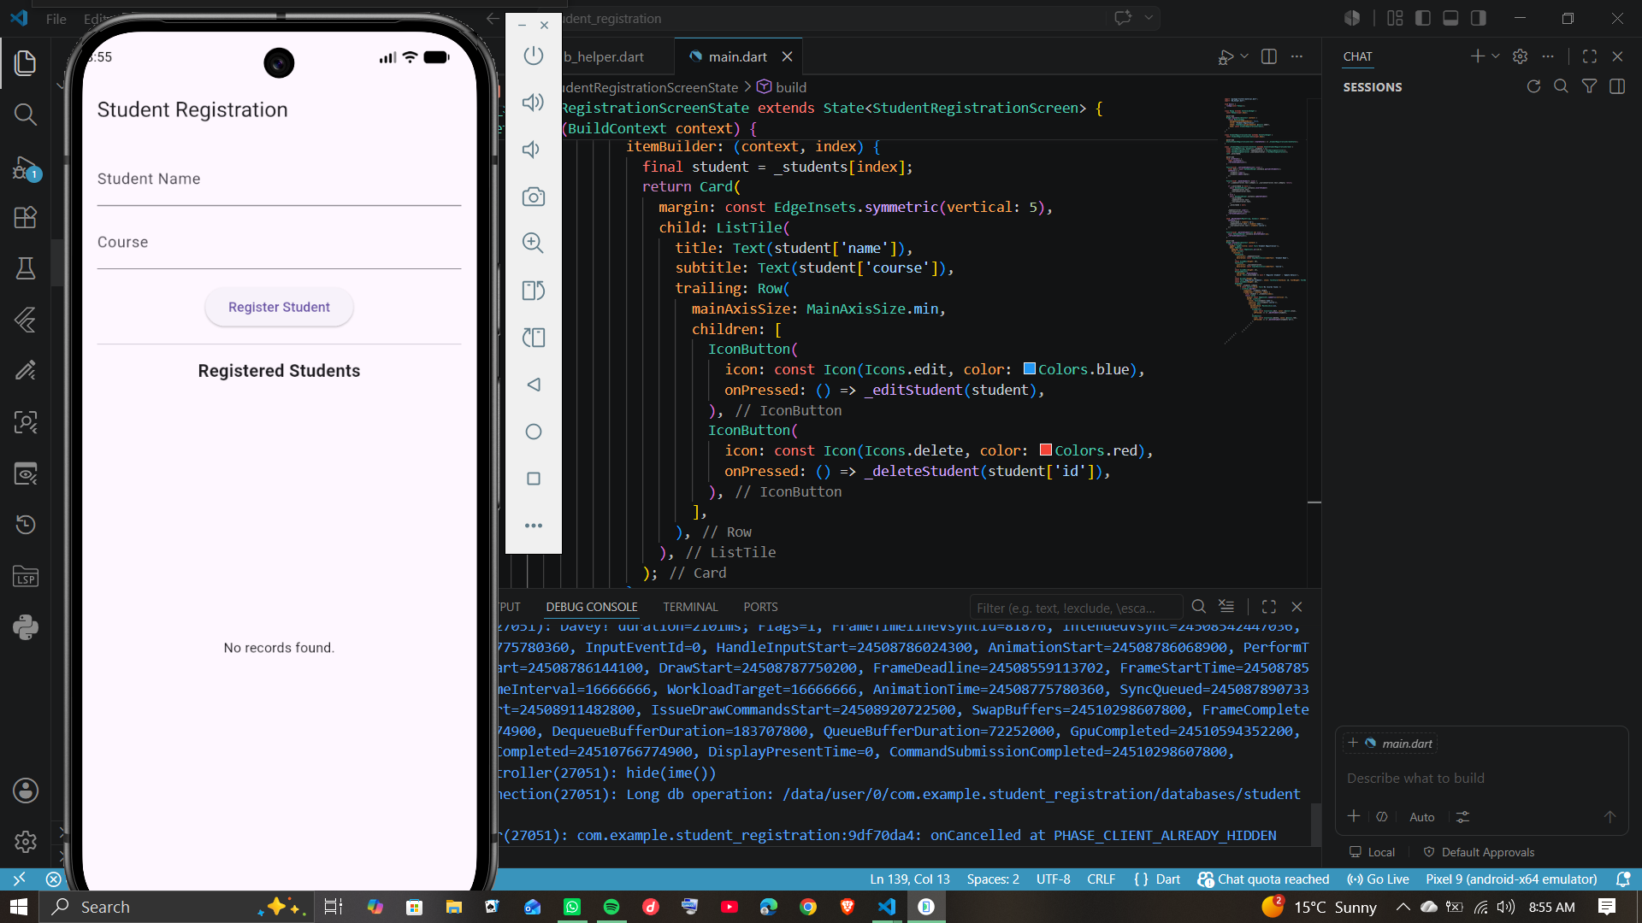
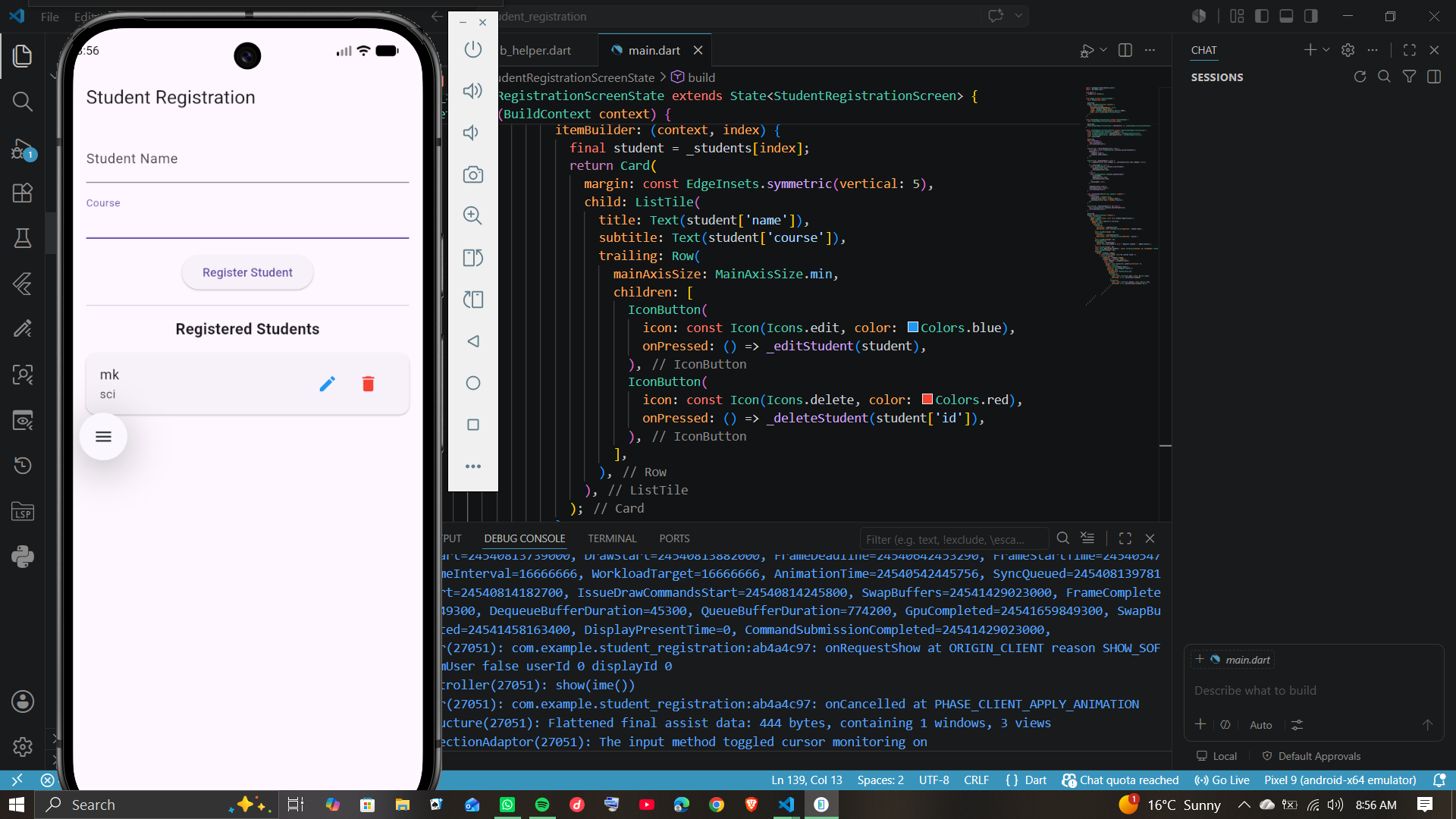
Week 6: Networking and APIs
NOTE: Week 6 work is an application that functions as a stateless mobile client that executes asynchronous HTTP GET requests against a remote RESTful API endpoint.
Practical Activities Undertaken
Analyzed networking components for five mobile apps, investigated a public REST API to compile a technical report, and structured student data records into valid JSON format.
Personal Reflection
Gained a deeper understanding of client-server data exchange protocols and realized how critical strict JSON data formatting is for seamless mobile backend integration.
Visual Evidence
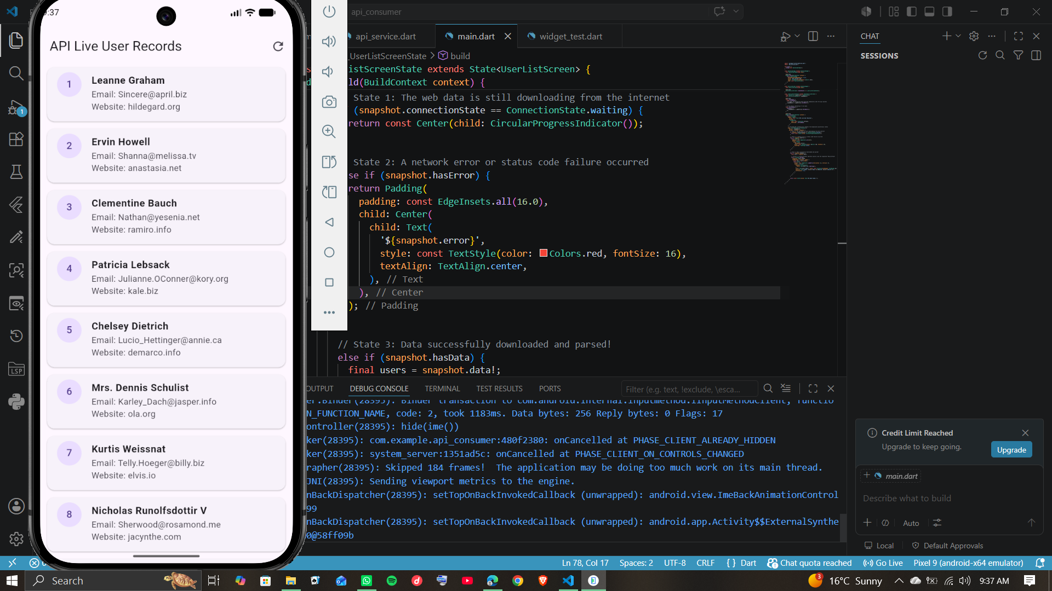

Week 7: Application Architecture
Practical Activities Undertaken
Compared four mobile storage mechanisms, designed a relational student database schema with primary keys, and formulated the architectural plan for an offline attendance-tracking mini-project.

Personal Reflection
Discovered that local SQLite databases offer superior data integrity and reliable offline access for mobile applications compared to network-dependent cloud alternatives like Firebase.
Visual Evidence
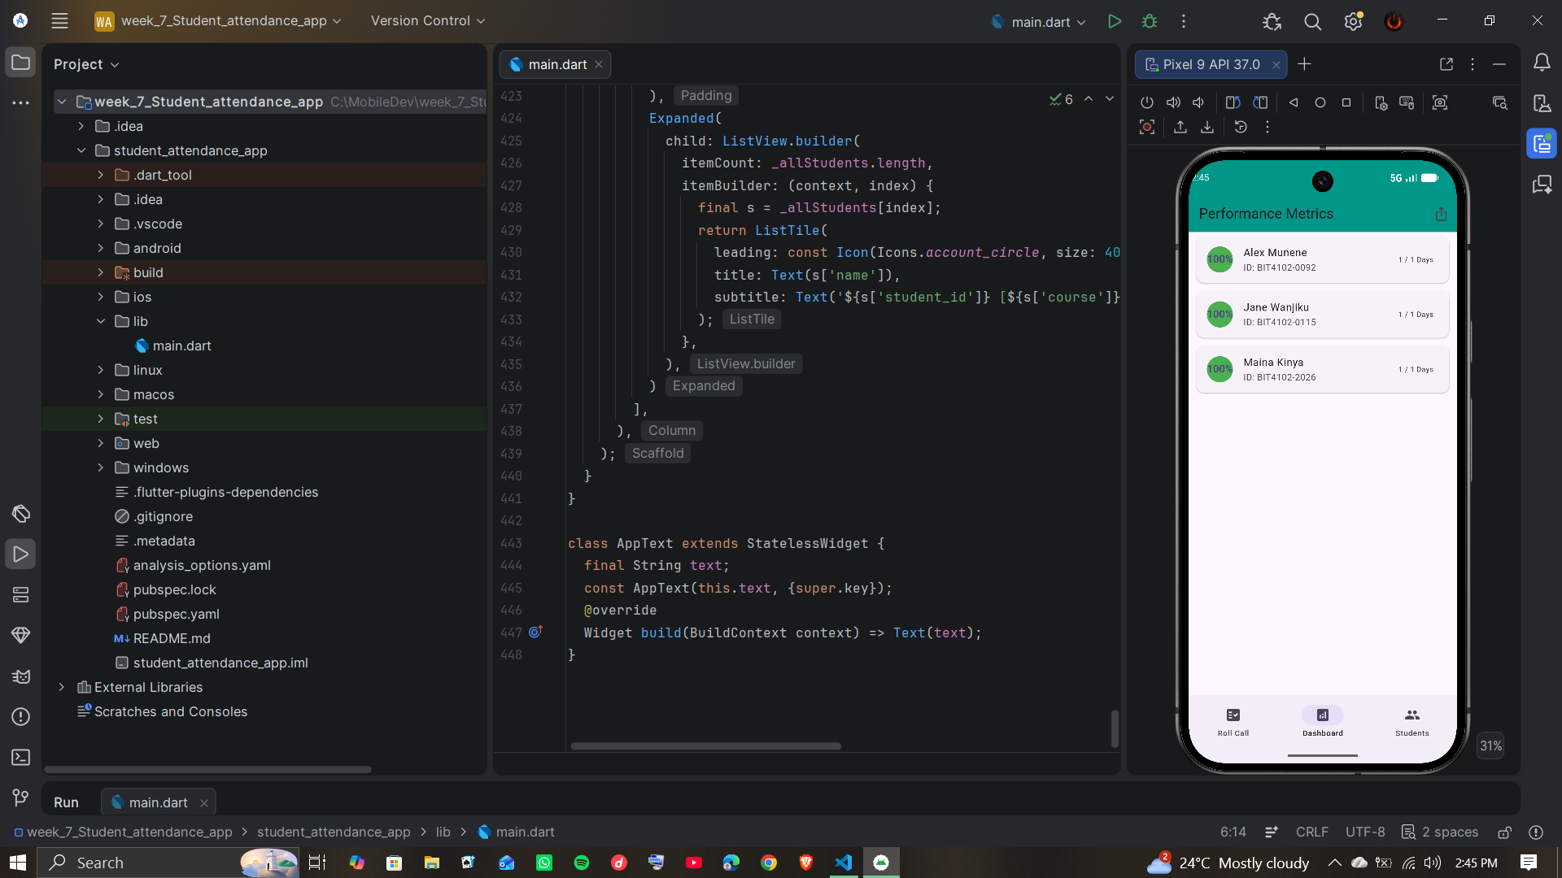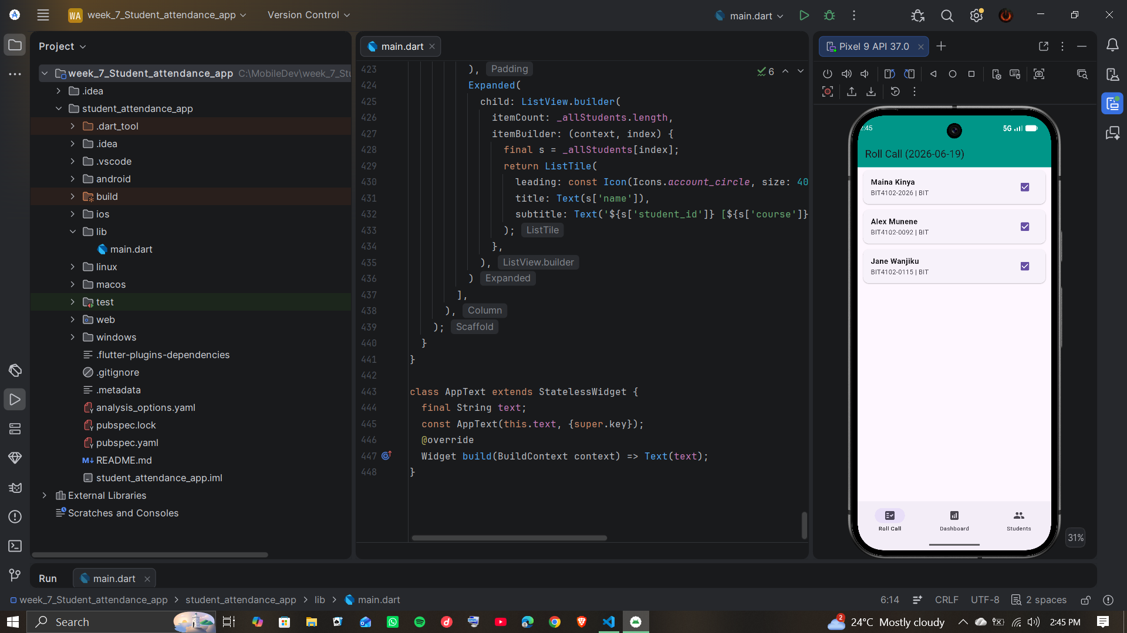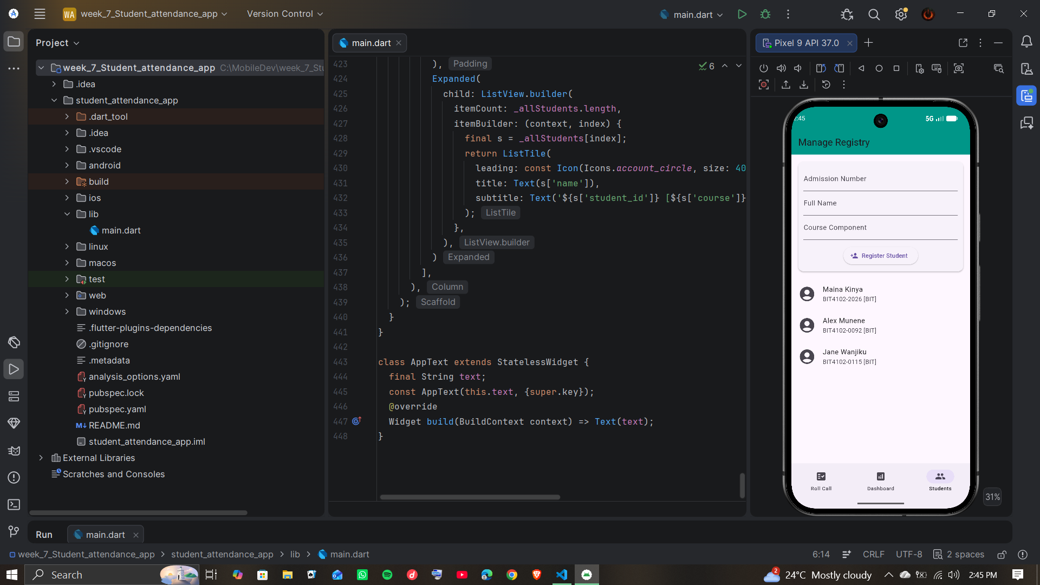

Week 8: Project Planning
Practical Activities Undertaken
Selected the offline attendance-tracking mini-project designed in Week 7 . Defined the formal functional requirements, structured the project timeline, and established immediate development milestones for the application.
- Separated form validation logic from the UI layer into a standalone FormValidator class.
- Implemented a GlobalKey<FormState> to manage and trigger text field validation down the widget tree.
- Added TextEditingController instances to safely capture student inputs and clean up resources on widget disposal.
- Formulated a regular expression pattern (BIT/YYYY/ID) to enforce accurate registration number syntax.
- Resolved a No ScaffoldMessenger widget found runtime crash by properly nesting the widget tree inside a parent MaterialApp.

Personal Reflection
Isolating validation code into its own class made the UI structural layout cleaner and significantly easier to read and maintain.
I encountered an application crash when displaying the success SnackBar. This taught me that behavioral feedback widgets require a proper MaterialApp context ancestor to render correctly.
With the event handling, validation hooks, and text controllers now operating smoothly, the core application structure is fully prepared for localized SQLite database integration.
Visual Evidence
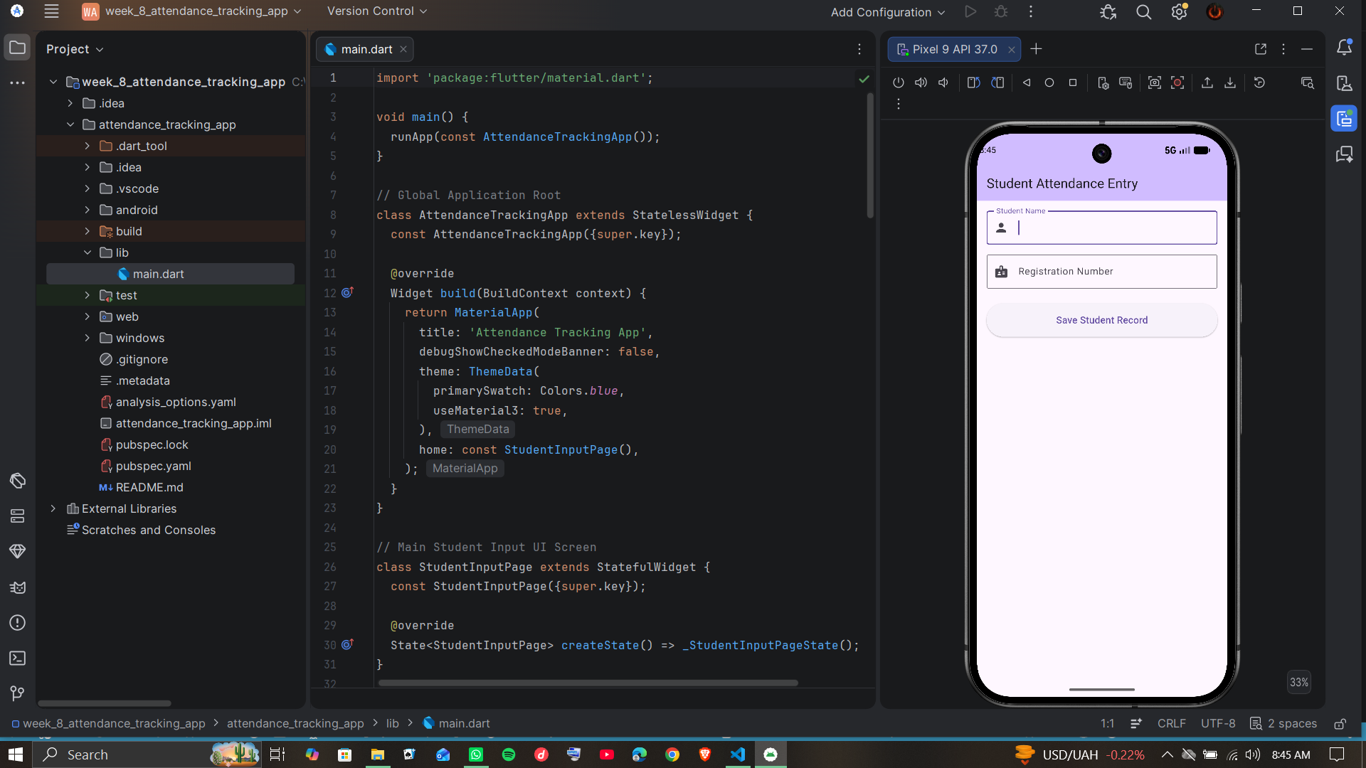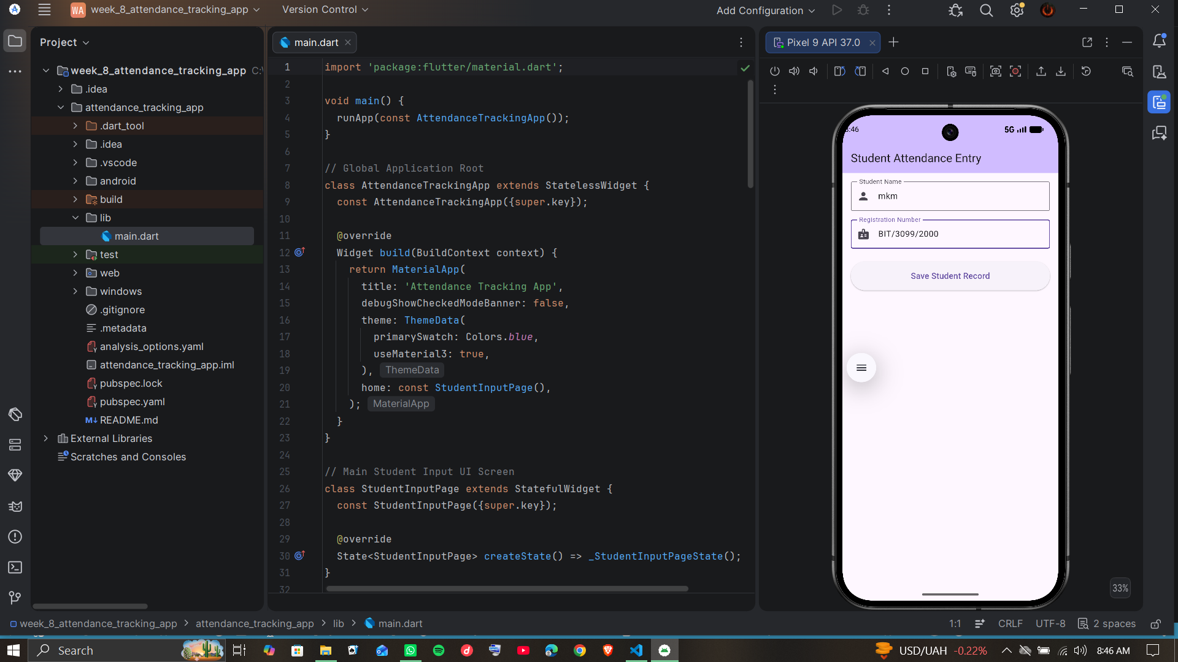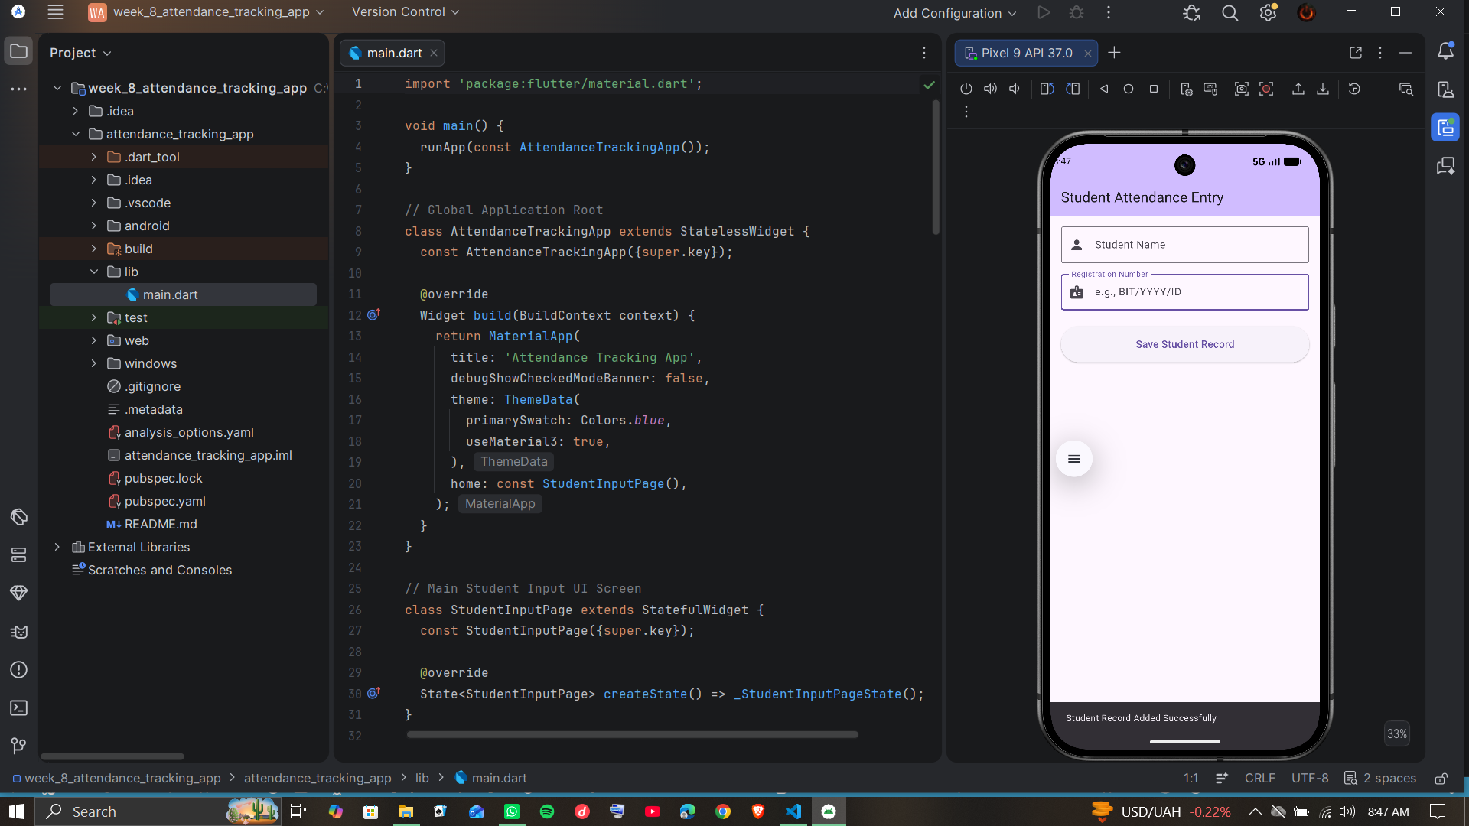

Week 9: Device Features and Sensors
Practical Activities Undertaken

Personal Reflection

Visual Evidence

Week 10: Notifications and Background Services
Practical Activities Undertaken

Personal Reflection

Visual Evidence

Week 11: Mobile Security
Practical Activities Undertaken

Personal Reflection

Visual Evidence

Week 12: Testing and Debugging
Practical Activities Undertaken

Personal Reflection

Visual Evidence

Week 13: Application Deployment
Practical Activities Undertaken

Personal Reflection

Visual Evidence

Week 14: Final Project Presentation
Practical Activities Undertaken

Personal Reflection

Visual Evidence

Semester Project Tracking
Project Title

Project Objectives

Project Requirements

Development Milestones

Testing Results

Lessons Learned

Future Improvements
End of Semester Reflection
Summary of Skills Acquired

Most Interesting Topic

Major Challenges Faced

How Challenges Were Overcome

Professional Growth Achieved

Overall Course Experience

Final Approval
Student Name: __________________________
Student Signature: ______________________
Date: _________________________________
Lecturer Name: _________________________
Lecturer Remarks: _____________________
Date: _________________________________

