Week 7 Documentation: Mobile Data Storage and Database Design
1. Evaluation of Mobile Storage Methods
This section outlines the technical selection criteria for local and remote data management in mobile application development.
Shared Preferences
Best Use Case: Storing small, primitive data types (booleans, strings, integers) such as user settings, login tokens, or theme preferences.
Limitations: Light key-value pair storage only; entirely unsuitable for relational or large-scale datasets.
Internal Storage
Best Use Case: Saving private application files, cached media, or raw text/JSON logs directly to the device file system.
Limitations: Reading and writing large structural data manually introduces high file I/O overhead and lacks querying capabilities.
SQLite Database
Best Use Case: Managing structured, relational local data that requires complex queries, indexing, and absolute offline reliability.
Limitations: Requires boilerplate setup code and schema migration management when data structures change.
Firebase Cloud Storage
Best Use Case: Storing centralized cloud data that requires real-time synchronization across multiple devices and user accounts.
Limitations: Dependent on network connectivity; incurs higher latency and potential operational costs compared to local options.
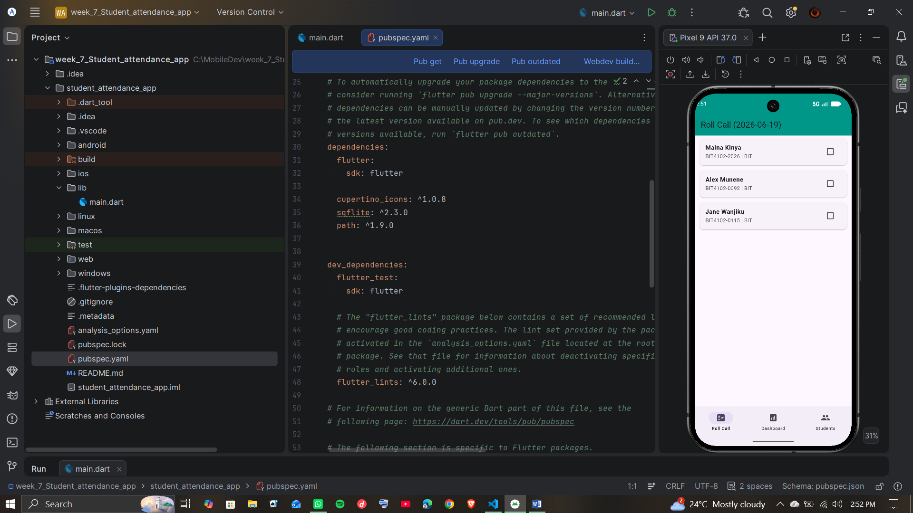
2. Relational Database Schema Design
The application structure requires a relational database model implemented via SQLite. The schema avoids flat-file limitations by separating entities into localized, connected structures.
Student Entity Definition
Field: student_id | Type: TEXT | Constraint: PRIMARY KEY
Field: first_name | Type: TEXT | Constraint: NOT NULL
Field: last_name | Type: TEXT | Constraint: NOT NULL
Field: course_code | Type: TEXT | Constraint: NOT NULL
Attendance Log Entity Definition
Field: log_id | Type: INTEGER | Constraint: PRIMARY KEY AUTOINCREMENT
Field: student_id | Type: TEXT | Constraint: FOREIGN KEY referencing Student(student_id) ON DELETE CASCADE
Field: session_date | Type: TEXT | Constraint: NOT NULL (Stored in YYYY-MM-DD format)
Field: status | Type: TEXT | Constraint: NOT NULL (Values restricted to 'Present' or 'Absent')
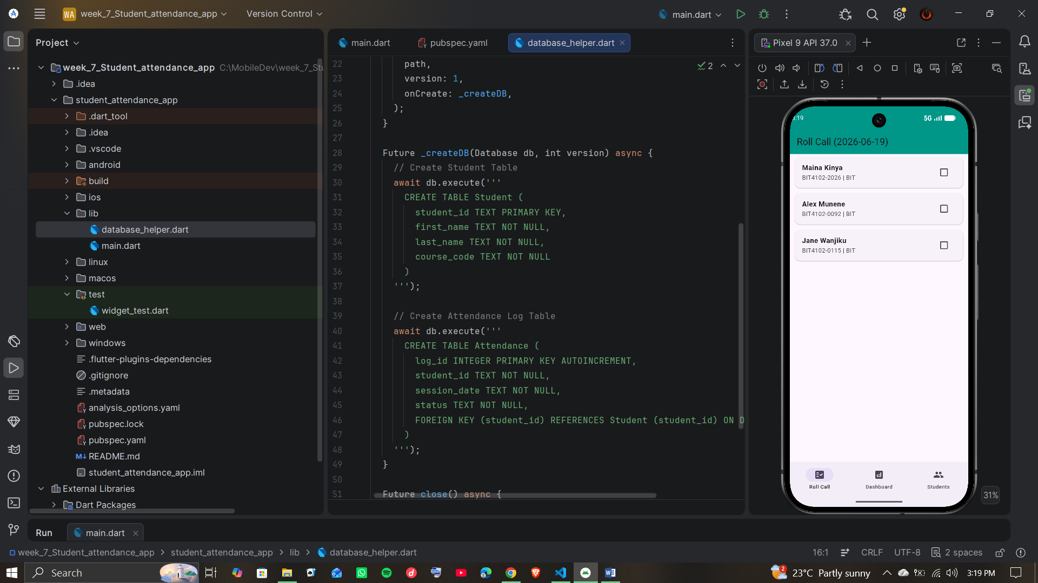
3. Attendance Tracker Project Implementation
The attendance tracking module leverages the SQLite architecture to perform local CRUD operations, ensuring zero dependency on network connectivity. Offline Reliable Architecture: Data reads and writes hit the local device SQLite instance first.
This layout ensures the application remains functional in low-connectivity environment scenarios. Roster Checklist Interface: A dynamic UI component that maps the Student entity query results to a scrollable checklist list view. Toggling state updates the Attendance Log entity directly. Summary Dashboard Engine: Background execution queries pull aggregated metrics (e.g., total present count vs. total registered count) to deliver instantly calculated analytics. Session Report Compilation: Data translation layer logic that converts relational database rows into structured, readable outputs for external sharing.

