Documentation: Week 3 Assignment - Multi-Screen Routing & Form Validation (Student Portal Prototype)
1. Project Overview
This advanced milestone assignment involved transitioning from single-page wireframes into a complete frontend application framework. The project implements an interactive 5-screen "Student Portal" prototype featuring an initial Splash screen, a security Login gateway, a master Dashboard layout, and supporting functional sub-views. The system enforces client-side form input validation checking to ensure clean application entry conditions before enabling navigation routes.
2. System Architecture & Core Components
The architecture introduces named application routing and user input state management handlers across separate screen layout modules.
Core UI Components & Navigation Modules
The system maps presentation screens and routing barriers across five functional views:
Navigator Navigation Routing Engine: Managing a linear stack array of named interface screens via pushNamed and pop arguments to jump between views safely.
Form Input Boundary Container: Grouping client text validation states together to evaluate all input conditions simultaneously before form processing.
TextFormField: Implementing user text entry blocks with built-in validator regex functions to catch empty string errors or incorrect email structures.
InkWell / GestureDetector: Mapping tap response tracking logic across static display cards to enable menu element selections.
Stateful Form Refresh: Triggering view modifications based on active data status changes during text entry evaluation workflows.
3. Multi-Screen Application Navigation Workflow
1. Delay Launch (Splash Screen): The application mounts a timed state event loop, presenting introductory branding assets for a fixed delay period before automatically pulling up the Login screen stack.
2. Credentials Evaluation (Login View): The user submits portal login fields; the application runs field checks, checks criteria constraints, and blocks screen progression if form inputs fail validation checks.
3. Route Dispatching (Dashboard Navigation): Upon clearing input verification barriers, the system dispatches named routing commands to shift the active screen forward into the core administrative dashboard grid.
4. Sub-View Interactivity: Interactive grid menu containers capture input events, routing the view stack seamlessly into supporting profile details or app configurations without losing session alignment.
4. Visual Evidence & Application Execution
Below are the designated areas for compiling multi-screen routing and validation flow screenshots.
[ PLACEHOLDER: SCREENSHOT 1 - ROUTING ARCHITECTURE & VALIDATION RULES ]
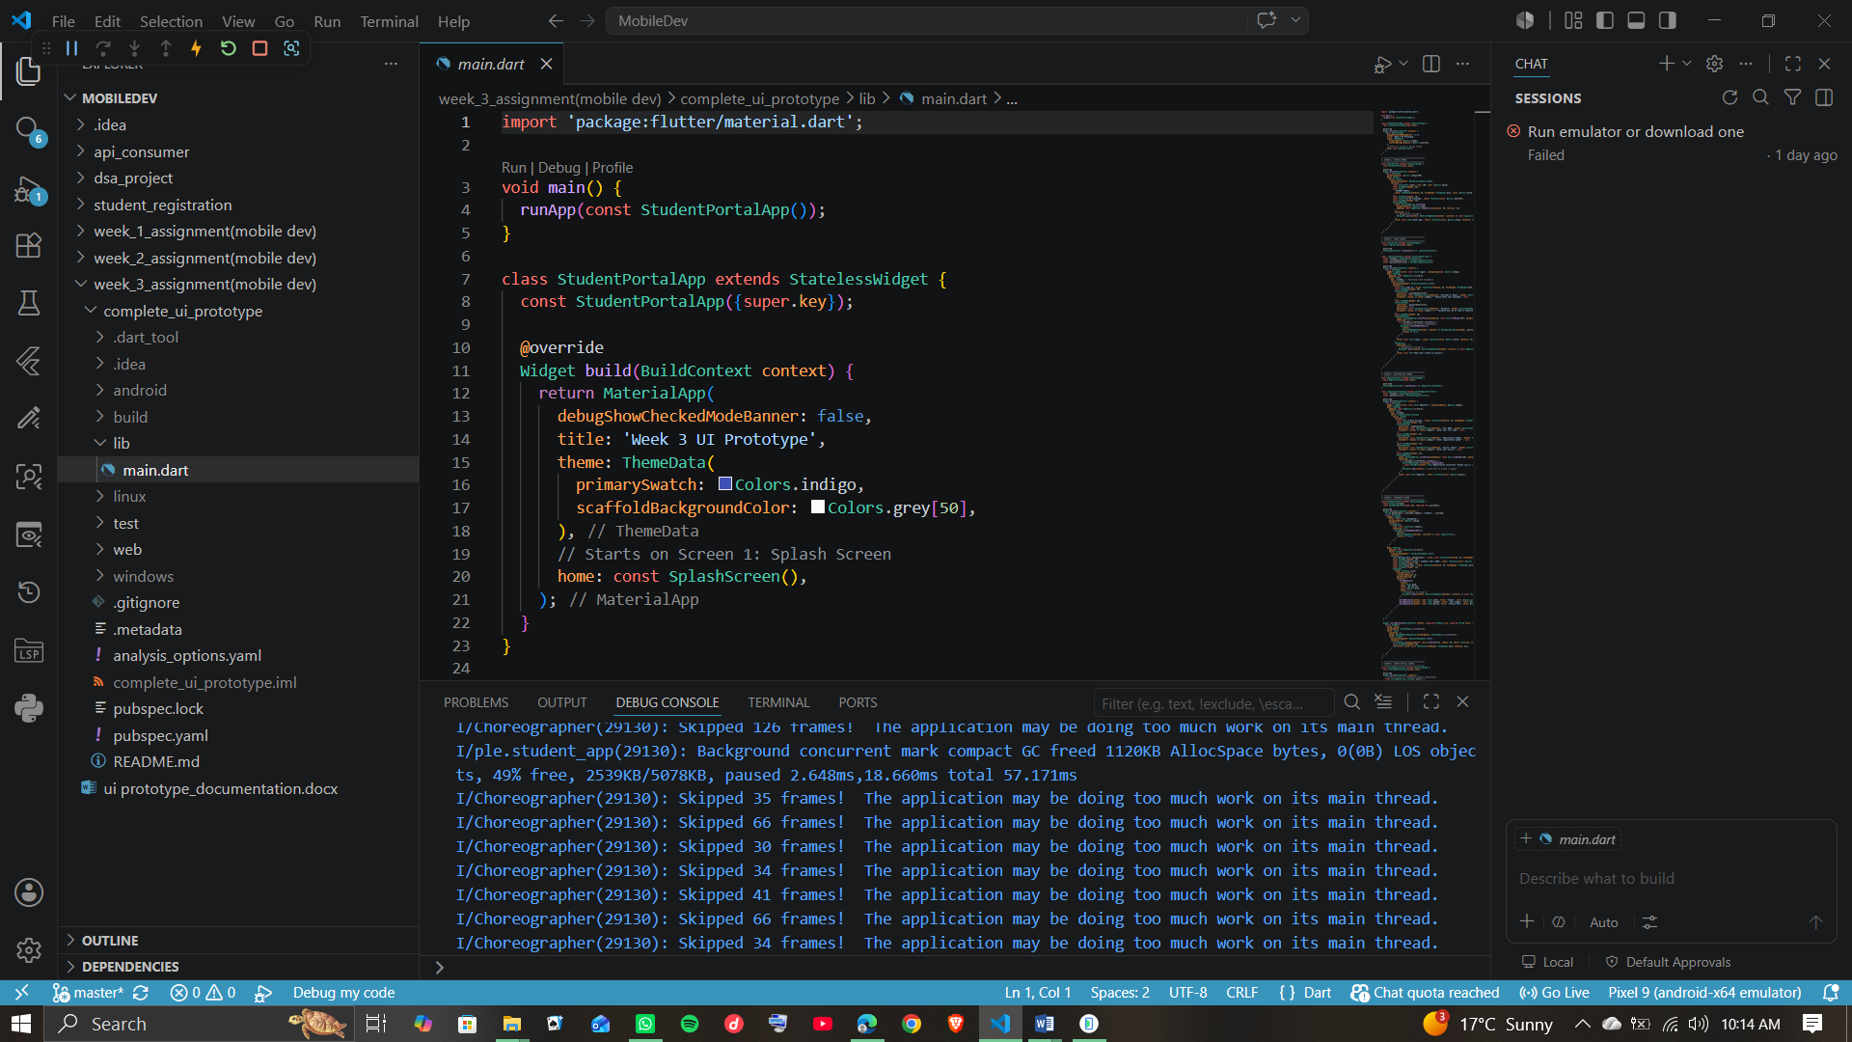
(Showing Named Routing Definitions & Form Validation)
[ PLACEHOLDER: SCREENSHOT 2 - ACTIVE PORTAL UI ON EMULATOR ] 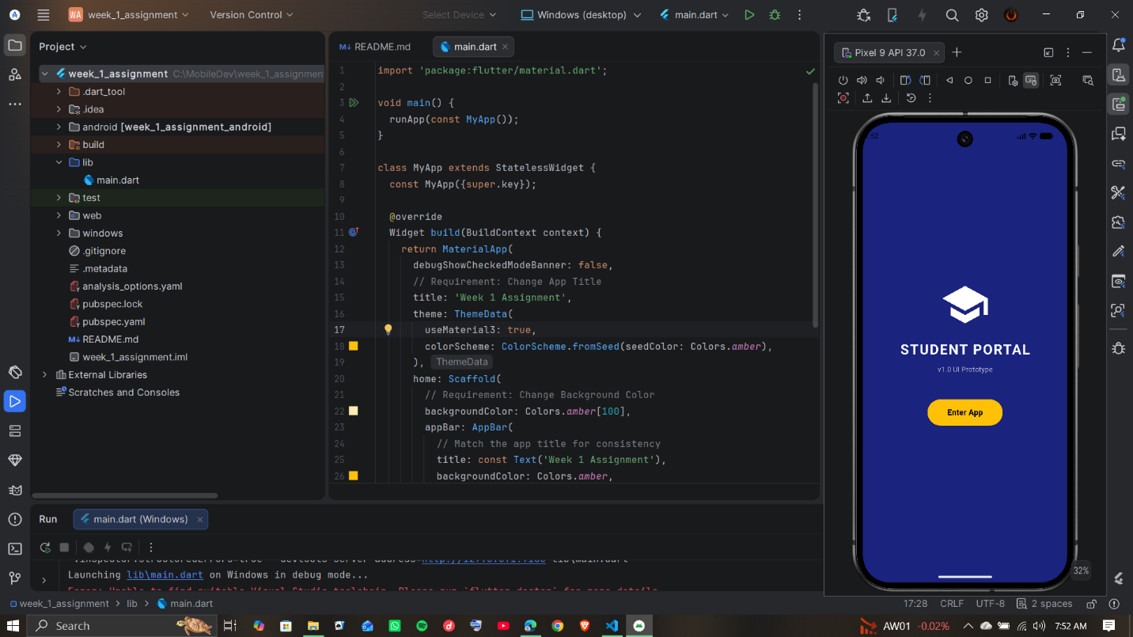
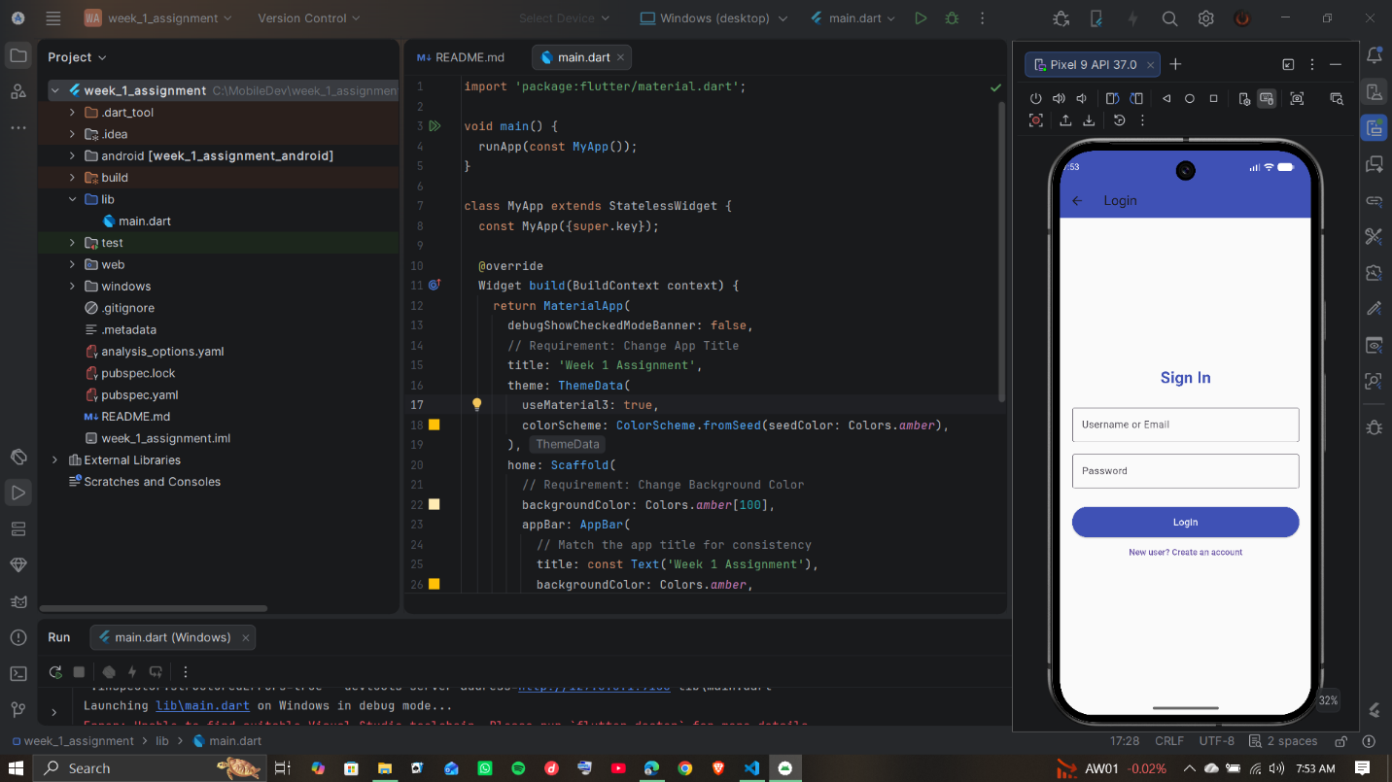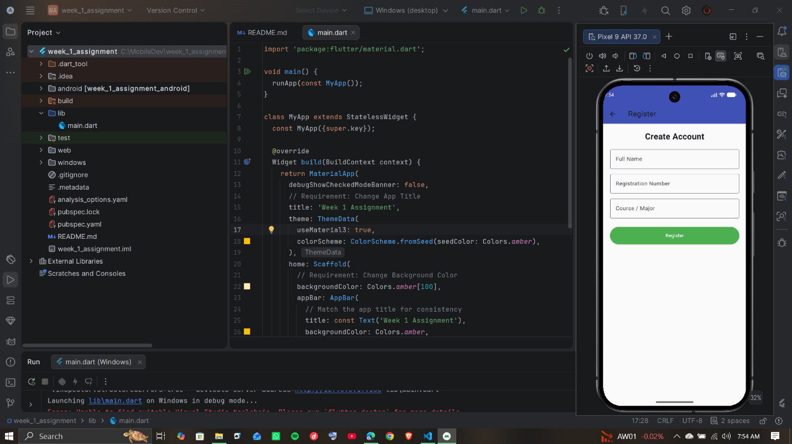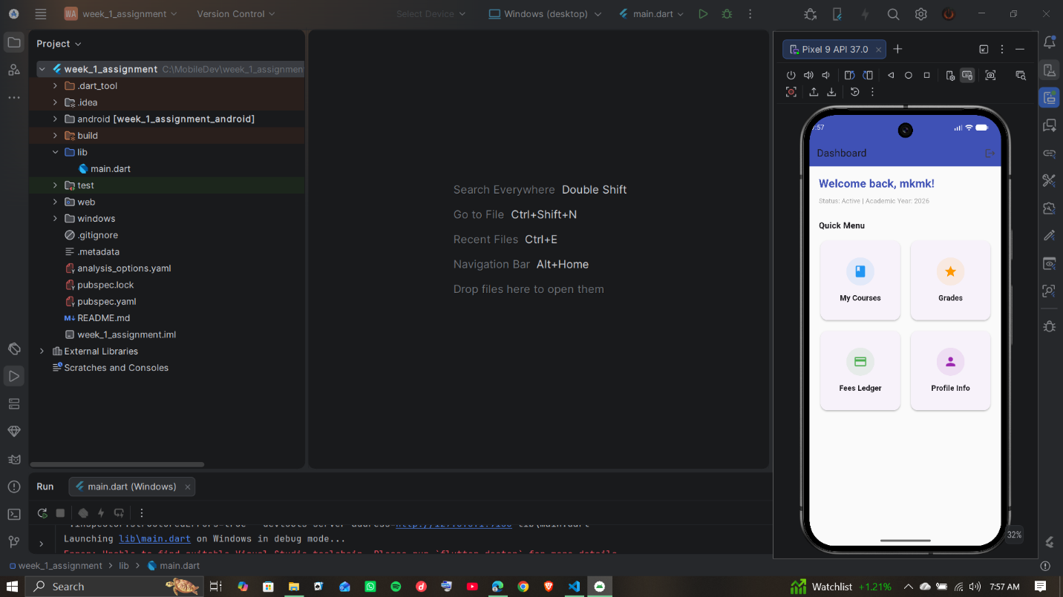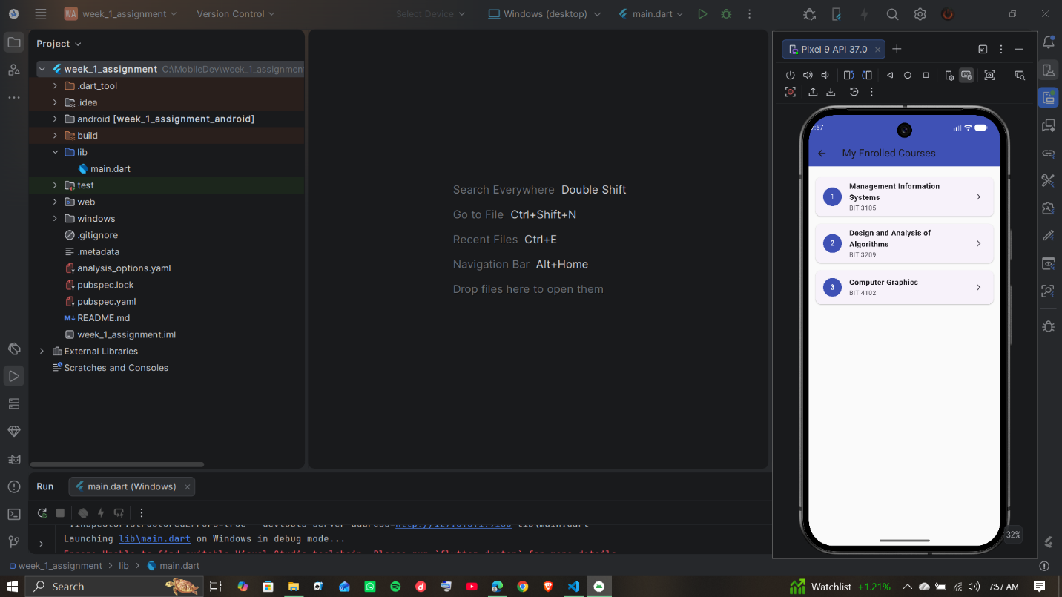
(Showing Active 5-Screen Student Portal Viewport)

