Technical Documentation: Week 1 Assignment - Flutter Environment Setup & Core Widget Baseline
1. Project Overview
This introductory assignment focused on initializing the cross-platform development environment, linking the Flutter SDK within VS Code, configuring an Android Virtual Device (AVD) emulator, and constructing a fundamental interactive baseline application. The project validates structural setup and the core compilation pipeline by rendering basic structural text and interactive layout primitives on a target screen.
2. System Architecture & Core Components
The layout isolates basic application instantiation parameters from structural presentation widgets inside a single baseline entry point.
Core UI Components (main.dart)
Instead of database dependencies, this assignment relies exclusively on foundational structural elements:
MaterialApp: Serving as the root application container to bootstrap the Material Design framework styling engine.
Scaffold: Supplying the core structural visual scaffold, including placeholders for status areas, application bars, and body views.
AppBar: Providing the top-anchored branding and header row for screen title rendering.
Center and Text: Managing single-child alignment constraints and rendering core string outputs with typography configurations.
FloatingActionButton: Introducing simple user-triggered event hooks to modify reactive text variables in real-time.
3. Technical Implementation Workflow
1. Environment Linkage: The local Flutter SDK path is assigned within system configurations, mapping commands directly to the VS Code terminal interface.
2. Project Generation: A clean software scaffold is compiled using CLI arguments, generating targeted underlying platform directories for build execution.
3. Layout Construction: Custom design primitives replace the boilerplate counter layout, defining explicit padding, text styling, and child alignments.
4. Compilation Execution: The compiler triggers target assets to build a debug version, pushing binary elements to the active emulator for deployment verification.
4. Visual Evidence & Application Execution
Below are the designated areas for compiling environmental build status verification screenshots.
[ PLACEHOLDER: SCREENSHOT 1 - FLUTTER ENVIRONMENT VERIFICATION ]
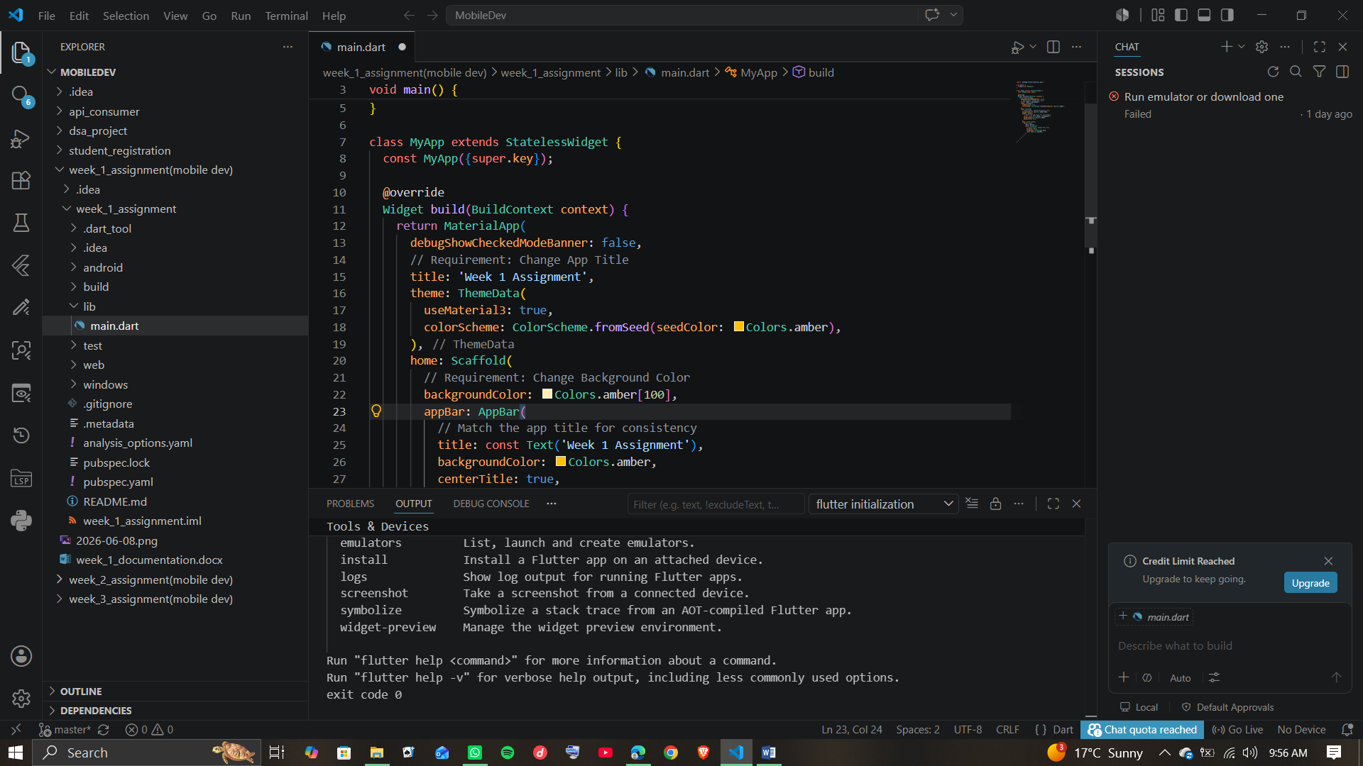
(Showing System Path Verification & SDK Setup)
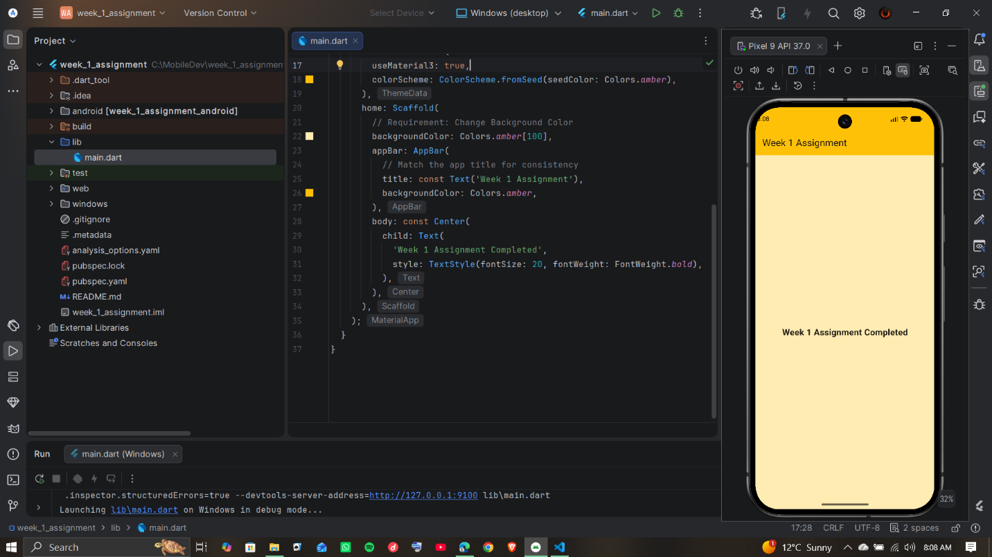
(Showing Compiled Basic Application Core Screen)

