Documentation: Week 2 Assignment - Multi-Widget Layout & Flexbox UI Modeling
1. Project Overview
This project expanded on baseline configurations by exploring complex single-screen layouts using structural multi-child layout mechanisms. The assignment focuses on UI layout modeling, converting graphical user design constraints into a structural tree using linear layout rows, column stacks, spacing boundaries, and customized button configurations.
2. System Architecture & Core Components
The interface layout utilizes flexible composition components to group distinct form and display clusters sequentially down the viewport axis.
Core UI Components (main.dart)
The single-screen presentation profile relies on structural layout nesting to enforce spatial constraints:
Column: Stacking separate user interface blocks vertically to dictate down-axis spacing controls.
Row: Wrapping elements horizontally, utilized for icon-and-text combinations and lateral command arrays.
Container: Supplying custom background color decoration blocks, specific height boundaries, border clipping adjustments, and margin settings.
Padding and SizedBox: Enforcing explicit component isolation distances and pixel margins to avoid layout crowding.
Icon: Loading system vector assets onto the viewport to enhance descriptive input parameters visually.
3. Technical Layout Workflow
1. Node Wireframing: Structural mockups are systematically split into specific child component rows and parent column groups.
2. Alignment Tuning: MainAxisAlignment and CrossAxisAlignment properties are assigned across layout blocks to balance component weight distributions safely.
3. Density Verification: SizedBox objects are inserted relative to visual nodes to ensure clear spacing balances without triggering container overflow clipping.
4. Asset Integration: Static icon glyph arrays are nested securely alongside standard text components within inline horizontal parent lists.
4. Visual Evidence & Application Execution
Below are the designated areas for compiling layout composition and execution screenshots.
[ PLACEHOLDER: SCREENSHOT 1 - VS CODE LAYOUT TREE DECLARATION ]
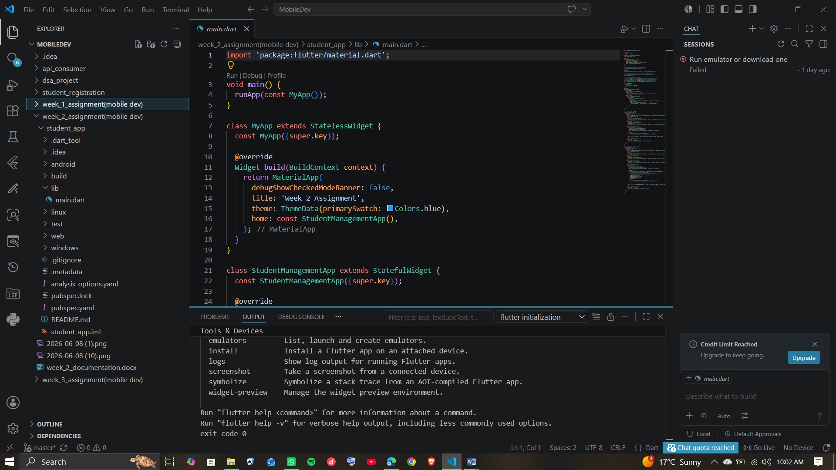

(Showing UI Composition & Nested Code Layout)
[ PLACEHOLDER: SCREENSHOT 2 - DESIGN LAYOUT OUTPUT ON EMULATOR ]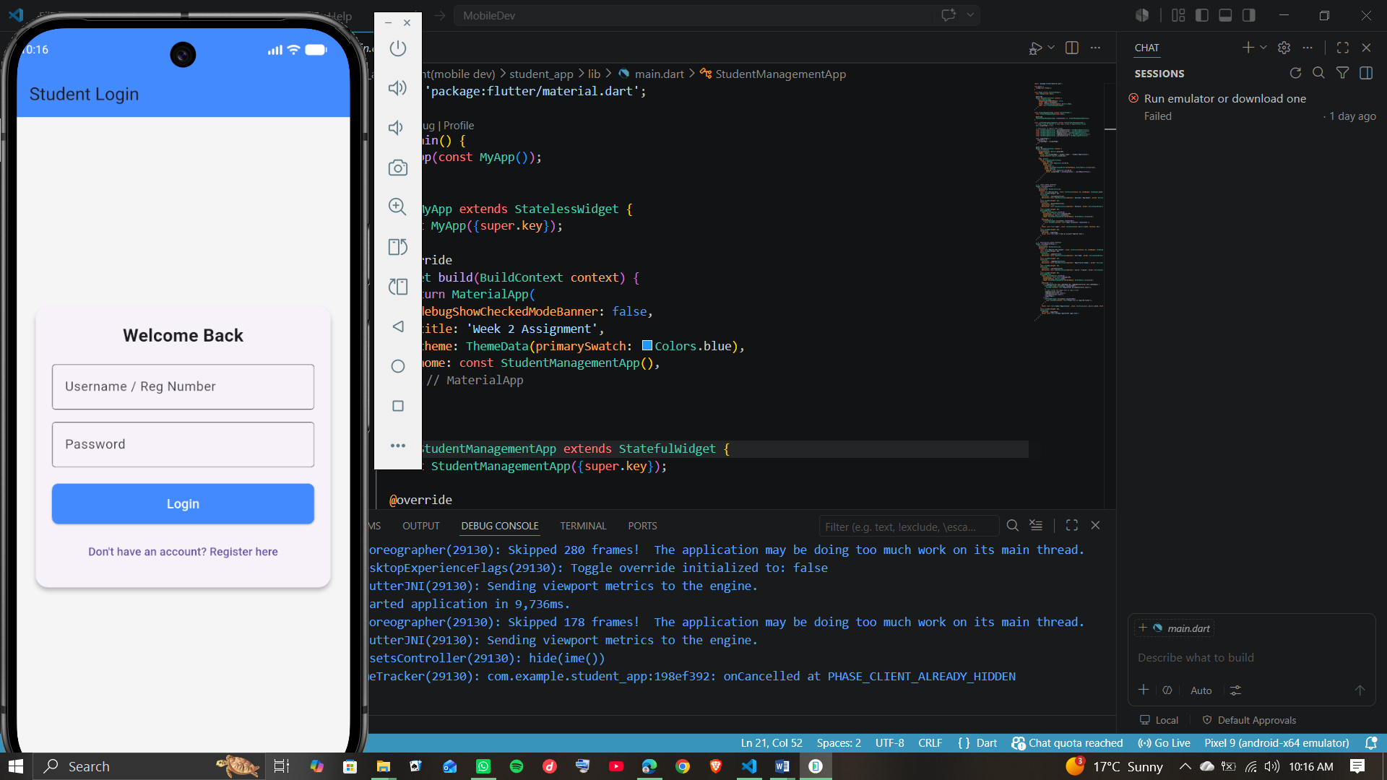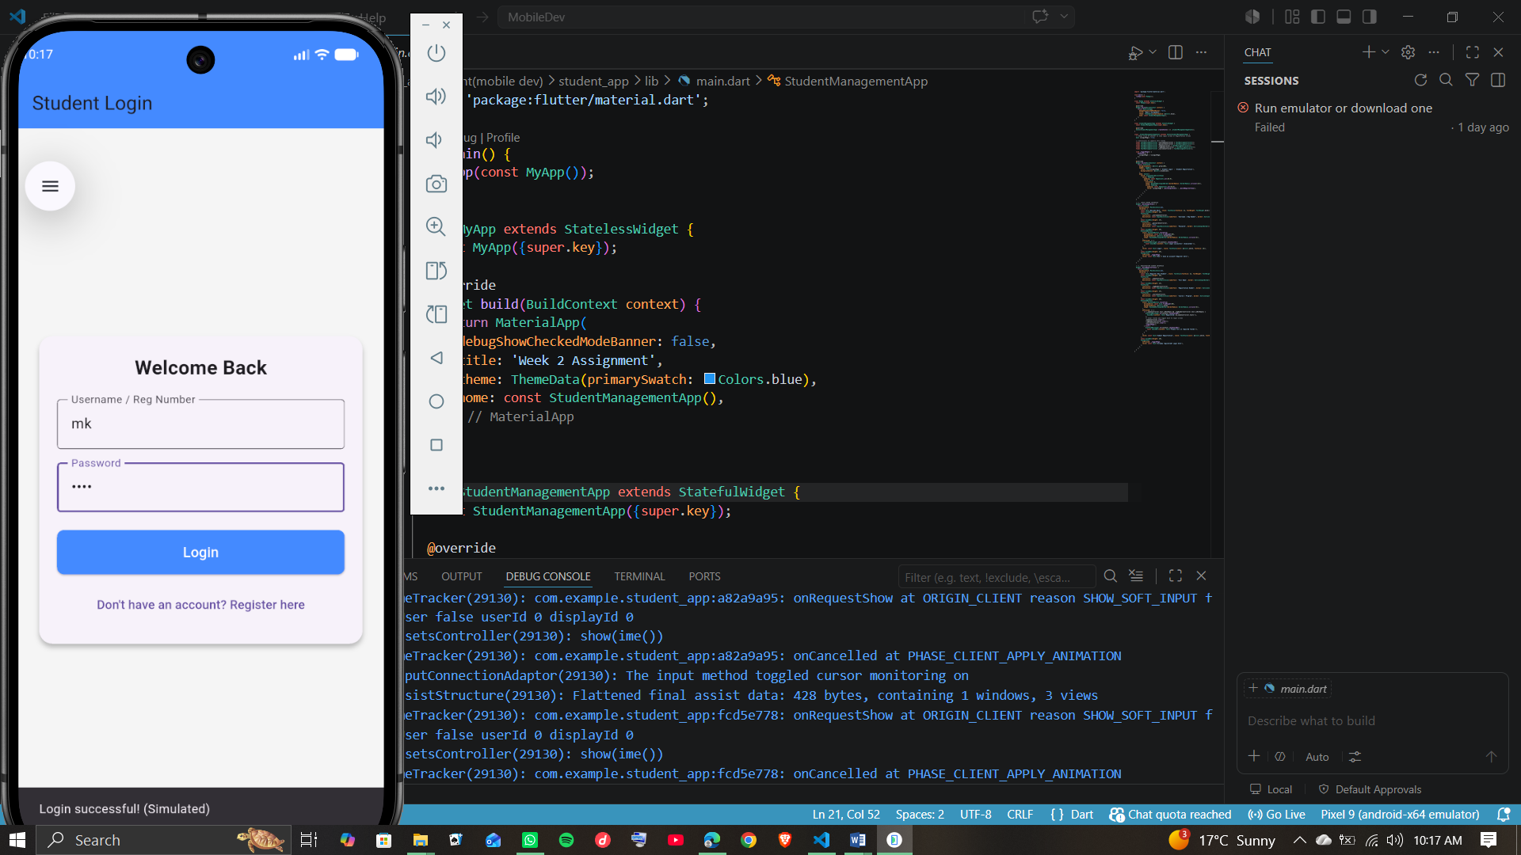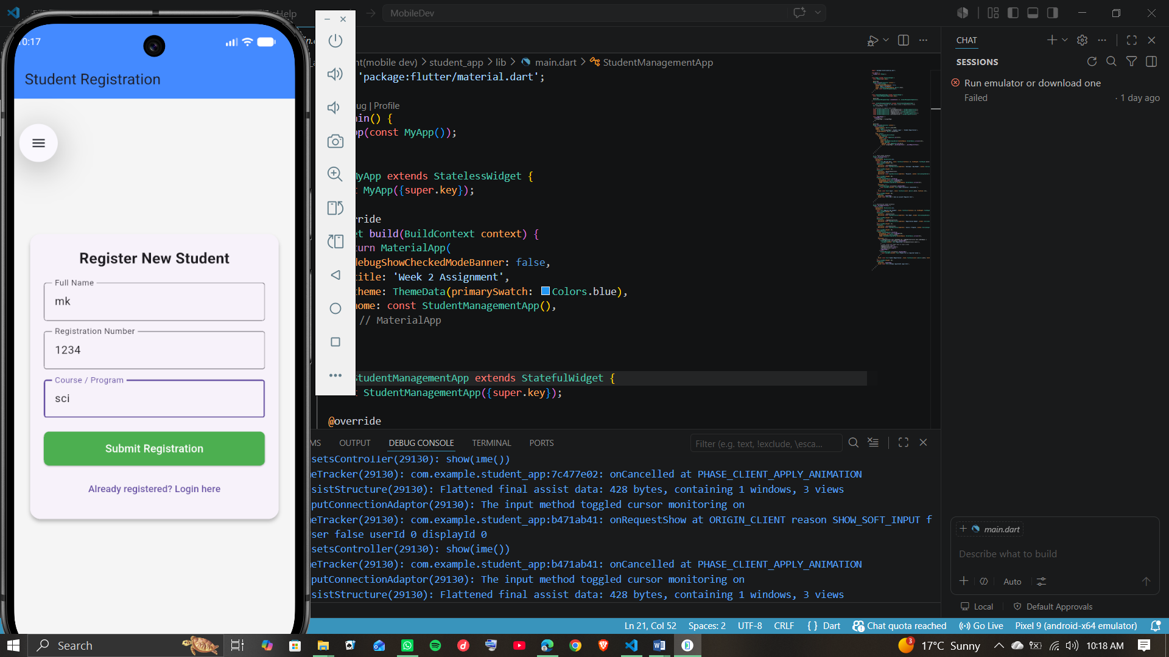
(Showing Rendered Layout Interface on Device screen)

