Technical Documentation: Mobile API Consumer Application
1. Project Overview
This mobile application is developed using the Flutter framework to serve as a live REST API consumer. The primary objective of the application is to connect to a public remote web server asynchronously, fetch external user records over HTTP, parse the JSON payload securely, handle standard network communication errors, and present the structured dataset in a clean user interface.
2. System Architecture & Core Modules
The system decouples the communication data-transfer layer from the user interface viewport layer.
A. Network Service Layer (api_service.dart)
This module is responsible for managing outbound web requests via the Dart http library. It acts as the gateway to the remote REST server endpoint:
Endpoint Communication: Sends an asynchronous HTTP GET request to the public user records endpoint ([https://jsonplaceholder.typicode.com/users](https://jsonplaceholder.typicode.com/users)).
Status Code Validation: Evaluates the server's numeric response headers to ensure safe data extraction. It checks for standard state codes:
200 OK: Successful download, triggering the JSON deserialization parser.
404 Not Found: Catches invalid resource pointer errors and halts data mapping with an explicit exception.
500 Internal Server Error: Flags server-side infrastructure crashes cleanly on the client end.
JSON Processing: Utilizes the dart:convert utility to convert raw JSON text data back into dynamic list collections that the application can manipulate.
Fault Tolerance: Integrates a structural try-catch block to gracefully intercept low-level hardware disconnections or network timeouts without causing application crashes.
B. User Interface Layer (main.dart)
A scannable layout configured completely with Flutter Material components to display live data state changes.
Asynchronous State Tracking: Utilizes a FutureBuilder widget to automatically listen to the web stream and cycle the screen through three distinct visual states:
Loading State: Displays a centered circular progress indicator while waiting for the remote server packets to land.
Error State: Dynamically outputs user-friendly text messages onto the viewport if a network drop or unexpected HTTP status code error is intercepted.
Success State: Renders the decoded dataset directly into the interface framework.
Dynamic List View: Utilizes a structured ListView.builder widget to populate individual data instances dynamically inside separate card containers, ensuring smooth memory optimization during scrolling.
3. Asynchronous Data Execution Workflow
1. Triggering: The interface runs fetchUsers() inside the application launch hook (initState) to ping the internet the exact millisecond the viewport opens.
2. Background Fetching: The system processing thread remains fully unlocked and responsive while the networking engine manages the background handshake download.
3. Stream Mapping: Once the packet arrives, the FutureBuilder tears down the loading indicator, parses the map values, and injects data directly into the structural layout.
4. On-Demand Refresh: Pressing the top AppBar refresh action icon triggers a manual state re-evaluation to re-query the web server for any changes instantly.
4. Visual Evidence & Application Execution
Below is the verified operational layout and execution status output from the active VS Code development workspace.
[ PLACEHOLDER: DEVELOPMENT ENVIRONMENT AND CODE]

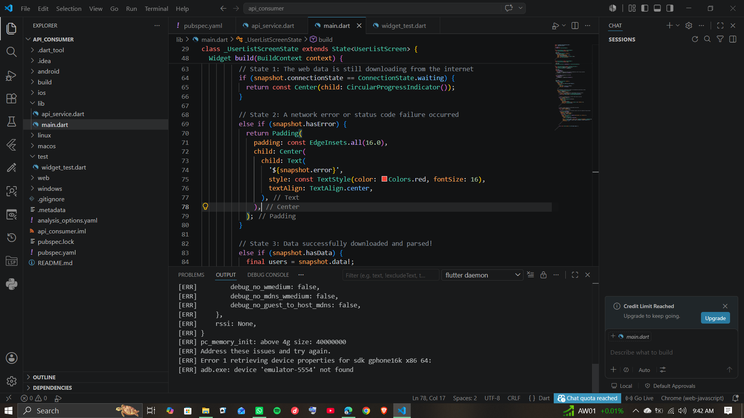
(Showing Workspace Environment & Network Services)
[ PLACEHOLDER: SCREENSHOT 2 - LIVE API FETCH ON EMULATOR ]
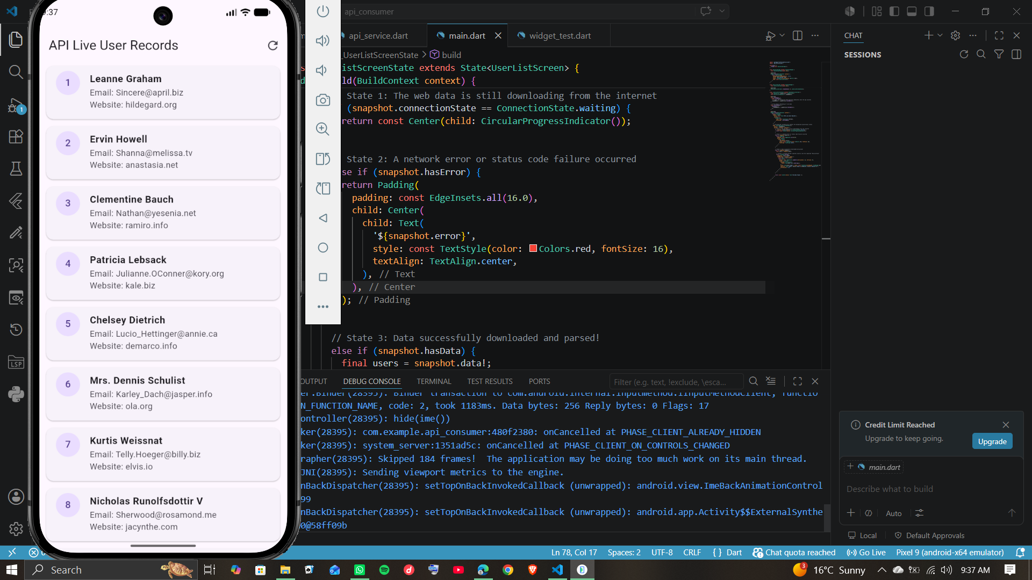

(Showing Successful Live REST API Data Display)

