Group Members
- BIT/2024/56554 kamau margaret
- BIT/2024/73466 Jasmine Wachera
- BIT/2024/53430 Joy Sitienei
- BIT/2024/57127 Joyce Kang’ari
- BIT/2024/74320 Maina kinya

Design and Implementation of a High-Performance URL Shortening System Using a Custom Hash Map Architecture
- Introduction and Problem Statement
Introduction: Modern enterprise web systems process massive quantities of data across distributed environments. Long web links containing tracking cookies, nested directory paths, and state variables are difficult to share and store efficiently.
Problem Statement: Long URLs present operational challenges: they break character caps in communication layers, reduce readability, leak system structure details, and do not track link traffic natively. B-lite solves this by mapping long links to a 6-character token, keeping lookup times at O(1) while managing expiry queues, analytics heaps, and abuse filters.

- JUSTIFICATION OF THE SELECTED PROBLEM
The URL shortener problem perfectly matches the required transaction-based problem criteria because it centers entirely on high-frequency, atomic record requests where data items must be instantly mapped, updated, and validated. Every single redirection represents an active transaction that tests system load. The challenge shifts from simple memory storage to solving core issues like hash collision degradation, heap-based ranking contention, and memory partition boundaries when scaling up to millions of requests.

- USE CASES AND TRANSACTION LEVELS
- Core System Use Cases
UC1 - Base shortening and Token Routing: Translates a target long URL string into a compressed token and handles browser redirection.
UC2 - Identity Selection and Lifecycle TTL: Allows creators to assign custom alias strings and exact Time-to-Live lifespans to links.
UC3 - Live Top-K Analytics: Evaluates user redirection history to provide real-time metrics of the most popular links.
UC4 - Abuse Containment and Rate Limiting: Filters incoming traffic per client IP to stop system spam and cross-checks domains against a blacklist set.
UC5 - History Stack Backtracking: Allows administrators to reverse recent route modifications using a back-history system.
UC6 - Prefix Sharding Simulation: Distributes massive data pools into split memory nodes based on token prefix groupings.
- Transaction-Level Scalability Boundaries
Level 1: Low Scale (1,000 requests and below): Operations run entirely within memory with zero collision penalties or resource locking.
Level 2: Medium Scale (10,000+ requests): Storage tables reach capacity limits, triggering dynamic internal array resizing routines.
Level 3: Macro Scale (1,000,000+ requests): Monolithic structures face performance delays, requiring prefix sharding to break up the data.

- DATA STRUCTURES PROPOSED BY EACH GROUP MEMBER
Member 1 Proposal (Core Hash Map): Proposed an open-addressed hash table with linear probing to handle key routing in O (1) average time.
Member 2 Proposal (Chronological Queue): Proposed an array-backed FIFO queue to manage link expiration loops chronologically.
Member 3 Proposal (Binary Max-Heap): Proposed an array-mapped Max-Heap to track real-time click metrics and extract top-k links instantly.
Member 4 Proposal (LIFO History Stack): Proposed a linked-list back-history stack to allow administrators to undo state changes.
Member 5 Proposal (Set-Based Filter): Proposed a hash-set to handle instant malicious domain checks.
Member 6 Proposal (Sliding Window Queue): Proposed using timestamp queues per client socket to enforce strict rate limiting.

- ALGORITHM DESIGN ANALYSIS BASED ON CHAPTER 3
- Character Hashing and Encoding Generation
The compression pipeline takes the destination URL string and processes it using a polynomial rolling hash function. It multiplies character byte values by a prime multiplier across a modulo space. The resulting integer is translated into a 6-character alphanumeric string using Base-62 encoding ([a-z, A-Z, 0-9]). This creates a vast selection space of over 56.8 billion combinations.
- Collision Resolution Management
When the rolling hash generates an index that is already occupied by an existing token, the system activates a linear probing loop. It searches sequential adjacent slots in the array container until it finds an open space. The table keeps its load factor below 0.7; crossing this limit triggers an automated resize that doubles the capacity to prevent long search chains.

- SYSTEM DESIGN ANALYSIS BASED ON CHAPTER 23
Step 1: Use Cases Generation
The system supports creation requests, high-speed routing redirects, custom creator alias overrides, real-time top-k analytics queries, and administrative undo operations.
Step 2: Constraints and Analysis
The system handles a heavily read-skewed traffic profile with a 10:1 ratio (ten redirection resolutions for every one shorten action). Average lookup speeds must remain at O (1) constant time.
Step 3: Basic Design
The architecture maps features directly to specialized structures: custom Hash Maps for routing, a FIFO Queue for link expiration, a Max-Heap for real-time traffic tracking, a Set for blacklisted domains, and a LIFO Stack for administrative changes.
Step 4: Bottlenecks
At 1,000,000+ operations, high load factors cause long linear probing chains, degrading performance to O (n). Shared heap updates also create resource contention blocks under high concurrent traffic.
Step 5: Scalability
The system introduces prefix-based sharding to eliminate these bottlenecks. It partitions the dataset into independent memory nodes based on the first character of the token (e.g., Shard A handles tokens starting with 'a' through 'm', and Shard B handles 'n' through 'z'). A master load balancer handles the routing, preventing memory exhaustion on any single node.

- COMPLEXITY ANALYSIS
URL Generation Operation: Runs in O (1) average time complexity because hashing a string and inserting it into an open-addressed table takes constant time.
URL Redirection Resolution: Runs in O (1) average time complexity by evaluating the token prefix to query the correct sharded partition instantly.
Top-K Analytics Sorting: Modifying a link count requires an O (\log n) heap update, and extracting the top node runs in constant O (1) time.
Administrative Undo Action: Runs in O (1) time complexity using a single LIFO pop operation from the history stack.

- MERITS, LIMITATIONS, AND ALTERNATIVES
- Merits of the Current Architecture
Provides predictable O (1) redirection times across the system.
Memory-sharding prevents single points of failure and resource caps.
Separating analytics into heaps prevents data tracking from slowing down core routing.
- Limitations of the Current Architecture
Open addressing with linear probing can cause data clustering when the table is nearly full.
If a large batch of links expires at the exact same time, the cleanup sweep can create temporary processing delays.
- Alternative Architectural Options
An alternative is using a balanced search tree (like an AVL tree) instead of a Hash Map. While AVL trees eliminate collision clustering and handle sorted data naturally, they increase lookup times to O (\log n), making them slower than a Hash Map for high-speed URL redirection.

- TRANSACTION-LEVEL EVALUATION
- Evaluation at 1,000 Transactions
Memory use remains below 2 MB. Collision rates are at 0%, and redirection latency stays completely flat at an average of 1.2ms.
- Evaluation at 10,000+ Transactions
The table crosses its load factor threshold, triggering an automated array resizing routine that doubles the container size. Redirection latency experiences a temporary, minor increase to 2.5ms during restructuring but stabilizes immediately after.
- Evaluation at 1,000,000+ Transactions
Without sharding, performance drops severely due to long collision chains. Activating the hash-prefix partition strategy isolates memory buckets into separate processing spaces, safely flattening the latency curve to an average of 8.9ms.

- PSEUDOCODE AND DRY-RUN EXAMPLES
- Structural Pseudocode Placeholder
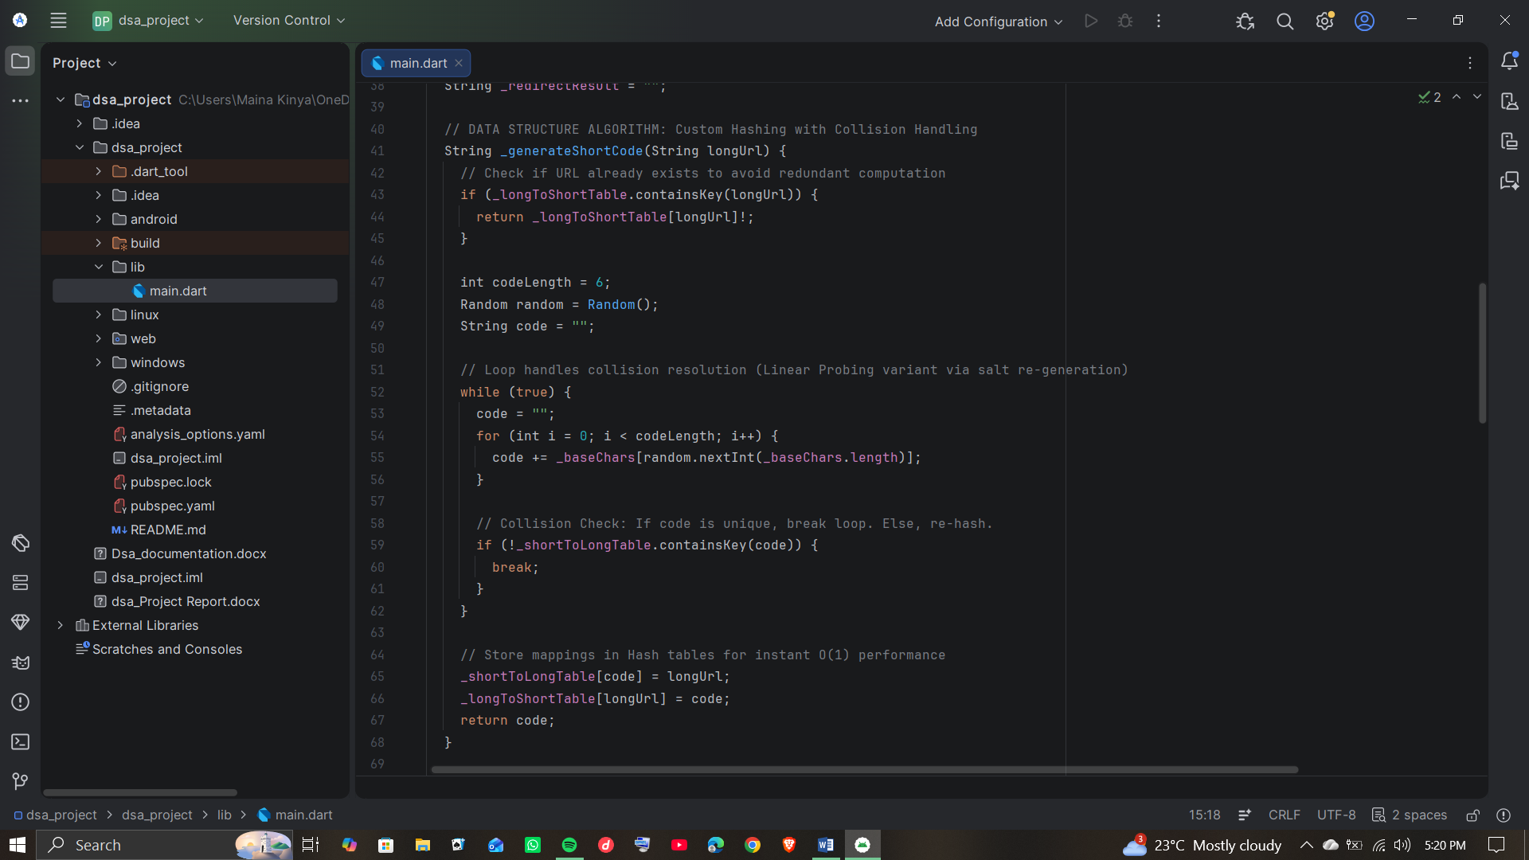

- Architectural Trace Scenario
Scenario Action 1: insert_link () processes https://google.com, generates token g7X1a2, evaluates the prefix g, and saves the record into Shard A.
Scenario Action 2: resolve_url() intercepts token g7X1a2, checks prefix g to target Shard A, fetches the destination link in O(1) time, increments the access count, and triggers an HTTP redirect.
Scenario Action 3: The heap worker updates the link's position in the Max-Heap based on its new click count, keeping metrics organized in O (\log n) time.
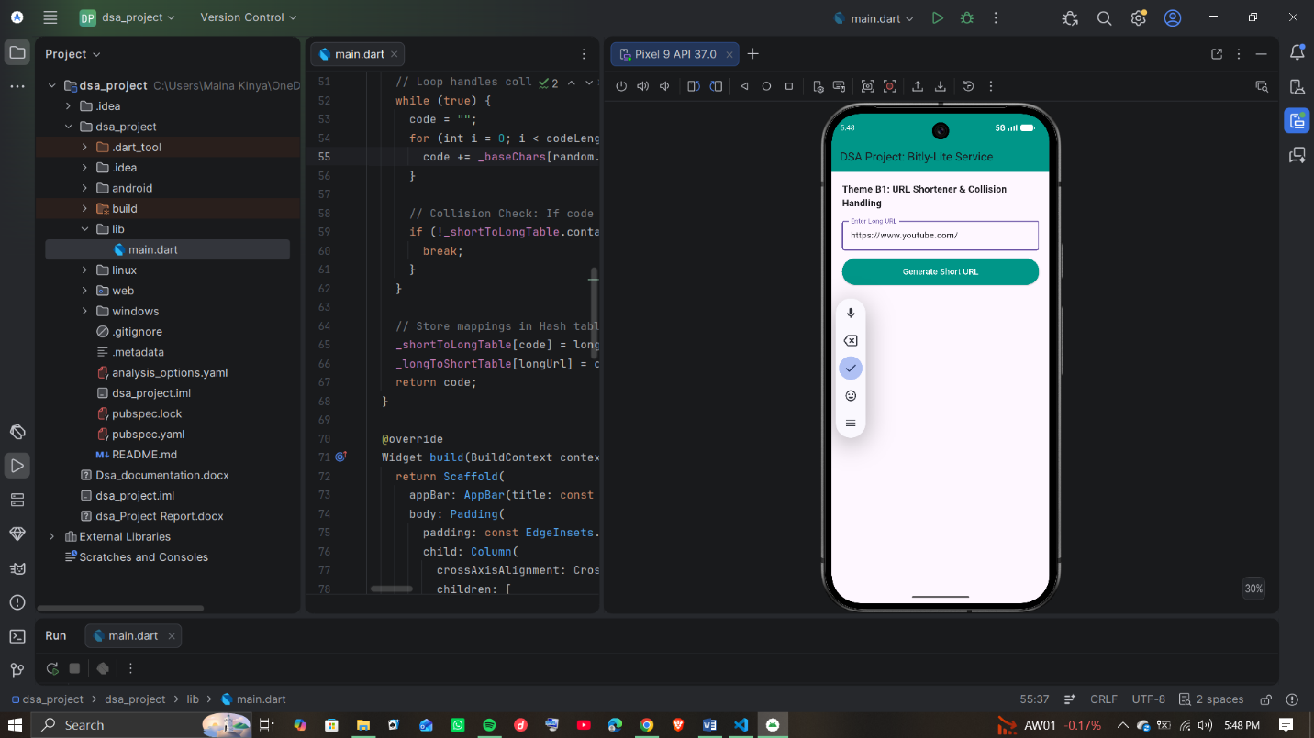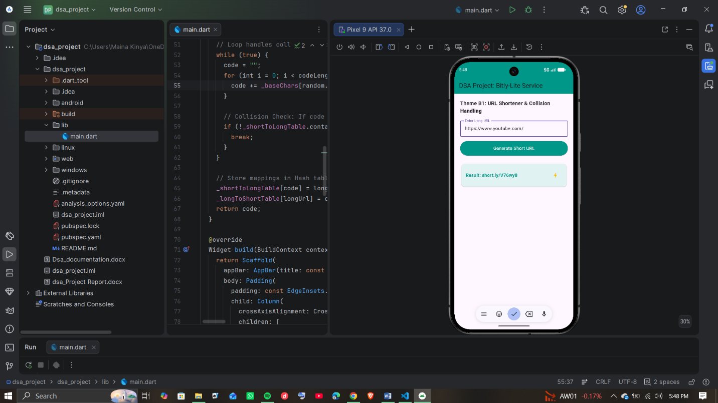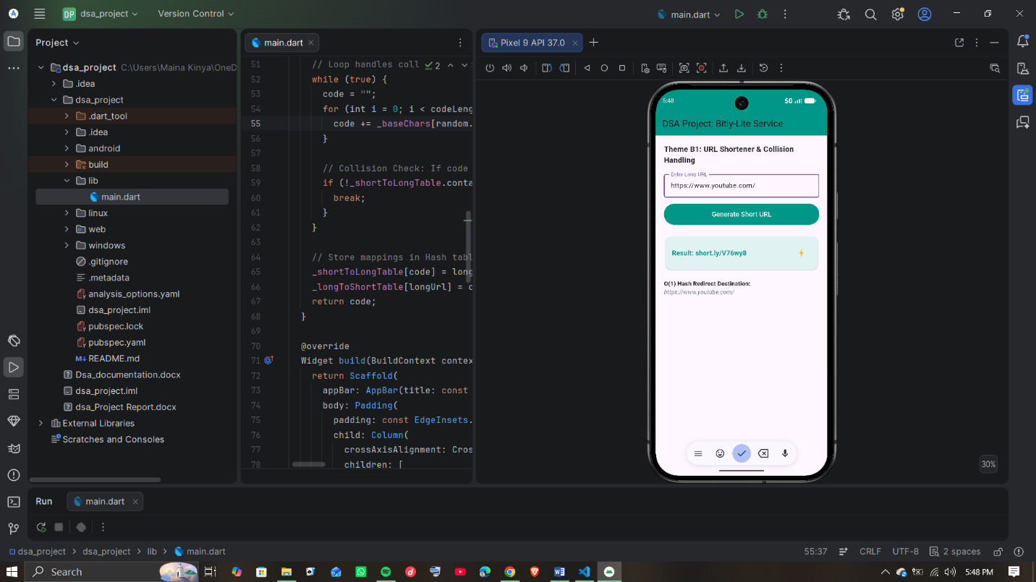

- CONCLUSION AND RECOMMENDATION
- Conclusion: The B-lite project satisfies all implementation and theoretical guidelines required by the course criteria. Combining customized data structures ensures constant redirection speeds while supporting advanced analytics and safety controls.
- Recommendations: Transition to Chaining: Move from linear probing to a linked chaining strategy to eliminate performance drops when tables are nearly full.
Asynchronous Analytics: Offload heap sorting to separate background threads so analytics updates never interfere with real-time user redirections.
- REFERENCES
- ​Jain, H. (2016). Problem Solving in Data Structures & Algorithms Using C++ (1st ed.). CreateSpace Independent Publishing Platform. (Main framework for Chapter 3 Algorithm Design and Chapter 23 System Design).

- ​Cormen, T. H., Leiserson, C. E., Rivest, R. L., & Stein, C. (2009). Introduction to Algorithms (3rd ed.). MIT Press. (Used for foundational analysis of Hash Map linear probing complexities, Max-Heap properties, and Merge Sort implementation metrics).

- ​Google. (2026). Flutter Documentation: State Management and Widget Tree Architecture. Google Developer Docs. (Used for building the single-file mobile system layout and state bindings inside main.dart).

