1. Go to <https://github.com/snowWinter312/server> and download all the files and copy under an folder on your computer(ex, let’s suppose that the folder is c:/server)
2. Create the “forum” DB and import forum.sql (It exists under root folder of GitHub) on phpMyAdmin (make the db user(username : user, password : user) ). Of course you have to install Mysql server and run so that our program can connect to MYSQL DB
3. Open the “command prompt” and Install node.js and npm
4. Go to the folder (c:\server) on command window
5. Run “npm install express” on command window
6. Run “npm install pm2 -g” on command window
7. Run “pm2 start server.js” on command window. If you want to stop this process , run “pm2 stop server.js”

If you see this screen, It is OK.

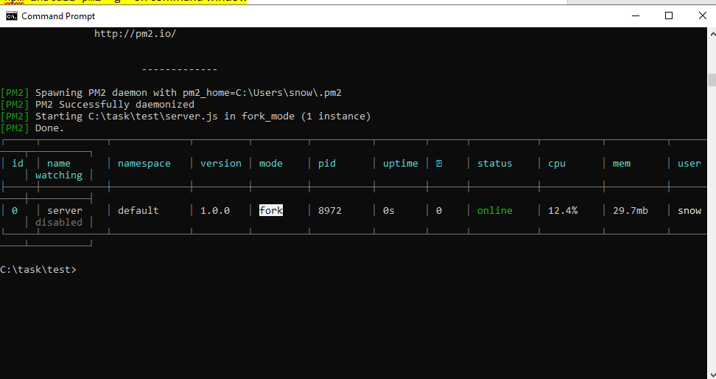

1. Go to this url(http://localhost:3000/) on browser

You can see the login screen (administrator -> username :1 password: 11, Consultants and Clinic Managers -> username:2, password:22, doctors and therapists -> username:3, password:33, parents -> username:4, password:44)

\* I made the 4 user groups

- level 1: administrator(that can see the admin menu and manage the site)

- level 2: Consultants and Clinic Managers

- level 3: doctors and therapists

- level 4: parents

1. Because you test on local, now I commented the email sending parts.

I don’t think it is full version and I think I have to do some correction works as bonus after you see the prototype .

Believe me. I will do my best until you satisfy

If you are going to help me, I hope we finish this task(with good review) and you post the correction works(150) as new task so that I can have the review on Freelancer(because I start at first on Freelancer, I am difficult to get the good tasks. I hope you understand me)