**Assignment1 Analysis Report**

* Xiaowei Wan

Plots:

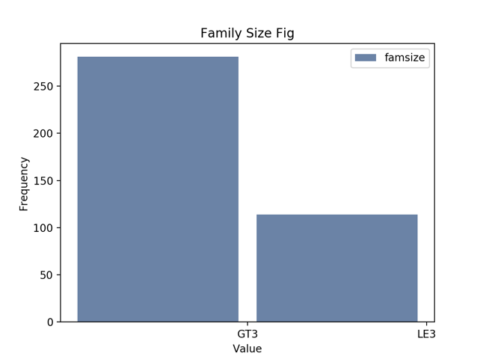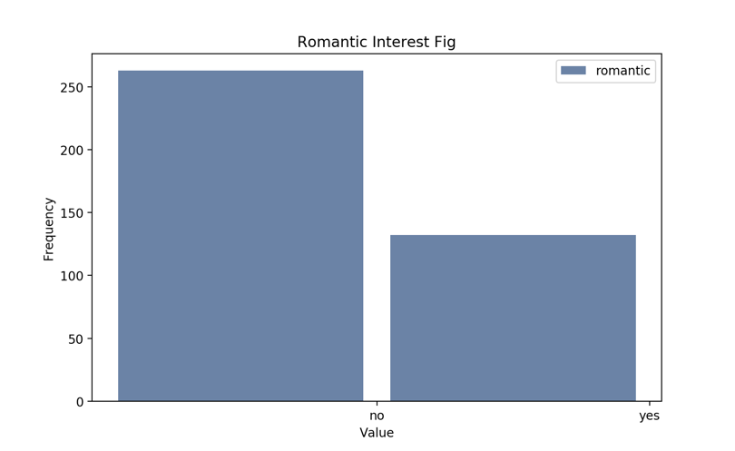

1. As family Size fig show that there are 114(LE3) family have three or less family members of 395 total family, thus it is around 29% of all family have three of less family members.

2. As Romantic interest fig show that there are 132(yes) romantic of 395 total, so it is around 33% of high school students are in relationship.