**Project 1 Analysis Report**

* Xiaowei Wan

Generate small random numbers using Random and Math both generators.

1. Using Random to generator random number, below plots shows random generator numbers.
2. Generator small number random numbers, generate (1-10) 10 numbers, plots PMF:

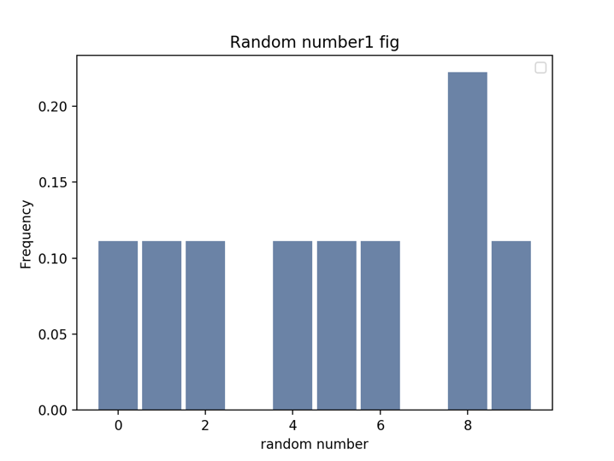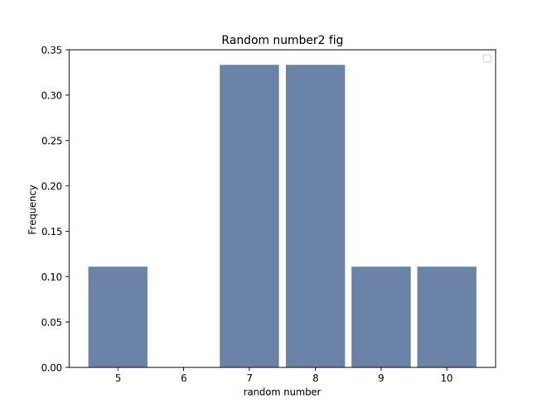

* Plot1 (random generator) showing there are some number missing, like 3, 7, 9, 10, if it is a good number generator, the probability of each number should be uniformity, and P(each number) = 1/10. But from plot, it is not very good.
* Plot2 (math generator), 1, 2, 3, 4, 6 are missing, it is not uniformity.

Generate large random number (100000) using random and math generators.

Plots:

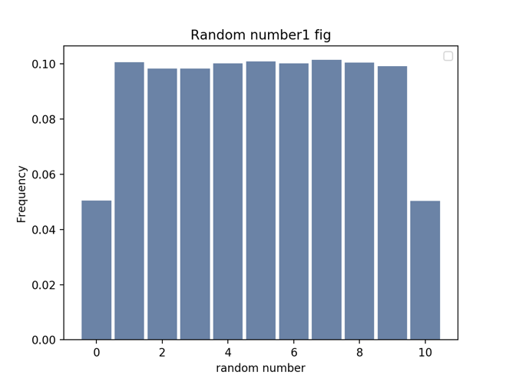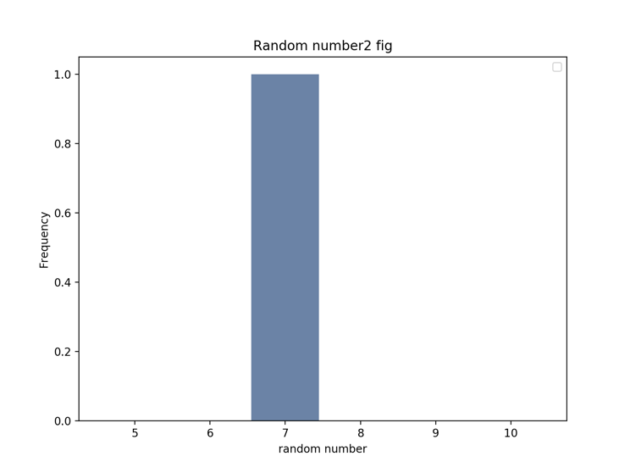

* Plot1 showing it generates all numbers from 1-10, and large numbers the probability of each number are similar, it is better than when generating small random number
* Plot2 showing almost only one number 7 was generated. Other number all are missing, so it is very poor random number generator.