This a sample RTF Fax Document (RTF)

RTF Docs: OnlineFaxes Fax API enable developers to send, download, list, delete, and get the status of fax on custom or existing applications. OnlineFaxes takes the spirit of 3 ancient scripts.

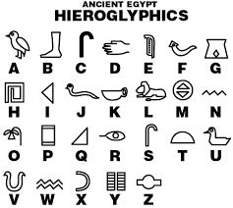 | 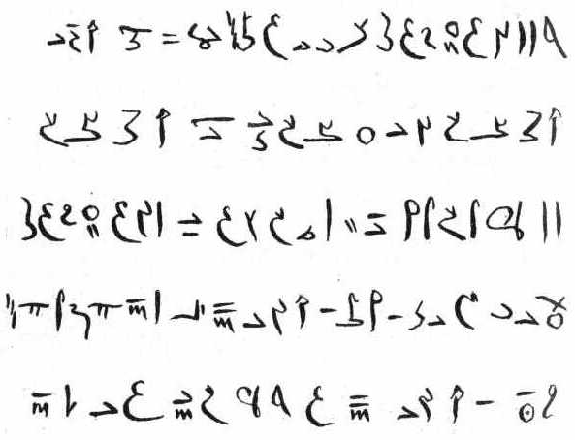
Hieroglyph | Demotic
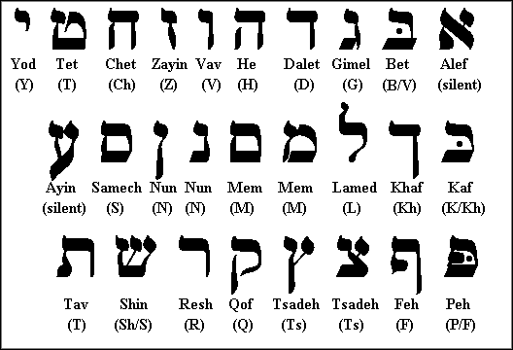 | 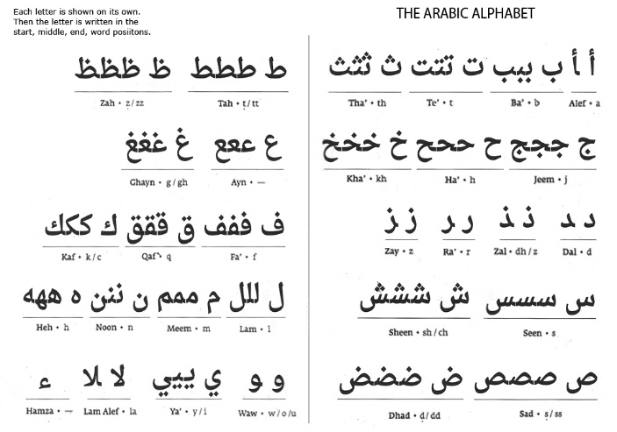
Hebrew | Arabic

Thanks for using OnlineFaxes API.

