1. Overview
2. 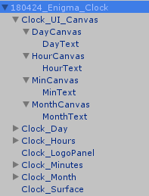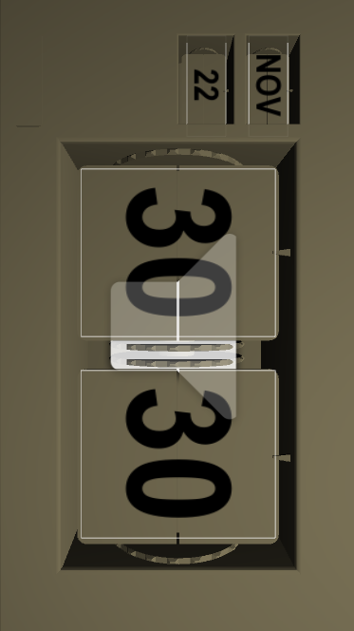Clock_UI_Canvas

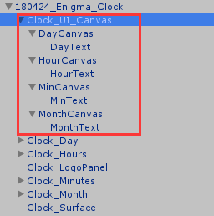

They are the UI panels which are floating on the clock’s surface to display the current time and date. There are four canvas in total; each of them contains a Text component.

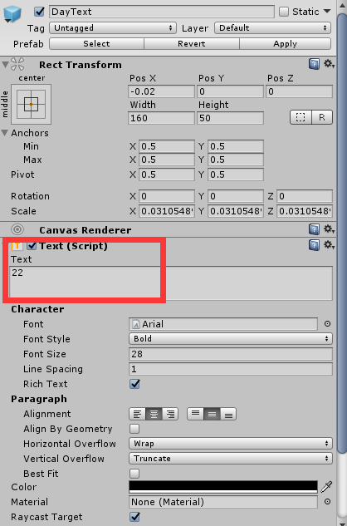Take DayText as an example:

The character’s font and style can be modified here.

The displayed text can directly be changed in the red area. However, it generally should be updated through the script.

1. Clock

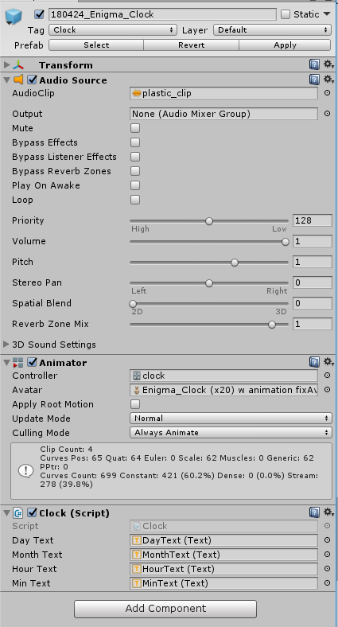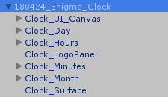

1. Set the Tag as “Clock”

Help scripts to find this gameobject through tag.

1. Add the audio source for the sound effect of flipping the panel.
2. Add the Animator

Add the correct Controller. The detailed settings can be found in the following section.

1. Add Clock

Each Text here is the Text object inside Clock_UI_Canvas. Details can be found in the previous section.

1. 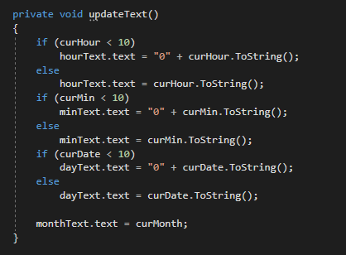Change the display text through the Clock script.

Clock.updateText()

Update the Text’s content with the current time and date.

1. 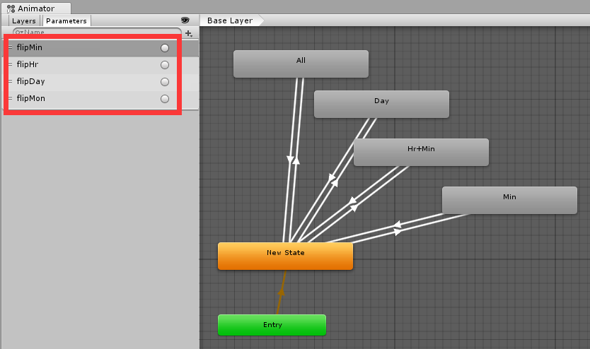Animation Controller for Clock

The controller of the current project can be found in Asset/Animation/.

There are four animation clips and four triggers.

Clock.playAnimation()

Play the animation according to the condition.

For example: If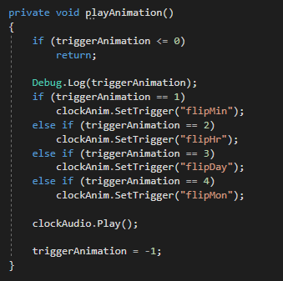 you want to play the animation of flipping Minute’s panel, simply use

clockAnim.SetTrigger(“flipMin”);

These triggers are set in the Animation controller as the previous picture shows.