1. Overview



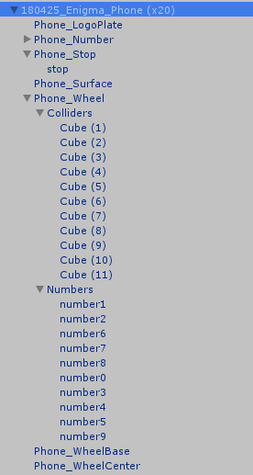

1. Phone Stop

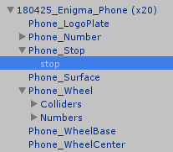 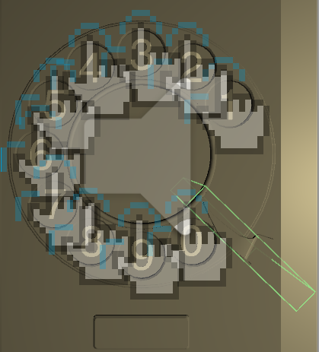

An object to add collider for the phone’s stop (the green box).

Change its size will change the collision area. Please be sure that this collider will not overlay any phone number’s collider.

1. 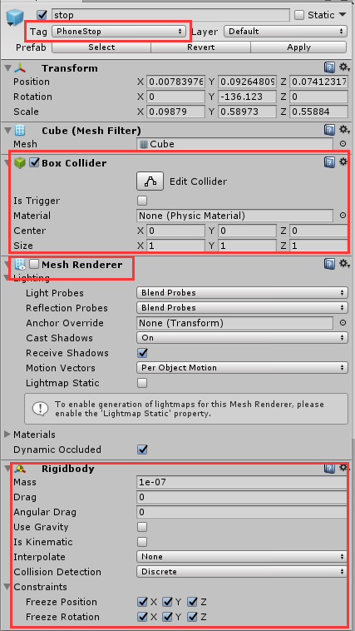Set Tag as “PhoneStop”

To help scripts to find this gameobject through tag.

1. Add a Box Collider

To use gestures, object must have a collider.

1. Disable the Mesh Renderer

Not showing collider objects in the scene.

1. Add a Rigidbody

OntriggerEnter() requires object to have a rigidbody.

Disable “Use Gravity”

Set Constraints as:

Freeze Position: X Y Z

Freeze Rotation: X Y Z

Make sure the object won’t move.

1. Phone Wheel

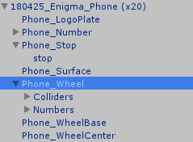

Contains most of the main functions of the phone.

It has two parts for sub-objects: Colliders and Numbers. They will be introduced in the following section.

1. 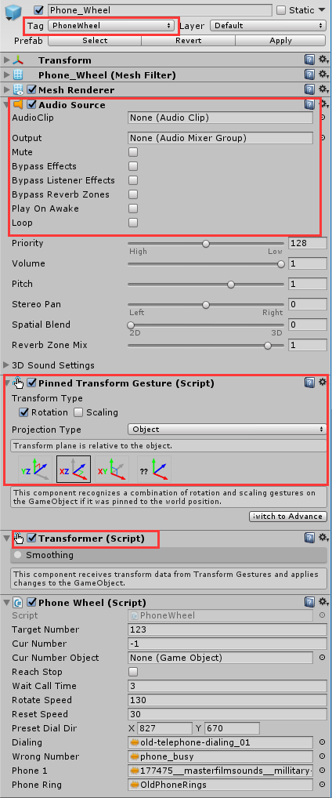Set Tag as “PhoneWheel”

To help scripts to find this gameobject through tag.

1. Add AudioSource Component

No need to set the AudioClip at here. The script will set audio clips.

Disable “Play On Awake”

1. Add Pinned Transform Gesture

Check the Rotation

Set Projection Type as “Object”

Choose XZ-axis

1. Add Transformer

Component that helps to move the object.

1. The script part will be explained in the following section.
2. Colliders

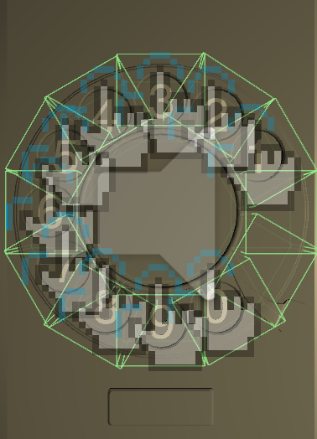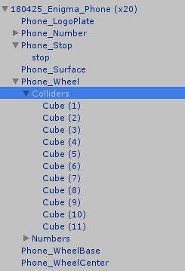

A set of object to make a ring-shape collider for the Phone_Wheel

To use the gestures, object must have a collider. Since Unity cannot generate a ring-shape collider, we have to use small cubes to make the collider by ourselves.

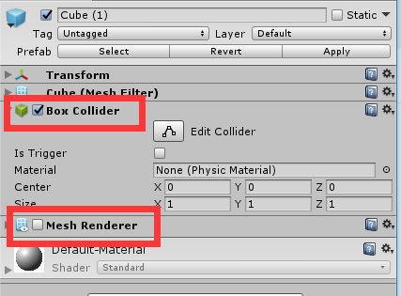

Each of them is a simple cube object which enable the Box Collider but disable the Mesh Renderer.

1. Numbers

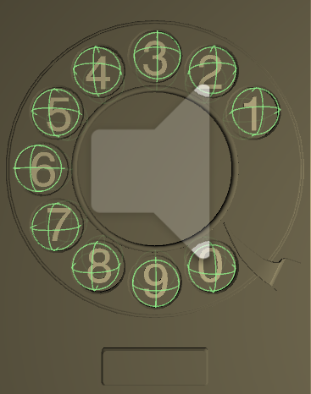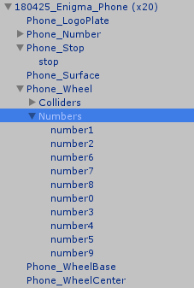

A set of objects for different numbers.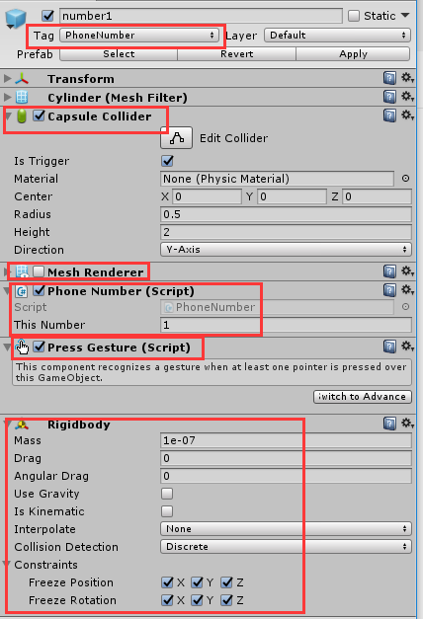

1. Set Tag as “PhoneNumber”

Help scripts to find this gameobject through tag.

1. Add a Capsule Collider

To use gestures, object must have a collider.

1. Disable the Mesh Renderer

No need to show these objects in the scene.

1. Add Phone Number

Enter the number for this phone button in “This Number”

1. Add Press Gesture
2. Add Rigidbody

OntriggerEnter() requires object to have a rigidbody.

Disable “Use Gravity”

Set Constraints as:

Freeze Position: X Y Z

Freeze Rotation: X Y Z

Prevent object from moving around.

1. Phone Wheel Script

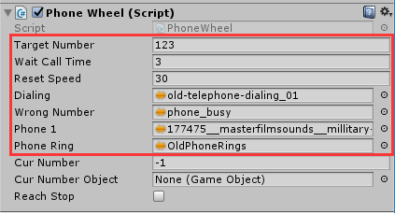

Developers should only customized the variables inside the rectangle.

1. Target Number

Set the right phone number.

Generally should be changed through the facilitator’s App.

1. Wait Call Time (in second)

If the player has dialed any number, and then stop dialing. After this amount of time’s waiting, the program will check whether the current number matches the target number. If true, then play the recording. If not, then play the error sound.

1. Reset Speed

The speed of the phone wheel rotating to reset itself.

1. Dialing

Sound effect for the phone wheel rotating.

1. Wrong Number

Sound clip for the error sound (Players dial a wrong number).

1. Phone 1

The sound clip for the right phone call (Players dial a right number).

1. Phone Ring

Sound clip for the phone ring.