1. Overview
2. 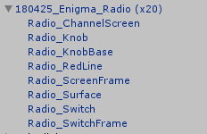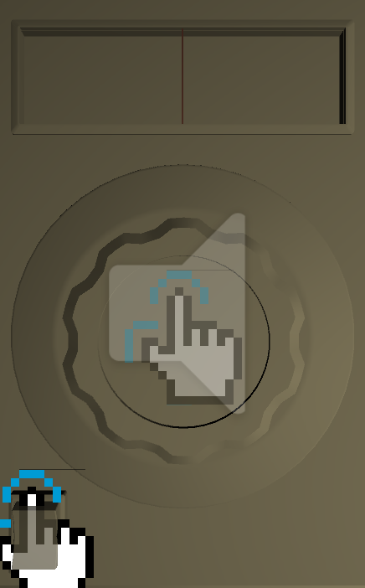Red Line

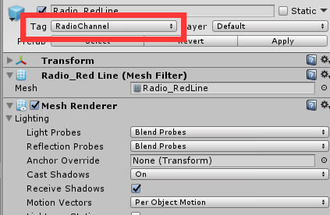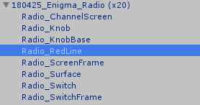

1. Set the Tag as “RadioChannel”

To help scripts to find this gameobject through tag.

1. 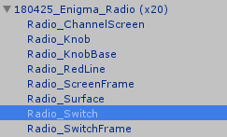Switch

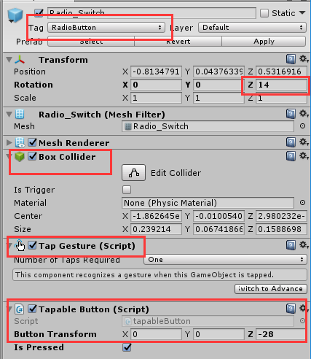

1. Set Tag as “RadioButton”

To help scripts to find this gameobject through tag.

1. The default transformation ( When the radio is off)
2. Add a box collider

To use gestures, object must have a collider.

1. Add a Tap Gesture
2. Add a Tapable Button

When player turn radio on/off. The button’s transformation will change.

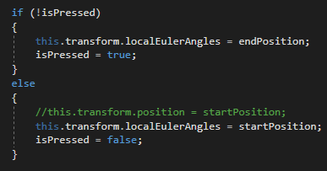

For example:

startPosition is the default transformation

(when Radio is off).

endPosition is the target transformation

(when Radio is on).

endPosition = startPosition + buttonTransformation

1. Knob

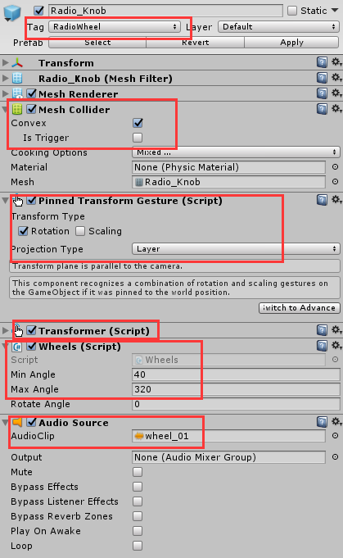

1. 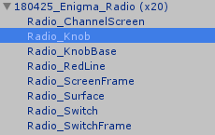Set Tag as “RadioWheel”

Help scripts to find this gameobject through tag.

1. Add a Mesh Collider

Check the Convex

To use gestures, object must have a collider.

1. Add a Pinned Transform Gesture

Select the Rotation

Choose the Projection Type as “Layer”

1. Add a Transformer

Component that helps to move the object.

1. Add a Wheels

Enter the minimum and maximum angles that the knob can go.

1. Add an Audio source for the knob rotating sound effect

To play the sound effect when radio rotating.

Uncheck the “Play On Awake”

1. Radio

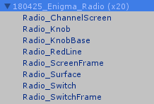

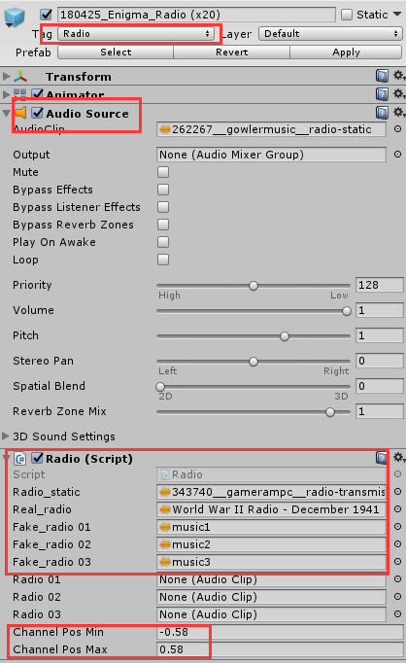

1. Set Tag as “Radio”
2. Help scripts to find this gameobject through tag.
3. Add an Audio Source

No need to set the AudioClip at here. The script will set audio clips.

Uncheck the “Play On Awake”

1. Add the Radio

Static: default sound clip.

Real: clip contains the important information.

Fake(s): clips that are not important.

Radio(s): Containers of current using clips.

Enter the minimum and maximum position of the Red Line.

1. 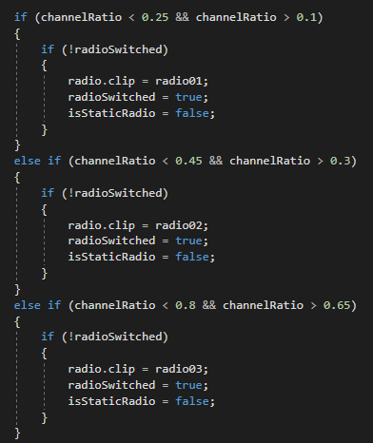The frequencies for radio can be changed at Radio.switchChannel()

channelRatio is the

(wheelRotation - minAngle) / angleDis

WheelRotation is the current angle of the knob.

Minangle is the minimum angle of the knob.

angleDis = maxAngle – minAngle.