1. Manage facilitator scenes sequence

To add/delete/change the sequence of the facilitator scenes, go to **FlowController** – **Flow Controller (Script)** – **Scenes**, enter the desired number of scenes in the **Size** and drag the scenes in sequence into **Element**s.

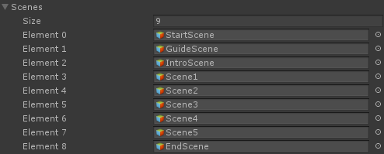

1. Create new facilitator scene

To create a new facilitator scene, open **Assets** - **Prefabs** folder and drag a **DefaultScene** into **FaciCanvas**.

->

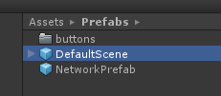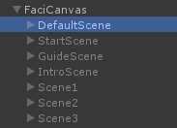

1. Edit the facilitator scene

In default, there are **SceneTitle** and **NextButton** in the scene. You could add buttons by dragging the functional buttons from **Assets** - **Prefabs** – **buttons**. The function of each button would be explained in the latter part.