Phone

1. Overview



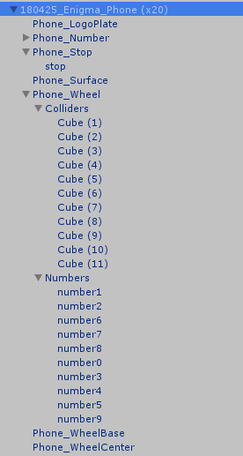

1. Phone Stop

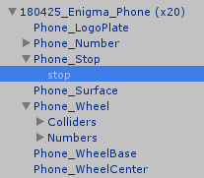

An object to add collider for the phone’s stop.

Change its size will change the collision area.

1. 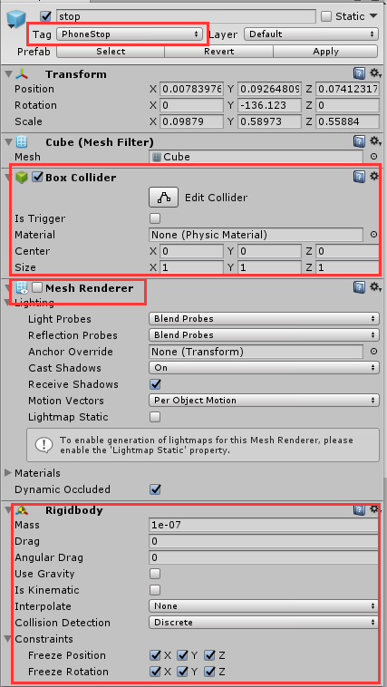Set Tag as “PhoneStop”
2. Add a Box Collider
3. Disable the Mesh Renderer
4. Add a Rigidbody

Disable “Use Gravity”

Set Constraints as:

Freeze Position: X Y Z

Freeze Rotation: X Y Z

1. Phone Wheel

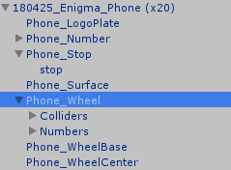

Contains most of the main functions of the phone.

1. 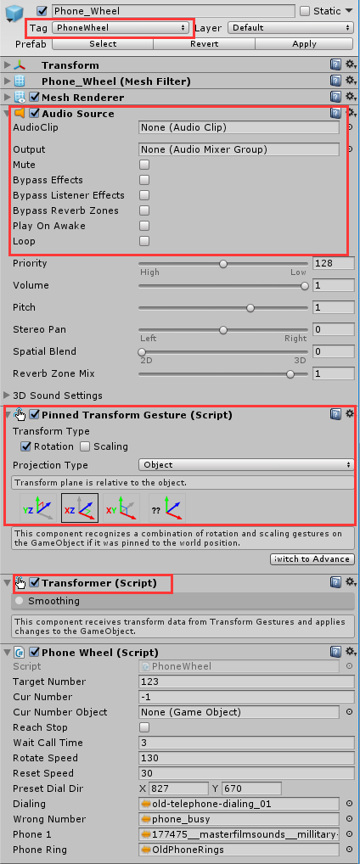Set Tag as “PhoneWheel”
2. Add AudioSource Component

The AudioClip will be set by the script.

Disable “Play On Awake”

Disable “Loop”

1. Add Pinned Transform Gesture

Check the Rotation

Set Projection Type as “Object”

Choose XZ-axis

1. Add Transformer
2. The script part will be explained in the following sction.
3. Colliders

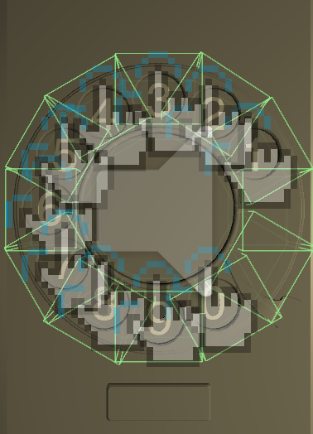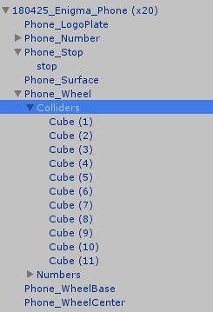

A set of object to make a ring-shape collider for the Phone_Wheel

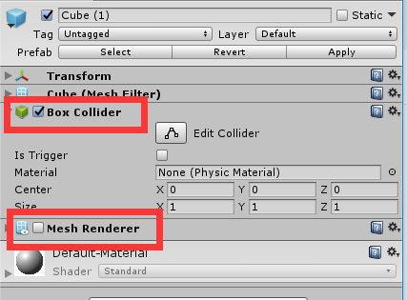

Each of them is a simple cube object which enable the Box Collider but disable the Mesh Renderer.

1. Numbers

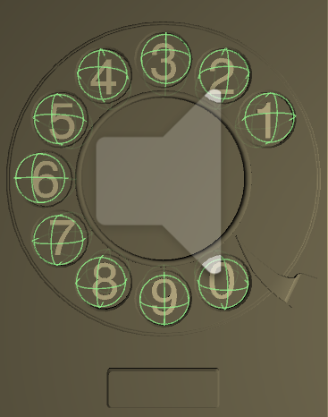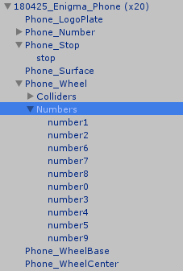

A set of objects for different numbers.

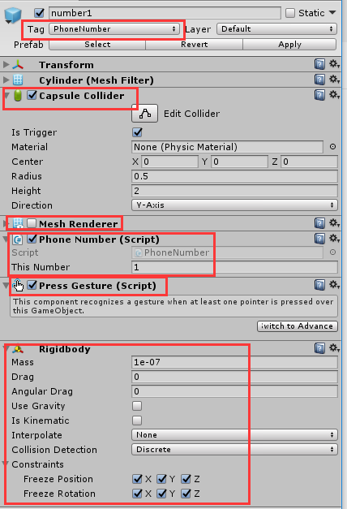

1. Set Tag as “PhoneNumber”
2. Add a Capsule Collider
3. Disable the Mesh Renderer
4. Add Phone Number

Enter the number for this phone button in “This Number”

1. Add Press Gesture
2. Add Rigidbody

Disable “Use Gravity”

Set Constraints as:

Freeze Position: X Y Z

Freeze Rotation: X Y Z

1. Phone Wheel Script

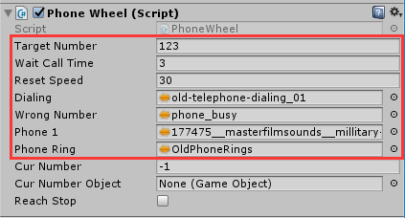

Developers should only customized the variables inside the rectangle.

1. Target Number

Set the right phone number.

Generally should be changed through the facilitator’s App.

1. Wait Call Time (in second)

If the player has dialed any number, and then stop dialing. After this amount of time’s waiting, the program will check whether the current number matches the target number. If true, then play the recording. If not, then play the error sound.