1. Overview
2. 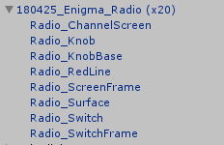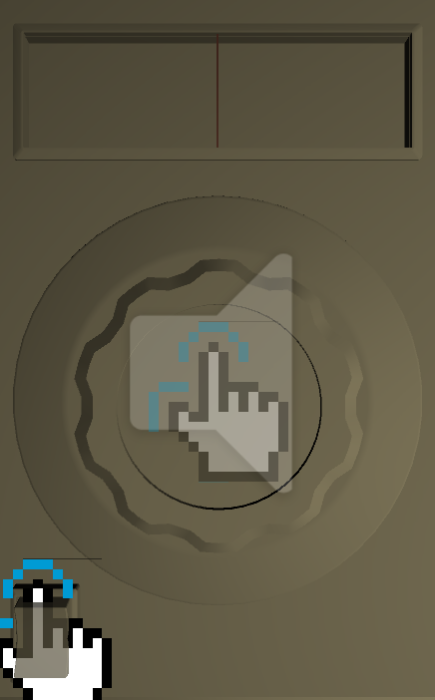Red Line

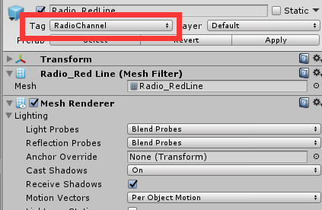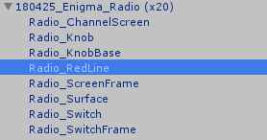

1. Set the Tag as “RadioChannel”
2. Switch

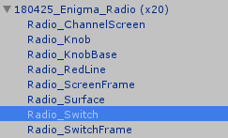

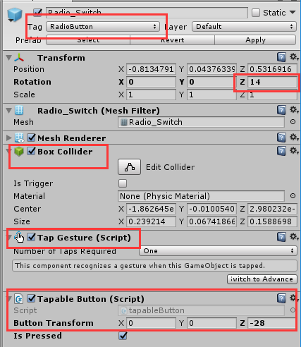

1. Set Tag as “RadioButton”
2. The default transformation ( When the radio is off)
3. Add a box collider
4. Add a Tap Gesture
5. Add a Tapable Button

Set the transformation when tapped.

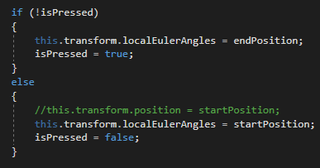

For example:

startPosition is the default transformation

(when Radio is off).

endPosition is the target transformation

(when Radio is on).

endPosition = startPosition + buttonTransformation

1. Knob

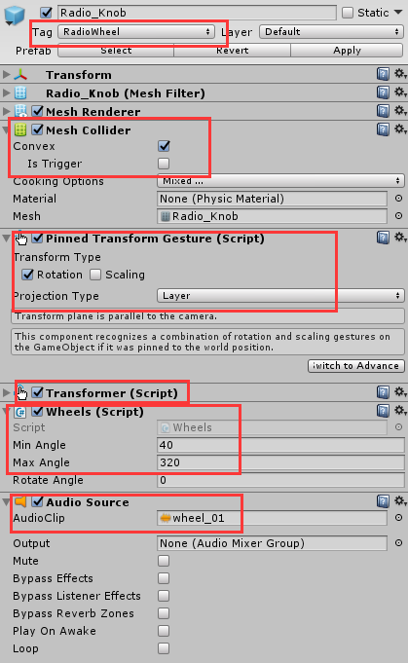

1. 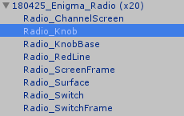Set Tag as “RadioWheel”
2. Add a Mesh Collider

Check the Convex

1. Add a Pinned Transform Gesture

Select the Rotation

Choose the Projection Type as “Layer”

1. Add a Transformer
2. Add a Wheels

Enter the minimum and maximum angles that the knob can go.

1. Add an Audio source for the knob rotating sound effect

Uncheck the “Play On Awake”