1. Can you just extract the day of week and hours they are open.

2. And then all the business info. (Text + Response(Bold)) separately.

3. And the People Might Consider Names (In Blue)

4. And the People Also viewed Names (In Blue)

-> Then I need the script or visual scraper details so that I can do it for other firms.

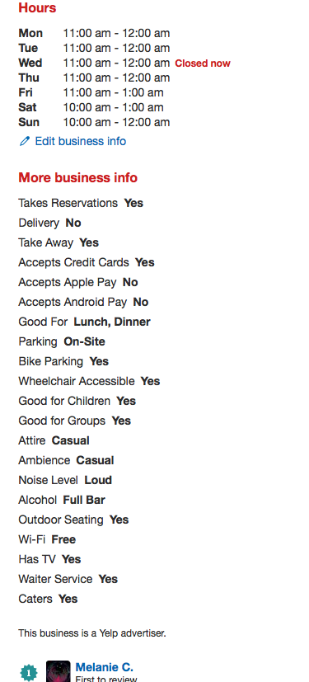

And this:

