FIRST LEVEL

1. *FirstGameScreen()* function

- Display first level screen

- Inherited from *PlayGameScreen()* in screens folder

- Including *on_key_down()* is an event handler function on the screen

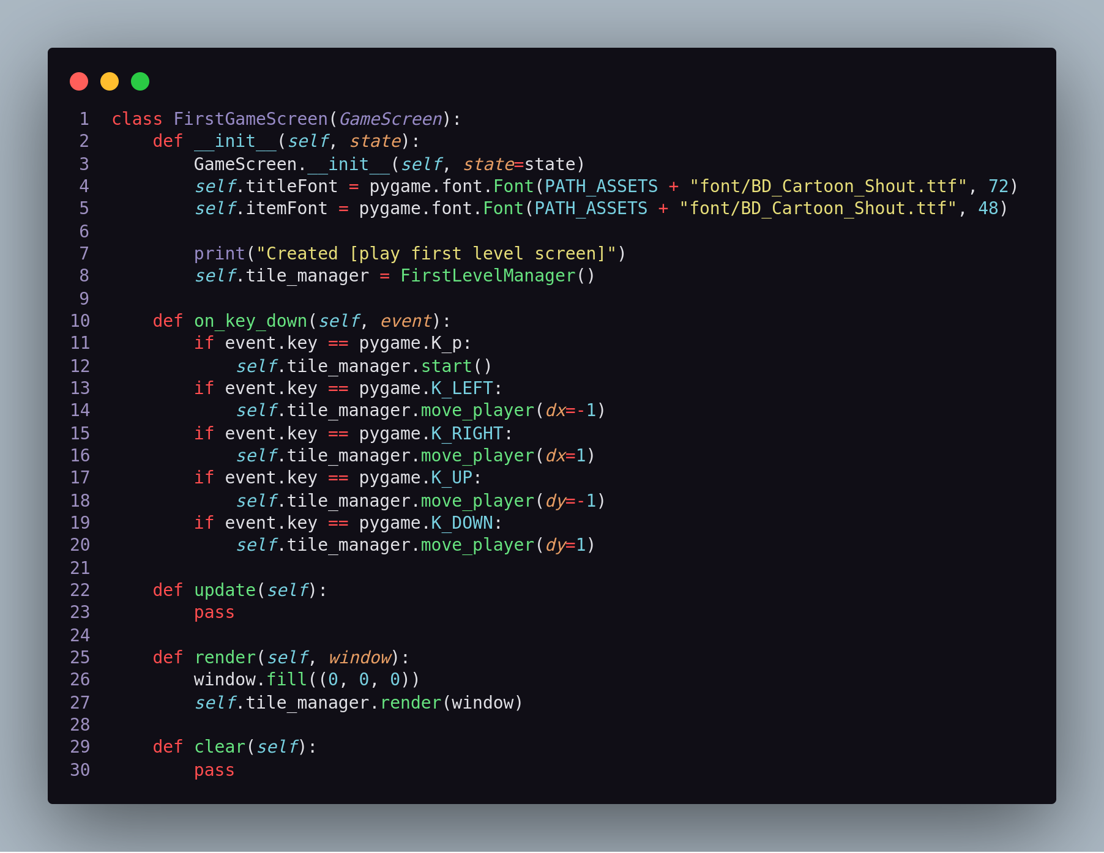

2. FirstLevelManager()

- Inherited TileManager() in cores folder

- In additions, it implements function display result screen including “GAME OVER” and scores that user archived when the game ends

- Variable *finished == True* → end game

* *game_over* → state of the game when ends
* *score* → stored the scores that user archived

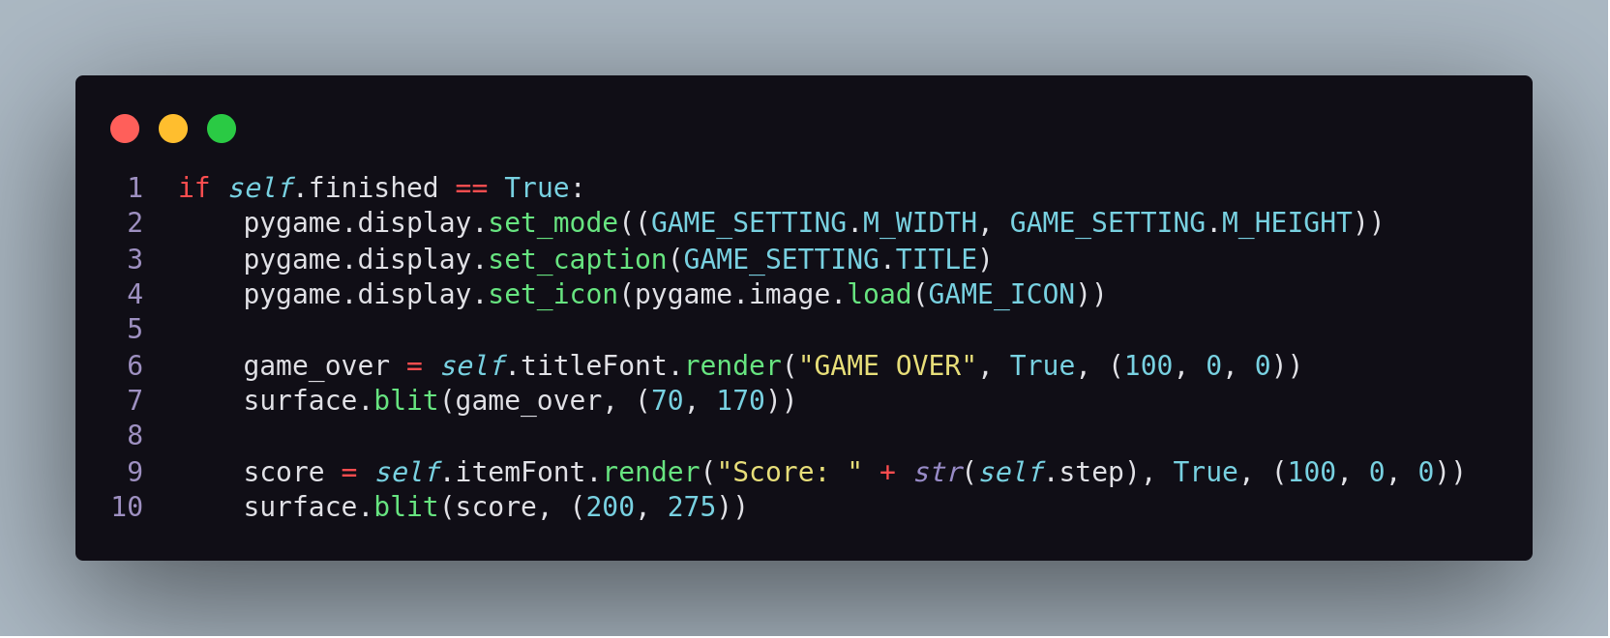

3. Test cases

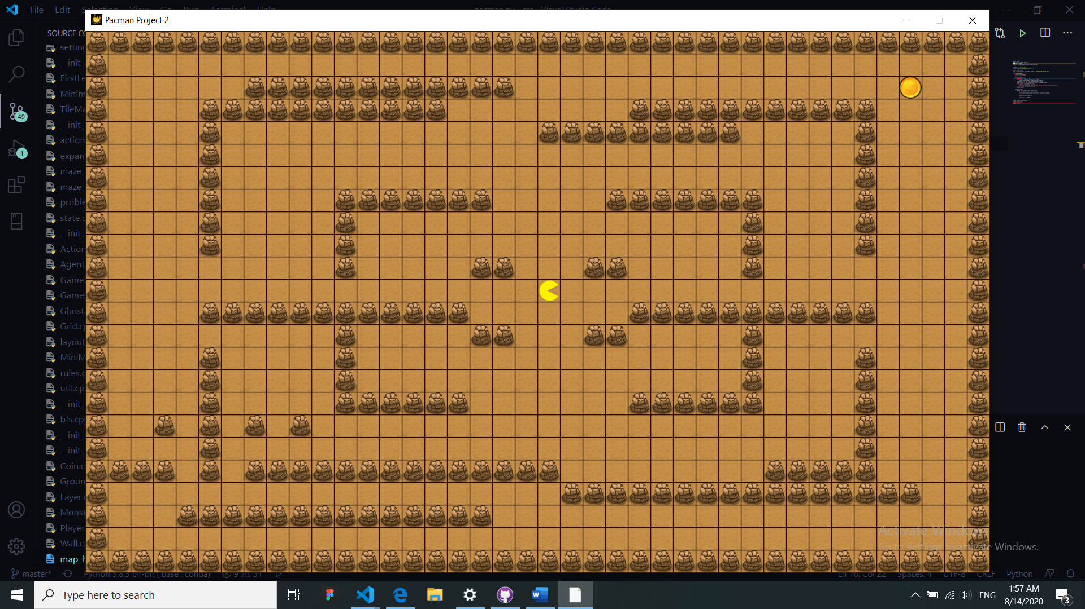*Case 1*