module three, part FOUR: panel data analysis
in Economic Education research using sas

Part Four of Module Three provides a cookbook-type demonstration of the steps required to use SAS in panel data analysis. Users of this model need to have completed Module One, Parts One and Four, and Module Three, Part One. That is, from Module One users are assumed to know how to get data into SAS, recode and create variables within SAS, and run and interpret regression results. They are also expected to know how to test linear restrictions on sets of coefficients as done in Module One, Parts One and Two. Module Three, Parts Two and Three demonstrate in LIMDEP and STATA what is done here in SAS.

THE CASE

As described in Module Three, Part One, Becker, Greene and Siegfried (2009) examine the extent to which undergraduate degrees (BA and BS) in economics or Ph.D. degrees (PhD) in economics drive faculty size at those U.S. institutions that offer only a bachelor degree and those that offer both bachelor degrees and PhDs. Here we retrace their analysis for the institutions that offer only the bachelor degree. We provide and demonstrate the SAS code necessary to duplicate their results.

DATA FILE

The following panel data are provided in the comma separated values (CSV) text file “bachelors.csv”, which will automatically open in EXCEL by simply double clicking on it after it has been downloaded to your hard drive. Your EXCEL spreadsheet should look like this:

“College” identifies the bachelor degree-granting institution by a number 1 through 18.

“Year” runs from 1996 through 2006.

“Degrees” is the number of BS or BA degrees awarded in each year by each college.

“DegreBar” is the average number of degrees awarded by each college for the 16-year period.

“Public” equals 1 if the institution is a public college and 2 if it is a private college.

“Faculty” is the number of tenured or tenure-track economics department faculty members.

“Bschol” equals 1 if the college has a business program and 0 if not.

“T” is the time trend running from −7 to 8, corresponding to years from 1996 through 2006.

“MA_Deg” is a three-year moving average of degrees (unknown for the first two years).

College | Year | Degrees | DegreBar | Public | Faculty | Bschol | T | MA_Deg
1 | 1991 | 50 | 47.375 | 2 | 11 | 1 | -7 | 0
1 | 1992 | 32 | 47.375 | 2 | 8 | 1 | -6 | 0
1 | 1993 | 31 | 47.375 | 2 | 10 | 1 | -5 | 37.667
1 | 1994 | 35 | 47.375 | 2 | 9 | 1 | -4 | 32.667
↓ | ↓ | ↓ | ↓ | ↓ | ↓ | ↓ |  | ↓
1 | 2003 | 57 | 47.375 | 2 | 7 | 1 | 5 | 56
1 | 2004 | 57 | 47.375 | 2 | 10 | 1 | 6 | 55.667
1 | 2005 | 57 | 47.375 | 2 | 10 | 1 | 7 | 57
1 | 2006 | 51 | 47.375 | 2 | 10 | 1 | 8 | 55
2 | 1991 | 16 | 8.125 | 2 | 3 | 1 | -7 | 0
2 | 1992 | 14 | 8.125 | 2 | 3 | 1 | -6 | 0
2 | 1993 | 10 | 8.125 | 2 | 3 | 1 | -5 | 13.333
↓ | ↓ | ↓ | ↓ | ↓ | ↓ | ↓ |  | ↓
2 | 2004 | 10 | 8.125 | 2 | 3 | 1 | 6 | 12.667
2 | 2005 | 7 | 8.125 | 2 | 3 | 1 | 7 | 11.333
2 | 2006 | 6 | 8.125 | 2 | 3 | 1 | 8 | 7.667
3 | 1991 | 40 | 35.5 | 2 | 8 | 1 | -7 | 0
3 | 1992 | 31 | 37.125 | 2 | 8 | 1 | -6 | 0
↓ | ↓ | ↓ | ↓ | ↓ | ↓ | ↓ |  | ↓
17 | 2004 | 64 | 39.3125 | 2 | 5 | 0 | 6 | 54.667
17 | 2005 | 37 | 39.3125 | 2 | 4 | 0 | 7 | 51.333
17 | 2006 | 53 | 39.3125 | 2 | 4 | 0 | 8 | 51.333
18 | 1991 | 14 | 8.4375 | 2 | 4 | 0 | -7 | 0
18 | 1992 | 10 | 8.4375 | 2 | 4 | 0 | -6 | 0
18 | 1993 | 10 | 8.4375 | 2 | 4 | 0 | -5 | 11.333
18 | 1994 | 7 | 8.4375 | 2 | 3.5 | 0 | -4 | 9
↓ | ↓ | ↓ | ↓ | ↓ | ↓ | ↓ |  | ↓
18 | 2005 | 4 | 8.4375 | 2 | 2.5 | 0 | 7 | 7.333
18 | 2006 | 7 | 8.4375 | 2 | 3 | 0 | 8 | 6

If you opened this CSV file in a word processor or text editing program, it would show that each of the 289 lines (including the headers) corresponds to a row in the EXCEL table, but variable values would be separated by commas and not appear neatly one on top of the other as in EXCEL.

As discussed in Module One, Part Two, SAS has a data matrix default restriction. This data set is sufficiently small, so there is no need to adjust the size of the matrix. We could write a “READ” command to bring this text data file into SAS similar to Module 1, Part 4, but like EXCEL, it can be imported into SAS directly by using the import wizard.

To import the data into SAS, click on ‘File’ at the top left corner of your screen in SAS, and then click ‘Import Data’.

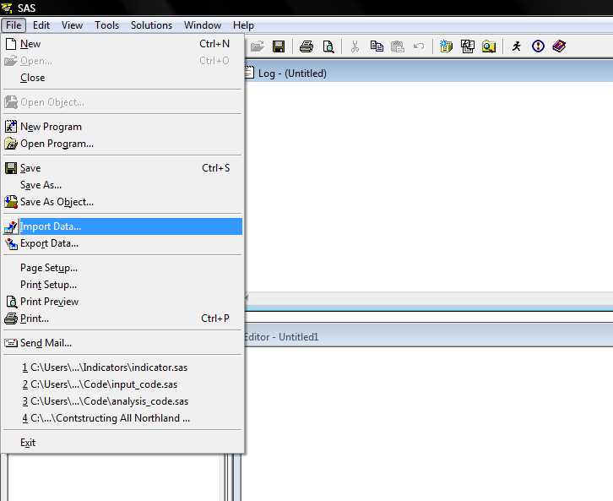

This will initialize the Import Wizard pop-up screen. Since the data is comma separated values, scroll down under the ‘Select data source below.’ tab and click on ‘Comma Separated Values (*.csv)’ as shown below.

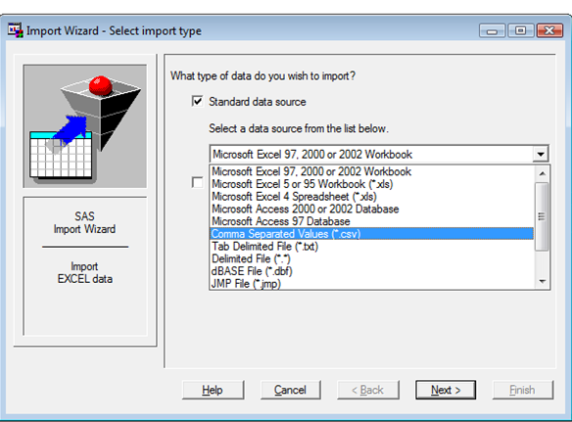

Click ‘Next’, and then provide the location from which the file bachelor.cvs can be located wherever it is stored (in our case in “e:\bachelor.csv”).

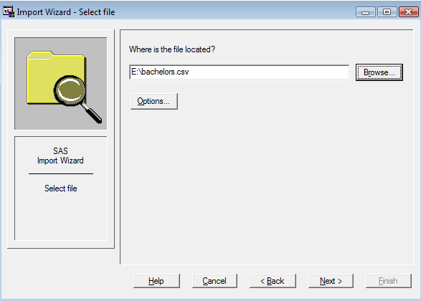

To finish importing the data, click ‘Next’, and then name the dataset, known as a member in SAS, to be stored in the temporary library called ‘WORK’. Recall that a library is simply a folder to store datasets and output. I named the file ‘BACHELORS’ as seen below. Hitting the Finish button will bring the data set into SAS.
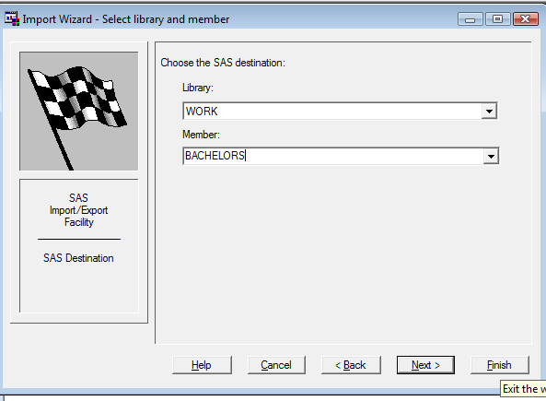

To verify that the wizard imported the data correct, review the Log file and physically inspect the dataset. When SAS is opened, the default panels are the ‘Log’ window at the top right, the ‘Editor’ window in the bottom right and the ‘Explorer/Results’ window on the left. Scrolling through the Log reveals that the dataset was successfully imported. The details of the data step procedure are provided along with a few summary statistics of how many observations and variables were imported.

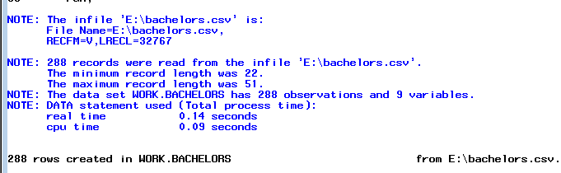

To view the dataset, click on the “Libraries” folder, which is in the top left of the ‘Explorer’ panel, and then click on the ‘Work’ library. This reveals all of the members in the ‘Work’ library. In this case, the only member is the dataset ‘Bachelors’. To view the dataset, click on the dataset icon ‘Bachelors’.

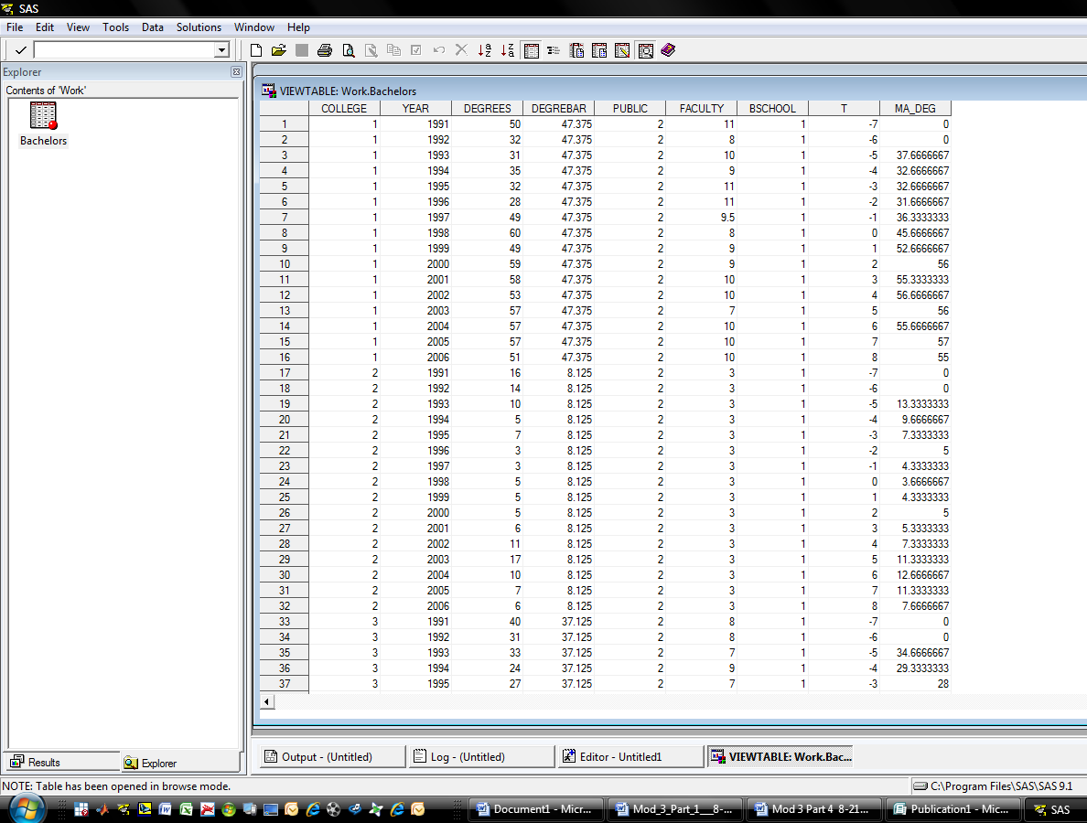

In addition to a visual inspection of the data, we use the “means” command to check the descriptive statistics. Since we don’t list any variables in the command, by default, SAS runs the ‘means’ command on all variables in the dataset. First, however, we need to remove the two years (1991 and 1992) for which no data are available for the degree moving average measure. Since we may need the full dataset later, it is good practice to delete the observations off of a copy of the dataset (called bachelors2). This is done in a data step using an ‘if then’ command.

data bachelors2;
set bachelors;
if year = 1991 then delete;
if year = 1992 then delete;
run;

PROC MEANS DATA=bachelors2;
RUN;

Typing the following commands into the ‘Editor’ window and then clicking the run bottom (recall this is the running man at the top) yields the following screen.

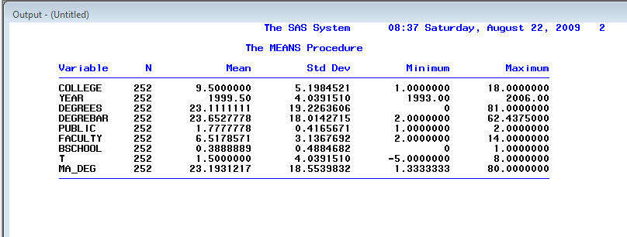

constant coefficient REGRESSION

The constant coefficient panel data model for the faculty size data-generating process for bachelor degree-granting undergraduate departments is given by

Faculty size_{it} = β₁ + β₂T_{t} + β₃BA&S_{it} + β₄MEANBA&S_{i} + β₅PUBLIC_{i}
+ β₆Bschl + β₇MA_Deg_{it} + ε_{it}

where the error term ε_{it} is independent and identically distributed (iid) across institutions and over time and E(ε_{it}²|x_{it}) = σ² , for I = 18 colleges and T = 14 years (−5 through 8) for 252 complete records. To take into account clustering, include the cluster option with the cluster being on the colleges. The SAS OLS regression command that needs to be entered into the editor, including the standard error adjustment for clustering is

proc surveyreg data=bachelors2;
cluster college;
model faculty = t degrees degrebar public bschool ma_deg;
run;

Upon highlighting and hitting the “run” button, the Output panel shows the following results

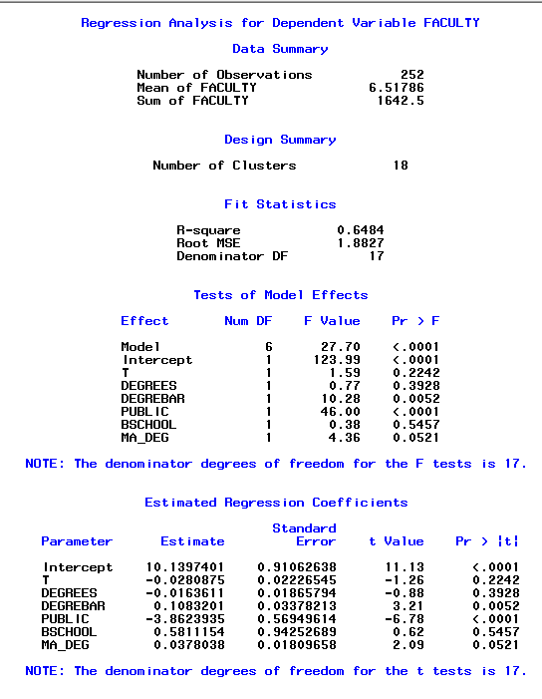

Contemporaneous degrees have little to do with current faculty size but both overall number of degrees awarded (the school means) and the moving average of degrees (MA_DEG) have significant effects. It takes an increase of 26 or 27 bachelor degrees in the moving average to expect just one more faculty position. Whether it is a public or a private college is highly significant. Moving from a public to a private college lowers predicted faculty size by nearly four members for otherwise comparable institutions. There is an insignificant erosion of tenured and tenure-track faculty size over time. Finally, while economics departments in colleges with a business school tend to have a larger permanent faculty, ceteris paribus, the effect is small and insignificant.

fixed-effects REGRESSION

The fixed-effects model requires either the insertion of 17 (0,1) covariates to capture the unique effect of each of the 18 colleges (where each of the 17 dummy coefficients are measured relative to the constant term) or the insertion of 18 dummy variables with no constant term in the OLS regression. In addition, no time invariant variables can be included because they would be perfectly correlated with the respective college dummies. Thus, the overall mean number of degrees, the public or private dummy, and business school dummy cannot be included as regressors.
The SAS code to be run from the editor window, including the commands to create the dummy variables is:

data bachelors2;
set bachelors2;

col1 = 0; col2 = 0; col3 = 0; col4 = 0; col5=0; col6=0;
col7 = 0; col8 = 0; col9 = 0; col10 = 0; col11 = 0; col12 = 0;
col13 = 0; col14 =0; col15 = 0; col16 = 0; col17 = 0; col18 = 0;

if college = 1 then col1=1; if college = 2 then col2=1;
if college = 3 then col3=1; if college = 4 then col4=1;
if college = 5 then col5=1; if college = 6 then col6=1;
if college = 7 then col7=1; if college = 8 then col8=1;
if college = 9 then col9=1; if college = 10 then col10=1;
if college = 11 then col11=1; if college = 12 then col12=1;
if college = 13 then col13=1; if college = 14 then col14=1;
if college = 15 then col15=1; if college = 16 then col16=1;
if college = 17 then col17=1; if college = 18 then col18=1;

run;

proc surveyreg data=bachelors2;
cluster college;
model faculty = t degrees ma_deg col1 col2 col3 col4 col5
col6 col7 col8 col9 col10 col11 col12
col13 col14 col15 col16 col17;
quit;

The resulting regression information appearing in the output window is

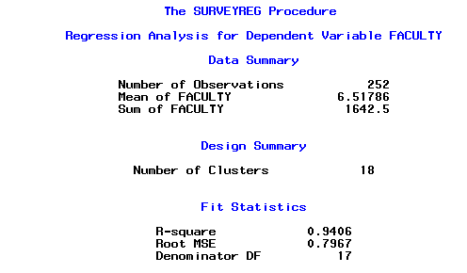

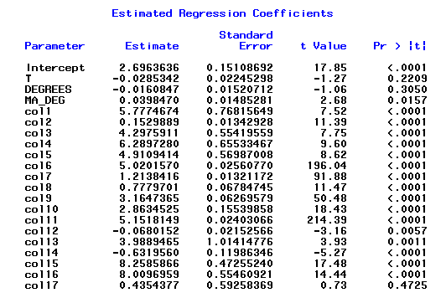

Once again, contemporaneous degrees is not a driving force in faculty size. An F test is not needed to assess if at least one of the 17 colleges differ from college 18. With the exception of college 17, each of the other colleges are significantly different. The moving average of degrees is again significant.

random-effects REGRESSION

Finally, consider the random-effects model in which we employ Mundlak’s (1978) approach to estimating panel data. The Mundlak model posits that the fixed effects in the equation, β_{1i} , can be projected upon the group means of the time-varying variables, so that

β_{1i} = β₁ + δ′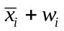

where is the set of group (school) means of the time-varying variables and w_{i} is a (now) random effect that is uncorrelated with the variables and disturbances in the model. Logically, adding the means to the equations picks up the correlation between the school effects and the other variables. We could not incorporate the mean number of degrees awarded in the fixed-effects model (because it was time invariant) but this variable plays a critical role in the Mundlak approach to panel data modeling and estimation.

The random effects model for BA and BS degree-granting undergraduate departments is

Faculty size_{it} = β₁ + β₂YEAR_{t} + β₃BA&S_{it} + β₄MEANBA&S_{i} + β₅MOVAVBA&BS
+ β₆PUBLIC_{i} + β₇Bschl + ε_{it} + u_{i}

where error term ε is iid over time, E(ε_{it}²|x_{it}) = σ² for I = 18 and T_{i} = 14 and E[u_{i}²] = θ² for I = 18.

In SAS 9.1, there are no straightforward procedures to estimate this model. In the appendix, I do provide a lengthy procedure that estimates the random effects model by OLS regression on a transformed model. This is quite complex and is not recommended for beginners. See Cameron and Trivedi (2005) for further details. SAS 9.2 has a new command called the PANEL procedure to estimate panel data. For our model, we need to attach the / RANONE option to specify that a one-way random-effects model be estimated. We also need to correct for the clustering of the data. Unlike simple commands in LIMPDEP and STATA, SAS does not have an option for one-way random effects with clustered errors.

This new SAS 9.2 procedure has more options for specific error term structures in panel data. Although SAS does not allow the CLUSTER option, there is a VCOMP option that specifies the type of variance component estimate to use. For balanced data, the default is VCOMP=FB. However, the FB method does not always obtain nonnegative estimates for the cross section (or group) variance. In the case of a negative estimate, a warning is printed and the estimate is set to zero. Because we have to address clustering, WK option is specified, which is close to groupwise heteroscedastic regression.

The SAS code to be run from the Editor panel (with 1991 and 1992 data suppressed) is

PROC SORT DATA=bachelors2;
BY college year;

PROC panel DATA=bachelors2;
ID college year;
MODEL faculty = t degrees degrebar public bschool MA_deg /RANONE VCOMP=WK;
RUN;

The resulting regression information appearing in the output window is

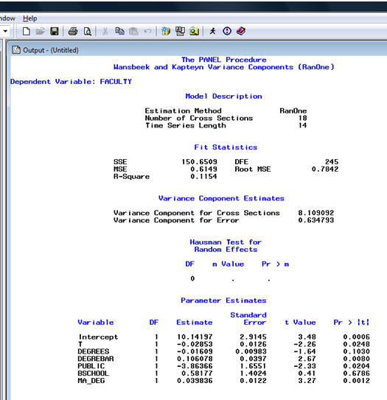

The marginal effect of an additional economics major is again insignificant but slightly negative within the sample. Both the short-term moving average number and long-term average number of bachelor degrees are significant. A long-term increase of about 10 students earning degrees in economics is required to predict that one more tenured or tenure-track faculty member is in a department. Ceteris paribus, economics departments at private institutions are smaller than comparable departments at public schools by a large and significant number of four members. Whether there is a business school present is insignificant. There is no meaningful trend in faculty size.

It should be clear that this regression is NOT identical to similar one-way random effect models controlling for clustering in LIMDEP or STATA. The standard errors are adjusted for a general groupwise heteroscedastic error structure. The difference does not alter the significance and the standard errors are, for the most part, very comparable.

Concluding Remarks

The goal of this hands-on component of this third of four modules is to enable economic education researchers to make use of panel data for the estimation of constant coefficient, fixed-effects and random-effects panel data models in SAS. It was not intended to explain all of the statistical and econometric nuances associated with panel data analysis. For this an intermediate level econometrics textbook (such as Jeffrey Wooldridge, Introductory Econometrics) or advanced econometrics textbook (such as William Greene, Econometric Analysis) should be consulted.

Appendix: Alternative Means to Estimate Random-Effects Model with Clustered Data.

The following code provides a necessary code to estimate the random-effect models with clustering. The estimation procedure is two-step feasible GLS. In the first step, the variance matrix is estimated. In the second step, this variance matrix is used to transform the equation.

Because the variance matrix is estimated and not the true variance, this causes the standard errors to be slight different than the standard errors provided by LIMPDEP or STATA when estimating a random effects model with clustering.

The code to be run in the editor window is:

/* get SSE and SSU */

proc sort data= bachelors2;
by college year; quit;

proc tscsreg data=bachelors2 outest=covvc;
id college year;
model faculty = t degrees degrebar public bschool MA_deg / ranone;
quit;

/* find number of years */

data numobs (keep = year);
set bachelors2;
run;

proc sort nodupkey;
by year;
quit;

proc means data = numobs
max;
output out = num;
quit;

/* create lamda */
proc iml;
use covvc;
read all var {_VARERR_ _VARCS_} into x;
use num;
read var {_freq_} into y;
print y;
sesq = x[1,1];
susq = x[1,2];
lamda = 1 - sqrt( sesq / (y[1,1]*susq + sesq) );
print x y lamda;
cname = {"lamda"};
create out from lamda [ colname=cname];
append from lamda;
quit;

/* find averages of each variable grouped by college #*/
proc MEANS NOPRINT
data=bachelors2;
class college;
output out=stats
mean= avg_year avg_degrees avg_degrebar avg_public avg_faculty avg_bschool avg_t avg_ma_deg;
run;

data bachelors3 (drop = _type_ _freq_);
merge bachelors2 stats;
by college;
if _type_ = 0 then delete;
one = 1;
run;

DATA bachelors4;
if _N_ = 1 then set out;
SET bachelors3;
l = one*lamda;
run;

/* transform data */
data clean (keep = college con nfaculty nt ndegrees ndegrebar npublic nbschool nMA_deg year);
set bachelors4;
nfaculty = faculty - lamda*avg_faculty;
nt = t - lamda*avg_t;
ndegrees = degrees - lamda*avg_degrees ;
ndegrebar = degrebar - lamda*avg_degrebar;
npublic = public - lamda*avg_public;
nbschool = bschool - lamda*avg_bschool;
nMA_deg = ma_deg - lamda*avg_ma_deg;
con = 1 - lamda*1;
run;

/* run regression on transformed equation assuming clustering */
/* Since intercept is included in transformed equation, use noint option*/

proc surveyreg data=clean;
cluster college;
model nfaculty = con nt ndegrees ndegrebar npublic nbschool nMA_deg / noint;
quit;

The output for this regression is:

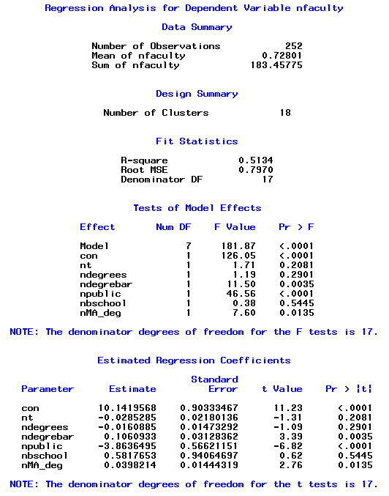

The standard errors associated with this regression are much closer to the standard errors from LIMPDEP and STATA. However, this is a complex sequence of codes which should not be attempted by beginners.

References

Becker, William, William Greene and John Siegfried (2009). “Does Teaching Load Affect Faculty Size? ” Working Paper (July).
Cameron, Colin and Pravin Trivedi (2005). Microeconometrics. 1st Edition, New York, Cambridge University Press.

Mundlak, Yair (1978). "On the Pooling of Time Series and Cross Section Data," Econometrica. Vol. 46. No. 1 (January): 69-85.

Greene, William (2008). Econometric Analysis. 6th Edition, New Jersey: Prentice Hall.

Wooldridge, Jeffrey (2009). Introductory Econometrics. 4th Edition, Mason OH: South-Western.

