QR Contacts

Tyler Thrailkill

October 9, 2012

CSCI498A: Mobile Device Programming

Fall 2012

Colorado School of Mines

Contents

Application Definition 2

Use Cases 3

Use Case Scenarios 3

Use Case Diagram: 3

Use Case Stories: 4

Use Case 1: Sabrina needs to give people her number faster 4

Use Case 2: Kyle doesn’t have time to hand out phone numbers 4

Use Case 3: Frank has trouble typing 4

Domain Classes 5

Screen Specification 5

# Application Definition

Smartphone users are in many ways impatient. They do not like clumsy ways of doing things. QR Contacts solves the clumsiness of trading contact info by transforming that text into a scannable code for quick transfer between phones, removing the clumsiness and slowness of typing contacts in manually. The story that follows demonstrates this ability:

Bob the Tomato meets a fellow financial advisor, Larry, during a business conference. He chats for a while with Larry until the main speaker for the conference calls the room to attention. Bob checks his pockets for a business card, but alas, he has forgotten them in his room. Larry checks his pockets too, no dice. Bob pulls out his phone because he's recently downloaded QR Contacts, an Android app that takes contacts and turns them into QR codes. He pops open the app, clicks one button and displays his contact information as an impromptu QR business card. Larry also has downloaded this app recently, hearing many great reviews of it on Engadget, Ars Technica, and many news networks. He pulls out his phone and pops open QR Contacts, opens the scanner function with one press of a button, and scans the QR code on Bob's screen. Immediately Bob's contact information is imported into Larry's contacts. In case Larry forgets later where he met Bob or even who Bob is, the location, date, and time are saved within the QR Contacts app searchable by Name, Date, and other parameters so that Larry can always figure out who Bob is later. Larry can now focus on the presentation at hand instead of trying to remember Bob the Tomato and his hilariously generic name.

Milestone 1:

Hurried or lazy people are able to create a QR Code with their contact information with the click of a single button.

Future Milestones:

These lazy people are able to choose between scanning or creating a QR Code. If creating, the lazy person will be able to select a contact, either their own or from their contact list, in order to share. They will also be able to share these codes via email or another messaging system, for those that do not already have the QR Contacts app.

The application might also be able to have a single widget on the homescreen for instant QR codes of a chosen contact.

# Use Cases

## Use Case Scenarios

These use cases define the absolute basic functionality of the system, transforming contacts into QR codes for easy transfer.

In these use cases, the actor is referred to as either a lazy person (because who wants to type stuff in) instead of User, even though User is just as appropriate, as long as the User owns a smartphone.

In order of priority:

1: Lazy person creates a QR code with their own information

2: Lazy person creates a QR code from a contact

3: Lazy person receives a QR code from camera

4: Lazy person saves contact from QR code

## Use Case Diagram:

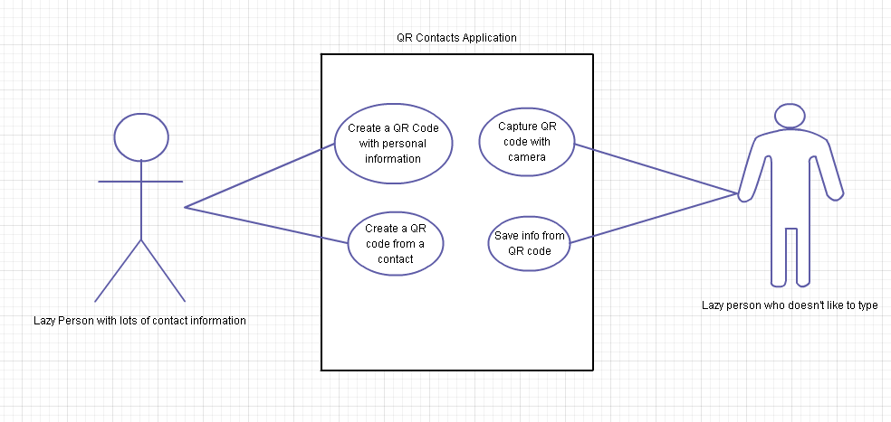

## Use Case Stories:

### Use Case 1: Sabrina needs to give people her number faster

Sabrina, almost not a teen, but still a teen and definitely not a witch, is a humble Mines student who only has time for homework and not for giving her number out to people. She’s an extremely popular person and as a result has a lot of people asking for her phone number on a daily basis. Sabrina finally gets fed up with being late for meetings, events, and classes because she spends all her time giving out phone numbers. She decides to look for a solution to this horrible, horrible problem. She searches and searches using the wonderful magician Google. She stumbles upon an Android app called QR Contacts. Using QR Contacts she can save her contact data into a single QR code that she can access at the touch of a button. Literally! The app allows for placing an icon on the homescreen to immediately display her contact data so that she can get back to doing her homework and making it to places on time. Then anyone who wants her number and contact information can just scan a picture of the QR code on her phone using their own QR code reader or the QR Contacts app itself.

### Use Case 2: Kyle doesn’t have time to hand out phone numbers

Kyle is a less important student at Mines with a lot more time on his hands, yet still he gets annoyed about giving numbers to people. He’s in a fraternity and he has to give out a lot of people’s phone numbers. He finds the QR Contacts app on the Play market and decides he will use it to more easily distribute phone numbers and people’s information. Using the QR Contacts app he can choose anyone’s contact information in his phonebook and turn it into a QR code for easy transfer to other phones. Now he is able to give people contact information more quickly and to also send out contact information in easily (phone) readable QR code format.

### Use Case 3: Frank has trouble typing

Frank is a partially blind business man who has trouble typing on his phone. He likes to use the text-to-voice function and the voice-to-text function because typing on the phone’s screen is difficult for him. So trying to type on his screen and read off contacts from other people’s phones is not easy. He uses QR Contacts so he can scan other people’s contact information and save it to his phonebook without typing anything in.

# Domain Classes

QR Creator The human who is trying to give contact info to another human

Qr Receiver The human who is getting contact information from another human

QR Code The Quick Response code and visual object that is used for transferring information

# Screen Specification

The screens depicted below are to further illustrate the functionality and design of the program.

## Main Screen Create QR Screen

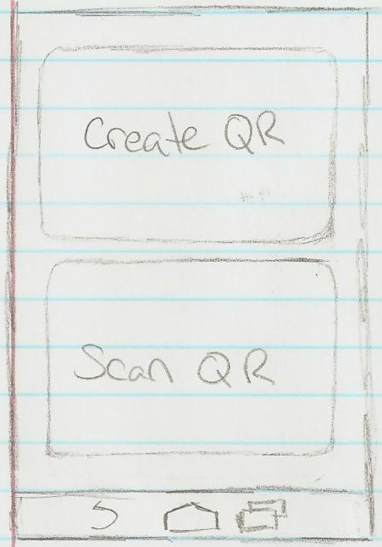 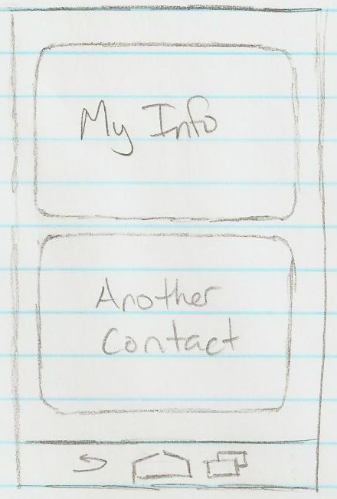

When the user opens to the main screen, he or she is shown only two choices and an options menu (not displayed). The user must then choose their next action from these two options.

When a user opts to create a QR code they are given only two choices, display their own contact info or choose a contact from their phonebook.

## Choose Contact Screen Display QR Screen

This is a simple display of the easy and fast display screen. The name, the QR code, and an easy share button are all made large, so that everything is as easy as possible.

Choosing a contact is as simple as selecting a contact in your actual phone book. The QR Contacts app will open straight to the People app so that a contact can be selected.

Though the Capture QR screen is not displayed, it is understood that it is simply a camera view used to capture the QR code from the real world and transfer it to the application where it can be decoded.