Identification of M1 breast cancer patients who may benefit from local therapy: evidence from SEER database and Chinese cohort based on an explainable machine learning mortality model

Long Jin 1,2, Qifan Zhao 3, Shenbo Fu 4, Zheng Chao 5, Fei Cao 6, Jie Wu 1, Dede Ma 2,7 and Xulong Zhu 2,7
1 Department of Radiation Oncology, Shaanxi Provincial People’s Hospital, Xi’an, China, 2 The Project of Shaanxi Breast Disease Clinical Medical Research Center Xi’an, China, 3 Department of Computer Science, The University of Hong Kong, Hong Kong, China, 4 Department of Radiation Oncology, Shaanxi Provincial Cancer Hospital, Xi’an,China, 5 Department of Medical Imaging Diagnosis,Hanzhong Central Hospital ,Hanzhong ,China 6 Department of Oncology, Shaanxi Provincial People’s Hospital, Xi’an, China, 7 Department of surgical oncology, Shaanxi Provincial People’s Hospital, Xi’an, 710068,China
Correspondence*:
Yuan Zhang legend7262010@hotmail.com

ABSTRACT
Background Local therapy (surgery and/or radiotherapy) plays a critical role in the potentially curative treatment of patients with non-metastatic breast cancer. The necessity of local therapy for M1 breast cancer patients remains controversial.
Objective This study aims to utilize explainable machine learning to evaluate cohort feature importance and identify subgroups that may benefit from local therapy.
Design This was a Cohort study (Prospective and Retrospective Cohort).
Methods Two machine learning survival models—a neural network and a Cox proportional hazards model—were trained and validated in this study. The training cohort comprised 10,214 patients with M1 breast cancer identified from the SEER database between 2013 and 2018. The external test cohort included 100 patients diagnosed with M1 breast cancer in China between January 2013 and December 2018. Subgroup analyses were subsequently performed to identify patients who may benefit from local therapy. Global and individual feature importance analyses were conducted to interpret the survival predictions generated by the models.
Results A total of 10,314 patients were included in this study. We identified that Surgery improved the OS in patients with metastasis at Bone:5-year OS rates of 76.9 versus 27.2% (surgery vs. non-surgery, P = 0.035) and cohort with non-triple-negative, 5-year OS rates of 84. versus 32.3% (surgery vs. non-surgery, P = 0.027).The deep learning network performed more stably and accurately in predicting patients survival than and Cox proportional hazard model on the internal test dataset (C-index=0.771 vs 0.632) and in the external validation(C-index=0.782 vs 0.650).The deep learning model identified several key factors that significantly influence patient survival, including Triple Negative, Mets at DX-brain and HER2-positive.
Conclusion Patients with metastasis at Bone could benefit from Surgery while metastasis at Brain,Lung and Liver does not. Meanwhile,Surgery is beneficial for non-triple negative breast cancer patients.
Keywords: M1 breast cancer; local therapy; machine learning; triple-negative

INTRODUCTION
Breast cancer is the most prevalent malignant tumor globally. According to the latest data from the World Health Organization’s International Agency for Research on Cancer (IARC),there were an estimated 19.29 million new cancer cases worldwide in 2020, with 2.26 million of those cases being breast cancer, making it the most common cancer. Among Chinese women, breast cancer is also the most prevalent malignant tumor. The number of new cases every year is about 416,000, accounting for 18.4% of the global number of breast cancer cases (1). About 6% of newly diagnosed breast cancer patients have already. The presence of distant metastasis is called newly diagnosed stage IV breast cancer (2).
Local therapy (surgery and/or radiotherapy) plays a critical role in the potentially curative treatment of patients with non-metastatic breast cancer. As for newly diagnosed stage IV breast cancer, systemic therapy is the primary treatment approach. However, the role of local therapy remains uncertain. (3, 4). The results of randomized controlled trials are contradictory: the Austrian ABCSG-28/POSYTIVE study
(3) (NCT01015625) shows similar 3-year overall survival in 90 patients, The 2-year survival outcomes are similar in 350 patients of the Indian TMH/153/2004 study (5) (NCT00193778);The Turkish MF07-01 study
(6) (NCT00557986) shows similar 36-month overall survival in 265 patients, with significant improvement in 40-month to 10-year overall survival. In contrast, some research projects draw the opposite conclusion. The multi-center, non-blinded, randomized controlled Phase III clinical trial EA2108 (7), conducted by institutions such as Northwestern University Feinberg School of Medicine’s Comprehensive Cancer Center and Dana-Farber Cancer Institute at Harvard University, enrolled 390 patients with distant metastatic breast cancer and intact primary tumors from February 2011 to July 2015. The patients received systemic therapy for 4-8 months. In this context, local treatment of the primary site is believed to potentially improve overall survival (OS), but the results reported in clinical trials remain controversial. A large retrospective study by Pons-Tostivint et al (8) showed that 4276 patients with stage IV breast cancer who received local therapy combined with systemic therapy had a 35% survival benefit compared with patients who received systemic therapy alone [hazard ratio (HR) =0.6, 95% confidence interval (CI) 0.55 0.76, P<0.01].
These studies suggest that not all patients with newly diagnosed stage IV breast cancer will benefit from local therapy. Thus, there remains ongoing debate regarding which specific subgroup may benefit. A retrospective study by Pons-Tostivint et al. (8) showed that young patients with only a single metastatic lesion or only bone metastasis are more likely to benefit from local treatment. Subgroup analysis of hormone receptor positive (HR+)/human epidermal growth factor receptor 2 (HER2) negative and HER2 positive OS benefit (P<0.001), while no OS benefit was observed in triple negative type (P=0.54). The meta-analysis results of Yu et al (9) showed that surgery can be beneficial to patients with simple bone metastasis can be (P<0.05). The BOMET MF 140-1 study (10) also reached the same conclusion.

With the advancement of breast cancer research, oncologists are facing greater challenges in managing patient information. Despite being developed to aid clinical decision-making, computational technologies have not yet been widely adopted in clinical practice. Consequently,We utilized treatment data and the patient’s clinicopathological characteristics, incorporating deep learning techniques to develop a model for stage IV breast cancer. This model includes an explainable module that offers both recommendations and description of the predicted log hazard rate. By establishing a communication channel between the model and clinicians, we enhanced transparency and reliability through the application of explainable AI technology. This allows doctors to better understand the recommendations made by the deep learning algorithm, facilitating a clearer interpretation of the model’s suggestions for specific local treatment options.

METHOD

Eligibility Criteria and Patient Information
We chose 10214 medical cases from the database to serve as the training cohort based on the submission dated November 2020: Incidence: National Cancer Institute, DCCPS, Surveillance Research Program, Total U.S., 1969-2019 Counties, SEER Research Plus Data, 18 Registries, Nov 2020 Sub (2000-2018), linked to county attributes, issued in April 2021.We included cases that met the following two criteria:
(1) histological diagnosis of M1 breast cancer in female patients diagnosed between January 2013 and December 2018; and (2) the presence of one malignant lesion. On the contrary, we eliminated instances cases that fulfilled the following criteria: (1) individuals having ambiguous or incomplete Metastasis location. Demographic data (age and marital status at diagnosis), characteristics specific to breast cancer (TNM stage, histology type, tumor laterality, breast Subtype, grade, ER status, PR status, metastasis location), and information about treatment (primary site surgery, radiation, and chemotherapy) were all included in the data. The main outcomes of interest were the patient survival time and mortality indicator.
We randomly selected data from 100 M1 breast cancer patients at Shaanxi Provincial People’s Hospital in China, who were diagnosed between January 2013 and December 2018, to form the external validation cohort.

Explainable Machine Learning Survival Model Design
This section will include training and analyzing the output of two machine learning models that predict survival outcome. The two algorithms are attempting to match the correlation between an individual’s log hazard and variables.The architecture of the model comprises of an input layer that receives the baseline data from the patient, fully linked hidden layers that are dotted with dropout layers. The log hazard is the network’s output. The activation function employed was the Rectified Linear Unit (ReLU). We used the gradient descent approach of Adam to update the model’s parameters throughout many epochs(11).As for hyper-parameter tuning, the learning rate in [0.00001, 0.01], the dropout rate in [0.5-0.8], the number of hidden layers in [1,10], and the number of nodes in each hidden layer in [10,80] were all subjected to a random search. We used the random search approach to train the Penalized Cox Proportional Hazard model and adjust the hyperparameter, especially the learning rate in [0.001,0.01] and the penalizer in [0.0001,1].As for the explainable module,Shapley value was applied to each clinical feature value in order to determine how each one contributed individually to the neural network’s predictions. Initially for individual predictions,In order to see how the neural network arrived at its predictions based on each clinical feature value of each individual feature of the breast cancer patient, we first calculated the shapley value of each feature and created a waterfall plot. We use the average of the absolute Shapley values for each feature

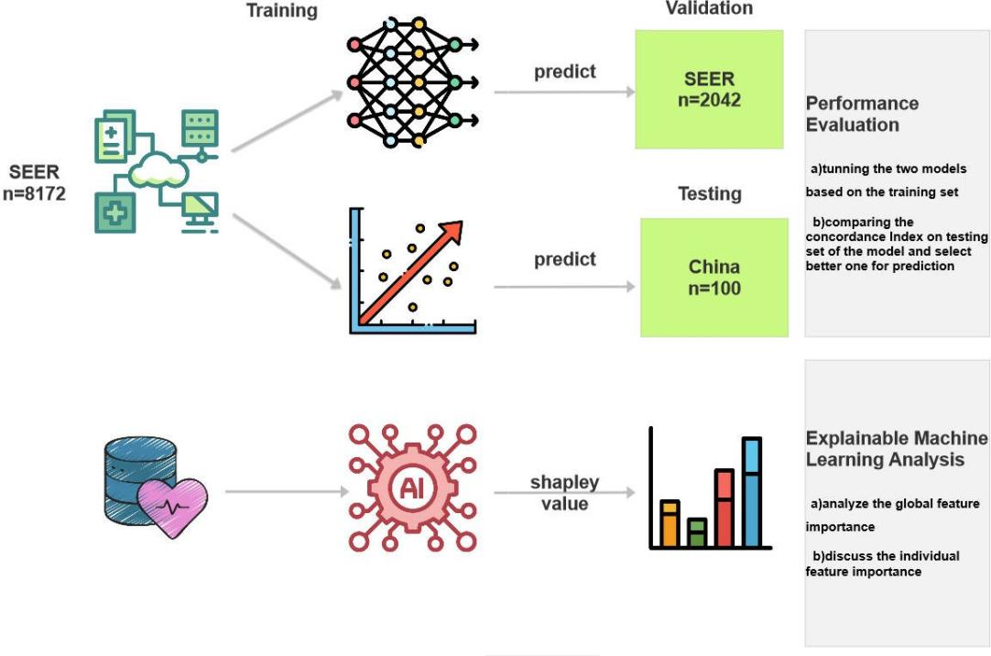

Figure 1. Diagram of the training and analyzing procedure.

throughout the extensive training set to get the global feature relevance. Plotting of the characteristics followed their order of diminishing significance. The workflow diagram goes here (Figure 1).

Computation Software
Python version 3.9 is used to train the models, PyTorch version 1.11.0 is used for the deep learning technique and PySurvival version 0.1.2 is used for training the penalized cox proportional hazard model. The reproduction link for the deep learning model and the dataset is on https://github.com/snowflake- Zhao/brca-IV-surgery.

RESULTS

Patient Baseline Characteristics
Based on the inclusion criteria, we selected 10,314 M1 breast cancer patients for this study. To evaluate the model’s performance, the cohort was divided into two groups: a test set consisting of 100 patients from the China Database and a training set comprising 10,214 patients from the SEER database. The baseline medical features of the two cohorts are displayed in (Table 1). In the SEER cohort, Infiltrating duct carcinoma makes up 76.69% of patient histological types. Meanwhile, lobular carcinoma was the second most prevalent histological type with 9.38% of cases. In terms of the breast molecular subtype, Luminal A breast cancer accounted for 58.29% of cases, while Triple Negative molecular subtypes comprised 14.70% of cases. In terms of the sites for metastasis, Approximately 65.14% of patients at bone,93.29% of at brain,74.11% of at liver and 69.32% of at lung.37.34% underwent surgery and 34.49% received beam radiation as part of the local therapy. In the test cohort, almost three forth patients had Infiltrating duct carcinoma as their histological type, and most of them have a moderately differentiated grade. Among this population, 62% had bone metastasis,87% had brain metastasis,76% had liver metastasis and 61% had lung metastasis. Nearly half of the patinets are Luminal, while 21% had Triple Negative subtypes. In terms of local therapy, over half underwent surgery, nearly quarter of the patients received beam radiation.

Table 1 Main Baseline Clinical Characteristics of Patients Characteristic Data set, No. (%)
 | Training | Testing
Age  85+ years | 455(4.45) | 1(1.00)
80-84 years | 551(5.39) | 4(4.00)
75-79 years | 689(6.74) | 2(2.00)
70-74 years | 867(8.48) | 8(8.00)
65-69 years | 1183(11.58) | 9(9.00)
60-64 years | 1383(13.54) | 8(8.00)
55-59 years | 1430(14.00) | 11(11.00)
50-54 years | 1274(12.47) | 15(15.00)
45-49 years | 928(9.08) | 8(8.00)
40-44 years | 610(5.97) | 15(15.00)
35-39 years | 435(4.25) | 14(14.00)
30-34 years | 273(2.67) | 4(4.00)
25-29 years | 113(1.10) | 1(1.00)
20-24 years | 22(0.21) | 0
15-19 years | 1(0.009) | 0
T stage  T0 | 17(0.16) | 0
T1 | 0 | 5(5.00)
T1a | 48(0.46) | 1(1.00)
T1b | 187(1.83) | 1(1.00)
T1c | 847(8.292) | 0
T2 | 3192(31.25) | 45(45.00)
T3 | 1764(17.27) | 14(14.00)
T4 | 87(0.85) | 8(8.00)
T4a | 404(3.95) | 1(1.00)
T4b | 1721(16.84) | 16(16.00)
T4c | 161(1.57) | 5(5.00)
T4d | 1006(9.84) | 5(5.00)
N stage  N0 | 1962(19.20) | 7(7.00)
N1 | 3735(36.56) | 18(18.00)
N1a | 613(6.00) | 1(1)
N2 | 228(2.23) | 25(25.00)
N2a | 981(9.60) | 1(1.00)
N3 | 94(0.92) | 27(27.00)
N3a | 675(6.60) | 1(1.00)
N3c | 578(5.65) | 18(18.00)
NX | 514(5.03) | 2(2.00)
Breast Subtype  Luminal A | 5954(58.29) | 10(10.00)

Luminal B | 1778(17.40) | 52(52.00)
Triple Negative | 1502(14.70) | 21(21.00)
HER2-positive | 980(9.59) | 17(17.00)
ER Status  Positive | 7563(74.04) | 60(60.00)
Negative | 2651(25.95) | 40(40.00)
PR Status  Positive | 6164(60.34) | 37(37.00)
Negative | 4050(39.65) | 63(63.00)
Mets at bone  Yes | 6654(65.14) | 62(62.00)
No | 3560(34.85) | 38(38.00)
Mets at brain  Yes | 9529(93.29) | 87(87.00)
No | 685(6.70) | 13(13.00)
Mets at liver  Yes | 7570(74.11) | 76(76.00)
No | 2644(25.88) | 24(24.00)
Mets at lung  Yes | 7081(69.32) | 61(61.00)
No | 3133(30.67) | 39(39.00)
Grade  Well differentiated | 780(7.63) | 5(5.00)
Moderately differentiated | 4223(41.34) | 81(81.00)
Poorly differentiated | 5133(50.25) | 14(14.00)
Undifferentiated | 78(0.76) | 0
Radiation  Beam radiation | 3523(34.49) | 24(24.00)
Combination of beam with implants or isotopes | 5(0.04) | 0
None | 6271(61.39) | 76(76.00)
Radiation, NOS method or source not specified | 50(0.48) | 0
Recommended, unknown if administered | 256(2.50) | 0
Refused | 99(0.96) | 0
Radioactive implants (includes brachytherapy) | 4(0.03) | 0
Chemotherapy  Yes | 6183(60.53) | 97(97.00)
No/Unknown | 4031(39.46) | 3(3.00)

Survival Feature Importance
The model and patient data are used to calculate the global feature significance (Figure 2). The three most significant variables for OS at first were HR-/HER2-(Triple Negative), Mets at DX-brain yes, and HR-/HER2-(HER2-positive patient), ranked from top to bottom. The variable to ascertain if the subtype is triple negative is the most important element influencing a patient’s overall prognosis. We might also see

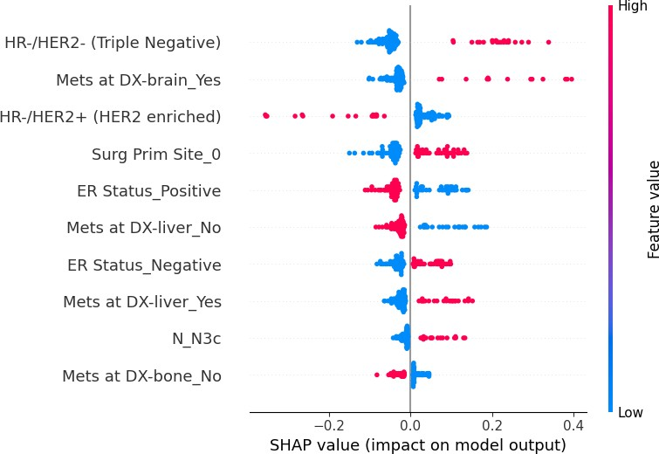

Figure 2. The average impact of the top 10 features from the neural network on output magnitude.The x-axis represents the mean value of shapley value, and the y-axis represents name of the input feature of the neural network

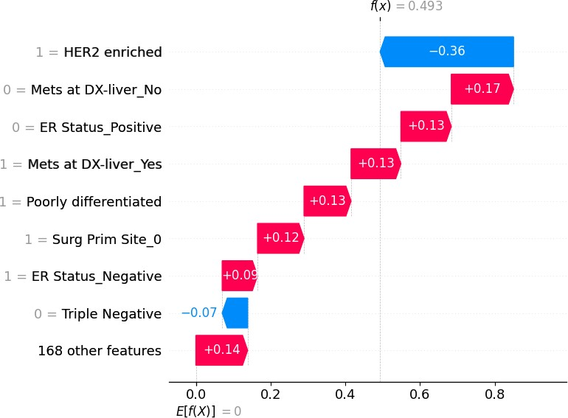

Figure 3. The individual feature impact of the top 8 features from the neural network on output magnitude.The x-axis represents the shapley value of the related feature and the y-axis represents name of the input feature of the neural network

the relationship between each feature’s trend and OS. The patient’s OS will get worse as the subtype of a patient is triple negative since it lacks specific biomarkers that can guide treatment decisions and predict guide to therapy, where the trend is consistent with ER status. Similarly, Metastases in the brain can lead to neurological complications due to the infiltration and compression of brain tissue; eventually, it will be detrimental to the OS of the patient. Conversely, if the patient’s subtype is HER2-positive, the OS could be beneficial from the HER2-directed therapy. So does the ER status. As for other metastasis locations including bone and liver, they are also important features for OS and the trend is the same as metastasis in the brain.

Regarding individual patient feature importance (Figure 3), we randomly selected one patient(HER2- positive, female, metastasis at liver, didn’t received surgery) from our testing dataset to show how the model arrives at the beginning log-partial hazard(0) when it has no prior knowledge of the patient and how it predicts the patient’s outcome.(0.493). At first, all the other insignificant 144 features initially increase the log hazard risk by 0.14. Since her breast subtype is not triple negative, the outcome decreases by 0.07 for this feature. Furthermore, we are filling out her ER status feature(0), grade(poorly differentiated) and surgery(0), which indicate that the extent of her tumor is at a higher degree of malignancy or aggressiveness and hormonal therapies could server as a treatment stagetegy for her. Clearly, these increase her risk at 0.009, 0.13, and 0.12, respectively. Considering the patient’s metastasis site for liver, an increase in risk by 0.13 was observed due to liver function impairment and potential complications including jaundice, ascites, liver failure and other symptoms that can significantly impact a patient’s quality of life. Eventually, because her breast subtype is HER2 positive, which lower her risk by 0.36. Eventually, the outcome result arrives at 0.493.

Survival Analysis for Subgroups
The different sites for metastasis may lead to the worse OS(12, 13), so we compared the OS between surgery and non-surgery in subgroups according to the metastasis site. Conversely, no significant difference of survival in three subgroups(Brain, Lung and Liver). Interestingly, In the Bone setting, patients with metastasis at Bone received Surgery has better OS than patients without Surgery: 5-year OS rates of 76.9 versus 27.2% (surgery vs. non-surgery, P = 0.035; Figure 4A). In Brain settings, 5-year OS rates of 0 versus 0% (surgery vs. non-surgery, P = 0.239; Figure 4B), in three Lung settings,5-year OS rates of 61.1 versus 28.3% (surgery vs. non-surgery, P = 0.283; Figure 4C)and in Liver settings,5-year OS rates of 41.1 versus 2.3% (surgery vs. non-surgery, P = 0.071; Figure 4D).
Alongside the site for metastasis, the breast subtype(triple negative and HER2-positive) ranks 2nd and 4th in the result of global feature importance, we want to combine the breast subtype with the metastasis site to find more detailed guidance for oncologists. Eventually, we found out that among bone metastasis breast cancer patients, if the breast subtype is triple negative,the estimated 5-year OS rates were 32.7 versus 0% (surgery vs. non-surgery, P =0.278; Figure 5A), and there is no significant difference of survival in all patients. On the contrary, For non-triple-negative patients, the difference is fairly large between the surgery and non-surgery groups: 5-year OS rates of 84.6 versus 32.3% (surgery vs. non-surgery, P =0.027; Figure 5B).

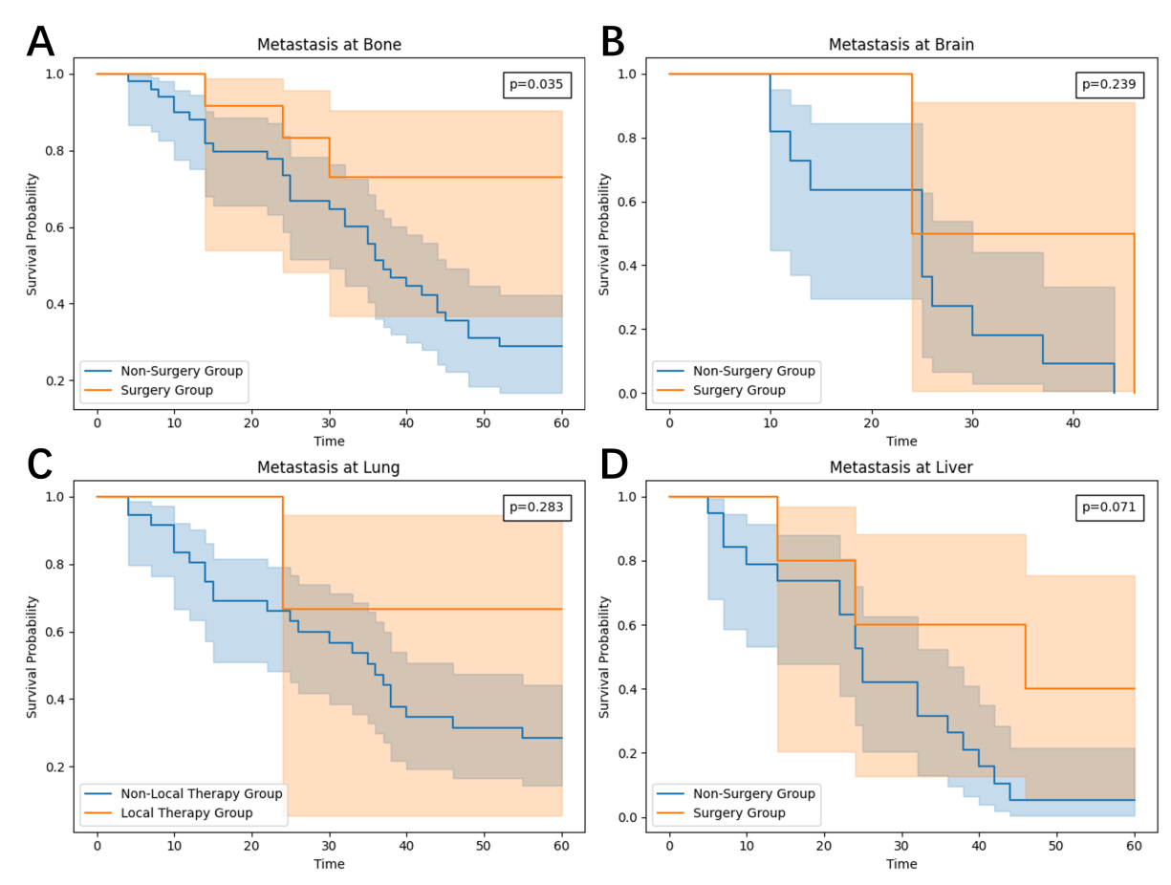
Figure 4. (A) The survival curve in stage-IV breast cancer patients with metastasis at Bone. (B) The survival curve in stage-IV breast cancer patients with metastasis at Brain. (C) The survival curve in stage-IV breast cancer patients with metastasis at Lung. (D) The survival curve in stage-IV breast cancer patients with metastasis at Liver.
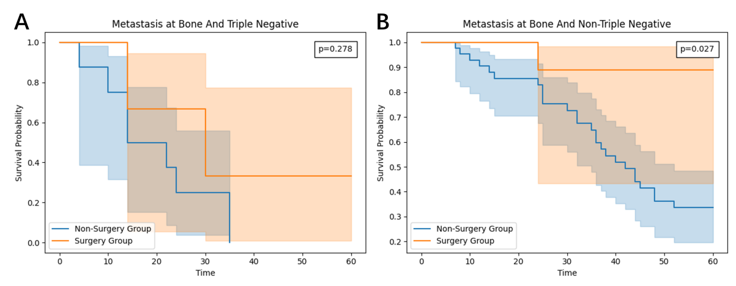
Figure 5. (A) The survival curve in stage-IV triple-negative breast cancer patients with metastasis at Bone.
(B) The survival curve in stage-IV non triple-negative breast cancer patients with metastasis at Brain.

Training curve and Model performance
The finalized model consists of 5 hidden layers, each with 10–24–47–22 neurons and a dropping-out unit between them. The learning rate was 0.00601 and the dropout rate was 0.736. The training loss curves demonstrate a gradual decrease in the loss for both the validation and training sets during the training process. After 96 epochs, the validation set’s loss reaches a plateau at 6.0229, while the training set’s loss continues to decrease from 5.1683. To prevent overfitting, we stop the optimization process and retain

the model for testing. In the Cox Proportional hazard model, we configure the penalizer to 0.002 and the learning rate to 0.002. The mean of the concordance index of the deep learning algorithm is 0. 771, which is significantly higher than cox proportional hazard model (0. 632) (Table 2). Clearly, the performance of the deep learning model is better (0.782 vs 0.650).
Table 2 Performance of the survival models to predict hazard rate MODEL Cross Validation External Validation
Concordance Index Mean Concordance Index
Deep Learning | 0. 771 | 0.782
Cox Proportional | 0. 632 | 0.650

DISCUSSION
The purpose of this study is to explore the controversy regarding the possible advantages of local therapy for patients with stage IV breast cancer who have had systemic therapy. This study discovered that individuals with bone metastases from stage IV breast cancer may benefit from local treatment. It is strongly recommended that patients who are not triple-negative and metastasized to the bone receive local treatment in addition to systemic therapy. This study incorporated an explainable module to offer insight into how the deep learning model predicts outcomes, based on the significance of various features, in addition to developing an accurate deep learning model. By utilizing the model and training data, we were able to determine the global feature importance of the model. To the best of our knowledge, this is the first explainable, data-driven approach that provides stage IV breast cancer patients with a reference for local therapy treatment planning.
Comparable to earlier research, such that done by Li K.et al(14), We discovered that patients with bone- metastasis may benefit from local treatment. Compared with visceral metastasis, bone metastasis itself progresses slowly and can be prevented and treated with drugs such as zoledronic acid. Some symptomatic lesions can be improved by radiotherapy. In a prospective study, the enrolled population in MF07-01 Study
(6) was mainly bone metastasis, and the patient’s tumor burden was small. The 5-year overall survival rate after resection of the primary lesion was significantly improved. The results of subgroup analysis also showed that Newly treated stage IV breast cancer with only bone metastases can benefit from surgery to remove the primary lesion. The population enrolled in TATA Study (5, 15) and TBCRC 013 Study (16, 17) was breast cancer with mainly visceral metastasis, with a large tumor burden and no survival benefit from surgical treatment of the primary lesion.We found out triple negative bone-metastasis breast cancer patients could not benefit from receiving local therapy. Triple-negative breast cancer (18) is a heterogeneous disease with no endocrine or targeted treatment options. Its clinical manifestations are the most aggressive, prone to recurrence and metastasis, and poor outcome. It lacks a precise ”target” to attack it. On the contrary, we strongly recommend the non-triple-negative bone-metastasis breast cancer patients should receive local therapy to improve the OS.
The model and training dataset were used to determine the global feature importance. Firstly, the significance of the site of metastasis in the M1 patient population has been widely recognized in previous studies. Many studies use bone metastasis as the reference, with patients having brain metastasis typically showing the worst prognosis. This finding aligns with our results, which identify brain metastasis as the most significant factor influencing patient survival and local therapy decision-making.Secondly, the subtype of breast cancer also plays a crucial role. Existing research consistently demonstrates that Breast subtypes

were correlated with the choice of surgery type (12, 13, 19). Luminal A and luminal B are linked to good prognosis, while Her2-enriched and triple-negative BC have a poor prognosis (20, 21, 22, 23). Similarly, in our experiment, triple-negative breast cancer (BC) and HER2-enriched subtypes were found to be highly significant factors for patient survival. Triple-negative BC is associated with poor survival outcomes. In contrast, HER2-positive patients have a better prognosis than triple-negative patients, as the advent of the first anti-HER2 monoclonal antibody, trastuzumab, marked the beginning of the targeted therapy era for breast cancer. Real-world studies show that the overall median OS of HER2-positive advanced breast cancer patients continued to increase from 2008 to 2017(24).By contrast, Other clinical characteristics investigated in our study did not demonstrate significant importance compared to as these four features.
To enhance the method’s applicability in real-world medical settings, causal inference should be incorporated into both the training and explanation processes.(25, 26, 27). To enhance the interpretability of feature attributions, we could integrate the assumptions of a causal model and design causal models by incorporating the sample reweighting technique into the loss function. This approach could be compared with the performance of our deep learning model.(28, 29, 30, 31).

CONCLUSIONS
Patients with metastasis at Bone could benefit from Surgery while metastasis at Brain,Lung and Liver does not.Additionally,Surgery is beneficial for non-triple negative breast cancer patients.The deep learning network performed more stably and accurately in predicting patients survival than Cox proportional hazard model on the internal test. Furthermore,HR-/HER2-(Triple Negative), Mets at DX-brain yes and HR-/HER2-(HER2-positive) are the most significant factors to the OS.

ETHICS STATEMENT
The study was approved by The Medical Ethics Committee of Shaanxi Provincial People’s Hospital (approval number: SPPH-LLBG-17-3.2) and conducted in accordance with the local legislation and institutional requirements. The participants provided their written informed consent to participate in this study.The Committee certifies that the study was performed in accordance with the ethical standards as laid down in the Declaration of Helsinki.

CONFLICT OF INTEREST STATEMENT
The authors declare that the research was conducted in the absence of any commercial or financial relationships that could be construed as a potential conflict of interest.

AUTHOR CONTRIBUTIONS
LJ and QZ designed the research. LJ collected the training and testing dataset. QZ trained the models and analyzed the model. LJ and QZ wrote the manuscript. SF, FC, JW,DM,XZ and YZ edited and critically revised the manuscript in regard to important intellectual content. All authors read and approved the manuscript.

FUNDING
This research was funded by a grant from The Science and Technology Elite Talent Project of Shaanxi Provincial People’s Hospital (2021JY-39) , The Science and Technology Development Incubation Fund project of Shaanxi Provincial People’s Hospital(2020YXM-05,2023YJY-35),Natural Science Foundation of Shaanxi Province(2024JC-YBQN-0988) and Xi’an Science and Technology Planning project (2022JH- YBYJ-0170).

DATA AVAILABILITY STATEMENT
The datasets analyzed for this study can be found in the https://github.com/snowflake-Zhao/ brca-IV-surgery.

REFERENCES
- .Sung H, Ferlay J, Siegel RL, Laversanne M, Soerjomataram I, Jemal A, et al. Global cancer statistics 2020: Globocan estimates of incidence and mortality worldwide for 36 cancers in 185 countries. CA: a cancer journal for clinicians 71 (2021) 209–249.
- .Siegel RL, Miller KD, Jemal A. Cancer statistics, 2019. CA: a cancer journal for clinicians 69 (2019) 7–34.
- .Bjelic-Radisic V, Fitzal F, Knauer M, Steger G, Egle D, Greil R, et al. Primary surgery versus no surgery in synchronous metastatic breast cancer: patient-reported quality-of-life outcomes of the prospective randomized multicenter abcsg-28 posytive trial. BMC cancer 20 (2020) 1–15.
- .Liu D, Wu J, Lin C, Andriani L, Ding S, Shen K, et al. Breast subtypes and prognosis of breast cancer patients with initial bone metastasis: a population-based study. Frontiers in oncology 10 (2020) 580112.
- .Badwe R, Hawaldar R, Nair N, Kaushik R, Parmar V, Siddique S, et al. Locoregional treatment versus no treatment of the primary tumour in metastatic breast cancer: an open-label randomised controlled trial. The lancet oncology 16 (2015) 1380–1388.
- .Soran A, Ozmen V, Ozbas S, Karanlik H, Muslumanoglu M, Igci A, et al. Primary surgery with systemic therapy in patients with de novo stage iv breast cancer: 10-year follow-up; protocol mf07-01 randomized clinical trial. Journal of the American College of Surgeons 233 (2021) 742–751.
- .Khan SA, Zhao F, Goldstein LJ, Cella D, Basik M, Golshan M, et al. Early local therapy for the primary site in de novo stage iv breast cancer: results of a randomized clinical trial (ea2108). Journal of Clinical Oncology 40 (2022) 978–987.
- .Pons-Tostivint E, Alouani E, Kirova Y, Dalenc F, Vaysse C. Is there a role for locoregional treatment of the primary tumor in de novo metastatic breast cancer in the era of tailored therapies?: Evidences, unresolved questions and a practical algorithm. Critical reviews in oncology/hematology 157 (2021) 103146.
- .Yu Y, Hong H, Wang Y, Fu T, Chen Y, Zhao J, et al. Clinical evidence for locoregional surgery of the primary tumor in patients with de novo stage iv breast cancer. Annals of Surgical Oncology (2021) 1–12.
- .Soran A, Dogan L, Isik A, Ozbas S, Trabulus DC, Demirci U, et al. The effect of primary surgery in patients with de novo stage iv breast cancer with bone metastasis only (protocol bomet mf 14-01): a multi-center, prospective registry study. Annals of Surgical Oncology (2021) 1–10.
- .Kingma DP, Ba J. Adam: A method for stochastic optimization. arXiv preprint arXiv:1412.6980
(2014).

- .Rouzier R, Mathieu MC, Sideris L, Youmsi E, Rajan R, Garbay JR, et al. Breast-conserving surgery after neoadjuvant anthracycline-based chemotherapy for large breast tumors. Cancer 101 (2004) 918–925.
- .Tryfonidis K, Senkus E, Cardoso MJ, Cardoso F. Management of locally advanced breast cancer—perspectives and future directions. Nature Reviews Clinical Oncology 12 (2015) 147–162.
- .Li K, Zhou C, Yu Y, Niu L, Zhang W, Wang B, et al. Metastatic pattern discriminates survival benefit of type of surgery in patients with de novo stage iv breast cancer based on seer database. Frontiers in Surgery 8 (2021) 696628.
- .Li C, Liu M, Zhang Y, Wang Y, Li J, Sun S, et al. Novel models by machine learning to predict prognosis of breast cancer brain metastases. Journal of translational medicine 21 (2023) 404.
- .King TA, Lyman JP, Gonen M, Voci A, De Brot M, Boafo C, et al. Prognostic impact of 21-gene recurrence score in patients with stage iv breast cancer: Tbcrc 013. Journal of Clinical Oncology 34 (2016) 2359.
- .Li C, Wang Y, Bai H, Liu M, Cai Y, Zhang Y, et al. Deep neural network provides personalized treatment recommendations for de novo metastatic breast cancer patients. Journal of Cancer 15 (2024) 6668.
- .Jiang Z, Ouyang Q, Sun T, Zhang Q, Teng Y, Cui J, et al. Toripalimab plus nab-paclitaxel in metastatic or recurrent triple-negative breast cancer: a randomized phase 3 trial. Nature Medicine (2024) 1–8.
- .Li C, Liu M, Li J, Wang W, Feng C, Cai Y, et al. Machine learning predicts the prognosis of breast cancer patients with initial bone metastases. Frontiers in Public Health 10 (2022) 1003976.
- .Leone BA, Vallejo CT, Romero AO, Machiavelli MR, Pe´rez JE, Leone J, et al. Prognostic impact of metastatic pattern in stage iv breast cancer at initial diagnosis. Breast cancer research and treatment 161 (2017) 537–548.
- .Smid M, Wang Y, Zhang Y, Sieuwerts AM, Yu J, Klijn JG, et al. Subtypes of breast cancer show preferential site of relapse. Cancer research 68 (2008) 3108–3114.
- .Rosa M. Advances in the molecular analysis of breast cancer: pathway toward personalized medicine.
Cancer Control 22 (2015) 211–219.
- .Kast K, Link T, Friedrich K, Petzold A, Niedostatek A, Schoffer O, et al. Impact of breast cancer subtypes and patterns of metastasis on outcome. Breast cancer research and treatment 150 (2015) 621–629.
- .Grinda T, Antoine A, Jacot W, Blaye C, Cottu PH, Die´ras V, et al. Evolution of overall survival and receipt of new therapies by subtype among 20 446 metastatic breast cancer patients in the 2008-2017 esme cohort. ESMO open 6 (2021) 100114.
- .Shen Z, Liu J, He Y, Zhang X, Xu R, Yu H, et al. Towards out-of-distribution generalization: A survey.
arXiv preprint arXiv:2108.13624 (2021).
- .Athey SC, Bryan KA, Gans JS. The allocation of decision authority to human and artificial intelligence. AEA Papers and Proceedings (American Economic Association 2014 Broadway, Suite 305, Nashville, TN 37203) (2020), vol. 110, 80–84.
- .Pearl J. Theoretical impediments to machine learning with seven sparks from the causal revolution.
arXiv preprint arXiv:1801.04016 (2018).
- .Kuang K, Cui P, Athey S, Xiong R, Li B. Stable prediction across unknown environments. proceedings of the 24th ACM SIGKDD international conference on knowledge discovery & data mining (2018), 1617–1626.
- .Cui P, Athey S. Stable learning establishes some common ground between causal inference and machine learning. Nature Machine Intelligence 4 (2022) 110–115.

- .Heinze-Deml C, Meinshausen N. Conditional variance penalties and domain shift robustness. Machine Learning 110 (2021) 303–348.
- .Xu R, Zhang X, Shen Z, Zhang T, Cui P. A theoretical analysis on independence-driven importance weighting for covariate-shift generalization. International Conference on Machine Learning (PMLR) (2022), 24803–24829.

