Enhancing pathological complete response prediction in stage II/III breast cancer: the role of radiomics signatures of MRI and its association with tumor microenvironment heterogeneity

Chao Zheng 1, Jiexin Sheng 1, Lin Yang 1, Meng Wang 1, Xinyu Luan 2, Chunling Zhang 3, Lihua Liu 4, Long Jin 5, Qifan Zhao 6 and Shenbo Fu 7
1 Department of Medical Imaging,Han zhong Central Hospital ,Hanzhong ,China, 2 Department of Endocrinology, Hanzhong Central Hospital, Hanzhong, China, 3 Department of Ultrasound, Hanzhong Central Hospital, Hanzhong, China, 4 School of Mathematics and Computer Science, Shaanxi University of Technology, Hanzhong, China, 5 Department of Radiation Oncology, Shaanxi Provincial People’s Hospital, Xi’an, 6 Department of Computer Science, The University of Hong Kong, Hong Kong, China, 7 Department of Radiation Oncology, Shaanxi Provincial Cancer Hospital, Xi’an,China
Correspondence*:
Bo Wang boboss1314@163.com

ABSTRACT
Background The pathological factors for predicting the benefit of Neoadjuvant chemotherapy (NACT) in breast cancer remains limited and challenged by substantial intertumoral heterogeneity. We want to explore and compare the value of radiomic features derived from both the tumor and the tumor microenvironment on MRI in the early prediction of pathological complete response(pCR) and identify the subgroup of the patients who may benefit from NACT.
Methods In this study, we trained and validated 2 radiomics machine learning models based on different ROIs: tumor only and tumor with microenvironment. The training dataset consists of 351 patients with complete MRI data and electronic health records. Area under Curve (AUC) is used to quantify the overall accuracy of the model and DeLong’s test determines if there is a significant difference between the ROC curves of two models.Then we did subgroup analysis to identify the subgroup who could benefit from NACT. Finally, we analyzed the global feature importance for the model to identify the important factors.
Results A total of 351 patients were included in this study. We identified that if the value of Informational Measure of Correlation(IMC1) <-0.188 in triple negative patients, the pCR is likely to be positive(pCR vs. non-pCR, P = 0.044 ). Meanwhile, for HER2-positive disease, patients could benefit from NACT if IMC1 <-0.247 (pCR vs. non-pCR, P = 0.046). The model based on the tumor with microenvironment outperforms that based on tumor only in AUC(0.71 vs 0.60), with statistically significant difference(p-value=0.023).Besides, the model identified several key
factors that significantly influence patient pCR, including HR, IMC1, and Large Dependence High Grade Level Emphasis (LDHGLE).
Conclusion Patients with triple-negative breast cancer are more likely to achieve pCR when IMC1 <-0.188 (pCR vs. non-pCR, p-value = 0.044 ), and those with HER2-positive disease may benefit from NACT when IMC1 <-0.247 (pCR vs. non-pCR, p-value = 0.046). The model incorporating both tumor and microenvironment radiomics features outperformed the tumor-only model (AUC 0.71 vs. 0.60, p-value = 0.023). HR status, IMC1, and LDHGLE were identified as the most significant predictors of pCR.
Keywords: breast cancer; MRI; machine learning; radiomics

INTRODUCTION
In 2022, there were 2.3 million new cases of breast cancer globally, resulting in 670,000 (95% CI: 650,000–680,000) deaths. Breast cancer had the highest incidence among women, accounting for 25% of all cancer cases and 15.5% of cancer-related deaths. Among 185 countries/regions, breast cancer was the most common or second most common type of cancer in women in 183 of them, and one of the top two leading causes of cancer-related death in women in 169 countries/regions(1).
Neoadjuvant chemotherapy (NACT) is currently an essential component of comprehensive breast cancer treatment, with the primary goals of tumor downstaging, breast conservation, and axillary preservation(2). The ideal outcome of NACT is pathological complete response (pCR), which is the absence of residual invasive cancer in the primary breast tumor and regional lymph nodes. Studies have shown that patients who achieve pCR have significantly better overall prognoses compared to those who do not (non-pCR)(3). However, due to individual patient variability and the inherent heterogeneity of breast cancer(4), only approximately 19% to 30% of patients achieve pCR(5), while about 5% to 20% may experience disease progression during NACT(6). Since confirmation of pCR relies on postoperative pathological biopsy, it is clinically impossible to accurately assess NACT efficacy before or during treatment(? ). Therefore, early-stage individualized efficacy prediction is urgently needed to identify potential beneficiaries.
At present, pathological factors are commonly used in clinical practice to predict the potential benefit of NACT, but their predictive accuracy is limited, making personalized response prediction difficult. Although several novel predictive factors have been proposed in recent years, their clinical feasibility and incremental utility remain limited due to the pronounced intertumoral heterogeneity of breast cancer (7). Breast MRI is widely used in clinical settings to assess NACT response in breast cancer, owing to its advantages of being radiation-free, having high soft-tissue resolution, and enabling multi-planar, multi-sequence, and multi-functional imaging. Radiomics, by extracting high-throughput quantitative features, provides a new way to characterize intratumoral heterogeneity and offers potential for evaluating tumor responsiveness and resistance(8). In recent years, the tumor microenvironment (TME) has garnered increasing attention as a key participant in tumor development and treatment response. The TME consists of various non-tumor components such as immune cells, vasculature, and stroma, and its role in achieving pCR is gradually being revealed. Studies have shown that TME characteristics are closely associated with NACT response in breast cancer. Therefore, integrating radiomic features of both the tumor and its microenvironment may further enhance the ability to predict pCR.
This study aims to explore the value of radiomic features derived from both the tumor and the TME on MRI in the early prediction of NACT response in breast cancer. By integrating interpretable machine
learning, the study further investigates the associations between these features and tumor heterogeneity in breast cancer patients, providing new insights and evidence to support precision treatment strategies.

METHOD

Eligibility Criteria and Patient Information
Regarding the training set, the multi-center I-SPY2 trial (clinical trial number: NCT01042379), 719 patients aged 18 years with locally advanced breast cancer (tumor size 2.5 cm) and no distant metastases were gathered from the publicly accessible dataset on The Cancer Image Archive between 2010 and 2016(9, 10). As for the testing set, from August 2012 to January 2015, 10 institutions enrolled 385 women with aggressive breast cancer in ACRIN 6698 trial 6698 (clinical trial number: NCT01564368)(11).
≥ ≥
For two cohorts prior to receiving NAC, each patient had a percutaneous biopsy and MR evaluation. Patients had surgical resection to evaluate any residual disease after NAC was finished. In Addition, clinical factors including HR, HER2, age, and pCR were included.The exclusion criteria included: (1) bilateral or multifocal cases (2) insufficient image quality (3) incomplete clinical or image information.

Imaging data and ROI segmentation
MRI scans performed at pre-treatment were chosen for radiomic feature extraction and analysis for each subject.All MRI examiNACTions used DCE-MRI, conducted using one of three MRI scanners (GE, Philips, or SIEMENS) with magnetic field strengths of 1.5T or 3.0T, with fat suppression required. Imaging was performed in the axial plane with a slice thickness ranging from 0.8 to 3 mm and pixel sizes between
0.3 and 1.4 mm. The number of slices varied between 56 and 256. Repetition times ranged from 3.8 to 9.3 seconds and echo times were between 1.3 and 4.8 seconds. The number of averages was between 0.7 and 3. Spacing between slices was 0.8 to 2.6 mm, with flip angles from 10 to 20 degrees. Total phase varied from 6 to 11. Sequence acquisition times were between 80 and 100 seconds, with total acquisition times of at least 8 minutes after the administration of the contrast agent.
Two ROIs (Tumor VS Tumor + Microenvironment) on MRI were separately manually segmented and labeled as regions of interest (ROIs). The images were manually segmented by one of two experienced radiologists (C.Z and L.J) who both had 10 years experience.

Image preprocessing and feature extraction
When preprocessing images, (1) use z-score normalization to fix any discrepancies across scanners or settings. Images are (2) resampled to 1*1*1 mm³ using a linear interpolator, and (3) discretized with a fixed bin width of 5.
The PyRadiomics program version 3.0.1 was used to extract radiomic features from each DCE-MRI phase in accordance with the standards and standardization found in the image biomarker standardization project. Shape features (VoxelVolume, ”SurfaceArea,” and ”SurfaceVolumeRatio”), first-order features (Entropy, ”Mean,” and ”Uniformity”) and texture features (n = 73) were among the features that were extracted.

Explainable radiomics machine learning model design
This section will include training and analyzing the output of two machine learning models that predict pCR. The two algorithms are attempting to match the correlation between classification labels for pCR

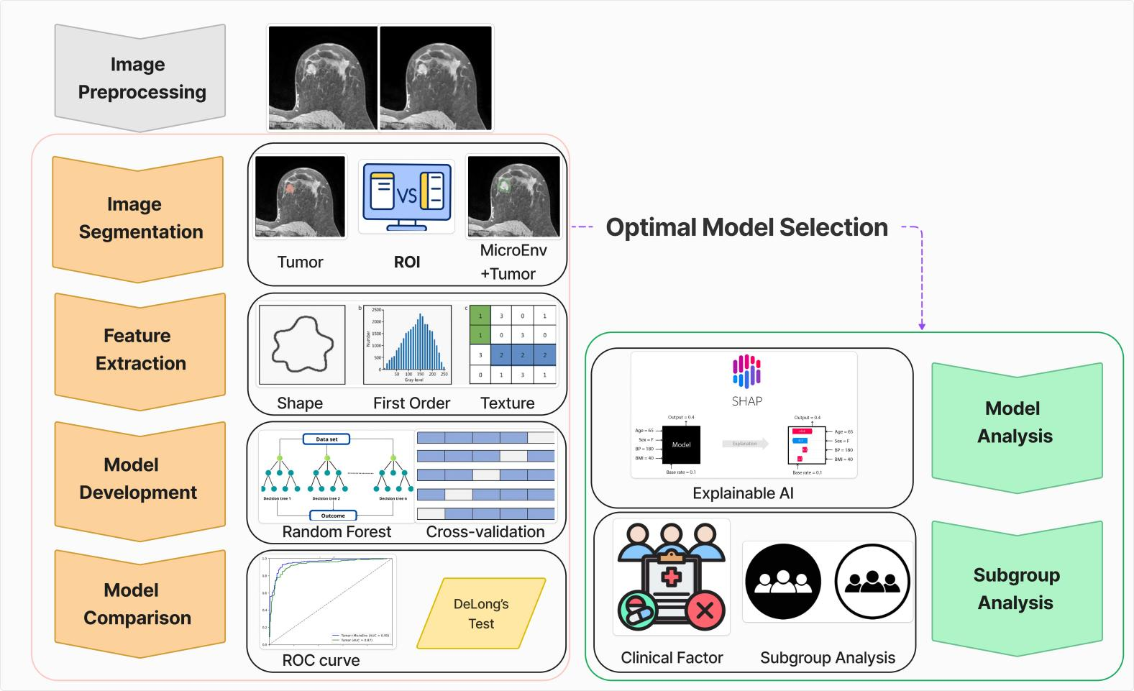
Figure 1. Diagram of the training and analyzing procedure.

and variables, including radiomic features and clinical factors.The architecture of the model comprises an input layer that receives radiomic features and clinical factors from the patient, followed by an ensemble of decision trees as the core component of the Random Forest. Each tree is trained on a random subset of the data with replacement, and splits are chosen based on random subsets of features at each node. The output of the Random Forest is the aggregated prediction of all trees, achieved through majority voting for classification or averaging for regression tasks. The model’s hyperparameters were tuned through a random search, with the number of trees in the range 50 to 1000, the number of samples used per tree varied from 8 to 200, and the minimum number of samples required to split a node is from 2 to 50. Then we generated two random forests with respect to radiomic feature for tumor only and for tumor alongside the microenvironment. The optimal model with a better result of receiver operating characteristic (ROC) will be selected for subsequent analysis.
As for the explainable module,Shapley value was applied to each clinical feature value in order to determine how each one contributed individually to the random forest’s predictions. We use the average of the absolute Shapley values for each feature throughout the extensive training set to get the global feature importance. Plotting of the characteristics followed their order of diminishing significance. The whole workflow diagram goes here (Figure 1).

Statistical analysis and software
The chi-square test was employed for statistical analysis in order to ascertain whether two category variables were related. In addition, the deLong test(12) was used to derive if there is a significantly different AUC between two classification models. A two-tailed p-value was accepted as statistically significant if it

was less than 0.05. Python 3.8 was used for the statistical analysis and the scikit-learn 1.0.2 module was used to implement Random Forest.

RESULTS

Patient Baseline Characteristics
The study comprised 351 patients with complete MRI data and electronic health records .The exclusion details for patients is shown in (Figure 2)As for model testing, the cohort was split into two sets: a training set of 251 patients from the I-SPY 2 and a test set of 100 patients from the ACRIN-6698. The two cohorts baseline medical features are displayed in (Table 1). In the I-SPY 2 cohort, the most prevalent age group was 50-59 years, accounting for 38.60% of the population, followed by the 40-49 age group (26.69%). HR-negative patients made up the majority at 52.98%, while HER2-negative cases constituted 78.09% of the cohort. In terms of pCR status, 60.15% of patients were pCR-negative, with 39.85% achieving pCR- positive status. Regarding race, White patients comprised 76.09%, followed by Black or African American patients at 15.53%, and Asian patients at 6.37%.In the testing cohort, the 40-49 age group was the most common, comprising 34%, followed by the 50-59 group at 28%. HR-positive cases slightly outnumbered HR-negative cases, which is 54.00% and 46.00%, respectively. HER2-negative status remained dominant at 75.00%. For pCR, 63.00% of patients were pCR-negative, with 37.00% achieving pCR-positive. In terms of race, White patients made up 68.00%.

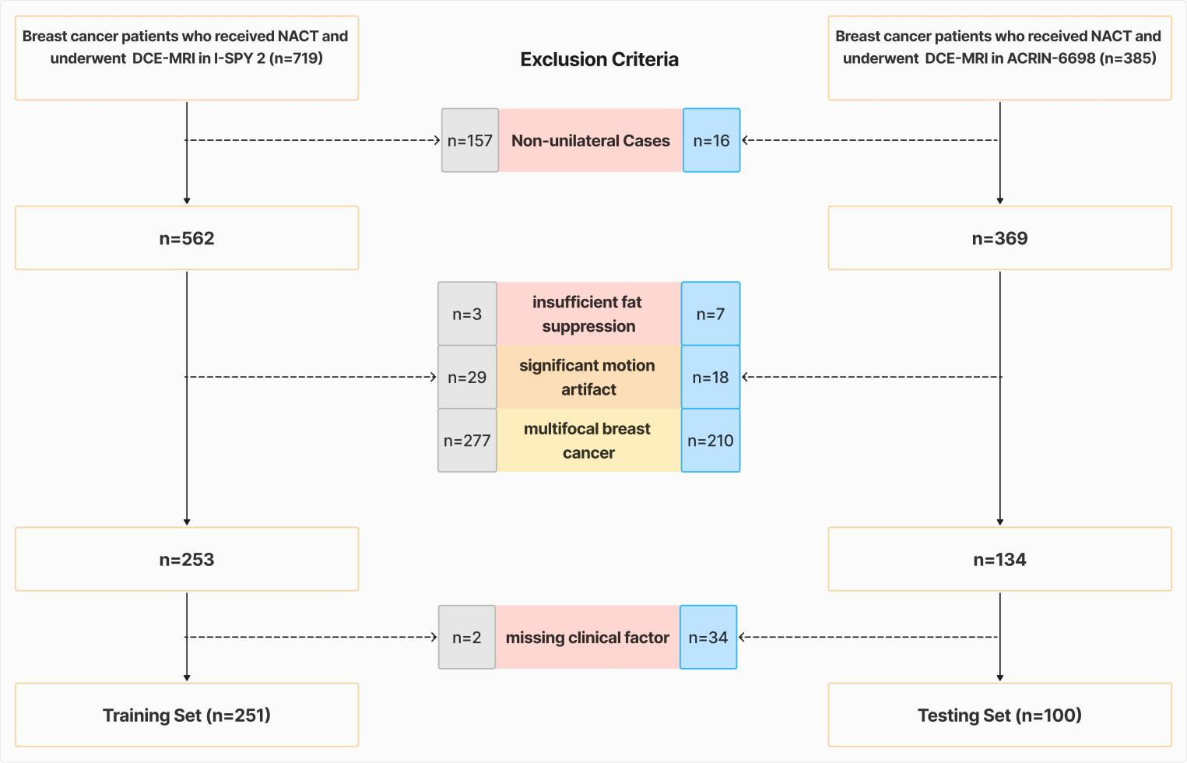

Figure 2. Study subject exclusion criteria.

Table 1 Main Baseline Clinical Characteristics of Patients Characteristic Data set, No. (%)
 | Training | Testing
Age  20-29 | 5 | 2
30-39 | 38 | 16
40-49 | 67 | 34
50-59 | 97 | 28
60-69 | 37 | 19
70-79 | 7 | 1
HR  Negative | 133 | 46
Positive | 118 | 54
HER2  Negative | 196 | 75
Positive | 55 | 25
pCR  Negative | 151 | 63
Positive | 100 | 37
Race  American Indian or Alaska NACTive | 2 | 1
Asian | 16 | 9
Asian;White | 1 | 0
Black or African American | 39 | 11
NACTive Hawaiian or Pacific Islander | 2 | 1
White | 191 | 68
Unknown | 0 | 7

Survival Feature Importance
The model and patient radiomics data were used to calculate the global feature significance (Figure 3). The three most significant variables for predicting the result of pCR were HR, Informational Measure of Correlation(IMC1), and Large Dependence High Grade Level Emphasis (LDHGLE), ranked from top to bottom. Among these, HR (hormone receptor) is the most important factor influencing the likelihood of achieving a pathological complete response (pCR). The SHAP analysis demonstrates the relationship between each feature’s trend and the probability of achieving pCR. HR-negative status is positively associated with pCR, aligning with the clinical understanding that hormone receptor-positive tumors may have reduced sensitivity to NACT. Conversely, positive HR reduces the likelihood of achieving pCR. For radiomics features, the higher values of IMC1, which means the more mutual information that the tumor and microenvironment shared, are associated with reduced pCR likelihood. So does the LDHGLE, A higher LDHGLE before treatment can be associated with a worse probability of positive pCR, indicating the tumor along with the microenvironment has large, uniform regions of high-intensity signal, leading to a lower chance of pCR.

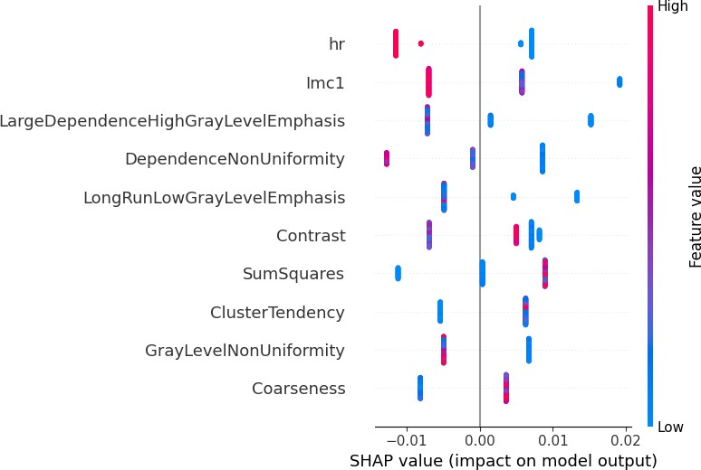

Figure 3. The average impact of the top 10 features from the random forest on output magnitude.The x-axis represents the mean value of shapley value, and the y-axis represents name of the input feature of the random forest

Survival Analysis for Subgroups
According to guidelines, the correlation between pathologic response and long-term outcome is strongest for TNBC, somewhat less so for HER2-positive disease, and least for ER-positive disease. Thus, we shift our attention to TNBC and HER2-positive patients and combine the top two most vital radiomics features to find more detailed guidance for oncologists. Eventually, we found out that among TNBC patients breast cancer patients, if the value of IMC1 <-0.188, then the result of pCR is likely to be positive(pCR vs. non-pCR, P = 0.044 ), so NACT should be recommended to the patients. Besides, when LDHGLE is
<113202.44, there is a relationship between the group and the result of pCR (pCR vs. non-pCR, P = 0.049). Similarly, for HER2-positive disease, patients could benefit from NACT if IMC1 <-0.247 (pCR vs. non-pCR, P = 0.046).However, there is no significant difference when checking LDHGLE affects the result of NACT. We believe the biologically aggressive,with high cell proliferation rates, HER2-positive cell overcomes the beneficial effect of lower LDHGLE, leading to the result.

Model comparison and performance
The study involves developing two distinct Random Forest models for predicting pCR to NACT. The first model utilizes radiomic features extracted solely from the tumor, while the second model incorporates both tumor radiomic features and features from the surrounding microenvironment. The second model achieved higher AUC than the first one in external validation(0.71 vs 0.60), with statistically significant difference(p-value=0.023)(Figure 4).The mean AUC of the second model is 0.76 while the value fro the first model is 0.63(Table 2). Clearly, the model integrates features from the surrounding microenvironment as well as tumor could capture more information about the spatial heterogeneity, which leads to the better performance on predicting the likelihood of pCR
Table 2 Performance of the survival models to predict hazard rate MODEL Cross Validation External Validation

Concordance Index Mean Concordance Index
tumor + micro-environment | 0. 76 | 0. 71
tumor only | 0. 63 | 0.60

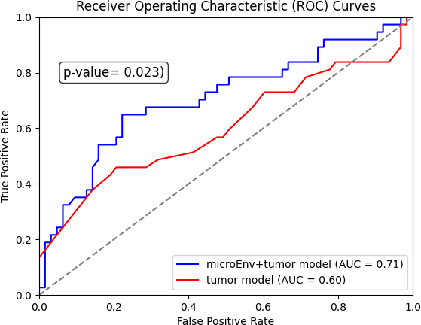

Figure 4. Reciever operating characteristic (ROC) curve analysis of models utilized feature extracted from tumor and tumor with micro-environment.

DISCUSSION
The purpose of this study is to investigate whether radiomic analysis on tumor and micro-environment could perform better than on tumor only and extract the radiomics knowledge to recommend stageII/III locally advanced breast cancer patient on decision to receive NACT.This study discovered that radiomics features combining tumor and surrounding microenvironment could greatly improve the performance on predicting pCR to NACT, compared with tumor only. Additionally, it is highly advised that HER2-positive stageII/III locally advanced breast cancer whose value of IMC1 <-0.247 could benefit from NACT. Meanwhile, for stageII/III TNBC patients, when IMC1 is <-0.188 or LDHGLE is <113202.44, they are more likely to respond positively for NACT.
Compared to earlier research, such that done by Nolan.et al(13),the initiation and progression of breast cancer are significantly influenced by the dynamic and multi-layered interaction between malignant and non-malignant cells within the TME(14). with tumor cells shaping their environment by reprogramming tissue-resident and recruited cells to support their survival(15), growth, and dissemiNACTion. Thus, these biological findings infer TME and tumor could provide more information than only tumor to predict the pCR of NACT,which is consistant with our results for model performance. As for feature importance analysis, heterogeneity may lead to different response in breast tumor to NACT(16),which introduces complications in making decisions about therapeutic therapy and follow-up management(17), Eventually our conclusion on IMC1 for pCR prediction could be validated. Meanwhile, our findings on LDHGLE could be supported by the biological evidence found by Zhang.et al, which is The discrepancy (high–tumor- stroma ratio vs low–tumor-stroma ratio) may indicate the high heterogeneity of the stromal components in certain molecular types of breast cancer(18). The structure of the stromal blood vessels, which supply tumor cells with nutrition and oxygen, can have a major effect on tumor growth and chemotherapy delivery(19); ultimately, the higher the tumor stroma ratio, the worse the pCR.
As opposed to other research projects to predict pCR based on radiomics,for instance, the AUC of Yu.et(20) al’s radiomics model is 0.605 while ours is 0.71, the reason is we consider TME and tumor instead of tumor only, confirming that TME could provide more information for pCR prediction.In terms of method for segmentation, Zhang.et al segmentated via functional tumor volume(21), which faces challenges including sensitivity to thresholds, spatial resolution issues and limited tumor characterization. However, our clinicians segmentated manually considering both functional and aNACTomical factors for a more comprehensive assessment of the tumor.
Causal inference should be incorporated into the explaNACTion and training processes to increase the method’s applicability in real medical contexts.(22, 23, 24). To improve the interpretability of feature attributions, for instance, by adding the sample reweighting approach to the loss function, we might create causal models and include the assumptions of the causal model. and compare the performance to our existing outcome later on. (25, 26, 27, 28)

ETHICS STATEMENT
The study was conducted in accordance with the Declaration of Helsinki (as revised in 2013). The study was approved by the Institutional Review Board of Hanzhong Central Hospital, and all patient requirements for informed consent were waived

CONFLICT OF INTEREST STATEMENT
The authors declare that the research was conducted in the absence of any commercial or financial relationships that could be construed as a potential conflict of interest.

AUTHOR CONTRIBUTIONS
CZ,LJ and QZ designed the research. LJ collected the training and testing dataset. CZ segmented the ROI in the dataset. QZ trained the models and analyzed the model. CZ,LJ and QZ wrote the manuscript. JS,LY,MW,XL,CZ,LL,LJ,QZ and SF edited and critically revised the manuscript in regard to important intellectual content. All authors read and approved the manuscript.

FUNDING
This work was supported by the Shaanxi Provincial Key Research and Development Program (2022SF- 556), the Shaanxi Provincial Health Commission Project (2022B011), and the Hanzhong Central Hospital Hospital-Level Research Fund (YK2406).The article has obtained consent for publication and funding.

DATA AVAILABILITY STATEMENT
The datasets analyzed for this study can be found in the https://github.com/snowflake-Zhao/ brca-NACT-pCR.

REFERENCES
- .Kim J, Harper A, McCormack V, Sung H, Houssami N, Morgan E, et al. Global patterns and trends in breast cancer incidence and mortality across 185 countries. Nature Medicine (2025) 1–9.
- .Zhimin S. Expert consensus on neoadjuvant treatment of breast cancer in china (2021 edition). China Oncology 32 (2022).
- .Woo J, Ryu JM, Jung SM, Choi HJ, Lee SK, Yu J, et al. Breast radiologic complete response is associated with favorable survival outcomes after neoadjuvant chemotherapy in breast cancer. European Journal of Surgical Oncology 47 (2021) 232–239.
- .Haque W, Verma V, Hatch S, Suzanne Klimberg V, Brian Butler E, Teh BS. Response rates and pathologic complete response by breast cancer molecular subtype following neoadjuvant chemotherapy. Breast cancer research and treatment 170 (2018) 559–567.
- .Panico C, Ferrara F, Woitek R, D’Angelo A, Di Paola V, Bufi E, et al. Staging breast cancer with mri, the t. a key role in the neoadjuvant setting. Cancers 14 (2022) 5786.
- .Romeo V, Accardo G, Perillo T, Basso L, Garbino N, Nicolai E, et al. Assessment and prediction of response to neoadjuvant chemotherapy in breast cancer: A comparison of imaging modalities and future perspectives. Cancers 13 (2021) 3521.
- .Zheng X, Yao Z, Huang Y, Yu Y, Wang Y, Liu Y, et al. Deep learning radiomics can predict axillary lymph node status in early-stage breast cancer. Nature communications 11 (2020) 1236.
- .Derouane F, van Marcke C, Berlie`re M, Gerday A, Fellah L, Leconte I, et al. Predictive biomarkers of response to neoadjuvant chemotherapy in breast cancer: current and future perspectives for precision medicine. Cancers 14 (2022) 3876.
- .Clark K, Vendt B, Smith K, Freymann J, Kirby J, Koppel P, et al. The cancer imaging archive (tcia): maintaining and operating a public information repository. Journal of digital imaging 26 (2013) 1045–1057.
- .[Dataset] Li W, Newitt DC, Gibbs J, Wilmes LJ, Jones EF, Arasu VA, et al. I-spy 2 breast dynamic contrast enhanced mri trial (ispy2) (version 1). Data set (2022). doi:10.7937/TCIA.D8Z0-9T85. The Cancer Imaging Archive.
- .[Dataset] Newitt DC, Partridge SC, Zhang Z, Gibbs J, Chenevert T, Rosen M, et al. Acrin 6698/i-spy2 breast dwi. Data set (2021). doi:10.7937/tcia.kk02-6d95. The Cancer Imaging Archive.
- .DeLong ER, DeLong DM, Clarke-Pearson DL. Comparing the areas under two or more correlated receiver operating characteristic curves: a nonparametric approach. Biometrics (1988) 837–845.
- .Nolan E, Lindeman GJ, Visvader JE. Deciphering breast cancer: from biology to the clinic. Cell 186
(2023) 1708–1728.
- .Keren L, Bosse M, Marquez D, Angoshtari R, Jain S, Varma S, et al. A structured tumor-immune microenvironment in triple negative breast cancer revealed by multiplexed ion beam imaging. Cell 174 (2018) 1373–1387.
- .Zhang Z, Luo L, Xing C, Chen Y, Xu P, Li M, et al. Rnf2 ablation reprograms the tumor-immune microenvironment and stimulates durable nk and cd4+ t-cell-dependent antitumor immunity. Nature cancer 2 (2021) 1018–1038.
- .Dagogo-Jack I, Shaw AT. Tumour heterogeneity and resistance to cancer therapies. Nature reviews Clinical oncology 15 (2018) 81–94.
- .Zardavas D, Irrthum A, Swanton C, Piccart M. Clinical management of breast cancer heterogeneity.
Nature reviews Clinical oncology 12 (2015) 381–394.

- .Zhang X, Qiu Y, Jiang W, Yang Z, Wang M, Li Q, et al. Mean apparent propagator mri: Quantitative assessment of tumor-stroma ratio in invasive ductal breast carcinoma. Radiology: Imaging Cancer 6 (2024) e230165.
- .Vangangelt KM, Green AR, Heemskerk IM, Cohen D, Van Pelt GW, Sobral-Leite M, et al. The prognostic value of the tumor–stroma ratio is most discriminative in patients with grade iii or triple- negative breast cancer. International journal of cancer 146 (2020) 2296–2304.
- .Yu Y, Wang Z, Wang Q, Su X, Li Z, Wang R, et al. Radiomic model based on magnetic resonance imaging for predicting pathological complete response after neoadjuvant chemotherapy in breast cancer patients. Frontiers in Oncology 13 (2024) 1249339.
- .Zhang X, Teng X, Zhang J, Lai Q, Cai J. Enhancing pathological complete response prediction in breast cancer: the role of dynamic characterization of dce-mri and its association with tumor heterogeneity. Breast Cancer Research 26 (2024) 77.
- .Shen Z, Liu J, He Y, Zhang X, Xu R, Yu H, et al. Towards out-of-distribution generalization: A survey.
arXiv preprint arXiv:2108.13624 (2021).
- .Athey SC, Bryan KA, Gans JS. The allocation of decision authority to human and artificial intelligence. AEA Papers and Proceedings (American Economic Association 2014 Broadway, Suite 305, Nashville, TN 37203) (2020), vol. 110, 80–84.
- .Pearl J. Theoretical impediments to machine learning with seven sparks from the causal revolution.
arXiv preprint arXiv:1801.04016 (2018).
- .Kuang K, Cui P, Athey S, Xiong R, Li B. Stable prediction across unknown environments. proceedings of the 24th ACM SIGKDD international conference on knowledge discovery & data mining (2018), 1617–1626.
- .Cui P, Athey S. Stable learning establishes some common ground between causal inference and machine learning. Nature Machine Intelligence 4 (2022) 110–115.
- .Heinze-Deml C, Meinshausen N. Conditional variance penalties and domain shift robustness. Machine Learning 110 (2021) 303–348.
- .Xu R, Zhang X, Shen Z, Zhang T, Cui P. A theoretical analysis on independence-driven importance weighting for covariate-shift generalization. International Conference on Machine Learning (PMLR) (2022), 24803–24829.

