GDFv

HERE

GDF Viewer and Browser

With UTF-8 Support

#### ***User’s Guide 1.4***

## 

## Table of Contents

Table of Contents 2

1. Introduction 3

2. Opening a GDF 4

3. Preferences 5

4. Accessing GDF Help Documentaiton 6

5. Setting Default Directories 7

6. Browsing the GDF 8

7. Increasing / Decreasing the Font Size 10

8. Viewing the GDF Properties 11

9. Change the GDFv Settings 13

10. Viewing the GDF map 14

11. Converting the GDF 17

12. GPS Tracking 19

13. Tips and Known Issues 21

14. Error Messages 22

15. GDFv License Agreement 24

## Introduction

GDFv is a tool designed for browsing and viewing HERE GDFs.

GDFv is compatible with all Microsoft® Windows® Operating Systems.

GDFv can display the content of a GDF as text (where users can quickly jump across records and record pointers) or as basic map data. GDFv can browse and display GDFs of any size without the need for slicing them.

GDFv can read compressed GDF without uncompressing them.

## Opening a GDF

* 1. Select “*Open*” from the “*File*” menu.

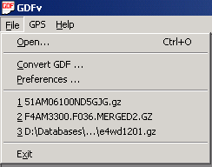

Recently Opened GDFs

* 1. Select a file that is either a .GZ compressed GDF or an uncompressed GDF[1].
  2. After some processing and indexing, the main GDF browsing window will open. See Browsing the GDF

The first time a GDF is opened some indexes will need to be built. Next time the same GDF is opened, the indexes, which are stored on disk, will be re-used so there will be no lag time.

During the opening phase, once the indexing is finished, GDFv will ask if an information file needs to be stored. Answering ‘*yes’* will enable fast reopening of the same GDF next time.

Both uncompressed GDFs or compressed GDFs can be opened. GDFv now only supports GZIP compressed (files with extension .GZ). See Converting the GDF.

## Preferences

* 1. The Preferences menu enables certain default behaviours.
  2. Select “*Preferences...*” from the “*File*” menu.  
        
       
     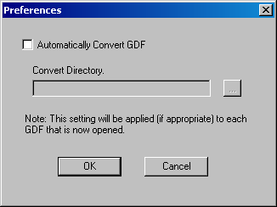
  3. If selected, this option will automatically decompress any .GZ file that is opened into the specified Convert Directory.
  4. The default behaviour at startup is to NOT Automatically Convert GDFs
  5. If the Convert Directory is left blank then the GDF will be decompressed into the same directory as the compressed file. NOTE: This will fail if the GDF is located on a CD/DVD.
  6. Once converted, the viewer will automatically start viewing the decompressed file.
  7. If the the decompressed file already exists at the specified location then it will be used immediately, without any conversion being needed.

## Accessing GDF Help Documentaiton

* 1. The GDF Ready Reference PDF is available from the Help pull down menu

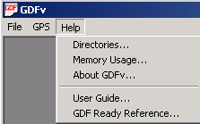

Load Ready Reference PDF

## Setting Default Directories

1. Default directories used by GDFv may be defined through the Help/Directories... menu



Set Storage Directories

1. A new dialogue box will open allowing you to specify the following default directories:
   1. Default location for reading GDFs
   2. Default location for storing intermediate files used for indexing the GDF to speed up access
   3. Default directory where converted GDFs will be stored (primarily used when original GDF is on CD or DVD). This may also be set in the Preferences menu dialog.

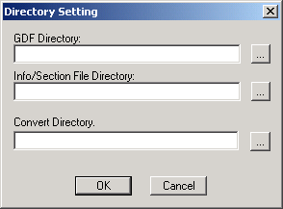

## Browsing the GDF

After a GDF is opened, the GDF Browsing Window will appear:

**A**

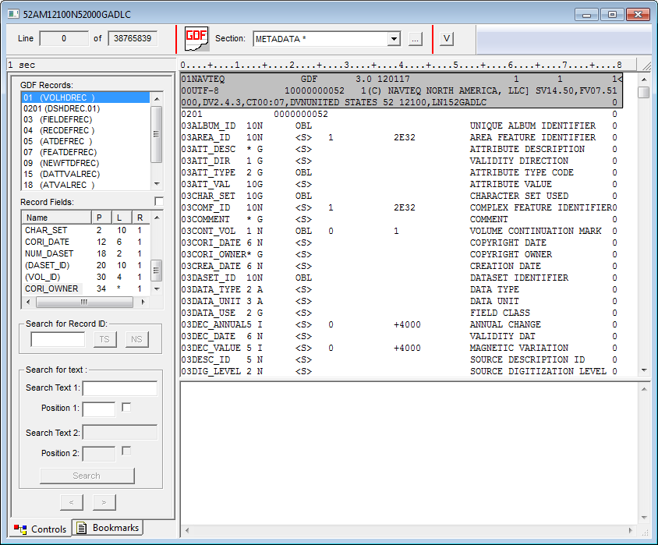

**F**

**G**

**K**

**ML**

**J**

**E**

**C**

**I**

**H**

**D**

##### B

**L**

**ML**

1. The current GDF line and the total number of lines in the GDF. Each GDF line is 80 characters.
2. Pull down control. This control allows the selection of a specific GDF section, including the metadata section. Clicking on the “…” button opens a window with additional information about each section. Clicking on the “V” button shows the GDF map for the current section. See Viewing the GDF map. Note that some GDFs may have only one section, called “dummy”.
3. Shows the time elapsed to open the GDF, in seconds.
4. Ruler to count position of fields and characters in the GDF. Ruler goes from position 0 (first character) to 79 (last character).
5. Shows available GDF record types in the current GDF section. This information is taken from the HERE GDF metadata. Clicking on a specific record type will jump among record types in the current section (the current section can be changed with B).
6. Shows GDF field definition for currently selected GDF record. In the list the following values are present:
   1. Name = Field Name
   2. P (Position) = Field Position
   3. L (Length) = Field Length
   4. R (Row) = Row within the current record, counting from 0.

This information is taken from the GDF metadata.

By clicking on a field the corresponding value in the GDF text view is shown.

1. Searches for a specific GDF record ID within the currently selected record type (selected with E). Click on the “TS” button to search within the current section only or click on the “NS” button to search starting from the next section.
2. Searches for text. Up to two different texts can be specified, one in Search Text 1 and the other in Search Text 2. A position within the record (from 0 to 79) can also be specified for each text, using “Position 1” and “Position 2” and ticking the box next to “Position 1” and “Position 2”.
3. Moves the view back and forward, jumping to the last or next selected record in the view.
4. This is the main text view of the GDF.
   1. Text can be selected with the left mouse button and then copied with Ctrl+C.
   2. Clicking on the view with the right mouse button will highlight and select the current GDF field.
   3. Double-clicking on the view with the right mouse button will move the GDF to the corresponding record pointed to by the field if the field is a record pointer.
   4. Leave the mouse pointer over a field for a moment and a description of the field will appear. For name record pointers, the name itself will appear.
5. This is an edit box where notes can be taken and text can be copied and pasted from the main text view during GDF browsing.
6. Switches between “Controls” and “Bookmarks”. Under “Bookmarks”, bookmarks can be added pointing to specific positions in the GDF to quickly return to the same point later on.

## Increasing / Decreasing the Font Size

The font size of the GDF Browsing Window can be increased or decreased from the “*View*” menu.

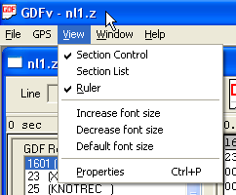

## Viewing the GDF Properties

GDF Properties can be viewed by selecting “*Properties*” from the “*View*” menu.



In the property window information about GDF Attributes, Feature Classes and Record Fields is shown. This information is taken directly from the GDF metadata.

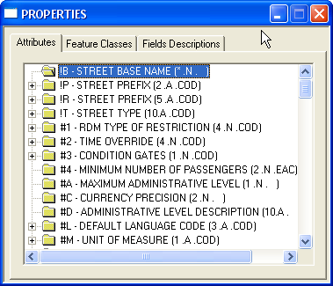**Attributes:** List of all GDF attribute codes and descriptions. For each of the attributes, this screen also lists all the valid attribute values.

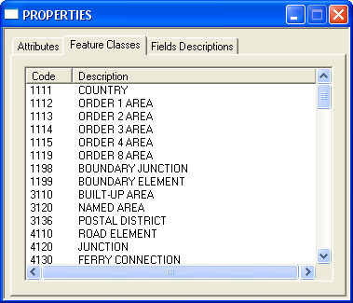**Feature Classes:** List of all GDF feature classes with corresponding code and description.

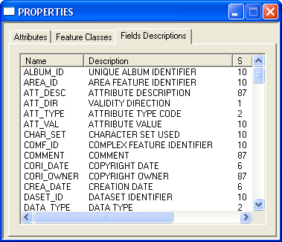**Field Descriptions:** List of all GDF record fields with corresponding Description, Size (S), Type (T), Blank Value, Min and Max.

## Change the GDFv Settings

* 1. Select “Settings” from the “Help” menu.

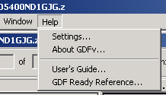

* 1. Settings Window will open.

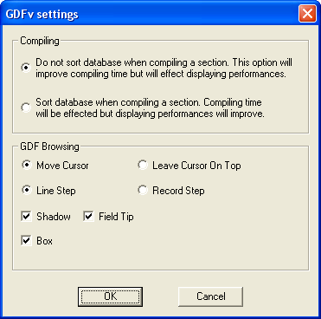

1. Selects between fast compilation of a section or displaying performance.

**A**

1. Selects between moving the cursor in the GDF Browsing Window and always leaving the cursor at the top.

**B**

1. When stepping up or down the browsing view, do a line step or a GDF record step.

**C**

**D**

1. Enable record shadow, field tip and box.

## Viewing the GDF map

GDFv visualizes a section of the GDF at a time.

* 1. Position the browsing view to the section to be visualized.
  2. Click on “V”.

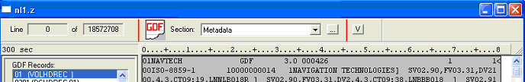

* 1. If the section has not been visualized before, GDFv will start compilation. Compilation consists of 4 scans. If the section has been visualized before, a “**\***” next to the section name will be present. In that case compilation will not be needed again and the section will be visualized instantly.
  2. At the end of compilation the GDF Map Window will open.

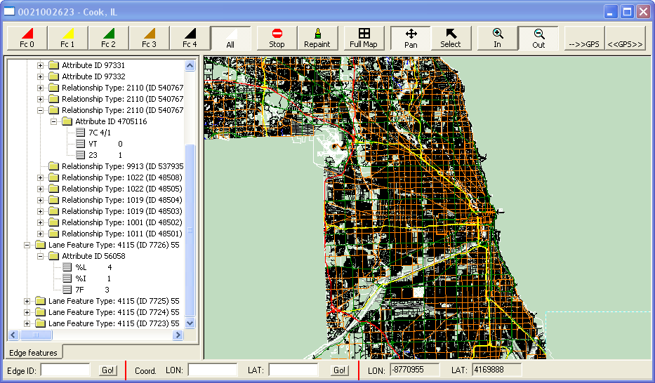

###### F

###### E

**D**

**C**

**B**

**A**

###### J

###### K

###### I

**H**

**G**

1. Selects which Functional Road Classes to show in the map. “*FC0*” means “Show all line features (links) with Functional Road Class equal to 0 or greater, “*FC1*” means “Show all line features (links) with Functional Road Class equal to 1 or greater, and so on. “*All*” means “Show everything, also non-roads elements (e.g. rivers, boundaries, etc.)”
2. *Stop* drawing immediately. *Repaint* immediately.
3. Repaint full map.
4. These 2 buttons control the functionality of the **left** mouse click on the map. If “Pan” is selected, clicking with the left mouse button on the map will pan the view. If “Select” is selected, clicking with the left mouse button on the map will select an edge (link).
5. These 2 buttons control the functionality of the **right** mouse click on the map. If “In” is selected, clicking with the right mouse button on the map will zoom in the view. If “Out” is selected, clicking with the right mouse button on the map will zoom out the view.
6. “-->>GPS” will zoom in the map around the current GPS location (if location is available). “<<GPS>>” will move the map and track the GPS location (e.g. map will move on current zoom level while GPS is moving). See GPS Tracking on how to setup the GPS
7. GDF map.
8. Shows attribute and feature information (including lane feature if available) about the selected edge element. An edge (link) on the map can be selected by clicking on it, after having set the control D to “select”.
9. Selects an edge (link) via its ID.
10. Zoom map to X,Y location.
11. Shows longitude and latutude of the current mouse pointer on the map.

## Converting the GDF

The GDFv program can open/read GDF uncompressed file and GDFs compressed GZIP (extension .GZ). The best performances are achieved with uncompressed GDF. But uncompressed GDFs also take up a lot of space on the disk. GDFv can convert GDFs between compressed and uncompressed formats.

Note that UTF-8 GDFs can NOT be viewed from their compressed format and must be converted.

* 1. Select “Convert GDF” from the file menu.



* 1. The GDF conversion window will open.

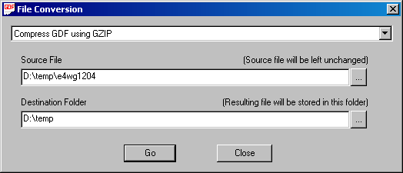

**D**

**B**

**A**

**C**

1. Selects which type of file conversion to perform.
2. Selects the Source File. The source file is the original file to be converted. The source file will be left unchanged, so this can be also a file on a read-only medium. Type the file name or click on “…” to browse.
3. Selects the Destination Folder, the folder where the resulting file from the conversion will be placed. Normally this is on the Hard Disk. Type the folder name or click on “…” to browse.
4. Click on “Go” when done with selections.

Once conversion is done, the new file can be opened with GDFv.

## GPS Tracking

GDFv can read standard NMEA GPS via the COM port.

* 1. To setup the GPS select “Status” from the “GPS” menu.

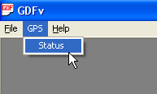

* 1. GPS Status Window opens.

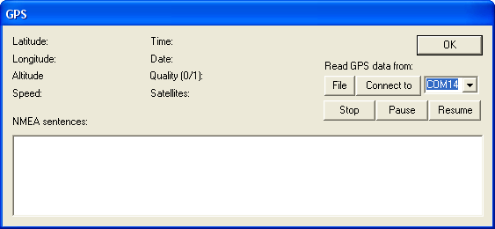

**A**

**B**

**E**

**D**

**C**

1. Shows GPS data once connected.
2. Reads GPS data from a file or connects to a COM port. To connect to a GPS device:
   1. Attach the GPS device to a COM port.
   2. Select the COM port to which you have attached the GPS device in (B).
   3. Click on “Connect to”.
   4. If successfully connected NMEA sentences will be shown in (D) and GPS extracted data in (A)
3. Stops, Pauses or Resumes the GPS data.
4. Shows NMEA sentences read from connected GPS device.
5. Click on “OK” to close window. Once the GPS device is connected you can track its position on the GPS map. See “Viewing the GDF map”

## Tips and Known Issues

* When opening a GDF compressed with GZIP format (.gz), the GDFv program may show the error “Can not allocate enough computer memory to handle the GZIP file”. In this case the best workaround is to uncompress the GDF. For help decompressing see the Preferences options and Converting the GDF.
* Performance when working with large .GZ files can be improved by increasing the amount of memory used by GDFv. Use the Memory Usage... option of the Help menu BEFORE opening a GDF:



* + In the following dialog box enter the amount of memory to be used by GDFv to process .GZ format GDFs. The default is 200MB, increasing this value will result in other applications on the computer running more slowly. This value should always be determined with consideration being given to how much memory (RAM) is installed in the computer running GDFv.

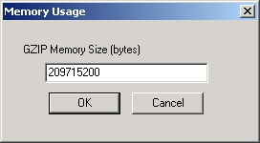

## Error Messages

When opening a GDF the following errors may be encountered:

* Error Message:

Unable to open GDF file for reading

An error occurred trying to open the GDF. Please verify the file access permissions.

* Error Message:

GDF file is too big

The GDF is too large for the viewer to process. Please contact your HERE TCS representative for advice.

* Error Message:

GDF file is empty

An attempt has been made to open an empty file. An incorrect file has been chosen, please retry with a different file.

* Error Message:

Can not open GDF file, not enough memory

The viewer has run out of memory. Close some applications OR decrease the viewer memory usage. See Tips and Known Issues.

* Error Message:

GDF path is too long

The full path to the GDF is too long for the viewer to manage. Please copy the GDF to a location with a shorter path name.

* Error Message:

Incorrect GDF line length. Not equal to 80 characters

An error has been found in the GDF. The GDF may be corrupt or an incorrect file has been opened. Check that the correct file is being opened.

* Error Message:

Error in GDF

An error has been found in the GDF. This may be due to opening a non HERE GDF.

* Error Message:

Error opening GDF

An error has been encountered opening the GDF. Retry with a different file.

* Error Message:

Error: Unable to process compressed UTF-8 GDF.

Please uncompress first or use Automatic Convert Preference

UTF-8 GDFs must be uncompressed before opening. See either section 3.Preferences or section 11.Converting the GDF

* Error Message:

Only GZIP compressed GDFs are currently supported

The viewer is only able to process GDFs that are either uncompressed or compressed in the GZIP compression format. GZIP compressed files typically end in the extension .GZ.

## GDFv License Agreement

This Agreement ("Agreement") is between you, the End User, and HERE International B.V. ("HERE"). The Agreement authorizes you to use HERE GDFv, under the terms and conditions set forth below.

Read this Agreement carefully before installing HERE GDFv. By clicking on the "I Agree" button, you agree to the terms and conditions of this Agreement. If you do not agree to all of the terms and conditions of this Agreement, please click the "I Decline" button and cancel the installation. YOU AGREE THAT YOUR USE OF HERE GDFv ACKNOWLEDGES THAT YOU HAVE READ THIS AGREEMENT, UNDERSTAND IT, AND AGREE TO BE BOUND BY ITS TERMS AND CONDITIONS.

1. License. HERE grants you a non-exclusive, non-transferable, non-sublicensable, restricted right to use HERE GDFv solely in combination with a license for HERE geographical data.
2. Term and Termination. This Agreement is effective from the date you install HERE GDFv. It shall expire on the date (i) you delete HERE GDFv from your system, or (ii) your license for HERE geographical data expires. HERE may terminate this Agreement at any time in the event of any breach by you.
3. Restrictions. You may copy or reproduce HERE GDFv for your internal use only. Any copies made of HERE GDFv shall be subject to the provisions of this Agreement. You may not sell, transfer, distribute or otherwise convey HERE GDFv to any third party whatsoever, except with HERE's prior written authorization. You may not reverse engineer, reverse compile, disassemble or otherwise attempt to discover the source code of HERE GDFv or create derivative works based on HERE GDFv.
4. Ownership/Assignment. HERE is the owner of HERE GDFv, including all intellectual property rights thereto. Nothing stated herein shall be deemed to grant, transfer, assign or set over unto you any right, title, interest or ownership of HERE GDFv, all of which is hereby expressly reserved by HERE. You may not assign your rights or obligations under this Agreement.
5. Disclaimer and Limitation. HERE GDFv is provided “as is” and HERE makes no representations or warranties. HERE expressly disclaims any implied warranties or conditions of any kind, including, without limitation, any warranty or condition of quality, performance, merchantability, fitness for a particular purpose or noninfringement. HERE does not warrant, guarantee, or make any representations regarding the use, or the results of the use, of HERE GDFv or any other materials in terms of correctness, accuracy, reliability, or otherwise. To the maximum extent permitted by law, HERE shall not be liable for any damages, whether direct, indirect, special, incidental, or consequential (including but not limited to lost profits, lost data, lost revenue, lost savings, lost business and loss of goodwill), arising out of your use or possession of HERE GDFv or from any defect. Notwithstanding the foregoing, in no event shall HERE’s liability with respect to this Agreement exceed five hundred (500) euro.
6. Indemnity. You agree to indemnify and hold harmless HERE from and against any and all claims, liabilities, losses and expenses, including reasonable attorneys' fees, arising out of your use of HERE GDFv.
7. Governing Law. This Agreement shall be construed in accordance with the laws of The Netherlands under the sole jurisdiction of the Dutch courts. The United Nations Convention of Contracts for the International Sale of Goods shall not apply to this Agreement.

1. Note that UTF-8 format GDFs cannot be opened if they are also .GZ compressed. See notes on converting GDFs to produce uncompressed files needed for UTF-8 data.