Step 1 : visit terraform.io page

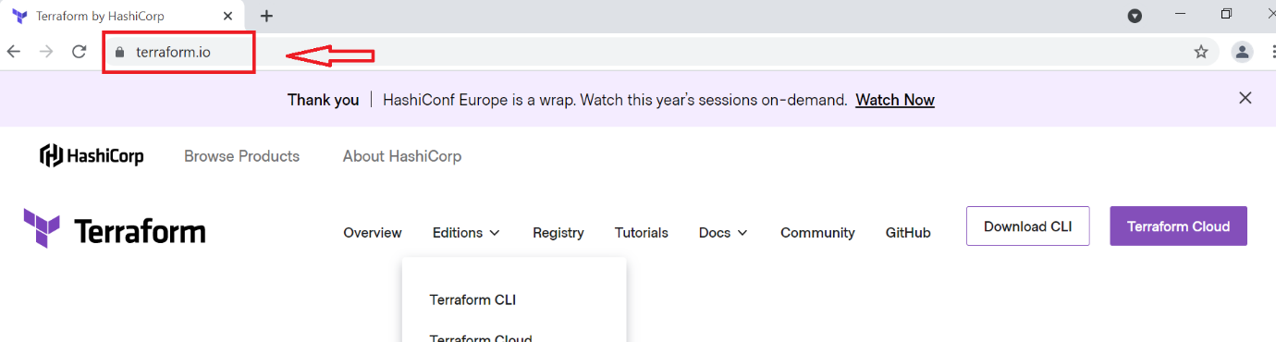

Step 2 : click on Download cli

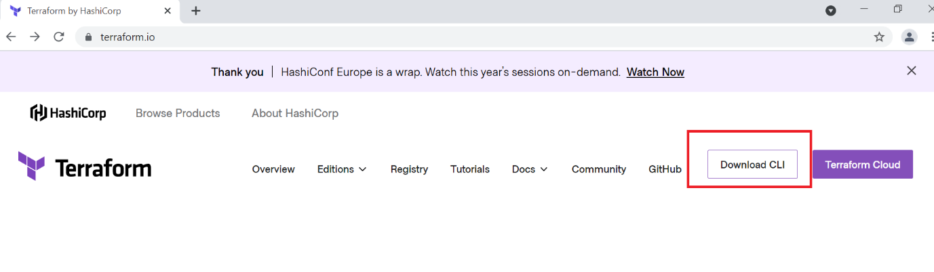

Step 3 : click on windows 64 bit to download it

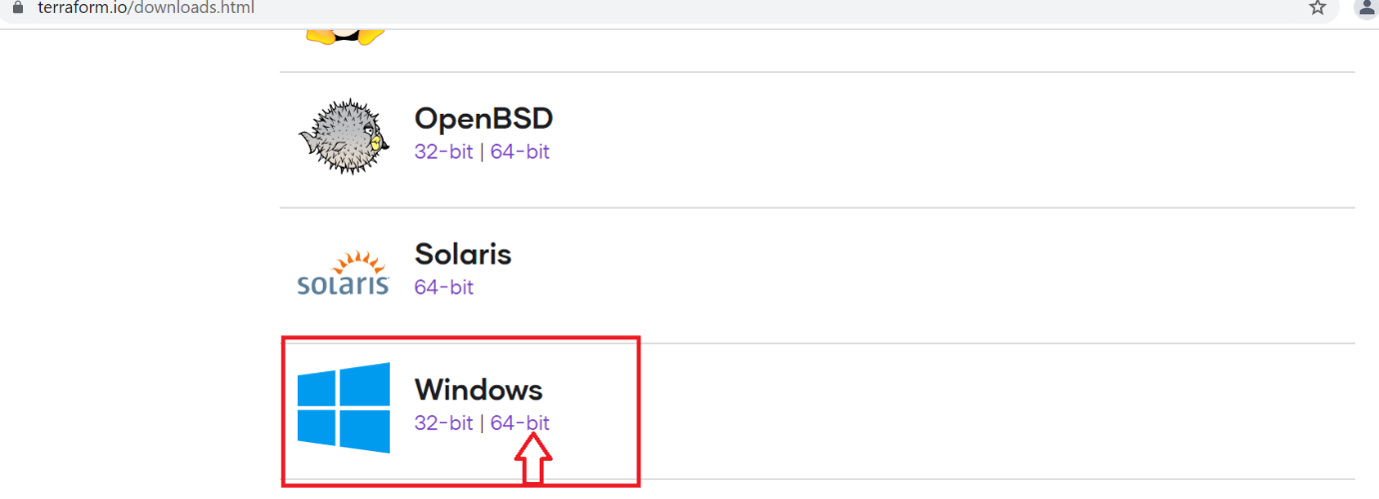

Step 4 : navigate to your downloads folder to unzip the terraform folder downloaded

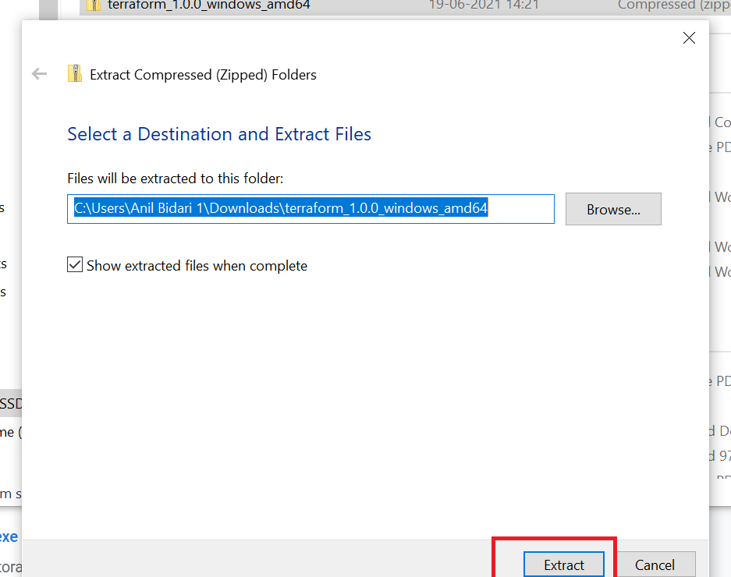

Step 5 : copy the terraform exe file

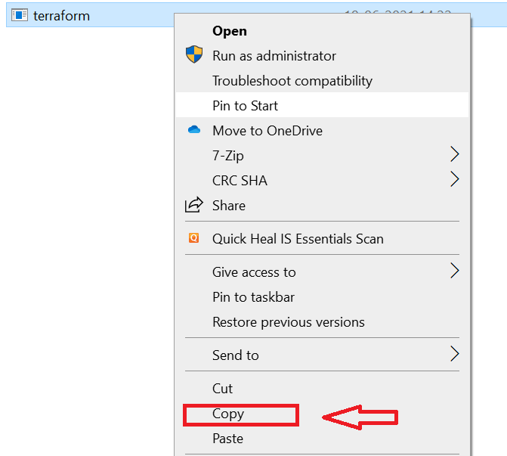

Step 6 : create a new directory named as terraform in c drive and save the exe file over there in it and copy the path of your folder in c drive

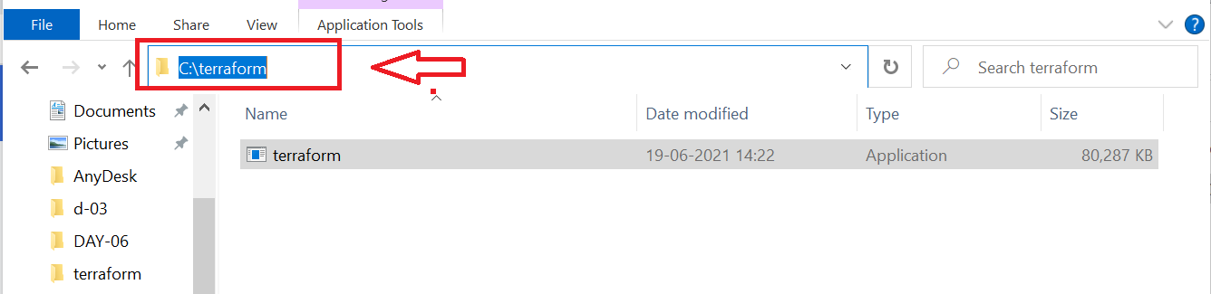

Step 7 : search with environment variables on your system and click on it

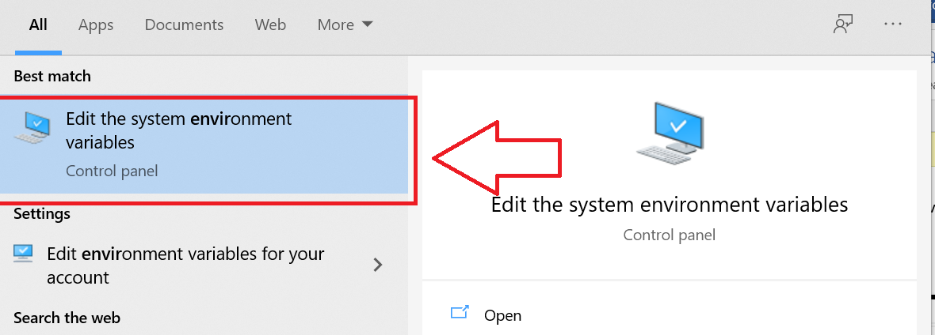

Step 8: click on environment variables

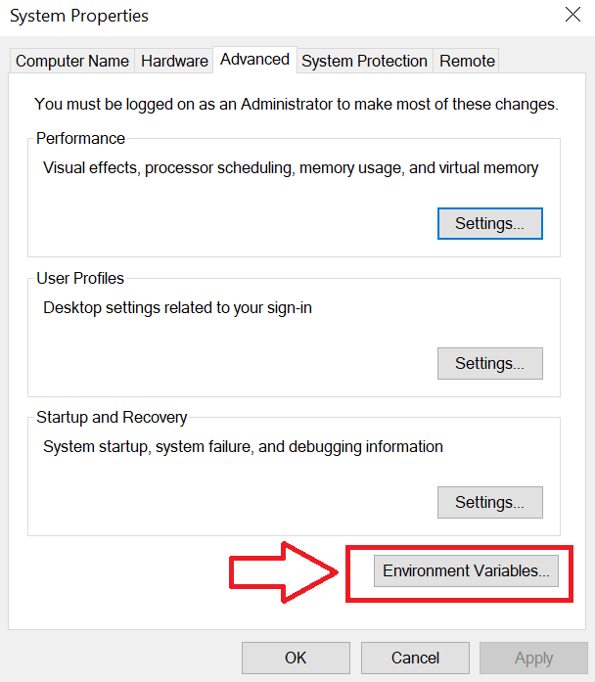

Step 9: click on path and then click on edit

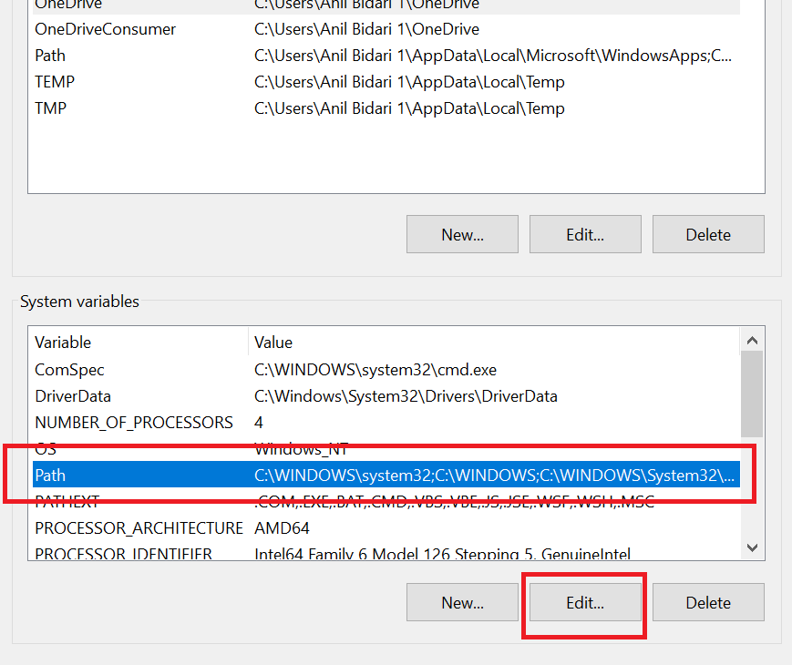

Step 10 : click on new

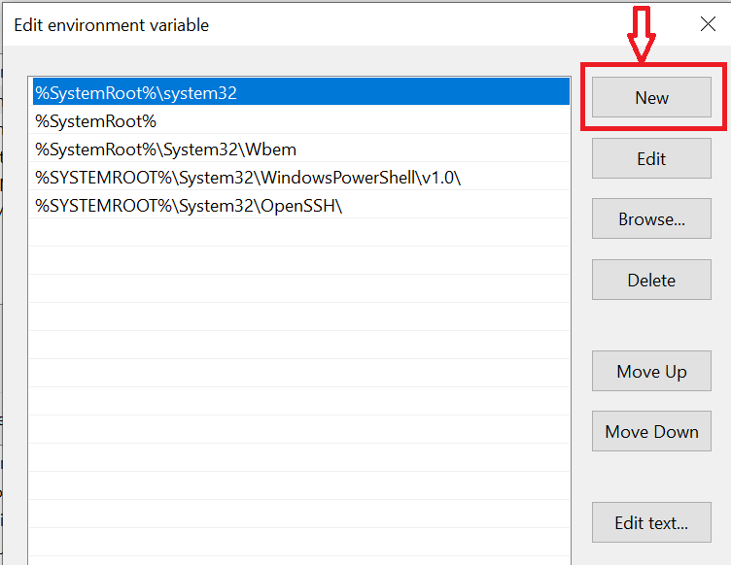

Step 11 : provide your terraform folder path and click on ok ok and ok

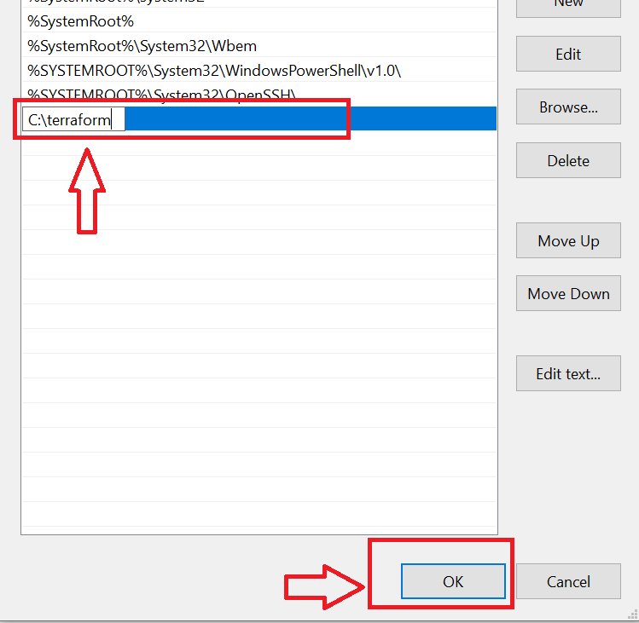

Step 12 : open cmd and run as administrator

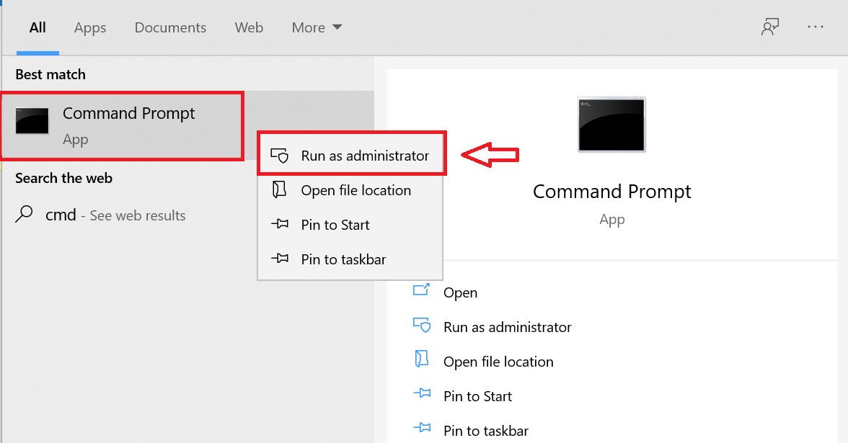

Step 13 : check with terraform -v command to verify your installation and configuration of terraform is done successfully on windows

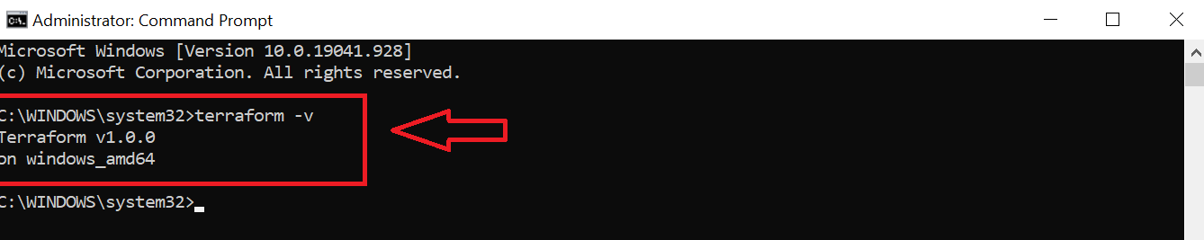

----------------------------------------complete--------------------------------------------------------