Step 1 : visit the below site to download visual studio code

<https://code.visualstudio.com/download>

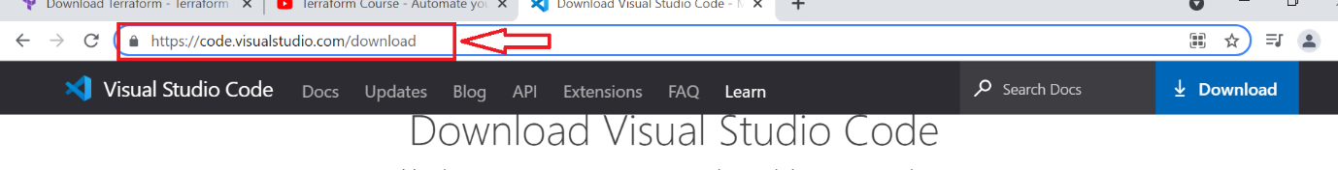

Step 2 : click on the windows link to download the visual studio code on your system

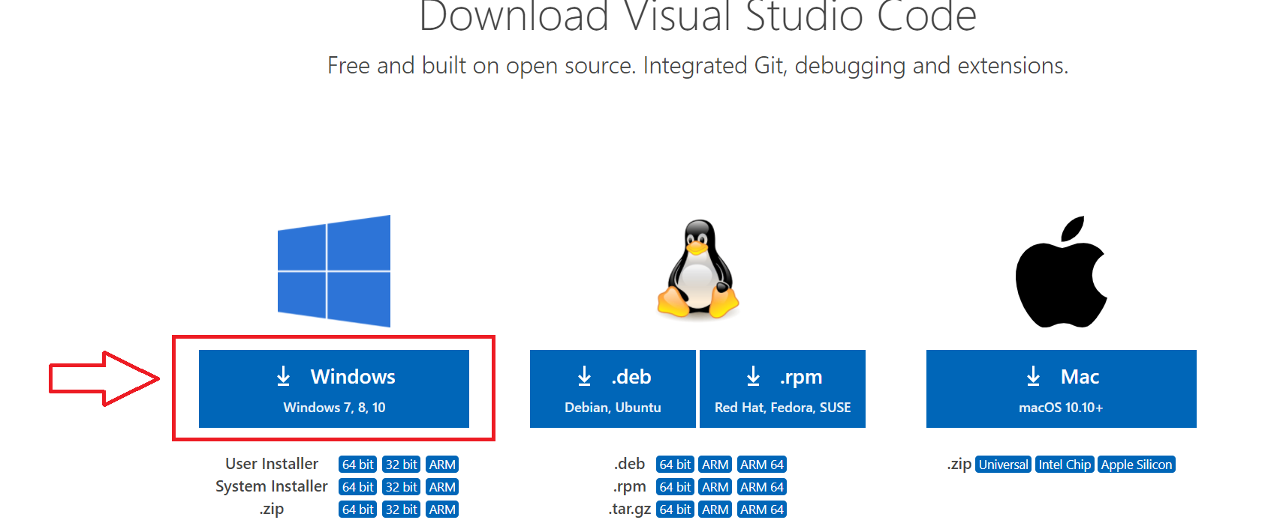

Step 3 : once downloaded run the exe file of visual studio code to get it installed on your system

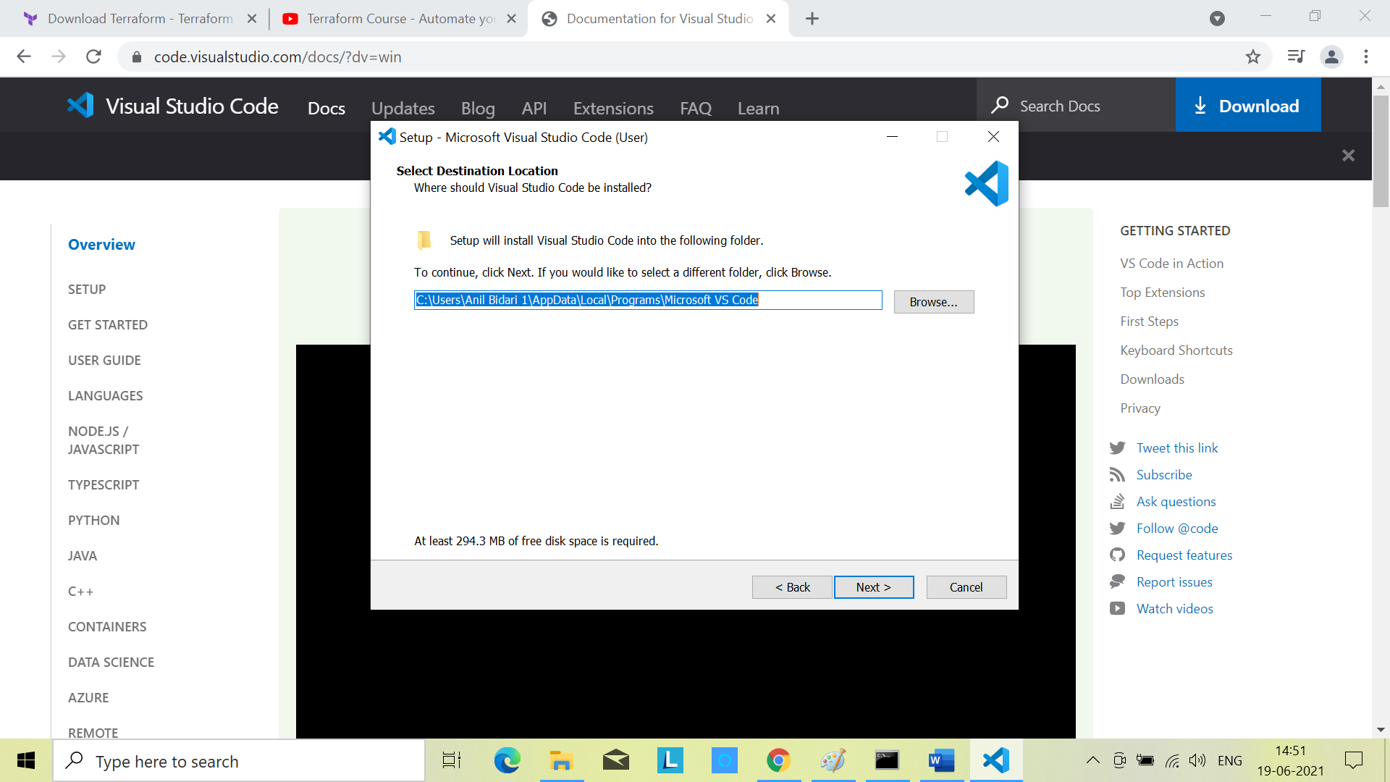

Step 4 : once installation is done open the visual studio code editor and click on the shown link for extentions

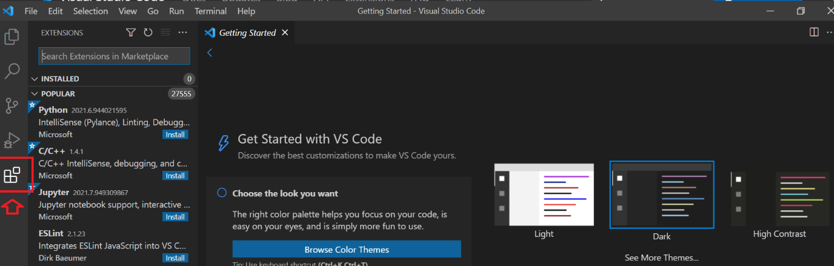

Step 5 : search with terraform and select the terraform from hashicorp and click on install to install it

