Computer science

Project

C++

Factorial

Permutation and combination

Ankit joshi

Class 11sci

Roll no. 05

**INDEX**

1. Acknowledgement
2. Introduction
3. User manual
4. System requirement
5. Functions
6. Source code
7. Merits and demerits
8. Bibliography

**ACKNOWLEDGEMENT**

I acknowledge my sincere regards to my computer science teacher Mr. Avinash Kulkarni sir for his valuable guidance while working on this project . I would also like to thank our principal madam Shastri , without whose motivation this it would have not been possible for me to complete this project.

Lastly I would like to thanks my friends who helped me throughout my project.

**Introduction**

This is a c++ programme to calculate factorial, permutation and combination of any number given by user by using turboc7. In mathematics, calculation of factorial, combination and permutation is time consuming, this programme minimizes the calculation time. It allows the user to choose the option.

Factorial= n!=n*(n-1)*(n-2)*(n-3)*(n-4)*....2*1

Permutations= npr=n!/(n-r)!

Combination=ncr=n!/r!(n-r)!

**System requirements**

Language of programme : C++

Application: turbo c7

Windows: windows 7 or more

RAM: 2GB or more

**User manual**

1. **Open turboc7, then click on file and click on open**

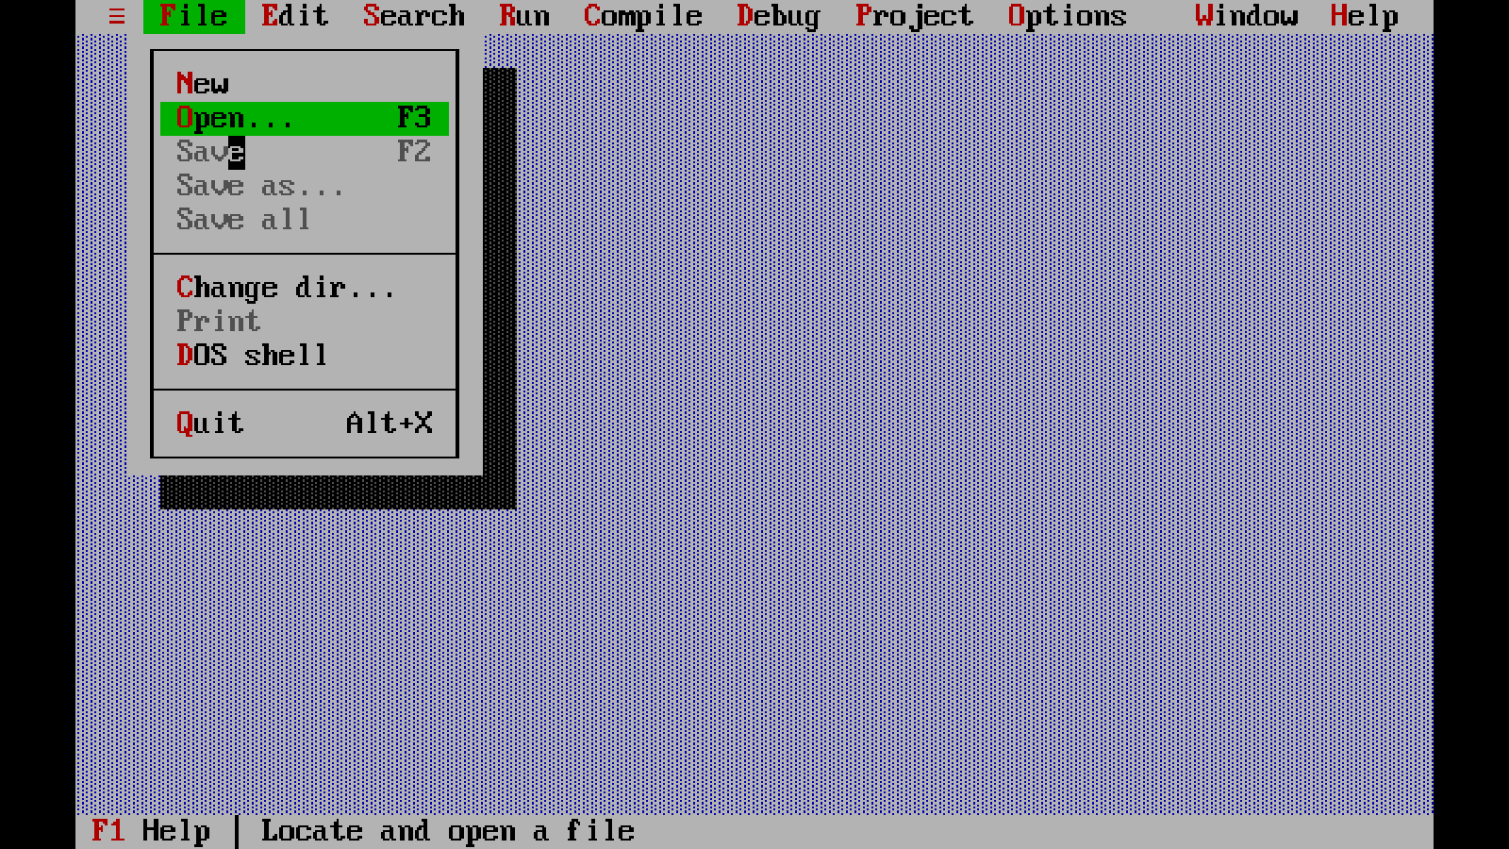

1. **Type projectpnc.cpp in search box and then click enter.**

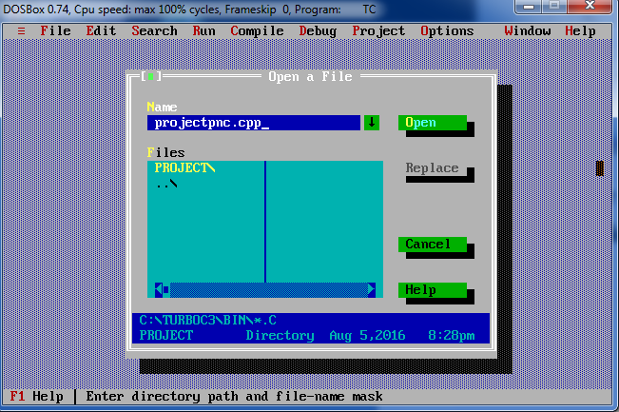

1. **After opening the programme, click on compile.**

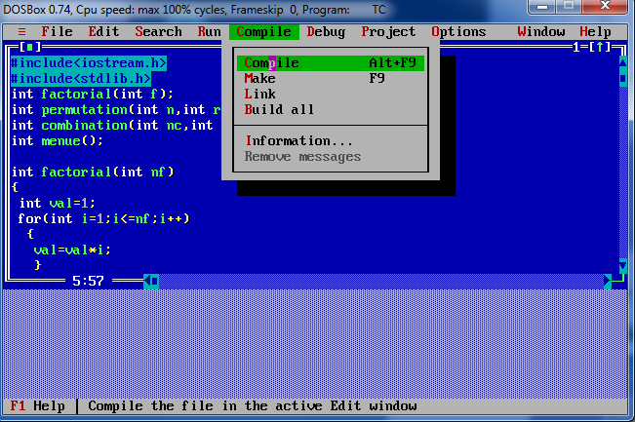

1. **After compiling message will flash of 0 error after that click on run.**

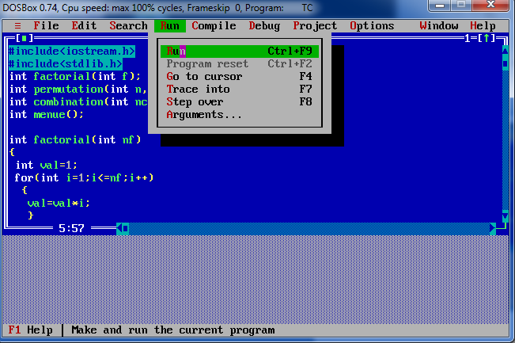

1. **After running the programme the output screen will come consisting of a menue for calculating factorial, permutation and combination.**

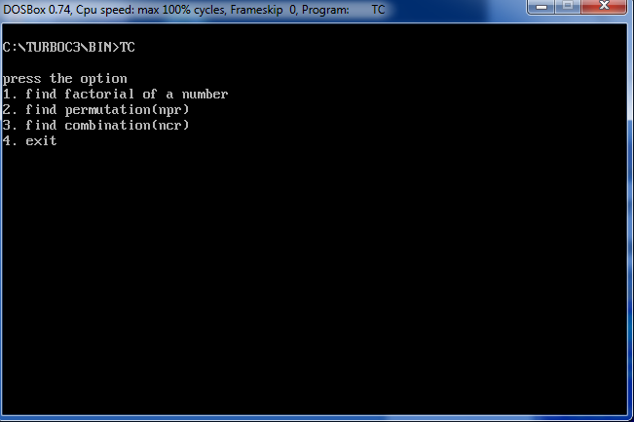

**Case 1 Factorial**

1. If user have to calculate the factorial press 1 from the keyboard. After pressing 1 user can give the value whose factorial is to be counted.

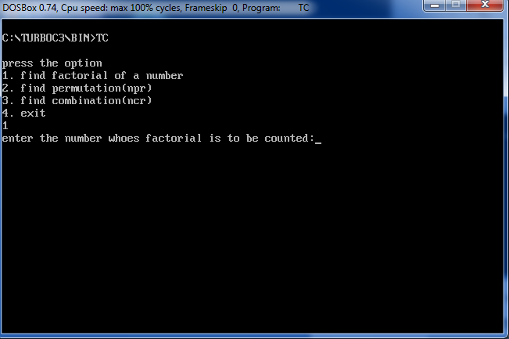

1. After entering the number whose factorial is to be counted it will give you the output.(example 3)

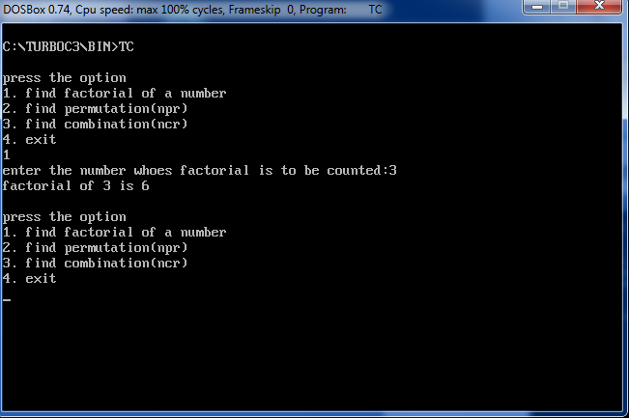

**Case 2 permutation**

1) If user wants to calculate permutation(npr).press 2 from keyboard and press enter. After pressing enter, give the value n and r.

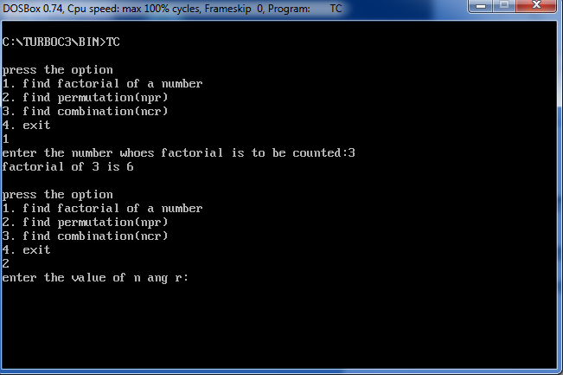

2) After giving the value n and r it will give you the output (example n=5,p=2)

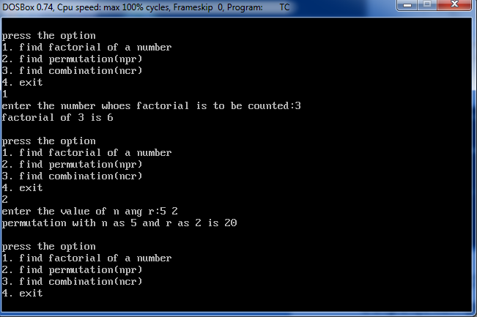

**Case 3 combination**

1) if the user want to calculate the combination(ncr). Press 3 from keyboard and then press enter. After pressing enter give the value of n and r.

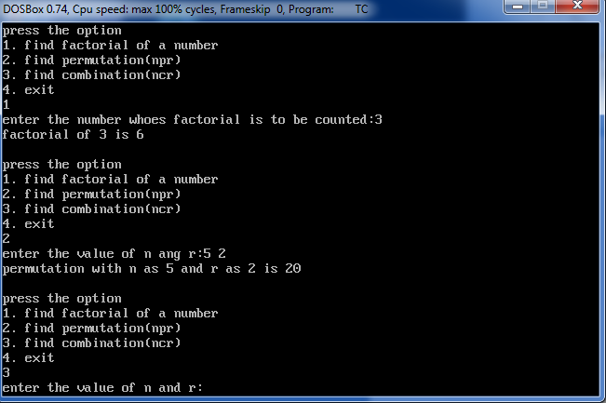

2) After giving the values of n and r it will give you the output.(for example n=5,r=2)

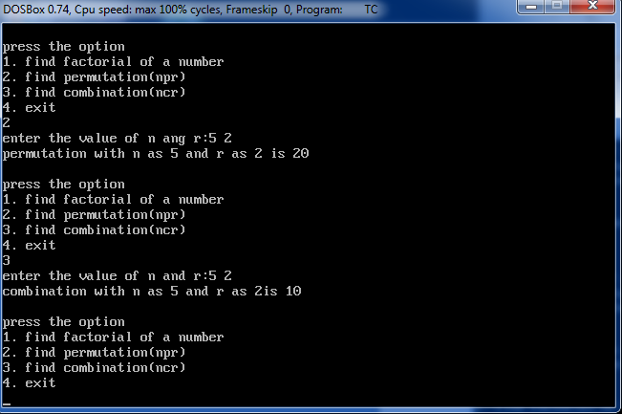

**Case 4 exit**

If user wants to exit from programme press 4 from keyboard and then press enter user will be back to input programme.

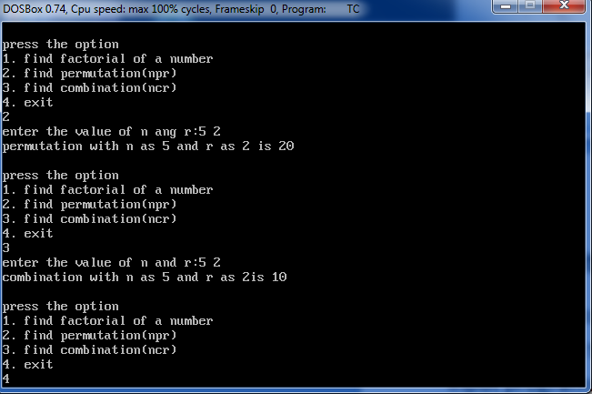

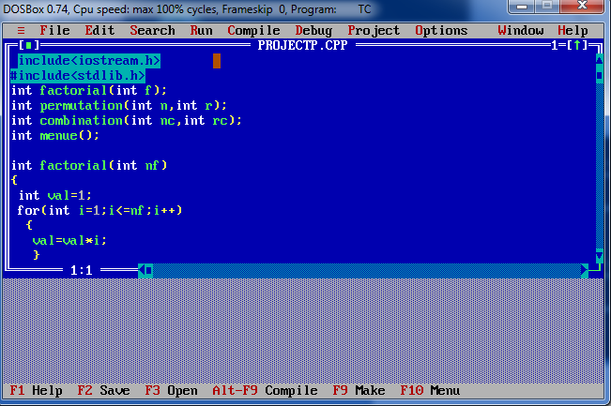

Algorithm

1) **The files included in programme are iostream.h and stdlib.h.**

**2) then function prototypes are given**

int factorial(int f);

int permutation(int n,int r);

int combination(int nc,int rc);

int menue();

**3) After that each function is defined.**

**Factorial function(nf!)** -1 is assigned initially to **val** wich is int data type. then by using **for** loop taking **i i**nitially as 1 it will be multiplied to **va**l whoes result is again assigned to **val**. Then value of i will be incremented by 1 and it will continue to be in loop until it is lower than user given number(**nf**).then the final value of val is returned.

**Permutation function (nPr)**- **num,den, val1 ,final** are int data type. Factorial of **n** is calculated and assigned to **num**. the the difference of n and r is assigned to val1 whose then factorial. Then final result

is provided by assigning the value of division of **num** and **den** to final. The value of **final** is returned

**Combination function (ncCrc)- num, den, val1, final** are int data type. The value of factorial **nc** is assigned to num. thendifference of **nc** and **rc** is assigned to val1.then the product of factorial **nc** and rc is assigned to den. At last division of num and den is assigned to final and it is returned.

**Menue function-** it is menue of option that user have to choose.

**4) Now in main do while loop is used. there is switch statement in loop which uses menue function. It takes the option from user and display respectively the result.**

if option is 1 then it will ask user to enter number(n). By using factorial function it will calculate factorial and display the result.

If option is 2 it will take values of n and r from user and by using permutation function it will calculate permutation and display the result.

If option is 3 it will take value of n and r and by using the combination fuction ti will calculate combination and display the result

If option 4 it will use exit function.

If any other option is used it will display “wrong option, please see the option.

This will continue until the true value of option is given.

**User defined function**

**1)** factorial(num)

2) permutation(ni,ri)

3) combination(nci,rci)

4) menue()

**Built in function**

1)exit() 2)main()

**Source code**

/* Name: ankit joshi

class: 11 sci

roll num:05

Topic: factorial, permutation and combination.

*/

#include<iostream.h>

#include<stdlib.h>

int factorial(int f);

int permutation(int n,int r);

int combination(int nc,int rc);

int menue();

int factorial(int nf)

{

int val=1;

for(int i=1;i<=nf;i++)

{

val=val*i;

}

return val;

}

int permutation(int n,int r)

{

int num,den,val1,final;

num=factorial(n);

val1=n-r;

den=factorial(val1);

final=(num/den);

return final;

}

int combination(int nc,int rc)

{

int num,den,val1,final;

num=factorial(nc);

val1=nc-rc;

den=(factorial(rc)*factorial(val1));

final=num/den;

return final;

}

int menue()

{

int option;

cout<<" \npress the option"<<endl;

cout<<"1. find factorial of a number"<<endl;

cout<<"2. find permutation(npr)"<<endl;

cout<<"3. find combination(ncr)"<<endl;

cout<<"4. exit"<<endl;

cin>>option;

return option;

}

main()

{

do

{switch(menue())

{

case 1:int num;

cout<<"enter the number whoes factorial is to be counted:";

cin>>num;

cout<<"factorial of "<<num<< " is "<<factorial(num)<<endl;

break;

case 2:int ni,ri;

cout<<"enter the value of n ang r:";

cin>>ni>>ri;

cout<<"permutation with n as "<<ni<<" and r as "<<ri<<" is "<<permutation(ni,ri)<<endl;

break;

case 3: int nci,rci;

cout<<"enter the value of n and r:";

cin>>nci>>rci;

cout<<"combination with n as "<<nci<<" and r as "<<rci<< "is "<<combination(nci,rci)<<endl;

break;

case 4:

exit(0);

break;

default: cout<<"wrong choice.please see the options again"<<endl;

}

}while(1);

}

**Merits, demerits and further scope**

**Merits**

1) It reduces the calculation time.

2) The programme is very easy to use for user.

**Demerits**

1) It directly show result and don’t show how it is calculated

2) It does not calculate factorial, permutation and combination of decimal number and negative number

**Further scope**

1) calculation of factorial, permutation and combination of decimal number(gamma function) and negative number can be calculated.

2) more mathematical function can be added like differentiations, integration etc.

**Bibliography**

1) Computer science with c++ by sumita aurora.

2)google.com