Project Idea for ECE 337
UART TO HDMI CONVERTER

Thor Smith

Chun Ta Huang

Zuguang Xiao

Hang Xie

Description:
This project will convert UART input like that of Lab 5 and output an HDMI compliant signal using HDMI 1.1, 1.2, or 1.3. The design will make use of two buffers to keep a consistent display. The intended use of this ASIC is to allow a microcontroller to easily output HDMI using a protocol available on most microcontrollers, UART. This design is more appropriate for an ASIC because a microprocessor will have to compete with instruction latency to output a smooth HDMI signal. An ASIC can remove any time delays associated with heavy data processing and allow another device to input the necessary data at it's leisure while still maintaining a steady output signal.

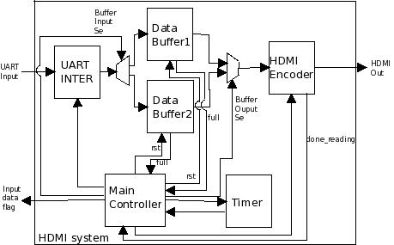

Block Diagram:

