Homework 4: Packaging Specifications and Design

Team Code Name: Augmented Reality Group No. 5
Team Member Completing This Homework: Steven Ellis
E-mail Address of Team Member: ellis15 @ purdue.edu
§
NOTE: This is the first in a series of four “design component” homework assignments, each of which is to be completed by one team member. The body of the report should be 3-5 pages, not including this cover page, references, attachments or appendices.

Evaluation:

SEC | DESCRIPTION | MAX | SCORE
1.0 | Introduction | 5
2.0 | Commercial Product Packaging | -
2.1 | <Product #1> | 10
2.2 | <Product #2> | 10
3.0 | Project Packaging Specifications | 20
4.0 | PCB Footprint Layout | 10
5.0 | Summary | 5
6.0 | List of References | 10
App A | Project Packaging Illustrations | 10
App B | Project Packaging Specifications | 10
App C | PCB Footprint Layout | 10
 | TOTAL | 100

Comments:
- Introduction
Our project is a multiuser augmented reality system, consisting of one or more headsets communicating with each other through a central control unit (CCU). Therefore the packaging will consist of two main separate components, that of the headset and the CCU. The headset packaging is particularly important since it is where the vast majority of user interaction will occur. It will need to provide the display overlay on top of the user’s vision, position all antennas such that signal strength is not adversely affected, stay securely on the user’s head, and be reasonably comfortable for extended periods of use. The goals of the CCU packaging are to provide good antenna placement and an input method to configure the software at initial boot. The CCU packaging is much less interesting than the headset and will thus only take up a small fraction of the report.
The project specific success criteria have not changed since the last report, and are:
- An ability to render graphics based on the orientation of the user’s head.
- An ability to render graphics based on the user’s current geospatial location.
- An ability to monitor and display the battery power level of the headset to the user.
- An ability to monitor and display the status and quality of the wireless connection to the central control unit.
- An ability to load headset graphics for a new simulation without re-flashing software on the headset’s microcontroller.

- Commercial Product Packaging

  - Product #1
Epson Moveria BT-100 [1]
The BT-100 is an augmented reality headset resembling a large pair of sunglasses. It uses a pair of projectors mounted in the sides of the frame aimed at pieces of half-mirrored beam splitter glass in front of the user’s eyes. This provides a transparent overlay on normal vision to achieve the augmented reality effect. The primary benefit of this approach is that the user’s normal vision is retained, not blocking out peripheral vision or introducing problems from the camera. The most obvious downside is that due to the display’s transparency, bright ambient light can reduce visibility. Also, if no eye tracking is integrated into the system, the augmented overlay will not line up with the user’s vision if they are not looking straight ahead. Additionally, the optics required for such a system to allow the user’s eyes to simultaneous focus on both the display and background would be extremely difficult and expensive to duplicate. Thus our implementation of the beam splitter optics does have the issue of not being able to focus on the display and background simultaneously.

  - Product #2
Vuzix WRAP 1200AR [2]
The WRAP 1200 AR is an augmented reality headset with a package resembling a pair of sunglasses with a pair of cameras mounted on the front. It has a pair of LCD displays with magnifying optics to create the illusion of larger displays placed farther away. One advantage of this approach is a wider field of view than provided by the beam splitter approach. Vuzix claims a field of view equivalent to a 75” diagonal display at a distance of 10’. Applying some simple trigonometry, this works out to a 35 degree diagonal field of view. This is just over 50% higher than the BT-100’s 23 degrees. The ambient brightness problem is also eliminated because the display is not transparent and the glasses format makes it relatively easy to block out ambient light. The simultaneous focusing on overlay and background problem is solved because in this approach they are both on the display. Construction would also be simplified somewhat since there would be no need to support the beam splitter glass hanging down. A disadvantage of this approach is the loss of peripheral vision. Another is the loss of fidelity in vision, as the display cannot match the resolution of human vision and may suffer from camera issues such as white balance and exposure hunting, poor low light performance, lack of dynamic range, and latency. An additional camera problem which this commercial unit does not face but our more budget constrained implementation would is the lack of depth cues from having only one camera. The Raspberry Pi is quite incapable of handing two cameras with acceptable latency, and any system with that sort of processing capability would be well outside our budget. This approach also increases the system’s power consumption, both from powering the camera itself and the additional processing resources required to process the camera feed and copy it into the framebuffer.

- Project Packaging Specifications
For the packaging of the headset, we decided to go with the beam splitter display approach. A hat will be used as a base to which components will be mounted. The current prototype is uses a baseball cap, but if it is found not to provide a secure enough mount we are considering a switch to a bicycle or motorcycle helmet. At the front of the head, a plastic enclosure will hold the display such that it is facing down and the bottom of the box is open. A custom plastic frame (3D printed) will ease mounting the bare LCD panel into the enclosure. The purpose of this enclosure is to both block ambient light reflections and increase the total distance between the user’s eye and display to make focusing easier. The LCD is of a 16:9 aspect ratio with a 5” diagonal, giving an overall size of 4.3”x2.5”, and so the enclosure will be about 6”x4”x2”. This size of enclosure is conveniently stocked at local electronics stores. This gives a bit of extra room around the edges to prevent unwanted reflections. In the current prototype, the enclosure is mounted to the brim of a baseball cap. Mounted to the bottom of the box is the actual beam splitter glass. The glass will be placed in a 3D printed plastic frame to make mounting easier, as it is very difficult to attach things directly to glass. A hinge along the front edge of the box is used along with two adjustable rods connecting the back end of the glass to the box for mounting. This allows the glass angle to be adjusted for optimal viewing with a range of head sizes. More specifically, the value that has to be adjusted for is the distance between the bottom of the headset and the user’s eye level. This may lead to a slightly different field of view for different users, which will need to be calibrated in software for the overlay to properly line up. The planned glass size is 4”x2.5”, which is just slightly larger than needed to see the entire display at the current viewing distance to allow for the frame cutting the edges off and slight misalightment.
On the back of the headset, another plastic enclosure will hold the stack of a Raspberry Pi Model A, our custom PCB, and the battery. The antenna for our XBee will protrude from the top of this. The dipole antenna we are using works best when pointing straight up. This positioning of this hardware will help counterbalance the weight of the display assembly in front, making the headset sit more stably and comfortably on the user’s head. There will be cables leading out of this enclosure for video, display power, and the GPS antenna. The GPS antenna is mounted on top of the hat in order to provide a little bit of distance to mitigate any potential interference from other components. This enclosure will measure about 3”x3”x1.5”, with the 3x3 being set by our PCB size and the 1.5” being the approximate depth of the PCB and battery stack if we go with a 6600mAh battery (which should provide about 5 hours of usage).
The CCU packaging will consist of another plastic enclosure with a Pi, XBee explorer module, and graphic display (the same display as the headset uses) sitting inside. Holes will be cut in the top for the display, a rotary pulse generator for user input, and the XBee antenna. Power will be supplied from an external USB wall wart, as everything can be run off of 5V. The enclosure will be about 4”x6”x2” which is a good fit for the display while leaving a some room for the rotary pulse generator knob and the antenna.

- PCB Footprint Layout
For the footprints of the major components in our design, we were actually left with very little choice in terms of the footprints. The STM32F405RGT6 microcontroller is only available in one package, which is LQFP64. The XBee radio transceiver, STEVAL-MKI108V2 9DOF sensor, and Venus 638FLPx are all mounted on small daughter boards connected to the main board via standard 0.1” pin headers. For the XBee, this is because it is the only package it can be purchased in. The GPS and 9DOF are both available only in LGA packages, which are extremely difficult to solder. A preliminary layout (performed by Stephen Carlson) puts the board size at 3”x3”.

- Summary
The packaging of our augmented reality system will consist of two main components, the headset and CCU. The headset will be using a piece of beam splitter glass to reflect an LCD display and overlay it on the user’s field of view. The display, mounted in an antireflective enclosure, and beam splitter optic assembly will be mounted to the front of the hat, with an adjustable angle for the beam splitter to accommodate different user head sizes. The PCB stack and battery will be placed in a separate enclosure mounted to the rear of the hat in order to balance out the weight. The CCU packaging will be a plastic enclosure with holes cut out for a display, rotary pulse generator knob, and XBee antenna.
6.0 List of References

- Epson Moveria BT-100 Wearable Display – Product Information [Online]. Available: http://www.epson.com/cgi-bin/Store/jsp/Product.do?sku=V11H423020#0

- Wrap 1200AR | Vuzix [Online]. Available: http://www.vuzix.com/augmented-reality/products_wrap1200ar.html

- Lithium Ion Battery Pack – 3.7V 6600mAh [Online] Available: http://www.adafruit.com/products/353

- Antenna GPS 3V Magnetic Mount SMA [Online] Available: https://www.sparkfun.com/products/464

- PCB Prototypes [Online] Available: http://www.custompcb.com/faq.htm

Appendix A: Project Packaging Illustrations

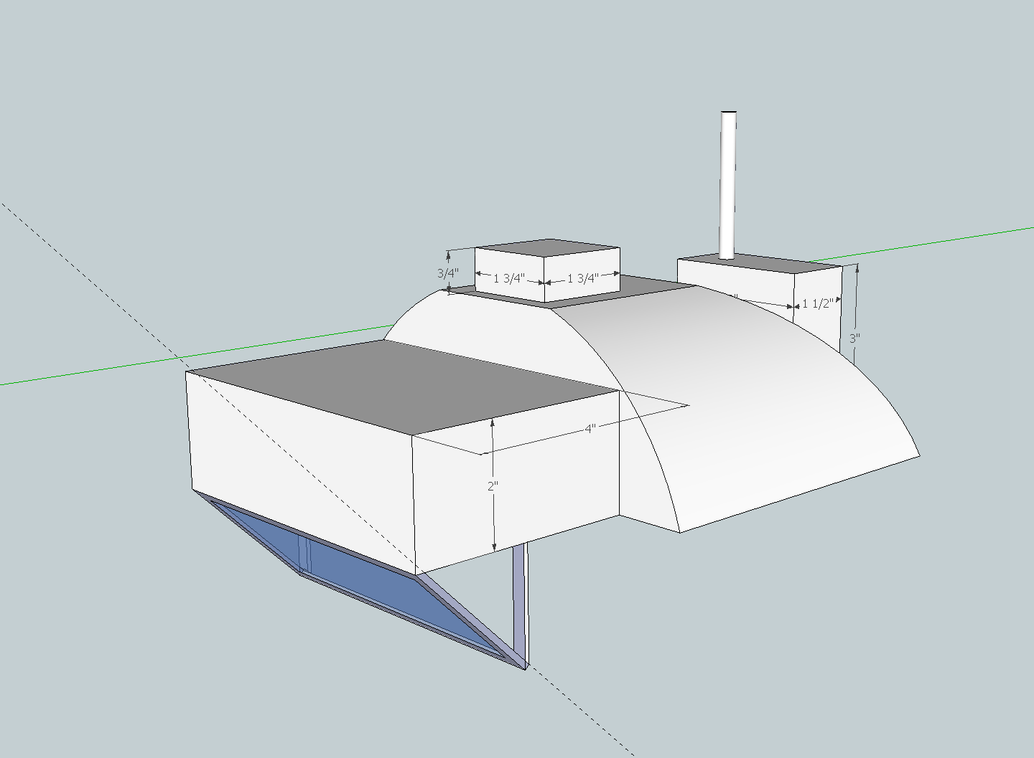
Headset, ¾ view
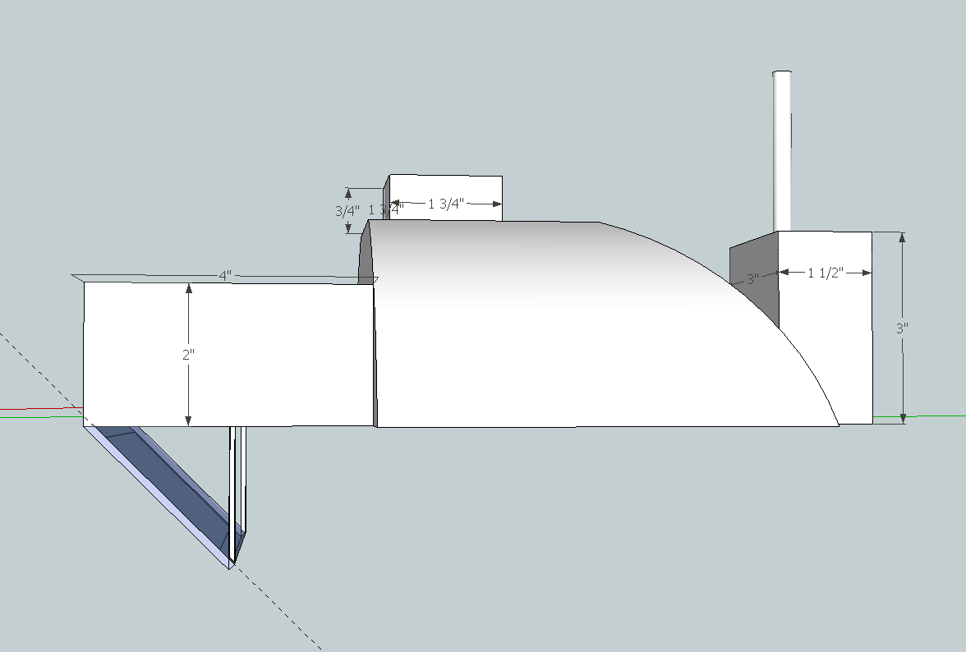
Headset, side view
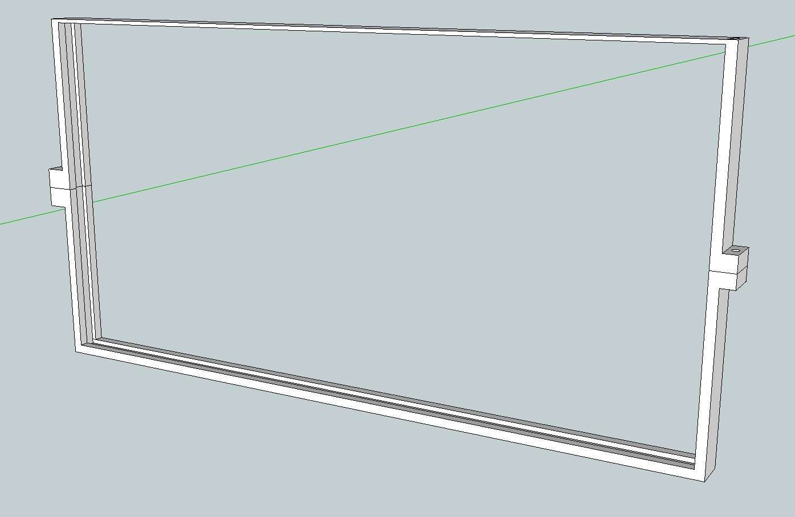
LCD/Glass frame
No dimensions given because there will be two similarly shaped but differently sized copies, for the LCD and beam splitter glass
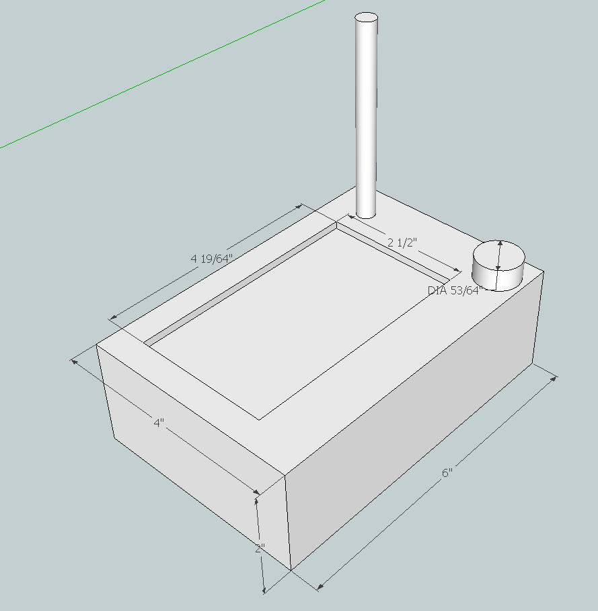
CCU packaging, ¾ view
Appendix B: Project Packaging Specifications

Headset Weight Estimate:
Component | Weight
Battery | 155g [3]
Display | 80g*
Pi Model A (with SD card) | 35g*
Hat | 50g*
XBee + antenna | 40g*
Custom PCB | 20g**
Beam splitter glass | 30g***
Front LCD enclosure | 120g*
Rear PCB/battery enclosure | 35g****
Printed frames | 25g*****
GPS Antenna | 50g[4]
Total | 640g

*Measured by me
**Based on an estimated PCB weight of .5lb for 100 sq inch[5], which is 2.3g per sq inch
***Extrapolated from mass of glass sample found in lab and planned size for final product
****Extrapolated from weight of LCD enclosure and planned size of PCB/battery enclosure
*****A guess
Headset Packaging Cost:
Component | Cost
Hat | $10
Beam splitter glass | $15
Front LCD enclosure | $6.50
Rear PCB/battery enclosure | $6.50
Printed frames | $20*
Total | $68

CCU Weight Estimate:
Component | Weight
Display | 80g
Pi Model A (with SD card) | 35g
XBee + antenna | 40g
Enclosure | 120g
Knob | 5g
RPG | 5g
Total | 285g
CCU Packaging Cost:
Component | Cost
Enclosure | $6.50
Knob | $1.00
Total | $7.50
Appendix C: PCB Footprint Layout

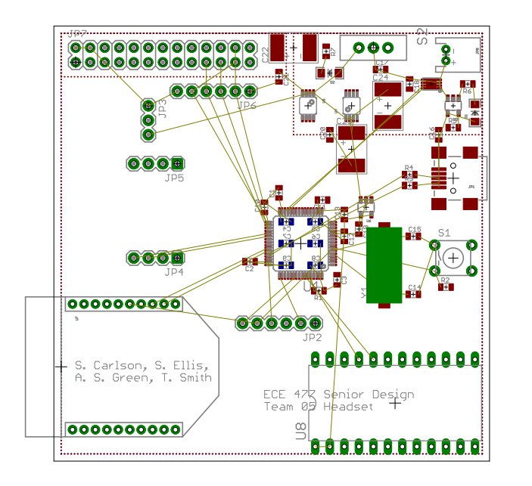

Top left: Raspberry Pi GPIO header
Top right: Power Supply
Center: micro
Left of center: GPS
Bottom left: XBee
Bottom right: 9DOF

