Homework 13: User Manual

Team Code Name: ____________________________________________ Group No. ______

NOTE: This is one of the last sections needed to finish the Final Report. This homework will count toward each team member’s grade, and therefore all team members should participate equally in completing it. The User Manual should be about 5 pages in length (one page per bullet).

User Manual Outline:

*Include this sheet as a cover page for your report*

* Brief (marketing-style) product description
* Product illustration annotated with callouts for each control/display
* Product setup instructions
* Product use instructions
* Product troubleshooting instructions

Evaluation:

|  |  |  |  |
| --- | --- | --- | --- |
| SEC | DESCRIPTION | MAX | SCORE |
| 1.0 | Product description | 20 |  |
| 2.0 | Product illustration | 20 |  |
| 3.0 | Product setup instructions | 20 |  |
| 4.0 | Product use instructions | 20 |  |
| 5.0 | Product troubleshooting instructions | 20 |  |
|  | TOTAL | 100 |  |

1. Product Description

The Augmented Reality Simulator is a headset device that will immerse you into a virtual world on top of your own reality. The device features a partially reflective screen that maximizes your ability to see and be aware of your surroundings. The headset is adjustable for a perfect fit to your head and balances weight on the front and back for maximum comfort. The lithium ion battery supplies as much as 5hrs of battery life for maximum play time. A battery indicator and wireless signal indicator will let you know when your battery gets low and the quality of your wireless signal. A Central Control Unit communicates the state of the game wirelessly to the headset. The device is designed to run a variety of augmented reality simulations that you may choose and swap out.

The Augmented Reality Simulator comes built in with a Pacman simulation based on the popular 2d Pacman game. The simulation brings Pacman to a whole new level. You are Pacman as you physically run away from ghosts and hurry to collect all of the pellets in the maze. Be sure to make full use of your ability to look around on all axis by simply tilting your head as you normally would! To collect pellets, you must pass through them. Try not to run into the walls! If you collide with a ghost, then you will lose the round and you must try again. Good luck collecting pellets!

1. Illustration

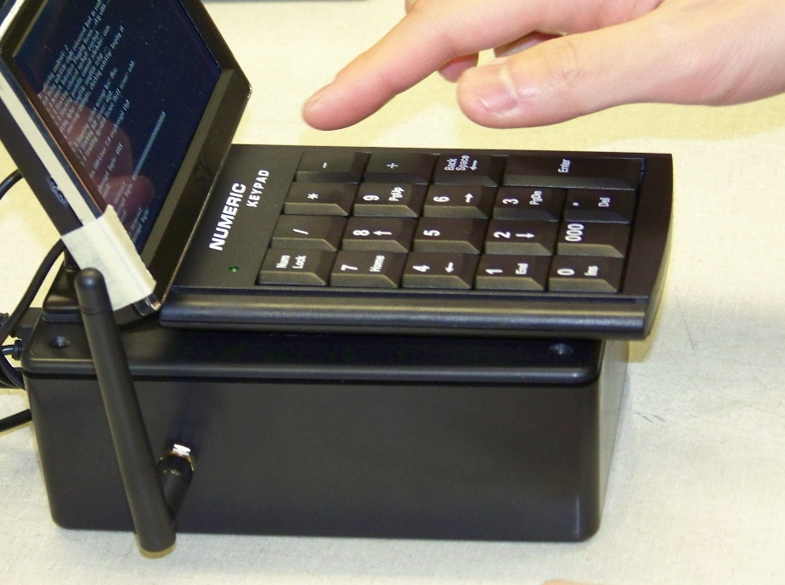

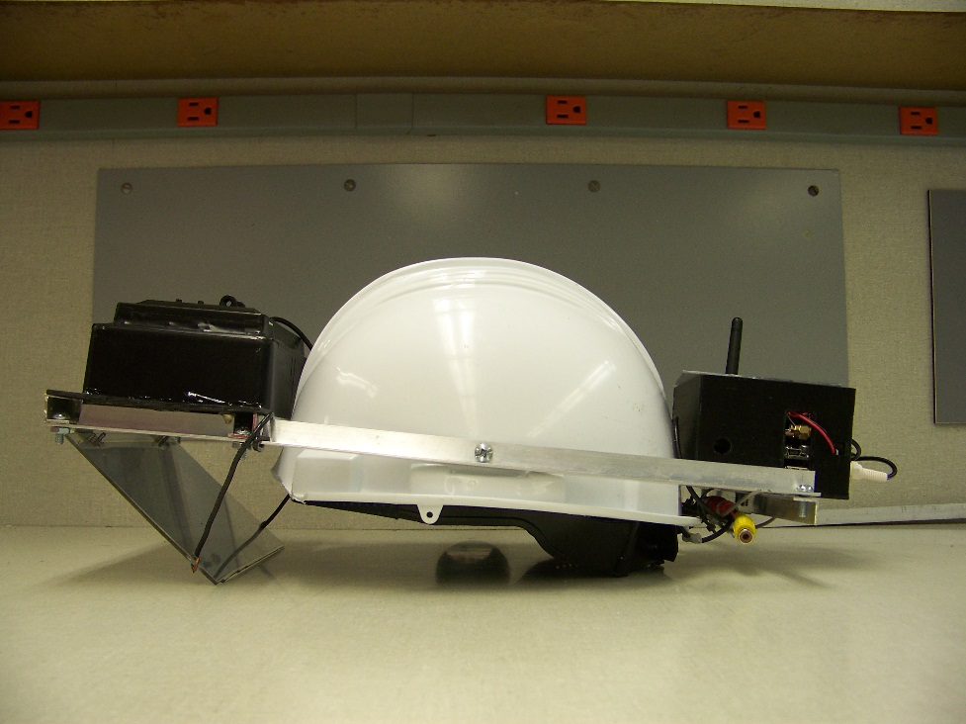

1. Product Setup Instructions

* Find a location to play:
  + Find a location outside to play, preferably a big open field with a building nearby that has an outlet on the outside. If necessary, acquire a long extension cord that can stretch into the field.
* Turn on the Devices:
  + Plug the Central Control Unit in to turn it on. Flip the switch on the back of the headset to turn it on as well. Wait until there is a red flashing light on the board in the back of the headset. This indicates that the Global Positioning System is ready.
* Initial Configuration:
  + Wait for a screen on the Central Control Unit that looks like the following:
  + 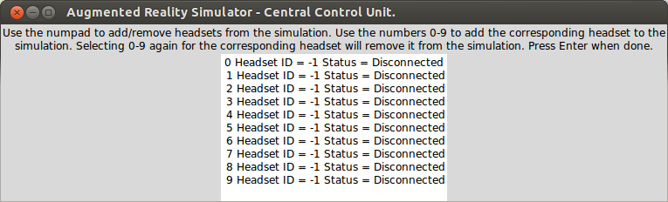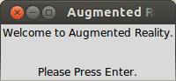Press “Enter” on the numeric pad to continue to the next screen that looks like the following:
  + 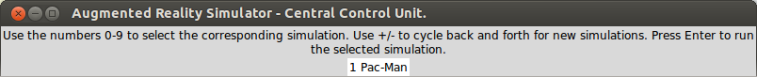Wait for the Central Control Unit to detect a headset. If no headset is detected, please refer to the troubleshooting section. When the Central Control Unit detects a headset, press “0” to select the headset. Multiple headsets are not currently supported. You may continue by pressing “Enter” on the numeric pad.
  + Press “1” on the numeric keypad to initialize the Pac-Man simulation. The plus and minus keys only work when there are more simulations than can be displayed on one screen. Press “Enter” to continue or “Backspace” to go back to the previous screen and re-select your headset.
  + The next screen will start your simulation which will appear on the headset. You may press “Backspace” at any time to quit the simulation and return to the headset selection screen.

1. Product Use Instructions

The first step in using the headset is to find a suitable area of play. Ideally, the play area will be: outdoors, free of clouds, dark, away from buildings, with at least one electrical outlet available. Do not use the headset while driving, operating heavy machinery, swimming, running, or are performing any other potentially dangerous activity. To start gameplay, plug in the CCU, set it down on top of a stable surface, and turn on all headsets. The CCU will turn on and boot into the game menu automatically when plugged in, and the headsets boot automatically into the game software. Wait for all machines to boot and at least one headset to acquire a GPS lock. Then, using the keypad on the CCU, select a simulation from the menu and start it. All headsets within range will connect automatically and the first GPS fix found will be used as a reference point for simulation logic. The CCU will transmit level data to each headset, and once this completes the simulation will begin.

After the simulation starts, walk into virtual objects to interact with them. Please take periodic breaks during use to prevent eyestrain.

WARNING: DO NOT USE THE HEADSET IF YOU HAVE A HISTORY OF EPILEPSY.

DO NOT CONTINUE USE OF DEVICE IF IT CAUSES VISUAL DISCOMFORT.

5.0 Product Troubleshooting Instructions

Problem: Headset display is blank.

Potential Solutions: Turn on the headset. Charge the battery of the headset.

Problem: Wireless communication is unreliable.

Potential Solutions: Stand closer to the CCU. Ensure that all antennas are oriented pointing upwards. Place the CCU in an elevated location, preferably about 100m above the ground.

Problem: GPS won’t lock.

Potential Solutions: Go outside. Wait until it isn’t cloudy outside. Stay away from buildings.

Problem: Screen visibility is low.

Potential Solutions: Go inside. Wait until it is cloudy outside. Wait until the sun goes down.

Problem: The compass orientation is wrong.

Potential Solutions: Step away from the magnet.

Problem: The simulation froze.

Potential Solutions: Turn it off and on again. Remove and reinsert the SD card, ensuring that it seats fully in the slot.

Problem: The CCU display is blank.

Potential Solutions: Plug in the CCU. Turn on the CCU.

Problem: The CCU display flashes.

Potential Solutions: Don’t worry, this does not affect the operation of the CCU.

Problem: The headset is unfashionable.

Potential Solutions: Apply stickers and/or glitter to the headset.

Problem: The headset is on fire.

Potential Solutions: Purchase a fire extinguisher.