Homework 1: Design Project Proposal

Team Code Name: _Augmented Reality Simulation__________________ Group No. __5___

Team Members (#1 is Team Leader):

#1: _Thor Smith__________________ Areas of Expertise: Software Design_____________

#2: _Stephen Carlson______________ Areas of Expertise: Schematic, PCB Layout_______

#3: _Steven Ellis_________________ Areas of Expertise: Graphics____________________

#4: _Alec Stephen Green___________ Areas of Expertise: Signal Processing____________

Project Abstract:

*Describe what your project is and what it does. Describe the competitive advantages you plan to incorporate in your design relative to the prior art.*

We propose an Augmented Reality Simulator that allows multiple users to play an electronic game in a mobile, outdoor environment. Our design aims to be cheaper than Google Glass, more portable than ARQuake, and allow more flexible choices for environment than Cast AR. The combination of these features in one design will make the project competative.

* Google Glass (U.S. Patent Application #20130044042): A pair of glasses which projects information onto the environment in a similar manner to the proposed idea. At a cost of $1500 for initial products and $300-500 in mass production per unit, we seek to undercut Google Glass in production cost.
* ARQuake: Project conceived in 2000 from the Wearable Computer Lab at the University of South Australia to make a real world version of the first person shooter Quake. Our project seeks to use the latest processing and display technology to be significantly more portable.
* Cast AR: A gaming device developed in 2012 using active shutter glasses developed by Valve to provide additional information to a user in a video game. This device is constrained to a relatively stationary user due to its use of a special screen configuration to track the user’s head orientation, while our planned design will allow more flexible choices of environment.

Design/Functionality Overview:

*Describe your proposed design project and the motivation behind it. Summarize the basic functionality of the finished device and the intended application. Indicate how each team member is expected to contribute to the overall project, given their areas of expertise.*

The Augmented Reality Simulator will be divided into two parts. A central control unit will coordinate the gameplay while per-player headsets will appropriately overlay game-object pixels on a semi-transparent panel that is suspended in front of the users’ eyes. This product is intended to be used for gaming and other potential simulations that require an augmented environment.

Thor Smith and Alec Green will contribute to software design on the central control unit and the embedded microcontroller and the communication between the devices. Stephen Carlson will contribute to hardware selection, configuration, soldering, and drivers. Steven Ellis will contribute to software design on the microcontroller working on aspects like the graphics processing and the sensor data processing.

Production Cost Estimate Per Unit:

|  |  |  |
| --- | --- | --- |
| *Component* | *Part No. (if known)* | *Unit Cost* |
| PCB (two-sided) | (N/A) | $33 |
| Microcontroller | STM32F405RGT6 | $11 |
| Xbee Communication Device | Pro 900HP S3B | $40 |
| Passive components (resistors, capacitors, etc.) | (N/A) | $10 |
| Xbee Antenna |  | $20 |
| Inertial Measurement Unit | Pololu MinIMU V2 9-DOF | $40 |
| Global Positioning System | Venus 938FLPx + Antenna | $60 |
| TFT Display Screen |  | $25 |
|  | Total | $240/1 |

|  |  |  |
| --- | --- | --- |
| *Component* | *Part No. (if known)* | *Unit Cost* |
| Motherboard | Raspberry Pi | $35 |
| Xbee Communication Device | Pro 900HP S3B | $40 |
| Xbee Antenna |  | $20 |
| Raspberry Pi Support Components | SD Card, USB Supply | $10 |
|  | Total | $105/1 |

Project-Specific Success Criteria:

1. An ability to communicate wirelessly between the control unit and headsets.
2. An ability to interact with and display real world landmarks.
3. An ability to meaningfully utilize multiple headsets in a coordinated simulation with one control unit.
4. An ability to render graphics based on the orientation of the user’s head.
5. An ability to render graphics based on the user’s current geospatial location.

Block Diagram:

The two block diagrams in Figure 1.1 show the important connections to realize the Augmented Reality Simulator design for the CCU and the Headsets. The CCU and Headset devices are connected wirelessly.

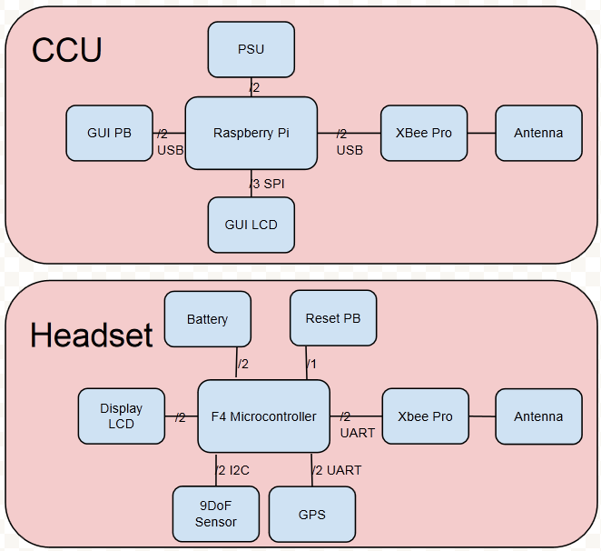

Figure 1.1: Block diagrams of the CCU (Central Control Unit) and headset respectively.

Division of Labor:

|  |  |  |  |
| --- | --- | --- | --- |
| *Design Component Homework* | | *Professional Component Homework* | |
| 4-Packaging Design and Specs | SE | 3-Design Constraint Analysis/Parts List | SC |
| 5-Hardware Narrative and Prelim Schematic | AG | 10-Patent Liability Analysis | AG |
| 6-PCB Narrative and Prelim Layout | SC | 11-Reliability and Safety Analysis | TS |
| 9-Software Design Narrative | TS | 12-Social/Political/Environmental Analysis | SG |

***Each*** *team member should take responsibility for* ***one*** *Design Component Homework and for* ***one*** *Professional Component Homework – note that these will count toward* ***individual*** *student grades.*