Homework 6: Printed Circuit Board Layout Design Narrative

Team Code Name: Augmented Reality Project______________________ Group No. ___5__

Team Member Completing This Homework: Stephen Carlson__________________________

E-mail Address of Team Member: carlson8 @ purdue.edu

Evaluation:

|  |  |  |  |
| --- | --- | --- | --- |
| SEC | DESCRIPTION | MAX | SCORE |
| 1.0 | Introduction | 5 |  |
| 2.0 | PCB Layout Design Considerations - Overall | 20 |  |
| 3.0 | PCB Layout Design Considerations - Microcontroller | 10 |  |
| 4.0 | PCB Layout Design Considerations - Power Supply | 10 |  |
| 5.0 | Summary | 5 |  |
| 6.0 | List of References | 10 |  |
| App A | PCB Layout Top & Bottom Copper Screenshot | 20 |  |
| App B | PCB Layout To-Scale Component Side Layout | 20 |  |
|  | TOTAL | 100 |  |

Comments:

1. Introduction

We propose an Augmented Reality Simulator that allows at least one user to play an electronic game in a mobile, outdoor environment. As the central control unit will not have a custom printed circuit board (PCB), this report will concentrate on the headset portion of the project, which will overlay appropriate game-object pixels on a semi-transparent panel that is suspended in front of the users’ eyes.

The headset PCB presents layout challenges for optimal performance. Connector placement and motherboard size dictate the form factor of the PCB. The combined power draw of the screen, motherboard, and radio systems presents challenges in designing high-current power supply routing, while the use of an external oscillator and USB connectivity brings difficulties with impedance matching. Electromagnetic interference (EMI) is also a concern as the noise-sensitive IMU breakout board must be insulated from noise generated by the high-power radio antennas of the GPS and wireless communication units.

1. PCB Layout Design Considerations - Overall

An investigation of the capabilities of the particular board design manufacturer which will be used for prototype production reveals the minimum limits for PCB design. Advanced Circuits quotes the limits shown in Table 1 for standard spec PCBs. [1]. For optimal manufacturing yield, the PCB was routed with wider tracing and spacing and a larger drill size. In addition, common pitfalls such as acute angles and sharp corners were also to be avoided.

Table : PCB specifications for low-cost "standard spec" boards from Advanced Circuits [1]

|  |  |  |
| --- | --- | --- |
| Metric | Minimum | Chosen for Manufacturability |
| Trace Thickness | 5mil | 10mil |
| Trace Spacing | 5mil | 8mil |
| Drill Diameter | 10mil | 15mil |
| Drill Tolerance | 5mil |  |

The first set of constraints on the PCB design is the form factor and connector placement. To allow the custom PCB to properly mate with the Raspberry Pi, the outer PCB dimensions and 26-pin I/O header placement had to exactly match the motherboard mechanical specifications [2]. The external connectors for USB charging, battery power, and radio antennas must also be facing outwards on the border of the PCB to fit in the target packaging constraints.

To reduce electromagnetic interference (EMI) received, the major radio frequency emitters were placed on the bottom left of the board as far away from the vulnerable inertial measurement unit (IMU) as possible in this design. As the GPS unit has an external antenna [3] which moves its noise emission far away from the PCB, the XBee radio and antenna [4] was placed in the far corner of the board with the GPS in the middle. Unintentional EMI emissions were also controlled by placing numerous decoupling capacitors on the microcontroller as recommended by SGS-Thompson [5] and locating the external oscillator as close as physically possible to the microcontroller clock pins.

1. PCB Layout Design Considerations - Microcontroller

Several of the components of this project, most notably the USB boot loader described in the microcontroller datasheet, depend on a stable clock source. Therefore, an external crystal oscillator in a through-hole package was utilized with the recommended load capacitance of 20pF [6]. As the traces leading to the crystal also add impedance, the EAGLE “*run length-freq-ri*” tool was used to match the oscillator trace lengths within 8mil. The crystal was also placed as close as possible to the microcontroller while still allowing a component-free area around the oscillator to limit noise coupling. Similarly, the same method was used to match the USB data traces to significantly less than the stated 50mil length tolerance [7].

Part placement near the microcontroller was also a major concern. In order for the PCB to be physically possible to route, pin assignments with multiple equivalent options on the microcontroller were chosen to limit the number of crossing signals. Careful effort was also spent in placing parts to minimize the number of traces looping around the microcontroller and interfering with power routing as shown in Figure 1. After placement was finalized, the most convenient spare I/O pins were brought out to pads and a spare serial port was connected to an unpopulated header for debugging and future expansion. Two spare LEDs also aid in debugging.

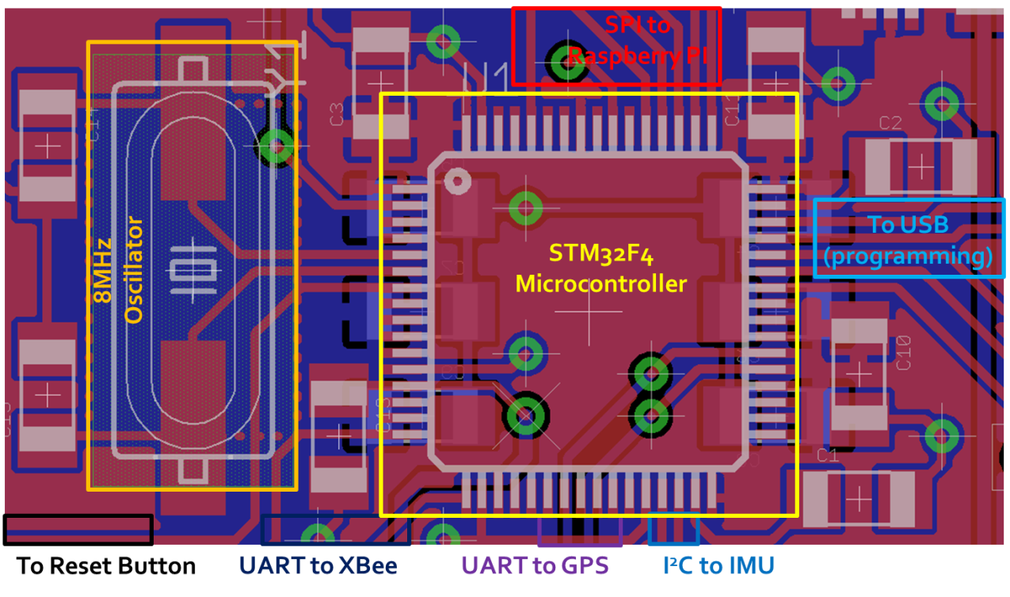

Figure : Signal routing near microcontroller showing oscillator circuit and decoupling capacitance

To ensure optimal power supply to the microcontroller, a large power and ground plane along with twelve decoupling capacitors were used. One of these capacitors was placed near each power supply pin, with the six remaining capacitors going underneath the microcontroller on the back of the board to keep them as close as possible. Additional 1 uF and 2.2 uF ceramic capacitors were placed according to the manufacturer recommendations to decouple the internal core voltage regulator. The power and ground planes were monitored during routing to ensure that power could come from all four directions of the board to avoid a weakly connected copper pour “island.” As the analog to digital converter on the microcontroller is not used, the routing of the analog supply and analog ground pins was less critical.

1. PCB Layout Design Considerations - Power Supply

The power supply design for this board must cope with a large, fluctuating load and power management concerns. Total current could be up to 2 A during radio transmission events as evidenced by design constraint analysis, so power supply traces were widened to 80mil or more to reduce resistive losses. Power and ground planes were emphasized to simplify power routing, and if power needed to switch sides on the board, multiple large vias were used to share the load. The bottom of the board was devoted to a ground plane with few signal traces to reduce the size of noise-inducing ground loops. Power planes were also used to reduce the resistance of power traces while providing thermal dissipation paths for the low-dropout regulator circuits. A sample of the result is shown in Figure 2.

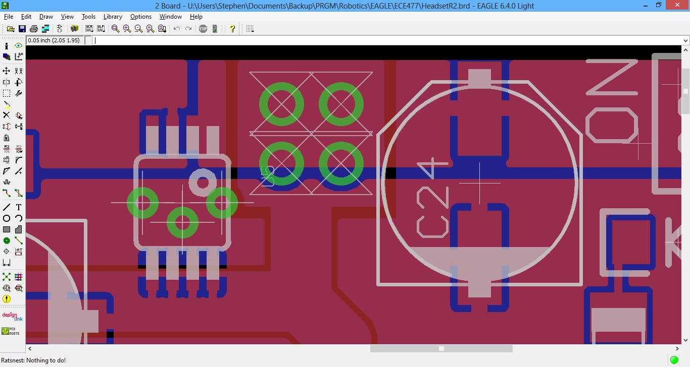

Figure : Close-up of power supply showing power transfer vias, bulk capacitance, and power plane usage

Bulk capacitors were chosen and placed on the board to handle the large inrush currents of the microcontroller and radios. Solid bulk capacitors with low equivalent series resistance (ESR) were placed at the board input and after each voltage regulator. Additional manufacturer recommended ceramic capacitors for stability were also placed close to each low-dropout regulator [8]. The step-up converter used to generate 5V for the display [9] was located as far away from the rest of the circuit as possible to minimize coupling of switching noise, but its onboard capacitors eliminate the need for additional bulk or decoupling capacitance. Bypass capacitance already used near other parts of the circuit handles power supply decoupling.

To reduce shared impedance noise coupling between the IMU and the digital circuits, a separate low-dropout regulator with outstanding ripple rejection was dedicated for IMU power supply and placed close to it. Although the IMU communicates digital results over I2C, the onboard sensor still uses an analog design where noise could disrupt the computed orientation [10]. As this regulator does not have to power other loads, switching noise is reduced, and any noise picked up on the battery supply trace from external sources is not coupled to the sensors.

1. Summary

Our proposed project, an augmented reality simulator, aims to display an image to the user that adapts to their position and direction. To accomplish these goals while minimizing interference, the custom headset PCB satisfied placement constraints to keep the powerful radio transmitters far away from the sensitive IMU and isolate switching noise from the sensor power supply. High peak power demands were tamed by sufficient bulk and bypass capacitance near each part as recommended by the manufacturer, along with power and ground planes providing distributed power from multiple directions. High-speed signals on the external oscillator and USB port satisfied careful trace length matching to avoid reflections. A solution to routing after component placement was found which minimized trace overlap due to careful pin selection on the microcontroller, leading to the finished layout shown in Appendix A.

6.0 List of References

1. Advanced Circuits, “Standard Spec vs. Custom Spec PCB”, 4pcb.com, [Online] Available: <http://www.4pcb.com/standard-custom-order-pcbs/> [Accessed Oct. 1, 2013]
2. Raspberry Pi Foundation, “Mechanical Profile – 3D models”, raspberrypi.org, [Online] Available: <http://www.raspberrypi.org/phpBB3/viewtopic.php?f=2&t=4402> [Accessed Oct. 3, 2013]
3. SkyTraq Technology, “Venus638FLPx GPS Receiver”, Venus638FLPx datasheet, Feb. 2010 [Revised Jan. 2011] <http://dlnmh9ip6v2uc.cloudfront.net/datasheets/Sensors/GPS/Venus/638/doc/Venus638FLPx_DS_v07.pdf>
4. SGS-Thomson Microelectronics, “ARM Cortex-M4 32b MCU+FPU”, STM32F405RG datasheet, Sep. 2011 [Revised Jun. 2013] <http://www.st.com/st-web-ui/static/active/en/resource/technical/document/datasheet/DM00037051.pdf>
5. Digi International, “XBee-Pro 900HP”, Xbee Pro 900HP datasheet, Aug. 2013 <http://www.digi.com/pdf/ds_xbeepro900hp.pdf>
6. SparkFun Electronics, “Crystal 8MHz”, sparkfun.com, [Online] Available: <https://www.sparkfun.com/products/538> [Accessed Oct. 2, 2013]
7. Cypress Semiconductor Corporation, “AN1168: High-Speed USB PCB Layout Recommendations”, Nov. 2011 <http://www.cypress.com/?docID=32407> [p. 3]
8. Micrel Inc., “500 mA-Peak Output LDO Regulator”, MIC5219 datasheet, Jun. 2009 <http://www.micrel.com/_PDF/mic5219.pdf>
9. Pololu Robotics and Electronics, “5V Step-Up Voltage Regulator U3V12F5”, pololu.com, [Online] Available: <http://www.pololu.com/catalog/product/2115> [Accessed Sep. 29, 2013]
10. SGS-Thomson Microelectronics, “L3GD20 and LSM303DLHC 9-axis module for a standard DIL socket”, STEVAL-MKI108V2 datasheet, Nov. 2011 <http://www.st.com/st-web-ui/static/active/en/resource/technical/document/data_brief/DM00041389.pdf>

Appendix A: PCB Layout Top & Bottom Copper

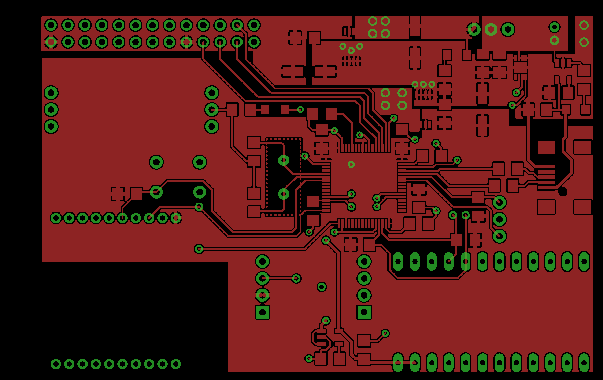

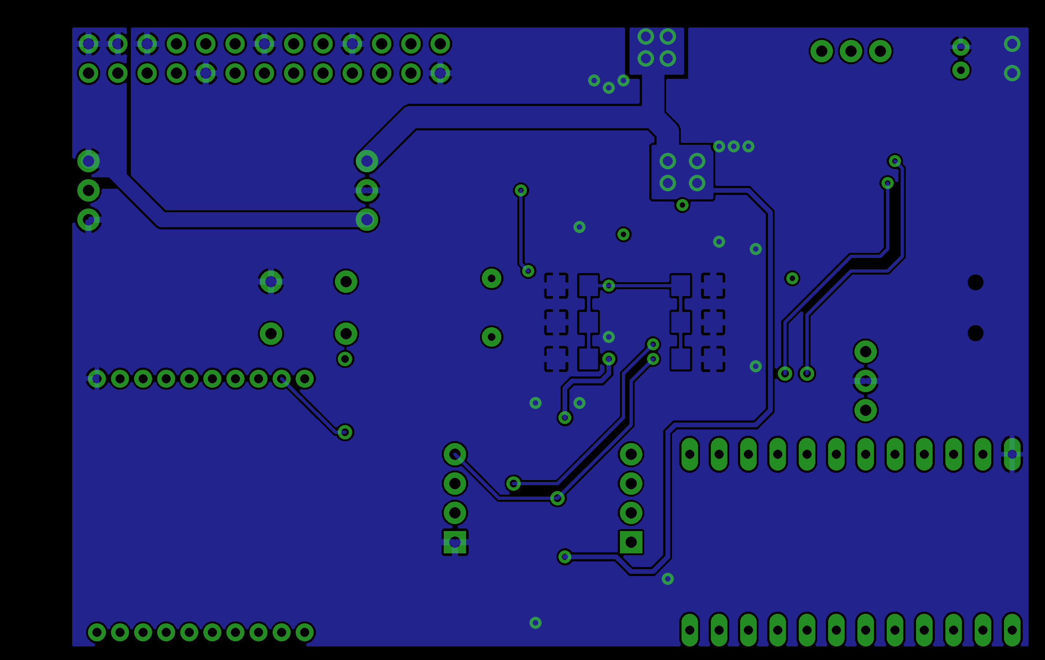

Appendix B: PCB Layout To-Scale Component Side Layout

