Homework 7: PCB Submission and Parts Acquisition/Fit

Team Code Name: Augmented Reality Project______________________ Group No. __5___

Print out: (1) an actual-size (1X) copy of your top copper layer and bottom copper layer, and (2) an actual-size combination of the silk screen and solder mask layers of the PCB you are submitting for fabrication, along with your Bill of Materials (BOM) Report. Be prepared to place the parts you have acquired on your “simulated” (paper) PCB to demonstrate that all footprints match. If all parts are present and match, no written report is necessary (“a picture is worth a 1000 words”). If parts are missing and/or do not match, *include a written explanation below that documents how any discrepancies will be resolved (this should be prepared IN ADVANCE of your demonstration).* If there are no discrepancies, this form must still be submitted, but the explanation section may be left blank.

Checklist:

|  |  |  |
| --- | --- | --- |
| **Component/Criterion** | **Date Verified** | **Initials** |
| Final Schematic and Updated Block Diagram | 10/12/13 | SC |
| Updated Bill of Materials Report | 10/17/13 | SC |
| Part Footprint Match (based on 1× silk screen + solder mask PCB printout) | 10/16/13 | SC |
| Part Acquisition Completion | 10/10/13 | TS |
| PCB File Submission | 10/17/13 | SC |

Written explanation (where required):

All parts fit. See images on the next few pages for details.

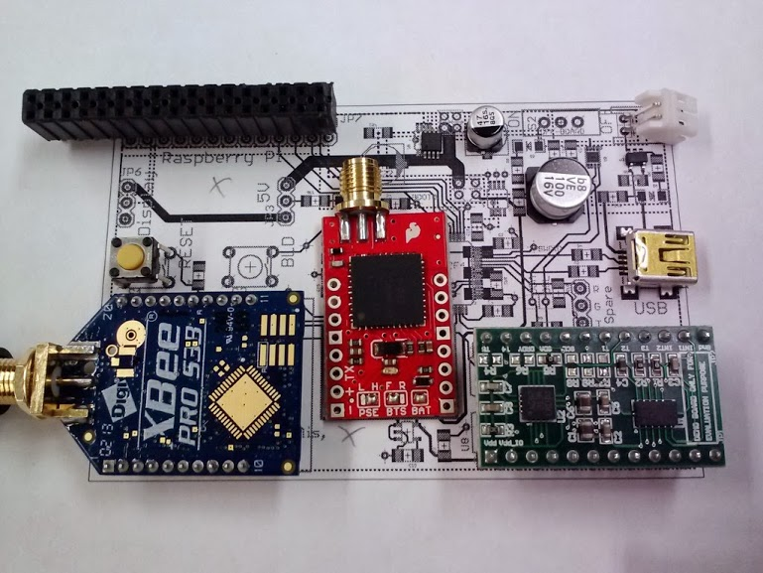

Figure : Parts fit 1-to-1, image 1 of 3

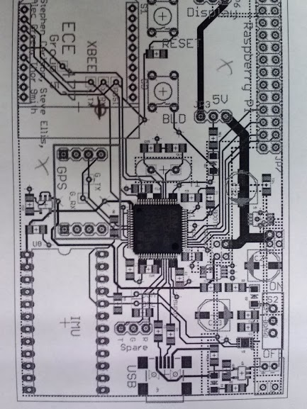

Figure : Parts fit 1-to-1, image 2 of 3

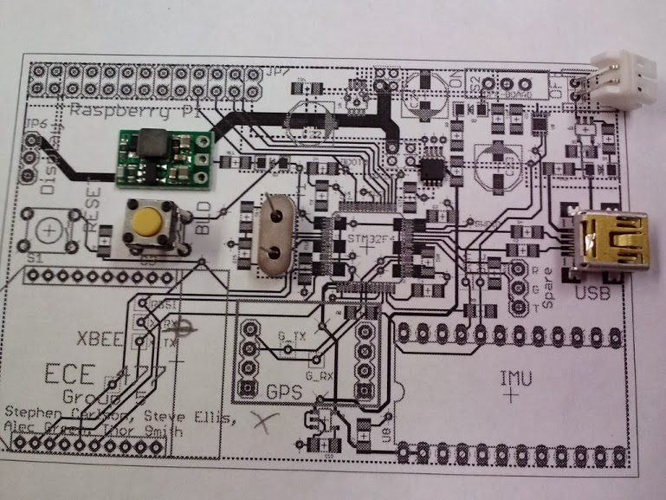

Figure : Parts fit 1-to-1, image 3 of 3