Homework 10: Patent Liability Analysis

Team Code Name: _Augmented Reality Headset___________________ Group No. __5__

Team Member Completing This Homework: __Alec Green__________________________

E-mail Address of Team Member: ___green26___ @ purdue.edu

Evaluation:

|  |  |  |  |
| --- | --- | --- | --- |
| SEC | DESCRIPTION | MAX | SCORE |
| 1.0 | Introduction | 5 |  |
| 2.0 | Results of Patent and Product Search | 40 |  |
| 3.0 | Analysis of Patent Liability | 30 |  |
| 4.0 | Action Recommended | 10 |  |
| 5.0 | Summary | 5 |  |
| 6.0 | List of References | 10 |  |
|  | TOTAL | 100 |  |

Comments:

*Comments from the grader will be inserted here.*

1. Introduction

We are designing an augmented reality headset for gaming and multimedia applications. A stationary central control unit (CCU) equipped with a user interface, processing power, and radio communications will coordinate the application (e.g. game) logic among multiple mobile, user-wearable headsets. The mobile headsets contain multiple intellectual property (IP)-sensitive areas. Namely, the use of an IMU/GPS to determine the orientation/position of a user in a 3D environment for gaming purposes, the use of that orientation/position data to render ‘augmented reality’ images (i.e. pixel overlay on a natural environment view), and projecting those images on a semi-transparent/semi-reflective display that is affixed in front of a user’s field of view all represent areas of potential infringement. (Note that by virtue of our purchase of the Digi Xbee wireless communication devices, we are implicitly licensing the radio IP and therefore are not in danger of infringement of this technology.)

1. Results of Patent and Product Search

Relevant published, active patents exist which could potentially overlap with the methods and functionality of our headset in the areas of: using a head-mounted measurement units (e.g. a gyroscope) for outdoor applications, using a semi-transparent/semi-reflective panel in a user’s field of view in order to overlay pixels on the environment, and using a measurement unit to dictate what visual information is overlaid on a such a head-mounted display.

[1] “Head Mounted Information Systems and Related Methods”

*Filed*

Jan 18, 2011

*Abstract*

A head mounted information system comprises a frame configured to be worn by a user, a sensor unit coupled to the frame, and a processor unit coupled to the frame. The processor unit is connected to receive signals from the sensor unit. A display unit may also be coupled to the frame to display the [sensor] parameters to the user.

*Key Claims*

1. A head mounted information system comprising:

a frame configured to be worn by a user;

a sensor unit coupled to the frame, the sensor unit comprising a gyroscope configured to produce angular velocity signals representing a head angular velocity about a generally horizontal z-axis oriented generally perpendicular to a direction the user is facing when the user is wearing the frame; and,

a processor unit coupled to the frame, the processor unit connected to receive signals from the sensor unit,

wherein the processor unit is configured to receive the angular velocity signals from the sensor unit, detect a jump by the user when the head angular velocity indicates upward head tilting exceeding a first jumping angular velocity threshold, and generate a jump output signal indicting one or more jump parameters.

21. A system according to claim 1 wherein the sensor unit comprises a three axis gyroscope configured to produce angular velocity signals about the z-axis, an x-axis and a y-axis, wherein the x-axis and y-axis are generally perpendicular to each other and to the z-axis, and wherein the processor is configured to, after detecting a jump and before detecting a landing, determine rotations about the x-axis, y-axis and z-axis.

22. A system according to claim 21 wherein the processor is configured to display orientation information in substantially real time based on the determined rotations.

[2] “Method and Apparatus for Displaying Images on Reflective Surfaces”

*Filed*

May 3, 2006

*Abstract*

A head mounted display (HMD) is worn on a user's head for displaying an image. A HMD is a personal see-through device designed to view still or video images or data that nonetheless permits the user to view his surroundings.

*Key Claims*

1. A reflective image display comprising:

a reflective, at least semi-transparent lens;

a frame for bearing the lens and configured to be worn by a user so as to place the lens in front of at least one of the user's eyes; and

a display, associated with the frame, for projecting an image onto a surface of the lens facing the user's eye or eyes such that the image is reflected thereon in a manner visible to the user.

2. The display of claim 1 further comprising a sensor for measuring an ambient condition and circuitry for causing the display to project information indicative of the measured condition

[3] “Method, System and Device for Augmented Reality”

*Filed*

March 20, 2002

*Abstract*

A portable electronic device comprises augmented reality viewing apparatus for viewing a real scene and a superimposed computer generated overlay scene. In one embodiment the viewing apparatus comprises a display screen and a semitransparent mirror. The device may be equipped with location determining means, the selection of a displayed image thereby being dependent on the location of the device, whether the images for display are stored locally in the device or transmitted by radio from a remote server. The device may also be equipped with an orientation sensor so that the selection of a displayed images is dependent on orientation of the device.

*Key Claims*

1. A method of preparing an overlay scene for display on an augmented reality viewing apparatus, characterised by generating an alignment indicator corresponding to a predetermined element of a real scene for inclusion in the overlay scene, the alignment indicator in use being aligned with the predetermined element of the real scene.

14. A device as claimed in any one of claims 3 to 10, comprising orientation sensing means for generating an indication of orientation, location determining means for generating an indication of location, and storage means wherein the storage means contains a plurality of overlay scenes each corresponding to a different real scene, and selection means for selecting which of the plurality of overlay scenes is displayed, wherein the selection means is responsive to the indications of location and orientation of the portable electronic device.

1. Analysis of Patent Liability

[1] “Head Mounted Information Systems and Related Methods”

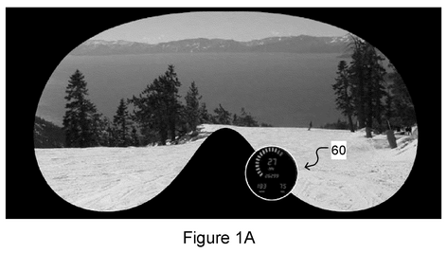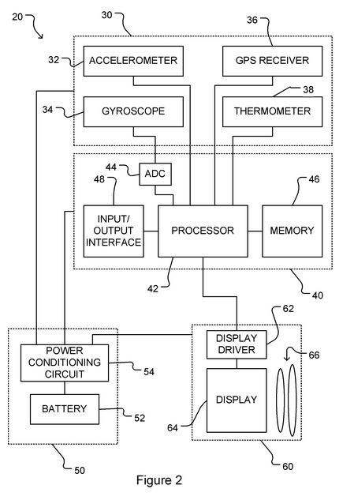

While the block diagram of the patent (Figure 2) is nearly identical to our block diagram, except for replacing a magnetometer sensor with a thermometer sensor, one must investigate the claims in order to determine if our application is truly in violation of this patent.

While the first three parts of claim 1 exactly describe our own application, the fourth component of claim 1 (using the angular velocity signals to determine jumping) differentiate this patent from our own application. This is because while we are sending gyroscope signals to a processor for calculation of orientation angles, we are not using these gyroscope signals for jump determination. Although it is unclear whether or not a claim must be considered in an atomic fashion (that is, must take all or none of the claim sub-components), we will assume that a claim must be considered atomically, and therefore our application does not literally or through doctrine of equivalents conflict with this patent on claim 1, because the intended functionality is distinct (jump detection vs general-purpose head orientation detection).

Claims 21 and 22 pose a similar situation as claim 1. That is, while we do use accelerometers and other IMU sensors to determine user orientation, we are not using this information to determine a user jump. Using the same logic used in the previous paragraph, we will again assume that our application does not conflict with these claims.

[2] “Method and Apparatus for Displaying Images on Reflective Surfaces”

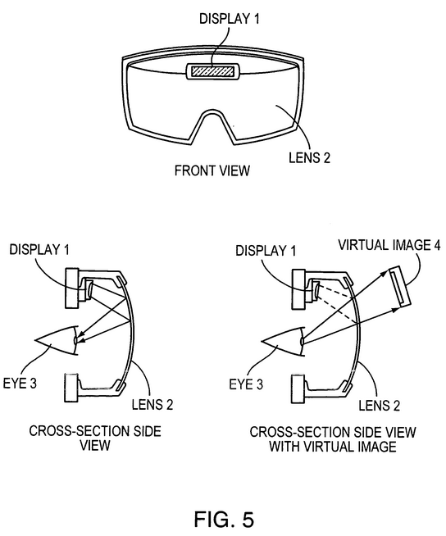

The two and only two claims of this patent are written in very general terms concerning the application of overlaying images on a heads-up display and using complementary sensors to influence the images rendered on the semi-reflective display. Therefore, it seems that we are literally infringing on this patent, or at least come into conflict with the claims in terms of doctrine of equivalents. Our application also utilizes a ‘display’ (specifically, an LCD) for ‘for projecting an image onto a surface of the lens facing the user's eye or eyes such that the image is reflected thereon in a manner visible to the user’ (from claim 1). However, it is debatable whether or not we are infringing on claim 2, as we are not using additional circuitry (e.g. an LED) to display information from the ambient sensors, but rather are using the identical augmented reality image rendering pathway for generating the images based on IMU sensor data.

[3] “Method, System and Device for Augmented Reality”

Although the abstract of this patent sounds highly relevant to our application, reading through the claims (e.g. claim 1), it becomes apparent that this application is dependent on an ‘alignment indicator’ in the real-world environment. This is also known as an augmented reality ‘marker’, in which a sensing device (e.g. camera) processes the real-world visual input to the user, and appropriately aligns a pixel overlay onto that real-world visual input. However, in our application, we do not rely on any external visual input for the generation of our augmented reality image rendering, and instead only rely on orientation and position sensors.

Further claims in the patent (e.g. claim 14), are nullified by the fact that they depend on previous claims which do not apply to our application. That is, although claim 14 speaks of utilizing IMU sensors for influencing the augmented image, this use of IMU sensors is piggybacked on the ‘alignment indicator’ system which our project will not use.

1. Action Recommended

[1] “Head Mounted Information Systems and Related Methods”

As determined in section 3.0, we will proceed on the assumption that claim conflicts must be considered atomically. Therefore, because our use of IMU sensing device and an augmented reality display are for a distinct purpose from this application, we are not in infringement of this patent, and no action needs to be taken.

[2] “Method and Apparatus for Displaying Images on Reflective Surfaces”

Because there is not a foreseeable way to modify our project so that it is not in violation of at least claim 1, we would need to obtain a license from the patent holder in order to manufacture and sell our application.

[3] “Method, System and Device for Augmented Reality”

Because we have determined that our application utilizes a significantly different method for augmented image overlay compared to this patent, no action needs to be taken.

1. Summary

Multiple relevant patents were considered and analyzed in order to determine whether or not our application infringes on current art published by the US Patent Office. Although two of the patents [1,3] appeared highly relevant based on the patent abstract, it was determined through the claims that our application does not infringe upon them. However, our application does come into conflict with one patent [2] regarding the use of a semi-transparent/semi-reflective material for projecting images in front of a user’s field of view, and therefore we will need to obtain licensing from this patent holder before commercial sale of our project.6.0 List of References

1. Abdollahi et al., “[Head Mounted Information Systems and Related Methods](http://www.google.com/url?sa=t&rct=j&q=&esrc=s&source=web&cd=1&ved=0CDkQFjAA&url=http%3A%2F%2Fpatentimages.storage.googleapis.com%2Fpdfs%2FUS20130044043.pdf&ei=wLJzUvfcDaXA2AWf9IGIBQ&usg=AFQjCNFM5zGL8rr4dAYFk0op5QYhD3un3A&sig2=IyQ3GM7FE-4fvkUlQE6bzw&bvm=bv.55819444,d.b2I&cad=rja),” U.S. Patent 0 044 043, Feb 21, 2013.
2. Grand et al., “[Method and Apparatus for Displaying Images on Reflective Surfaces](http://www.google.com/url?sa=t&rct=j&q=&esrc=s&source=web&cd=1&ved=0CC4QFjAA&url=http%3A%2F%2Fpatentimages.storage.googleapis.com%2Fpdfs%2FUS20060250574.pdf&ei=D7RzUpL3JIHN2AX1roGYBQ&usg=AFQjCNHBChgA3ATHF8aifdty0soTwYc0WQ&sig2=BEmFFU9XHpeMj1fnY970aw&bvm=bv.55819444,d.b2I&cad=rja),” U.S. Patent 0 250 574, Nov 9, 2006.
3. Valdes et al., “[Method, System and Device for Augmented Reality](http://www.google.com/url?sa=t&rct=j&q=&esrc=s&source=web&cd=4&cad=rja&ved=0CEQQFjAD&url=http%3A%2F%2Fpatentimages.storage.googleapis.com%2Fpdfs%2FUS20020167536.pdf&ei=K7xzUon6AsrQyAGWuoHQCQ&usg=AFQjCNFo9yFvoYFZqS0BKkAFKc5qTuig7Q&sig2=yslOkg8pP4HNkx1S87AGUg&bvm=bv.55819444,d.aWc),” U.S. Patent 0 167 536, Nov 14, 2002.