Homework 11: Reliability and Safety Analysis

Team Code Name: ______Augmented Reality Simulator_________ Group No. __5___

Team Member Completing This Homework: _______Thor Smith_________________

E-mail Address of Team Member: ___smith777_ @ purdue.edu

Evaluation:

|  |  |  |  |
| --- | --- | --- | --- |
| SEC | DESCRIPTION | MAX | SCORE |
| 1.0 | Introduction | 5 |  |
| 2.0 | Reliability Analysis | 40 |  |
| 3.0 | Failure Mode, Effects, and Criticality Analysis (FMECA) | 40 |  |
| 4.0 | Summary | 5 |  |
| 5.0 | List of References | 10 |  |
|  | TOTAL | 100 |  |

Comments:

*Comments from the grader will be inserted here.*

1. Introduction

We propose an Augmented Reality Simulator that allows at least on user to play an electronic game in a mobile, outdoor environment. The device is split into two primary physical parts, but only the headset’s schematic will be considered for safety and reliability in this report. The report will focus on three sections of the headset’s schematic.

The Augmented Reality Simulator design includes four power supplies, a lithium ion battery, battery charging circuitry, a microcontroller, and other components. Failures related to the battery present potential hazards. Other failures will not cause harm to the user, but may render the device inoperable.

1. Reliability Analysis

The mean time to failure (MTTF) allows one to compute an estimate of how frequently a part will fail given a certain number of parts in the field. Three components were selected to be measured based on military standards for reliability and safety of electronic equipment. The MCP73831 battery charger, MIC5219 voltage regulator, and STM32F4 microcontroller components were selected. The MCP73831 was selected because it works with the lithium ion battery, which is the most dangerous component on our device. The MIC5219 was selected because it delivers voltage to other components. If it fails then it could ruin those components and generate heat. The STM32F4 was selected because it is the most complex component in the schematic, and it controls the communication between all of the peripheral devices. The analysis for each component is shown in Table 1, Table 2, and Table 3. The Gate/Logic array formula in section 5 from [1] was used for all components.

Some assumptions were made when determining values. For the battery charger and the voltage regulator, the number of transistor was assumed to be a couple hundred. This assumption was based on an example calculation by Novacek. [2][3][4] The TjMax value for each component was calculated based on the power dissipated by the device. For example, the voltage regulator TjMax value was calculated based on the following: the battery’s maximum input voltage of 4.2V [8], the expected output voltage of the regulator at 3.3V, and the maximum current before the regulator fails of 0.5A. [6] The power is calculated as the quantity 4.2V minus 3.3V multiplied by the maximum current. This yields a result of 450mW. The θJC from the regulator datasheet is 60°C/W [6]. This gives a temperature rise of 27°C. This rise was added to 35°C, the T­A for GBE (Ground Benign Environment) [1] to get a value of 62°C, which was rounded up to 70°C.

Table 1: MCP73831 Battery charger failure analysis.

|  |  |  |  |
| --- | --- | --- | --- |
| Parameter name | Description | Value | *Comments* |
| C1 | Die complexity | *.20* | *Guess a couple hundred Transistors* |
| πT | Temperature coeff. | *28* | TjMax = 110 deg C |
| C2 | Constant for number of pins | *.0025* | Nonhermetic, 5pins |
| πE | Environmental Constant | *.50* | Ground Benign Environment |
| πL | Learning Factor | *1* | More than 2yrs production |
| πQ | Quality Factor | *10* | Commercial |
| *λ* | *(C1\** πT *+C2\** πE*)*πQπL | *5.60x10-5* | *MTTF = 2.03yrs* |

Table 2: MIC5219 Voltage regulator failure analysis.

|  |  |  |  |
| --- | --- | --- | --- |
| Parameter name | Description | Value | *Comments* |
| C1 | Die complexity | *.20* | *Guess a couple hundred Transistors* |
| πT | Temperature coeff. | *2.8* | TjMax = 70 deg C |
| C2 | Constant for number of pins | *.0034* | Nonhermetic, 8pins |
| πE | Environmental Constant | *.50* | Ground Benign Environment |
| πL | Learning Factor | *1* | More than 2yrs production |
| πQ | Quality Factor | *10* | Commercial |
| *λ* | *(C1\** πT *+C2\** πE*)*πQπL | *5.62x10-6* | *MTTF = 20.3yrs* |

Table 3: STM32F4 Microcontroller failure analysis.

|  |  |  |  |
| --- | --- | --- | --- |
| Parameter name | *Description* | *Value* | *Comments* |
| C1 | *Die complexity* | *.56* | *32bit Microcontroller* |
| πT | *Temperature coeff.* | *0.6* | TjMax = 70 deg C |
| C2 | *Constant for number of pins* | *.032* | *64 pins* |
| πE | *Environmental Constant* | *.50* | Ground Benign Environment |
| πL | *Learning Factor* | *1* | More than 2yrs production |
| πQ | *Quality Factor* | *10* | Commercial |
| *λ* | *(C1\** πT *+C2\** πE*)*πQπL | *3.52x10-6* | *MTTF = 32.4yrs* |

The part with the least MTTF is the battery charger. The MTTF is low because of its potential for a high operating temperature when the battery’s voltage has sunk to 3.4V. The incoming voltage from USB is 5V. However, battery charging does not occur while the device is being used for a simulation. It is expected that charging will occur overnight because the batteries take a long time to charge. If this device shorts V_USB to V_BAT (see Appendix A), the battery protection circuit will prevent overcharging of the battery. The component that is next most likely to fail is the voltage regulator. This device has a higher failure rate because of its temperature coefficient as well, but it is significantly smaller than the battery charger’s temperature coefficient. Increased safety could be achieved by monitoring the temperature of the battery charger through the microcontroller and disconnecting power from the USB connector if the temperature reaches a given threshold. A different modification could measure the current coming out of the battery charger in conjunction with a reading of the battery’s remaining charge to provide a redundant shutoff if the battery charger attempts to overcharge the battery.

1. Failure Mode, Effects, and Criticality Analysis (FMECA)

Our design defines three criticality levels which are used in Appendix B for rating specific failure modes: High, Medium, and Low. High criticality indicates that the failure may cause physical harm to the user and possibly death. For this criticality level, *λ* must be less than 10-9. The remaining criticality levels may have *λ* less than 10-6. Medium criticality indicates that the user may experience discomfort while using the device, but no physical injury. This refers specifically to the possibility of displaying images at arbitrary locations, orientations, and zoom levels on the screen. Low criticality indicates that a benign failure of the device occurs such that the user is not harmed. The device may be rendered inoperable.

For the purpose of analysis, the Augmented Reality Simulator schematic was broken into six sections: the microcontroller, debug connectors, battery charging, power supplies, Raspberry Pi GPIO, and sensors. The microcontroller, battery charging, and power supplies blocks are highlighted in Appendix A because they represent the most critical parts of the design in terms of safety. The FMECA charts in appendix B show failure modes for each of the three blocks. The two high criticality failures P1 and B1 are in regards to the power supplies and the battery charging. If any of the power supply regulators fail by shorting to ground and for some reason the battery protection circuit fails as well, then the battery could discharge at an unsafe rate. A similar failure could happen if the battery charger shorted V_USB to V_BAT and the battery protection circuit failed. This could result in overcharging the battery, which could cause excessive heat. The failure rates of the regulator and the battery charger from Table 1 and Table 2 were not found to be sufficient to meet the requirements specified for a high criticality failure. However, these failures will be lower than that of the battery charger and regulator individually because the battery protection circuit must fail as well. Failure M2 is rated as medium because the microcontroller controls what data is sent to the Raspberry Pi for display. If the microcontroller failed in such a way that arbitrary data was sent to the Raspberry Pi, then the user could experience a disorienting display. Failures P2, P3, P4, B2, and M1 are rated low because while the device may cease to function, the user is not harmed in any way. The effect of many of the low criticality failures for the user results in a display that either doesn’t work or doesn’t change. Sensors may be ruined as in P2, P3, and P4 which will make data reported unreliable, but the user will only notice that the device “doesn’t work”.

1. Summary

Our proposed project, an augmented reality simulator, aims to display an image to the user that adapts to their position and head orientation. Failure of this device to operate, in most circumstances, will only cause an inconvenience to the user because none of the expected functionality is critical for the user’s wellbeing. If the battery protection circuit fails, then damage to the user could result from failure of the battery charger or any of the voltage regulators. The possibility of this scenario is decreased because of two levels of redundant circuitry.

5.0 List of References

1. U.S. Department of Defense, “Reliability Prediciton of Electronic Equipment,” Government Printing Office, Washington D.C., Tech. Rep. MIL-HDBK-217F, 1991
2. G. Novacek, “Designing for Reliability, Maintainability, and Safety: Part 1---Getting Started,” Circuit Cellar 125, December 2000
3. G. Novacek, “Designing for Reliability, Maintainability, and Safety: Part 2---Digging Deeper,” Circuit Cellar 126, January 2001
4. G. Novacek, “Designing for Reliability, Maintainability, and Safety: Part 3---A Sure Thing,” Circuit Cellar 129, April 2001
5. Microchip, “Miniature Single-Cell, Fully Integrated Li-Ion, Li-Polymer Charge Management Controllers”, MCP73831/2 datasheet, Nov. 2012, <http://ww1.microchip.com/downloads/en/DeviceDoc/20001984F.pdf>
6. Micrel, “500mA-Peak Output LDO Regulator”, MIC5219 datasheet, June 2009, <http://www.micrel.com/_PDF/mic5219.pdf>
7. STMicroelectronics, “ARM Cortex-M4 32b MCU+FPU,…”, STM32F405xx and STM32F407xx datasheet, June 2013, <http://www.st.com/web/en/resource/technical/document/datasheet/DM00037051.pdf>
8. Unionfortune, “585460 Li-Polymer Battery Packs Specification.”, 585460 2000mAh datasheet, March 2006, <http://www.sparkfun.com/datasheets/Batteries/UnionBattery-2000mAh.pdf>
9. Great Power Battery Co., Ltd, “广州鹏辉电池有限公司”, P-1S5045BC datasheet, Jan. 2012, <http://dlnmh9ip6v2uc.cloudfront.net/datasheets/Prototyping/BatteryProtection.pdf>

Appendix A: Schematic Functional Blocks

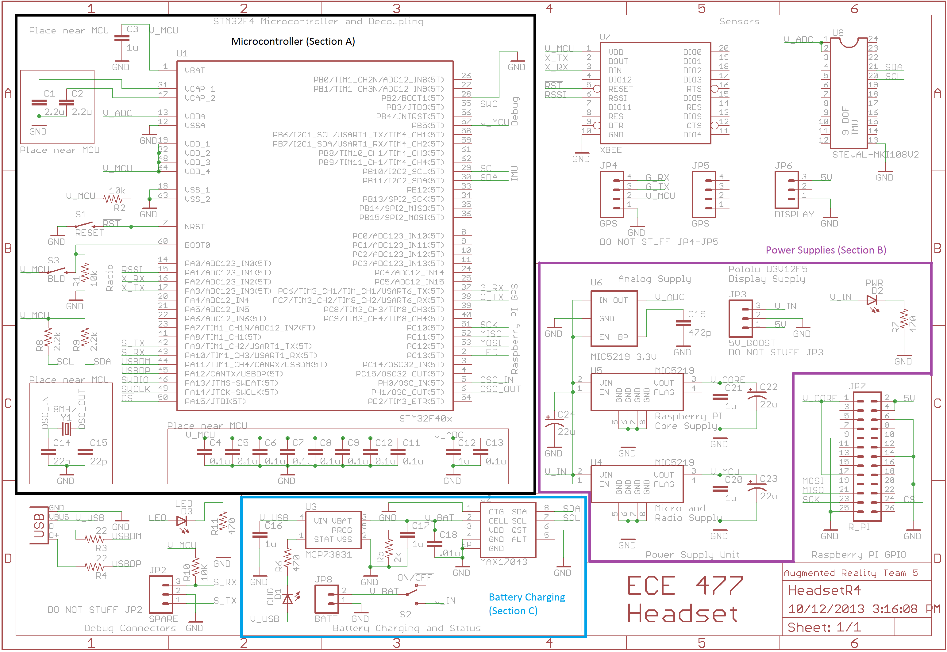

Appendix B: FMECA Worksheet

|  |  |  |  |  |  |  |
| --- | --- | --- | --- | --- | --- | --- |
| **Power Supplies** | | | | | | |
| **Failure No.** | **Failure Mode** | **Possible Causes** | **Failure Effects** | **Method of Detection** | **Criticality** | **Remarks** |
| P1 | Vin shorts to ground and battery protection circuit fails. | Failure of JP3, U6, U5, U4, Battery protection circuit | Excessive heat generation from power supply. Fire and or battery explosion. | Observation | High | Low probability because of redundant circuitry |
| P2 | V_ADC > 3.3V | Failure of U6, VIN shorted to V_ADC | IMU may not report values and may become permanently damaged. | Cannot move “around” virtual objects. | Low |  |
| P3 | V_CORE > 3.3V | Failure of U5, VIN shorted to V_CORE | Raspberry Pi may reset repeatedly, work fine, or be permanently damaged. | No display shown. | Low |  |
| P4 | V_MCU > 3.3V | Failure of U6, VIN shorted to V_MCU | Micro and Xbee may become permanently damaged. | No display or static display. Objects to not update their location. | Low |  |

|  |  |  |  |  |  |  |
| --- | --- | --- | --- | --- | --- | --- |
| **Battery Charging** | | | | | | |
| **Failure No.** | **Failure Mode** | **Possible Causes** | **Failure Effects** | **Method of Detection** | **Criticality** | **Remarks** |
| B1 | V_USB shorts to V_BAT and battery protection circuit fails | Failure of U3 | Battery could get overcharged and cause heating or explosion. | Observation | High | Unlikely because two components need to fail. |
| B2 | U2 fails open | Failure of U2 | Reported battery charge incorrect and does not vary with time. | Observation of battery charge indicator. | Low | User unaware of how much battery life is left. Inconvenience |

|  |  |  |  |  |  |  |
| --- | --- | --- | --- | --- | --- | --- |
| **Microcontroller** | | | | | | |
| **Failure No.** | **Failure Mode** | **Possible Causes** | **Failure Effects** | **Method of Detection** | **Criticality** | **Remarks** |
| M1 | Micro fails to run | Failure of C1, C2, C3, C4, C5, C6, C7, C8, C9, C10, C11, C12, C13, R2, Y1, U1 | Display does not change or no display. | Observation | Low | Device just “doesn’t work” |
| M2 | Micro runs but does not function properly. | Failure of C1, C2, C3, C4, C5, C6, C7, C8, C9, C10, C11, C12, C13, R2, Y1, U1, Software | Unpredictable Behavior: Intermittent display problems or errors in simulation. | Observation | Med | User could be disoriented by moving pictures. |