Project: Super Smash
Team ID: 7

Place picture of project with team members here.

Complete the caption, below.

Delete this text box before pasting in your photo!
NOTE: Use the on-line form on the Mini-Project website page to submit this report (.doc file) along with your source code file (.asm or .c)

Delete this text box before submitting your report! Also, delete all highlighted instructions provided in this skeleton file as you edit each section of your report.
Team members, left to right are: <name 1>, <name 2>, <name 3>, and <name 4>.

Mini-Project Evaluation – Team ID: 7

ID | Name | Class No. | Score
M1 | David Kauer | 5602-K
M2 | Kyle Brown | 7187-B
M3 | Thor Smith | 8090-S
M4 | Vipul Bhat

CRITERION | TEAM | M1 | M2 | M3 | M4
Originality, creativity, level of project difficulty
Technical content of report
Writing style, professionalism, references/citations
Demonstration of functionality (success criteria)
Overall quality/integration of finished product
Effective utilization of microcontroller peripherals
Quality of technical contribution (documentation)*
Significance/effectiveness of technical contribution*
Early completion bonus
Flash utilization bonus
Class demo bonus (by invitation only)

* individual evaluation criteria have twice the weight of team criteria

Scoring:
10 | Excellent – among the very best projects/reports completed this semester
8-9 | Good – all requirements were amply satisfied
6-7 | Average – some areas for improvement, but all basic requirements were satisfied
4-5 | Below average – some basic requirements were not satisfied
1-3 | Poor – very few of the project requirements were satisfied

Instructor comments regarding project/demonstration:

______________________________________________________________________________

______________________________________________________________________________

TABLE OF CONTENTS

1.0 Introduction | 1
2.0 Interface Design | 2
3.0 Peripheral Utilization | 4
4.0 Software Narrative | ?
5.0 Packaging Design | ?
6.0 Summary and Conclusions | ?
7.0 References | ?
Appendix A: Individual Contributions and Activity Logs | ?
Appendix B: Interface Schematic | ?
Appendix C: Software Flowcharts | ?
Appendix D: Packaging Design | ?

1.0 Introduction
This team has put an enormous amount of effort to turn this project into a success. Each team member enjoys taking the ECE 362 class and learning about microcontrollers. All of us decided that our project would have to be ambitious; something that other people would appreciate and admire. The goal of this project is to create a version of the Super Smash Brothers video game. The idea originally came from Kyle who thought it would be a neat idea. The team started early enough to plan ahead and make some decisions on the more difficult aspects of the design such as VGA. We then divided up the tasks and focused on our separate areas, however we also helped each other when needed. We mostly relied on Git Hub as a repository to store all of our source code, datasheets, and other documents [9].
The game has a number of features that should be mentioned here. There is a menu selection screen, where the player can determine which character to choose, which battlefield to play on, and when to start the match. During this time, music will loop in the background. There can be two players that control two characters on the screen. Each player has a controller with a joystick that determines which direction to move the character and two buttons that are used for combat and selection. When the player starts the game, the music will stop and the game will begin. To win, the player needs to hit his opponent to the edges of the screen five times. This is because the game was designed to where the character will lose a life if he touches the edges, and they have five lives each. After a character has died, it will respawn as long as it has lives left to spend. When a fighting animation occurs, a short sound will go off. After the match is over, the screen goes back to the menu and the music begins again.
This project was a collaborative effort between all of the members in the group, however each of us focused on certain aspects of the project. Vipul worked with PWM module to produce the sound and music in the game. David handled the hardware design and interfacing with off-chip components, and coded the XIRQ and IRQ service routines. Thor was the developer and coded the logic for game, which including character/map selection, collision physics, and animations to name a few. Kyle worked on packaging the microcontroller and off-chip components, made the controllers and ATD service routine, and created art mock ups for the game.

2.0 Interface Design
There are several components that interface with the 9S12C that are required to run the design. Referring to the overall schematic in Figure B-1, the project comprised of PLDs, VGA port, a speaker for PWM sounds, a few buttons, joysticks, potentiometers, diodes, and a 25.175 MHz Crystal Oscillator [8]. The PLDs cover the VGA timing and pixel shifting, the VGA port communicates with a monitor for display, and the crystal oscillator is the base clock for the VGA timing. The speaker outputs music and fighting sounds, whereas the joysticks and pushbuttons allows the player to control and move the character around the screen. Lastly, the potentiometers allows for changing the color hue displayed on the screen, and the diodes prevents feedback and controls the current flow to go in only one direction.
The majority of the interfaced components is made up of five PLDs that handle the VGA hSync and vSync timing and pixel data shifting. Figure C-1 can show how the PLD signal work together. The first PLD is a clock divider that cuts the 25.175 MHz crystal oscillator by a factor of 32, which is used for the hSync and vSync PLDs. The second PLD was used to generate the hSync pulse, which runs at 31.4 KHz. The third PLD was used to generate the vSync pulse, which runs at 60 Hz [2]. The fourth PLD is used to act as a pixel clock, which tells the pixel buffer PLD when to latch new pixel data and when to shift the next pixel to the VGA port. The last PLD buffers two pixels worth of data and output a 3-bit RGB value to the VGA port. It also detects a specific RGB value that would originally output the color teal to the screen. However, when the value is detected the logic in the PLD will change the RGB values to brown.
The pixel data outputted by the pixel buffer PLD goes through a potentiometer and a diode. The potentiometer has the ability to change the color hue displayed on the screen. These diodes were added as a safety measure to prevent fighting and feedback loops going to the PLD. They were necessary to the design because they were needed to implement the color brown. This is because the PLD needs to output Red and Green (Brown) instead of Blue and Green (Teal) [1].
The microcontroller will interface with a audio jack, which can connect to a speaker to produce sound. The audio jack is connected to the port T0 pin on the microcontroller, which outputs a PWM signal.
Lastly, the game controls consist two controllers. Each controller has one analog joystick, and two pushbuttons (A,B). The joysticks are made up of two potentiometers that determines which direction the joystick is turned [5]. The two pushbuttons are active low, and are pulled high when not pressed [6]. Each controller is connected to an ethernet cord, and are plugged into the ATD pins of the microcontroller.

3.0 Peripheral Utilization
The TIM module was used to perform precise delays and character related physics operations. Originally we used this module to display a splash screen for one second before going to the menu. However, later on the team thought it necessary to include a small physics engine to handle velocity and acceleration. So, we created a algorithm that calculates the velocity and acceleration of a player, which is incorporated into the Timer service routine. It also handles the sound code that is played whenever a character performs an animation. The Timer was initialized to run at 1.5 MHz, uses an output compare with channel 0, and was enabled before the main program. The counter was set to 15000 in order to get an interrupt every 10 ms. As soon as the interrupt is flagged, the value in TC0 is added by 15000. This way, the value in TC0 should wrap around and create a reliable interrupt rate.
PWM was utilized for sound generation. Most the parameters for frequency control were kept the same and only the PWMSCLA register values were altered to obtain the desired frequency. Frequency values were found out for various notes ( C, E and A) at different octaves and were utilized in the sound generation. The frequency values vary from 311 Hz to 1864 Hz [4]. The PWM signal was set to its default setting of being left aligned and having negative polarity, and was set to use channel0 or the port T0 pin on the microcontroller. The PWMDTY0 register which controlled the duty cycle for the PWM output on channel zero was set to 80t.
The ATD module was used to sample the joysticks. They are just potentiometers with the wiper pin connected to the ATD pins. They are sampled 60 times a second, using a subroutine that is triggered off of an IRQ from the Vsync PLD. The data is stored in global variables as 8 bit, left-aligned values. ATDCTL2 was set to 0x80 to enable the ATD. ATDCLT3 was set to 0x08 to enable non-FIFO mode, with one conversion per sequence. ATDCTL4 was set to 0x85 to set 8 bit resolution and the nominal sampling time. ATDCTL5 changes based on the channel we are sampling, for channel 7 it is 0x47 for left justified, signed, single conversion.
The majority of the port T pins were used to push out the RGB pixels to the PLDs and then to the VGA port. Since each byte of data corresponded to two pixels, we needed six pins (port T7 – T2). The data remained on the port pins for no more than ten cycles before changing to the next two pixels because then the pixels displayed on the screen are wider and more visible. This setup allowed to use less SRAM to store pixel data, and the use of no operation commands were used to realize this.
4.0 Software Narrative
Describe the software written and provide a narrative on how it operates. Submit your complete software listing on-line separately. Include a flowchart to document program structure in Appendix C.

Length should be about one page.

5.0 Packaging Design
We recognized the importance of packaging and decided that it was not enough if our project worked, but did not look good as well. We wanted to solder everything down to minimize noise in the circuit and allow our project to function years after we had submitted it. We had a lot of components so this required careful planning and a thoughtful layout. We were able to remap some of the pins of the PLD’s in order to make this job easier. The controllers are soldered on to 1x1” perf-boards and the main console is soldered to a 2x3” perf-board. All of the soldering was done point-to-point, as we did not have time to design and fabricate a PCB. This technique is not as reliable or easy to reproduce as a printed circuit board, but will suffice for a mini-project.
We knew we wanted to have our controllers wired separately from the main console to closely emulate the look of a commercial video game console. To accomplish this we wanted to socket our controllers and we decided on RJ-45 sockets, due to the snap in connectors and the 8 pins of connectivity. We decided to house our controllers in Altoids containers, because they are sturdy and approximately the right size to fit in the hand of a user. The cabling is hardwired on the controller side and uses RJ-45 wall adapters on the console side. The large holes were drilled and then ground with a Dremel until they were the right size. The smaller holes were just drilled and deburred. The joysticks are mounted from the top and secured with brass screws, lock washers, nylon spacers, nuts and lock nuts.
For the main console, we chose to emulate to form factor of the Nintendo Gamecube and go for the aesthetics of the Crate item from the Super Smash Brothers game [10]. To create the real life version of the crate, lattice stripping was cut and stapled together using a hack saw and a staple gun. We opted for all brass fittings to increase the overall luster of our box. The top is hinged to allow access to the internals. Holes for the RJ-45 ports were routed using a Dremel, everything else was drilled. All of the components are mounted with nuts and bolts or wood screws, which should allow the project to last longer than hot glue or Loctite. The mounting panels for the VGA, audio, and power were constructed from steel pieces from a computer case. We were forced to use 3/8” staples to join 1/4” slats of wood, because we did not want to have 1/2” staples poking through the box. This caused the box to be not as sturdy as we liked, so the seams were secured with glue.
The wood and RJ-45 connectors were purchased from Von Tobbles Hardware. The crystals and VGA connectors were purchased from Digikey [8]. The joysticks were purchased from Sparkfun [5]. The buttons and other assorted electronic components were purchased from Radioshack [6,7]. All other hardware was either purchased from Ace hardware or found in Kyle’s basement.
6.0 Summary and Conclusions
This project has taught us a lot regarding the capabilities of the 9S12C32 microcontroller. Between the four of us, we’ve not only learned a lot about the different modules such as PWM, ATD, TIM but also new topics such as VGA and designing a game. We’ve made every attempt to finish this project in a very disciplined and organized manner. Starting with coming up with a project idea and assigning team roles early in the semester down to using a revision control service ( GitHub ) to keep track of our progress and development, we’ve managed to stay on top for the most part [9]. Though the last few weeks have been hectic, we never encountered a major problem which held us back over the past two months. The division of labor was very appropriate because each team member got to focus on what he was good at, which was probably why we managed to stay on track. At the end of the project, we were all well versed with what each of us had worked on, and that in our opinion was efficient management of time and labor.
While we are pleased with what we’ve achieved so far, we do realize that in hindsight, we could have made the game better. Given more time or another chance, we would probably try to implement unique attack functions for each character. Also, we would have liked to have included projectile attacks in the game. That in our opinion would give the game a more realistic touch. Moreover, to enhance the game play we would also work on improving the graphics of the game and try and include more battlefields and characters. We might also have designed controllers with more buttons for the new attack functions. Improving our sound would definitely be another consideration. Though sound was our lowest priority, an improvement to our current sound effects would be welcome. We would have taken the time to actually get the PWM output from the microcontroller to play something melodious throughout the game and focused on volume control as well.
In conclusion, while we do have some improvements in mind, we believe that we have done a reasonably well job in completing what we set out to achieve several weeks ago. Working on the mini project was probably the most enjoyable and educational experience we’ve had in the class and we felt like it gave us a reasonable idea as to what to expect if we chose to take ECE 477 for our senior design.

7.0 References
[1] VGA on AVR
Build the VGA Video Generator. (n.d.). Retrieved from
http://lucidscience.com/pro-vga%20video%20generator-1.aspx
[2] VGA 640x480 Information
"VGA industry standard" 640x480 pixel mode. (n.d.). Retrieved from
http://martin.hinner.info/vga/640x480_60.html
[3] Microcontrollers Class 362 Web page
ECE 362 Mini Project. (n.d.). Retrieved from
http://engineering.purdue.edu/ece362MiniPrj/index.html
[4] Frequency ranges for musical notes
Digital Audio - Frequency Ranges (n.d). Retrieved from
h ttp://www.zytrax.com/tech/audio/audio.html
[5] Thumb Joystick
Spark Fun Electronics. (n.d.). Retrieved from http://www.sparkfun.com/products/9032
[6] LED Tactile Button
Spark Fun Electronics. (n.d.). Retrieved fromhttp://www.sparkfun.com/products/10442
[7] LED Tactile Button Breakout
Spark Fun Electronics. (n.d.). Retrieved fromhttp://www.sparkfun.com/products/10467
[8] 25.175MHz Crystal Oscillator
Digi Key. (n.d.). Retrieved from http://search.digikey.com/us/en/products/SG-51P
%2025.1750MC/SE1715-ND/38171
[9] Git Hub Repository
Git Hub(n.d). Retrieved from
https://github.com/snowpuppy/vga_9s12
[10] Super Smash Bros. Crate Image
Super Smash Bros. Wikia (n.d). Retrieved from
http://images2.wikia.nocookie.net/__cb20110929222561/ssb/images/7/7b/CrateMeleeTrophy.png

Appendix A:

Individual Contributions
and
Activity Logs

Activity Log for: David Kauer Role: Interface Leader

Activity | Date | Start Time | End Time | Time Spent
Team Meeting, Discussed Project, Assigned Roles | 3/4/12 | 12pm | 4pm | 4 Hours
Worked on making a counter using a PLD with reset | 3/20/12 | 5pm | 9pm | 4 Hours
Finished making the counter on the PLD for the Hsync pulse | 3/24/12 | 5pm | 9pm | 4 Hours
Finished making the Vsync pulse PLD | 3/25/12 | 4pm | 5pm | 1 Hour
Tried to get VGA display to work using the PLDs created | 3/29/12 | 5 pm | 10pm | 5 Hours
I've managed to sync the vga connector with a computer screen | 3/31/12 | 6pm | 12am | 6 Hours
We got VGA to display pixels onto a computer monitor | 4/8/12 | 10am | 12am | 14 Hours
We got VGA to display an entire static image onto the screen | 4/9/12 | 12am | 8pm | 8 Hours
Tried to make a synchronizer to stabilize the images displayed on the screen | 4/14/12 | 1pm | 9pm | 8 Hours
Tried to debug the synchronizer | 4/17/12 | 5pm | 8pm | 3 Hours
We got the syncrhonizer to work and we are now able to display clear pixels on the screen | 4/18/12 | 5pm | 10pm | 5 Hours
Tried to get characters to move across the screen, and we soldered all of our hardware components to a solder board | 4/19/12 | 5pm | 8pm | 3 Hours

Written Summary of Technical Contribution: David Kauer
My primary role in this project was to design and interface hardware with the microcontroller. I had to program a total of five PLDs using ABEL in the design, which cover the VGA timing and the RGB pixel shifting. I had to use ISPLever and Dataman programs extensively to ensure each PLD was preforming correctly, and to move certain pins around to make the circuit board soldering process easier to manage. I also helped the team code the XIRQ and IRQ signals that interface with the microcontroller's external interrupt pins.
Starting with the PLDs that were programmed, I had to create five PLDs to handle the VGA timing and the pixel data shifting. I mostly used GAL26s since some of the designs were rather large, however I was able to fit a couple designs onto two GAL22s. There are four PLDs that basically perform as counters. These PLDs were used to generate the timing required for the VGA hSync and vSync pulses as well as to clock pixel data to the VGA port. The last PLD acts as a pixel buffer/decoder. I had to program this PLD to buffer two pixels worth of data and output a 3-bit RGB value to the VGA port. The decoding portion is used to detect a specific RGB value, which would originally output the color teal, but outputs a brown color instead. The team felt like we needed this in the design to draw characters like Donkey Kong or Fox.
In terms of the C code that is programmed on the microcontroller, I have coded two IRQ service routines that run off of hSync and vSync pulses. The hSync signal acts as an XIRQ because the microcontroller does not have a lot of time to process requests during the horizontal blanking period. It should be focused on outputting pixel data at the start of a new line. The vSync signal acts as an IRQ because the microcontroller has time to process requests during the vertical blanking period. Therefore, the microcontroller's attention does not have to be immediate. I was able to utilize the external interrupt pins on the microcontroller to interface the XIRQ and IRQ pulses coming from the PLDs. In the C file, I had to ensure that both the IRQ and XIRQ were enabled during the initialization, so that the microcontroller can serve the requests.
I had to use ISPLever and Dataman to program the PLDs in ABEL. I had to use these tools to ensure that the devices were outputting the correct frequency and shifting pixels at the proper time. I also had to relabel signals to certain pins in order to make the soldering process simpler.
I made the schematic for the entire design, which can be seen in Appendix B. I had to make my own footprints in Orcad in order add components that were not in the library such as the 9S12C or the VGA Port.

Activity Log for: Vipul Bhat Role: TDP

Activity | Date | Start Time | End Time | Time Spent
Team meeting, Discussed Project, Assigned Roles | 3/4/2012 | 12:00 pm | 4:00 pm | 4 hrs
Researched into sound effects for our video game. Decided on Atari Punk Console as a sound system. | 3/20/2012 | 6:00 pm | 10:00 pm | 4 hrs
Bought parts for an Atari punk console and attempted to build it. | 3/24/2012 | 6:00 pm | 12:00 am | 6 hrs
Consulted TA for sound effects. Decided to change the setup so that the console would be compatible with a generic speaker. | 3/29/2012 | 7:30 pm | 9:30 pm | 2 hrs
Wrote code for PWM to run the speaker and tested speaker. | 4/7/2012 | 5:00 pm | 9:00 pm | 4 hrs
Researched music notes for game music. Tried different patterns to choose the nicest tone. Worked on character artwork. | 4/14/2012 | 10:00 am | 4:00 pm | 6 hrs
Worked on code to play sounds due to actions in the game (punching, etc). Had issues by the end of the night | 4/18/2012 | 6:00 pm | 1:00 am | 7 hrs
Met TA during lab hrs and fixed issues with code. | 4/19/2012 | 2:30 pm | 4:30 pm | 2 hrs
Looked up methods to control the volume and worked on game artwork. | 4/20/2012 | 8:00 pm | 10:00 pm | 2 hrs
Incorporated music code into the main game code developed by Thor and tested the game. | 4/23/2012 | 6:00 pm | 9:00 pm | 3 hrs
Worked on report and added final touches to project. | 4/24/2012 | 8:00 pm | 12:00 am | 4 hrs

Written Summary of Technical Contributions: Vipul Bhat
My responsibility included coming up with a sound system for the game. On Kyle’s suggestion, I decided to look up an electronics project called an “Atari Punk Console”. It is a sound generator, whose original circuit was developed by Forrest M. Mims III in the 1980s and was originally called a stepped tone generator. It utilizes two timer ICs and generates pulses. According to the original schematic, the frequency and the pulse width are controlled by potentiometers. Our initial plan was to replace the potentiometers that controlled the voltage (for volume and frequency control) with pulse width modulation. After buying the necessary parts and building the circuit displayed in the schematic (references), I faced issues getting the sound generator to play music properly. The sound generated got unpleasant to listen to over an extended period of time. Moreover, I was told by a TA that there was an easier and nicer option as far generating game music went. We decided to use PWM to generate music from a generic speaker as opposed to building an elaborate system that more or less achieved the same purpose.
Once I’d decided to use a generic speaker, the task got a lot easier. I connected the audio jack of the speaker to the PWM output of the microcontroller. I then experimented with various frequencies for the PWM at different rates. I used the timer interrupt to keep track of what musical note was playing and switched it accordingly. I then worked with Thor Smith to incorporate the music into the game source code. We decided to play the music when we turned on the game and turn it off when the characters started to fight. We decided to do this by disabling the PWM output all together and turn it on only when necessary, i.e for noises in the middle of a fight. Once Thor figured out the attack logic for the game, I used the same principles I‘d used to play the music to make game noises as well. So for example, if a player punches his opponent during the game, a flag is set which causes the PWM to get enabled and play a certain noise (based on what action was carried out by the player). The noise will be played as long as the flag is set. The flag is cleared when the action is completed. In the example mentioned above, that would be when the character is done punching which lasts for a fraction of a second.
Activity Log for: Kyle Brown Role: Peripheral Leader

Activity | Date | Start Time | End Time | Time Spent
Drawing Image Mockups, Researching VGA, Preliminary Planning | 3/2 | 10PM | 2AM | 4
Team Meeting | 3/4 | 12PM | 4PM | 4
Team Meeting, working on PLD's and timing | 3/20 | 12PM | 3PM | 3
Team Meeting, soldered joysticks, wrote ATD routines | 3/23 | 12PM | 4PM | 4
Went to the hardware store and worked on controller | 3/24 | 5PM | 7PM | 2
Worked on VGA with David | 3/31 | 12PM | 7PM | 7
Got the VGA to work!!! | 4/7 | 12PM | 9PM | 9
Tried to remove jitter from VGA, built controllers | 4/15 | 12PM | 8PM | 8
Worked on removing jitter using PLD's | 4/17 | 12PM | 6PM | 6
Perfected the VGA on a breadboard, promptly destroyed it due to late night soldering | 4/18 | 6PM | 3AM | 9
Used a toothbush to scrub the board, magically fixing everything. Soldered everything else down. We now have final hardware, less a power switch and a barrel connector. | 4/19 | 6PM | 9PM | 3
Built crate | 4/20 | 5PM | 7PM | 2
Purchased extra hardware for crate, painted crate, began mounting parts | 4/22 | 12PM | 5PM | 5
Character attack animations and splash screen, fixed floating buttons in controllers | 4/23 | 9PM | 12AM | 3
Finishing up everything, drawing maps | 4/24 | 8PM | 5AM | 9

Written Summary of Technical Contributions: Kyle Brown
I came up with the initial idea to create a VGA powered video game based on Super Smash Brothers. I researched the VGA signal and came up with a way to create a 48x48 display using the limited resources of a 9S12 microcontroller and parts that we had left over from the ECE 270 parts kits and our ECE 207 parts kit. I designed the basic gameplay and drew concept art for our limited display and scheduled a meeting with the group the next day. The group was enthusiastic about my idea and we decided to try and implement it as our mini-project. I shared the block diagrams I had drawn up and we divided responsibilities amongst the group.
David and I were in charge of getting the VGA to work. We worked together for two long Saturdays programming the PLD’s and staring at the oscilloscope trying to get the monitor to sync with the timing signals we were producing. I can up with the outline for what all of the PLD’s needed to do and assisted David in programming them to accomplish this task. I handled much of the debugging and oscilloscope work, while David manned the keyboard. I also designed how the PLD’s would interface with the microcontroller and helped write the microcontroller routines as well.
I designed the hardware for the controllers, picked out the parts and figured out how they would interface with the microcontroller. I wrote the ATD sampling routines for the joysticks and flag setting for the pushbuttons. I originally made a very foolish error and forgot to pull the pushbuttons high, which caused some sampling errors, but was quickly remedied. I handled all of the construction of the controllers, including drilling, grinding, sanding, soldering and mounting all of the components.
I designed and constructed the casing for our project. I constructed the box using 1- ¾” wide, ¼” thick lattice stripping and a 3/8” staple gun. I drilled all of the holes, mounted the hinges, routed the controller ports, painted the sides and mounted all of the components. I was also in charge of all of the layout and soldering. Everything is point-to-point solderblobbed and very compact. The only components not soldered directly to the board are power, VGA, audio and controller connectors. Each of the PLD’s and microcontroller is socketed to allow removal, in case one of the parts fails.
I also assisted Thor in designing the block diagram for the game as well as doing most of the testing. I drew all of the art for the game and helped create the data structures that hold the levels. I helped Thor debug sections of the code when needed, but he was very diligent in his planning and we encountered very few setbacks.
Activity Log for: Thor Smith Role: Software Leader

Activity | Date | Start Time | End Time | Time Spent

Written Summary of Technical Contributions: Thor Smith

Provide a detailed (one page minimum, two page maximum) description of your technical contributions to the project.

Appendix B:

Interface Schematic

Figure B-1 : Overall Circuit Schematic (David Kauer)
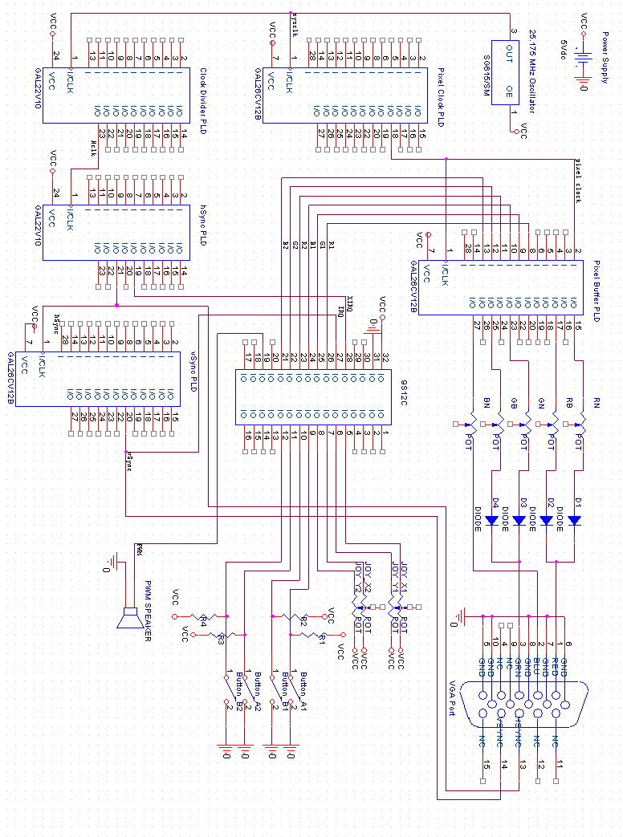

Appendix C:

Software Flowcharts

Figure C-1 : PLD Flowchart by David Kauer
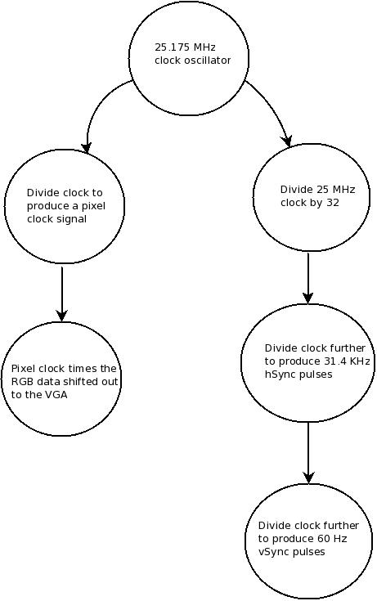

Appendix D:

Packaging Design

Packaging Documentation Completed by Kyle Brown
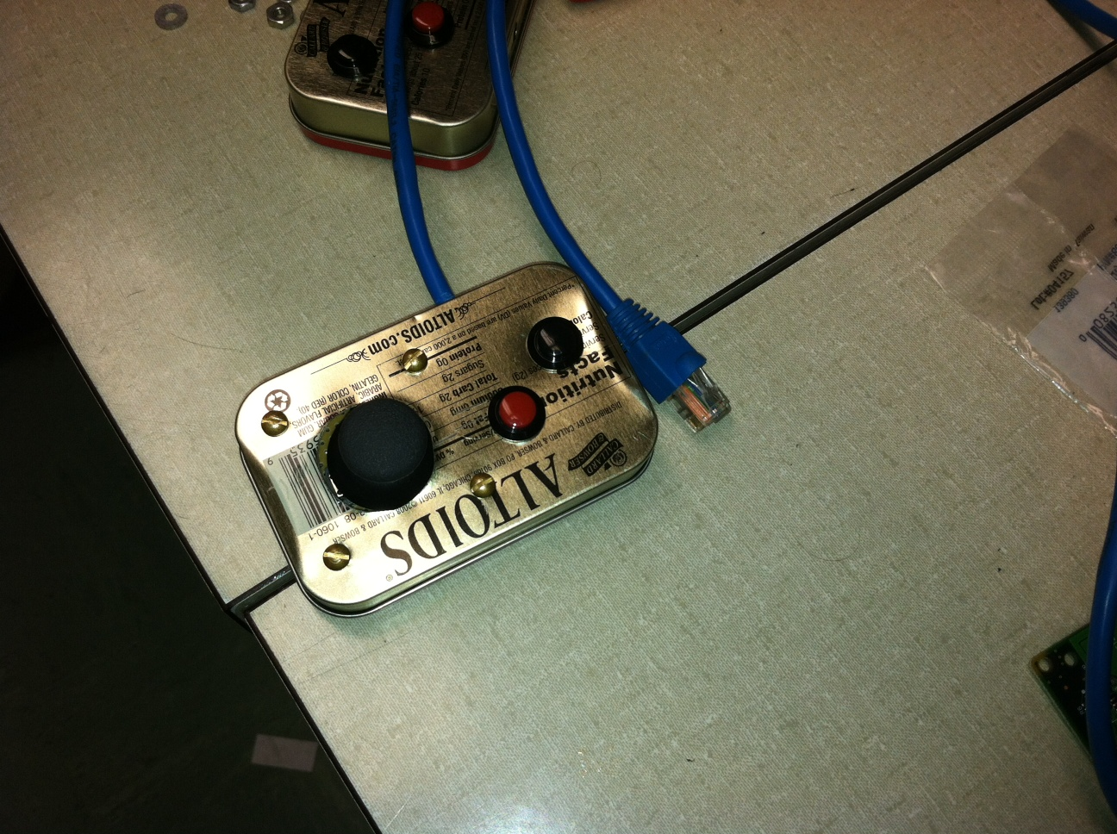Figure D-1 : Controller External
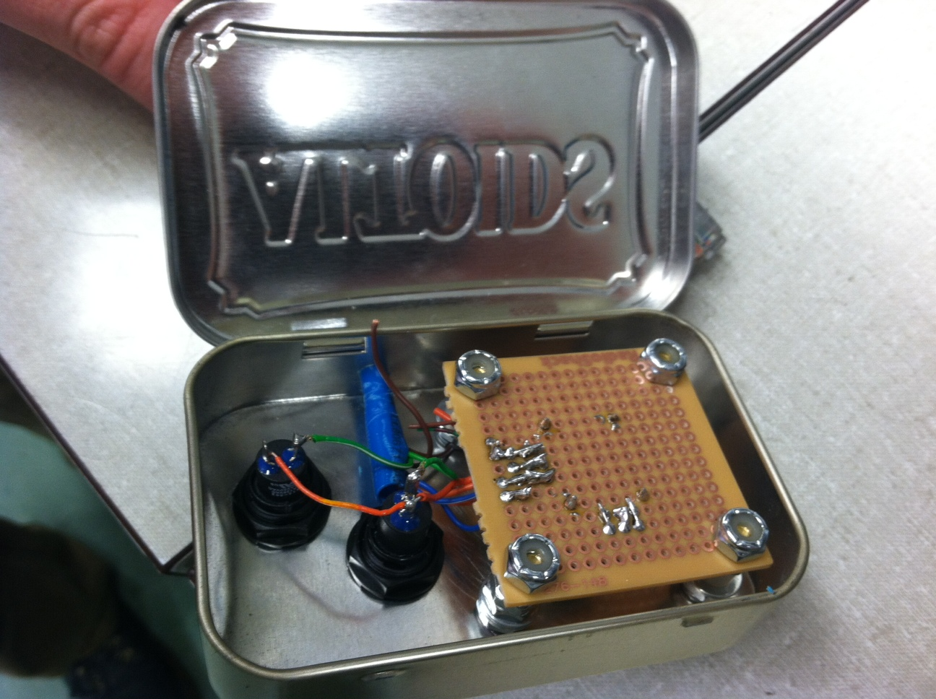Figure D-2 : Controller Internal

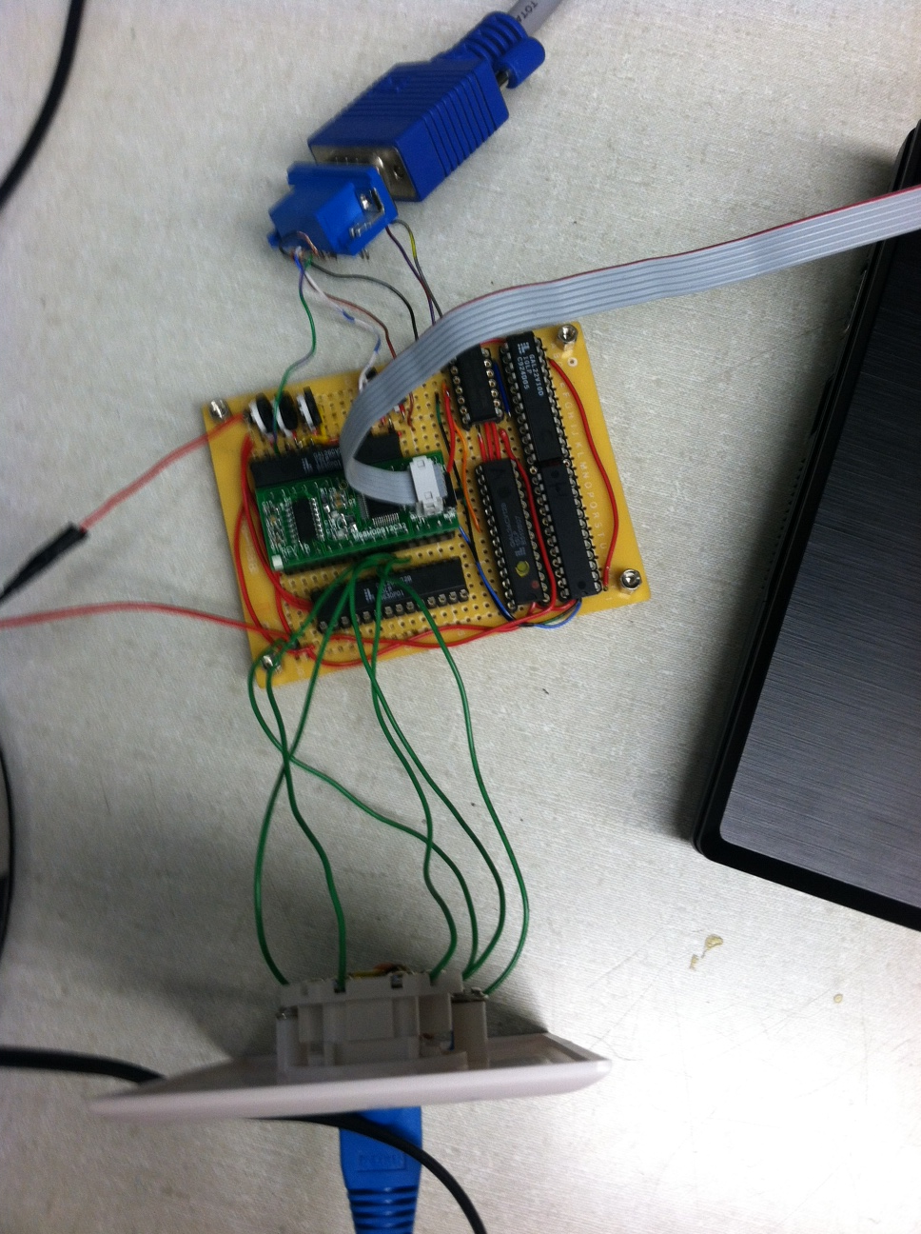Photo D-3 : Soldered Perfboard
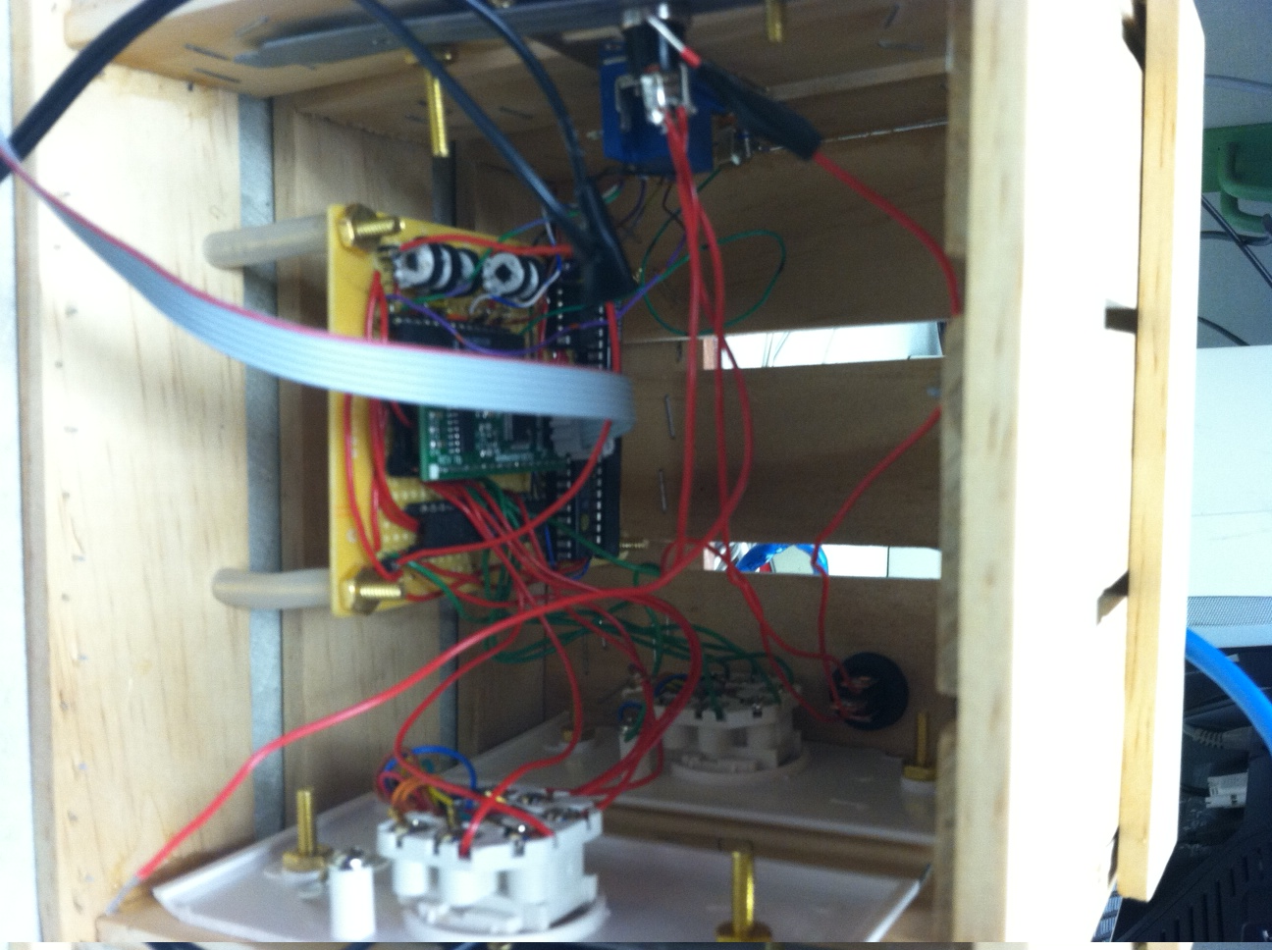Photo D-4: Final Box Internal

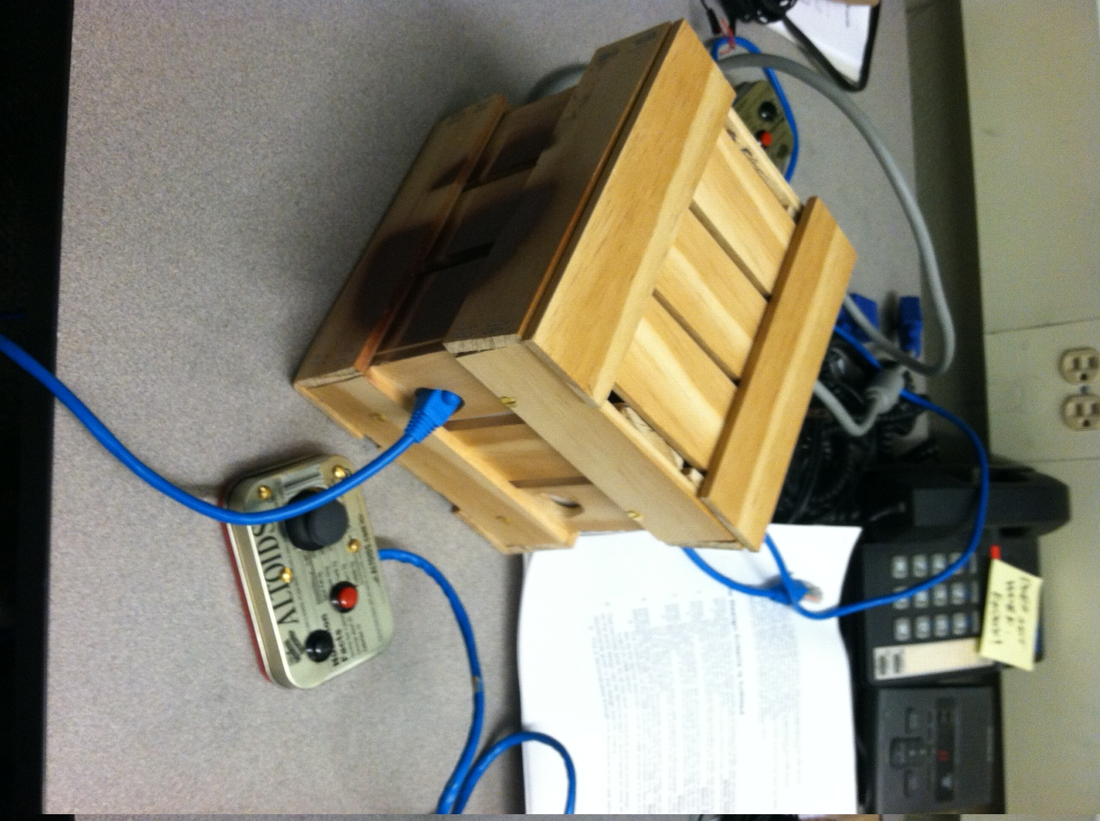
Photo D-5: External Case and Controller

