Meko memory sharing
between datapacks
A feature we wanted while building OpenHuman
team tungtungtungsahur / hackCBS 9.0 / 1 November 2026
We'd love a way to share one useful memory from an employee's private datapack into the company's common knowledge, while keeping a link to where it came from. If the fact changes later, we should be able to find and withdraw the old shared copy.

Where we ran into this
We're building OpenHuman, where companies hire AI employees and work with them in Slack. A datapack is Meko's container for memory and knowledge. Alex has a private one. Company knowledge has its own. Our HR employee, Allison, needs her own private space too.
Meko already promotes memories into shared knowledge inside the same datapack. Its docs say promotion does not cross datapacks. Putting everyone in one pack would give us the wrong privacy boundary. [1]
So we wrote that piece ourselves: read the selected fact, ask the operator to confirm it, upload it as a company knowledge document, and save the source employee and memory IDs. On correction or deletion, our app also has to find and remove the shared copies.

What we want instead
An operator picks a fact, chooses a destination and reviews the exact text. Meko keeps the original private record and publishes an approved copy into the destination's Shared Knowledge. A receipt connects the records and the source trace.
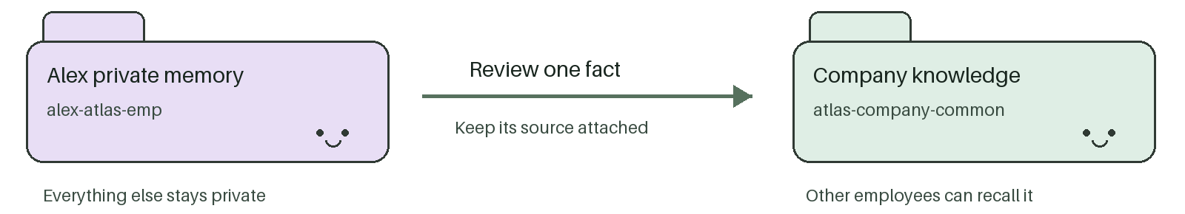
Our demo rule is that AMBER-217 goes to Isha in Access Ops and must never be handled with a password reset. Our current sharing path would copy that lesson into the company pack. With this feature, we'd review and share it through Meko. Another employee could recall the approved lesson without seeing Alex's private conversations.
If the source changes, mark the shared copy out of date and stop retrieving it until it is reviewed again. Editing a private memory must never silently publish new private details.

The call we wish we had
MCP is the tool interface our agents use to call Meko. This tool is proposed, not released. The IDs and receipts below are placeholders.
Proposed tool memory_share
Request
{
"source_datapack_id": "<Alex datapack ID>",
"target_datapack_id": "<company datapack ID>",
"memory_ids": ["<selected memory ID>"],
"target_layer": "shared_knowledge",
"mode": "copy", "seed": "share-17", "dry_run": true
}
Preview response
{
"review_token": "r17", "source_version": 1, "writes": 0,
"shared_text": "AMBER-217 goes to Isha. No password reset."
}
The preview writes nothing. After approval, repeat with dry_run set to false and review_token set to r17. Recheck permissions and the source version. If the reviewed text changes, prepare a new preview. The same seed should return the same receipt.
Publish response
{"share_id":"s17", "status":"indexing", "document_key":"s17.md"}
Use the document key with Meko's existing indexing-status check. Only show success when knowledge is ready. The receipt should also let us withdraw that published copy. [2]

Why we would pitch this
Shared memory exists elsewhere. Letta lets several agents use the same memory block. Our request is more specific: publish a reviewed fact between isolated Meko datapacks, with its source, revision and withdrawal history. We haven't found this operation in Meko's published tools. [1-3]
A local development setup could help too, but Meko's installer already supports local endpoints. We'd first ask what supported backend packaging is available. A save receipt that distinguishes 'stored' from 'extracted and searchable' is another useful idea. Sharing between datapacks fits our app most directly. [4]

What we would keep strict
Privacy: require owner or maintainer approval in both packs. Preview the exact text and destination. Do not automatically export conversations or HR records.
Cost and misuse: start with one fact and one destination. Keep storage and embedding limits, rate-limit requests, and reuse receipts on retries. Avoid automatic chains of re-sharing.
Withdrawal: remove the linked copy from future retrieval. Old replies, downloaded files and independent copies are outside that promise.

Build trail and references
Our share_fact and withdraw_shared_copies code is in apps/api/app/memory/service.py. The correction and forgetting flow has service-stub checks; this is not a claim of a live cross-datapack promotion feature.
Build datapack: tungtungtungsahur-build. Architecture evidence: document 64a98277-09b3-40f1-8789-201b04517a0c, sections Storage and access and Approved chat-router policy.
[1] Meko Learnings
[2] Meko MCP tools
[3] Letta shared memory
[4] Meko local endpoints

