1. Design Home Page for an online book store web site. The static home page must contain three frames. Top frame: Logo and the college name and links to Home page, Login page, Registration page. Left frame: At least two links for navigation. Right frame: The pages to the links in the left frame must be loaded here. Initially this page contains description of the web site. head.html

<!DOCTYPE html>

<html lang="en">

<head>

<meta charset="UTF-8">

<title>Online Book Store</title>

<style>

/* Basic styling */

body { font-family: Arial, sans-serif; margin: 0; padding: 0; }

/* Top frame styling */

.top-frame { background-color: #4CAF50; color: white; padding: 10px; text-align: center; }

.top-frame a { color: white; margin: 0 15px; text-decoration: none; font-weight: bold; }

/* Main container */

.main-container { display: flex; height: calc(100vh - 60px); }

/* Left frame styling */

.left-frame { width: 20%; background-color: #f4f4f4; padding: 10px; }

.left-frame a { display: block; margin-bottom: 10px; color: #333; text-decoration: none; }

/* Right frame styling */

.right-frame { flex-grow: 1; padding: 10px; }

</style>

</head>

<body>

<!-- Top Frame -->

<div class="top-frame">

<h1>College Book Store</h1>

<a href="head.html">Home</a>

<a href="login.html">Login</a>

<a href="register.html">Register</a>

</div>

<!-- Main Container (Left and Right Frames) -->

<div class="main-container">

<!-- Left Frame -->

<div class="left-frame">

<h3>Navigation</h3>

<a href="books.html" target="right-frame">Books</a>

<a href="authors.html" target="right-frame">Authors</a>

</div>

<!-- Right Frame (Content Changes Based on Left Links) -->

<div class="right-frame" id="right-frame">

<h2>Welcome to Our Online Book Store</h2>

<p>Discover a wide selection of books from various genres and authors. Register to start your reading journey today!</p>

</div>

</div>

</body>

</html> 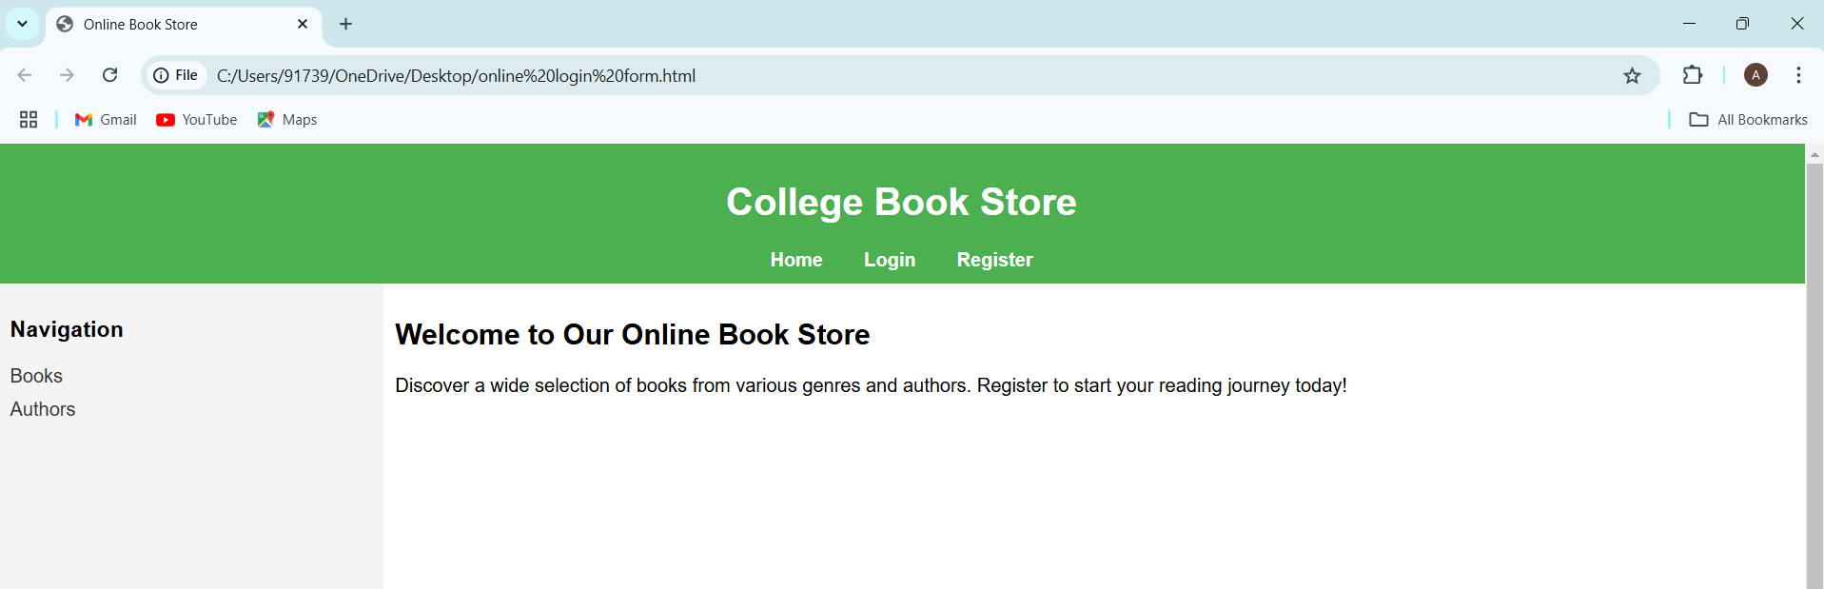

2) Create a “registration form “with the following fields 1) Name (Text field) 2) Password (password f ield) 3) E-mail id (text field) 4) Phone number (text field) 5) Sex (radio button) 6) Date of birth (3 select boxes) 7) Languages known (check boxes – English, Telugu, Hindi, Tamil) 8) Address (text area)

<!DOCTYPE html>

<html lang="en">

<head>

<meta charset="UTF-8">

<meta name="viewport" content="width=device-width, initial-scale=1.0">

<title>Registration Form</title>

</head>

<body>

<h2>Registration Form</h2>

<form action="#" method="post">

<!-- Name Field -->

<label>Name:</label>

<input type="text" name="name" required><br><br>

<!-- Password Field -->

<label>Password:</label>

<input type="password" name="password" required><br><br>

<!-- Email Field -->

<label>E-mail ID:</label>

<input type="email" name="email" required><br><br>

<!-- Phone Number Field -->

<label>Phone Number:</label>

<input type="text" name="phone" required><br><br>

<!-- Sex Field (Radio Buttons) -->

<label>Sex:</label>

<input type="radio" name="sex" value="male" required> Male

<input type="radio" name="sex" value="female"> Female

<input type="radio" name="sex" value="other"> Other<br><br>

<!-- Date of Birth Field (Select Boxes) -->

<label>Date of Birth:</label>

<select name="day">

<option>Day</option>

<option>1</option><option>2</option><option>3</option> <!-- add up to 31 -->

</select>

<select name="month">

<option>Month</option>

<option>January</option><option>February</option> <!-- add all months -->

</select>

<select name="year">

<option>Year</option>

<option>2000</option><option>2001</option> <!-- add needed years -->

</select><br><br>

<!-- Languages Known Field (Checkboxes) -->

<label>Languages Known:</label>

<input type="checkbox" name="languages" value="English"> English

<input type="checkbox" name="languages" value="Telugu"> Telugu

<input type="checkbox" name="languages" value="Hindi"> Hindi

<input type="checkbox" name="languages" value="Tamil"> Tamil<br><br>

<!-- Address Field (Text Area) -->

<label>Address:</label><br>

<textarea name="address" rows="4" cols="50"></textarea><br><br>

<!-- Submit Button -->

<input type="submit" value="Register">

</form>

</body>

</html>

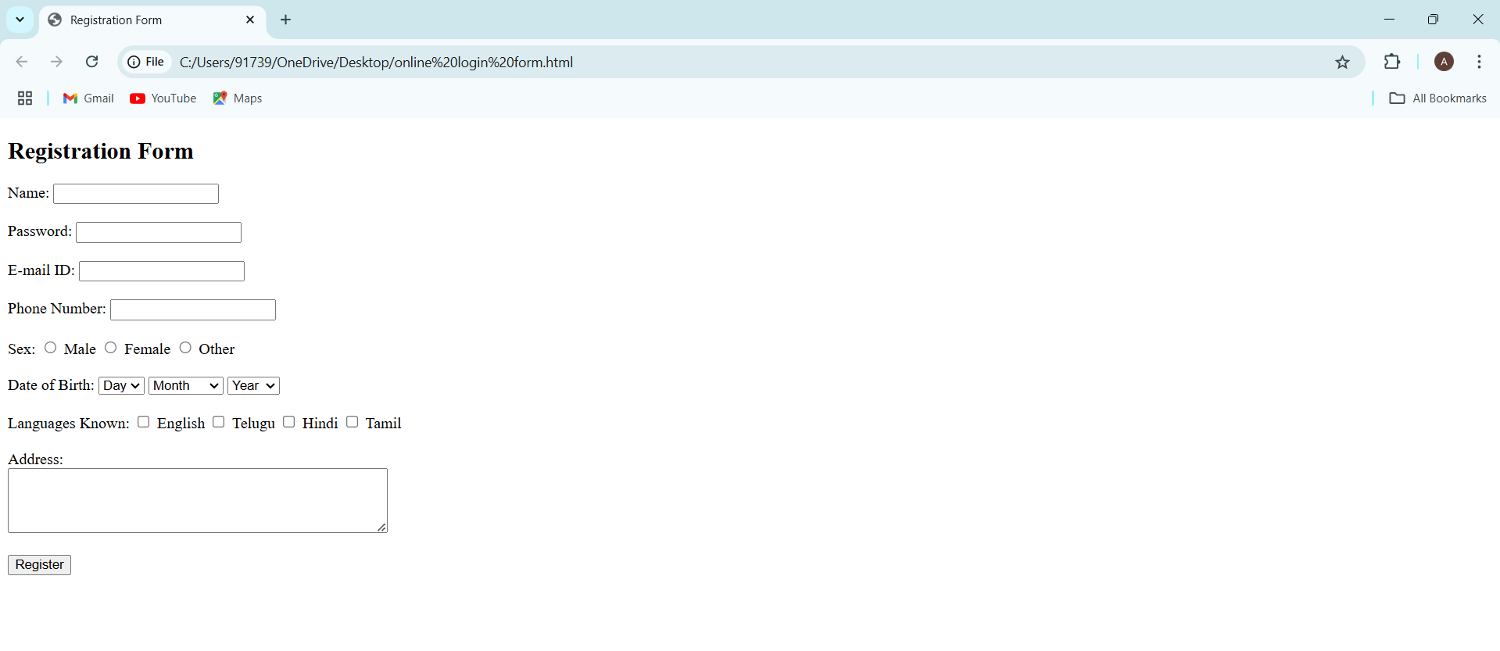

3) Design a web page using CSS (Cascading Style Sheets) which includes the following: Use different font, styles: In the style definition you define how each selector should work (font, color etc.). Then, in the body of your pages, you refer to these selectors to activate the styles

<!DOCTYPE html>

<html lang="en">

<head>

<meta charset="UTF-8">

<meta name="viewport" content="width=device-width, initial-scale=1.0">

<title>Stylish Web Page</title>

<style>

/* Body Styling */

body {

font-family: Arial, sans-serif;

margin: 0;

padding: 0;

background-color: #f4f4f9;

color: #333;

}

/* Header Styling */

header {

background-color: #4CAF50;

color: white;

padding: 20px;

text-align: center;

font-family: 'Georgia', serif;

font-size: 2em;

}

/* Navigation Styling */

nav {

margin: 20px;

font-size: 1.2em;

}

nav a {

color: #4CAF50;

text-decoration: none;

margin-right: 10px;

}

nav a:hover {

text-decoration: underline;

}

/* Section Styling */

section {

margin: 20px;

}

.highlight {

color: #FF6347;

font-weight: bold;

}

/* Paragraph Styling */

p {

line-height: 1.6;

font-family: 'Courier New', Courier, monospace;

}

/* Button Styling */

.btn {

background-color: #008CBA;

color: white;

padding: 10px 20px;

text-align: center;

font-size: 1em;

border: none;

cursor: pointer;

border-radius: 5px;

font-family: 'Verdana', sans-serif;

}

.btn:hover {

background-color: #005f75;

}

/* Footer Styling */

footer {

background-color: #333;

color: white;

text-align: center;

padding: 10px;

font-size: 0.9em;

font-family: 'Tahoma', sans-serif;

}

</style>

</head>

<body>

<header>

Welcome to My Stylish Web Page

</header>

<nav>

<a href="#home">Home</a>

<a href="#about">About</a>

<a href="#contact">Contact</a>

</nav>

<section>

<h2>About This Page</h2>

<p>This page demonstrates the use of <span class="highlight">different font styles</span> and <span class="highlight">CSS styling</span> elements.</p>

<p>The header, navigation, and footer sections are all styled with unique font families and colors to create a visually appealing layout.</p>

<button class="btn">Click Me!</button>

</section>

<footer>

&copy; 2024 My Stylish Web Page. All Rights Reserved.

</footer>

</body>

</html>

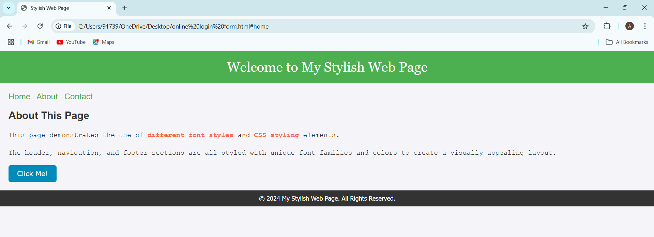

4) Design a dynamic web page with validation using JavaScript

<!DOCTYPE html>

<html lang="en">

<head>

<meta charset="UTF-8">

<meta name="viewport" content="width=device-width, initial-scale=1.0">

<title>Simple Form with Validation</title>

<style>

/* Basic styling */

body {

font-family: Arial, sans-serif;

display: flex;

justify-content: center;

align-items: center;

height: 100vh;

margin: 0;

background-color: #f4f4f4;

}

.form-container {

background-color: #fff;

padding: 20px;

border-radius: 5px;

width: 280px;

box-shadow: 0 0 5px rgba(0, 0, 0, 0.2);

}

label {

display: block;

margin-top: 10px;

}

input[type="text"], input[type="email"], input[type="password"] {

width: 100%;

padding: 8px;

margin: 5px 0;

}

.error {

color: red;

font-size: 0.85em;

}

button {

background-color: #4CAF50;

color: white;

padding: 10px;

width: 100%;

border: none;

border-radius: 5px;

margin-top: 10px;

cursor: pointer;

}

</style>

</head>

<body>

<div class="form-container">

<h3>Register</h3>

<form id="registrationForm">

<label>Name:</label>

<input type="text" id="name">

<span class="error" id="nameError"></span>

<label>Email:</label>

<input type="email" id="email">

<span class="error" id="emailError"></span>

<label>Password:</label>

<input type="password" id="password">

<span class="error" id="passwordError"></span>

<button type="button" onclick="validateForm()">Submit</button>

</form>

</div>

<script>

function validateForm() {

// Clear previous errors

document.getElementById('nameError').textContent = "";

document.getElementById('emailError').textContent = "";

document.getElementById('passwordError').textContent = "";

// Get form values

const name = document.getElementById('name').value.trim();

const email = document.getElementById('email').value.trim();

const password = document.getElementById('password').value.trim();

let isValid = true;

// Simple validation checks

if (name === "") {

document.getElementById('nameError').textContent = "Name is required";

isValid = false;

}

if (email === "" || !email.includes("@")) {

document.getElementById('emailError').textContent = "Valid email is required";

isValid = false;

}

if (password === "" || password.length < 6) {

document.getElementById('passwordError').textContent = "Password must be at least 6 characters";

isValid = false;

}

// Final alert if valid

if (isValid) alert("Form submitted successfully!");

}

</script>

</body>

</html>

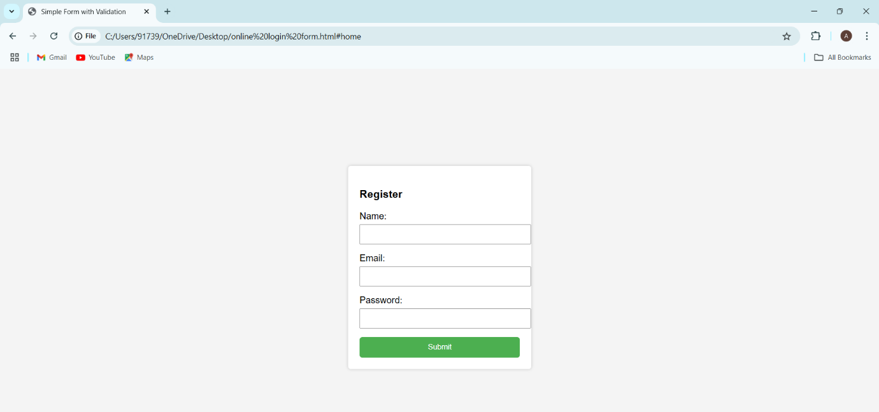

5) Design a HTML having a text box and two buttons viz Factorial, Fibonacci. When a button is pressed an appropriate JavaScript function should be called to display

a. Factorial of that number b. Fibonacci series up to that number

<!DOCTYPE html>

<html lang="en">

<head>

<meta charset="UTF-8">

<meta name="viewport" content="width=device-width, initial-scale=1.0">

<title>Factorial and Fibonacci Calculator</title>

<style>

body {

font-family: Arial, sans-serif;

text-align: center;

margin-top: 50px;

}

input, button {

margin: 5px;

padding: 8px;

}

.result {

margin-top: 10px;

font-weight: bold;

color: #333;

}

</style>

</head>

<body>

<h3>Enter a Number:</h3>

<input type="number" id="numberInput" placeholder="Number">

<br>

<button onclick="calculateFactorial()">Factorial</button>

<button onclick="calculateFibonacci()">Fibonacci</button>

<div id="result" class="result"></div>

<script>

function calculateFactorial() {

let num = parseInt(document.getElementById("numberInput").value);

let result = 1;

if (isNaN(num) || num < 0) {

document.getElementById("result").innerText = "Enter a non-negative number.";

return;

}

for (let i = 1; i <= num; i++) {

result *= i;

}

document.getElementById("result").innerText = `Factorial: ${result}`;

}

function calculateFibonacci() {

let num = parseInt(document.getElementById("numberInput").value);

if (isNaN(num) || num < 0) {

document.getElementById("result").innerText = "Enter a non-negative number.";

return;

}

let fib = [0, 1];

for (let i = 2; i <= num; i++) {

fib[i] = fib[i - 1] + fib[i - 2];

}

document.getElementById("result").innerText = `Fibonacci: ${fib.slice(0, num + 1).join(", ")}`;

}

</script>

</body>

</html>

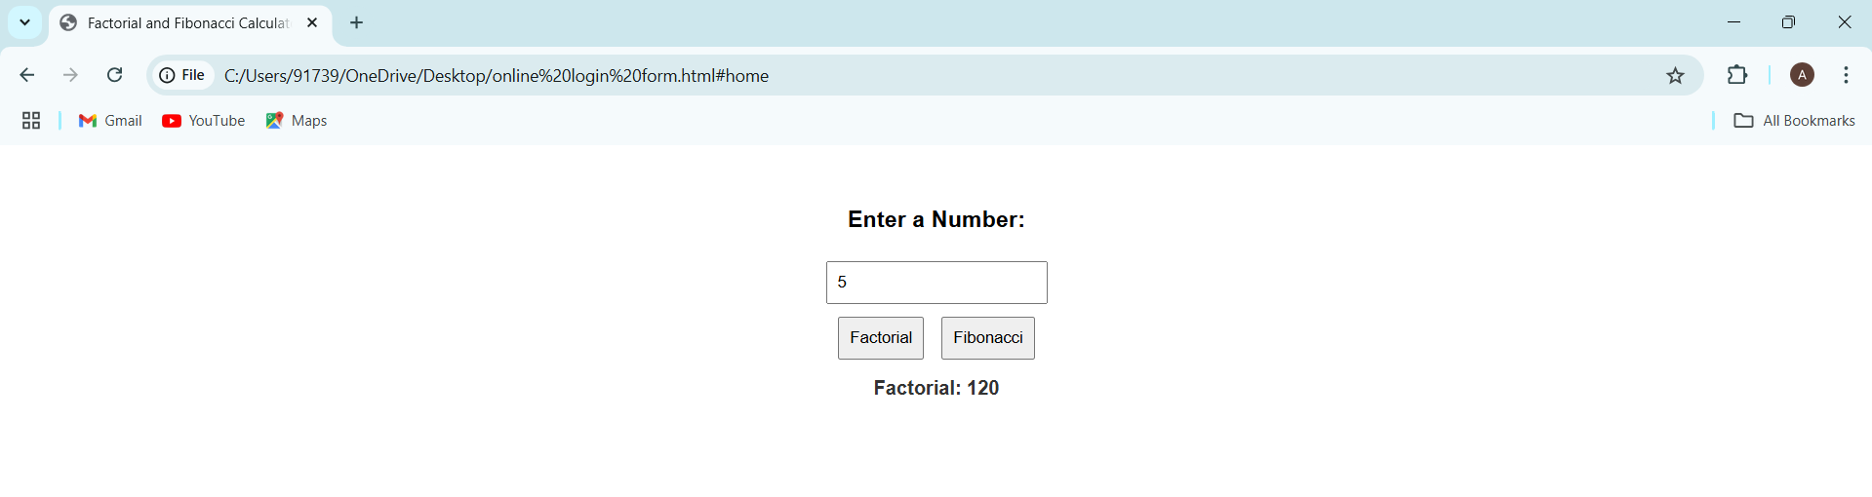

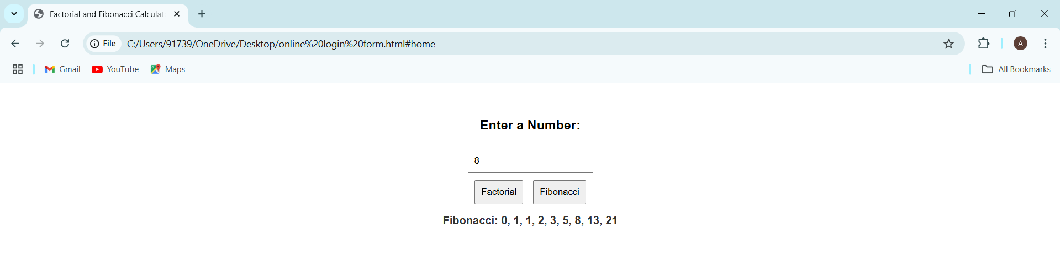

6) Design a HTML having a text box and two buttons viz Prime, and Palindrome. When a button is pressed an appropriate JavaScript function should be called to display

a. Prime numbers up to that number b. Is it palindrome or not

<!DOCTYPE html>

<html lang="en">

<head>

<meta charset="UTF-8">

<meta name="viewport" content="width=device-width, initial-scale=1.0">

<title>Prime and Palindrome Checker</title>

<style>

body {

font-family: Arial, sans-serif;

text-align: center;

margin-top: 50px;

}

input, button {

margin: 5px;

padding: 8px;

}

.result {

margin-top: 10px;

font-weight: bold;

color: #333;

}

</style>

</head>

<body>

<h3>Enter a Number:</h3>

<input type="number" id="numberInput" placeholder="Number">

<br>

<button onclick="checkPrime()">Prime</button>

<button onclick="checkPalindrome()">Palindrome</button>

<div id="result" class="result"></div>

<script>

// Check if a number is prime

function checkPrime() {

let num = parseInt(document.getElementById("numberInput").value);

if (isNaN(num) || num < 2) {

document.getElementById("result").innerText = "Enter a valid number greater than 1.";

return;

}

let isPrime = true;

for (let i = 2; i <= Math.sqrt(num); i++) {

if (num % i === 0) {

isPrime = false;

break;

}

}

document.getElementById("result").innerText = isPrime ? `${num} is Prime.` : `${num} is not Prime.`;

}

// Check if a number is a palindrome

function checkPalindrome() {

let num = document.getElementById("numberInput").value;

if (num === "") {

document.getElementById("result").innerText = "Please enter a number.";

return;

}

let isPalindrome = (num === num.split("").reverse().join(""));

document.getElementById("result").innerText = isPalindrome ? `${num} is a Palindrome.` : `${num} is not a Palindrome.`;

}

</script>

</body>

</html>

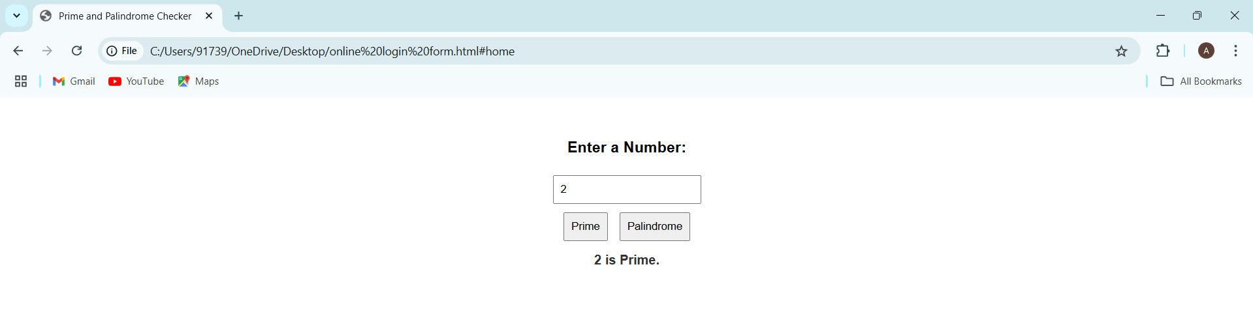

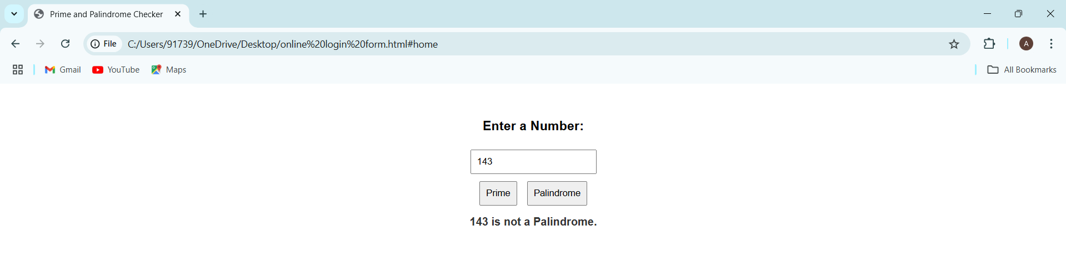

7) .Develop and demonstrate a HTML5 document that illustrates the use of headings, ordered list, unordered list, table, borders, padding, color, and the & tag.

<!DOCTYPE html>

<html lang="en">

<head>

<meta charset="UTF-8">

<meta name="viewport" content="width=device-width, initial-scale=1.0">

<title>HTML5 Demo</title>

<style>

body {

font-family: Arial, sans-serif;

background-color: #f0f0f0;

margin: 20px;

}

h1 {

color: #4CAF50;

}

.container {

border: 1px solid #ccc;

padding: 20px;

background-color: #fff;

border-radius: 5px;

}

table {

width: 100%;

border-collapse: collapse;

margin: 20px 0;

}

th, td {

border: 1px solid #ccc;

padding: 10px;

text-align: left;

}

th {

background-color: #4CAF50;

color: white;

}

.highlight {

color: #d9534f; /* Highlight color */

font-weight: bold;

}

</style>

</head>

<body>

<div class="container">

<h1>HTML5 Document</h1>

<h2>Unordered List</h2>

<ul>

<li>HTML</li>

<li>CSS</li>

<li>JavaScript</li>

</ul>

<h2>Ordered List</h2>

<ol>

<li>Learn HTML</li>

<li>Learn CSS</li>

<li>Learn JavaScript</li>

</ol>

<h2>Sample Table</h2>

<table>

<tr>

<th>Item</th>

<th>Description</th>

<th>Price</th>

</tr>

<tr>

<td>Apple</td>

<td>Fresh and juicy</td>

<td>$1</td>

</tr>

<tr>

<td>Banana</td>

<td>Rich in potassium</td>

<td>$0.5</td>

</tr>

<tr>

<td>Cherry</td>

<td>Sweet and tart</td>

<td class="highlight">$2</td>

</tr>

</table>

<h2>Using <span> and <div> tags</h2>

<p>This uses a <span style="color: #4CAF50;">span</span> tag to highlight text.</p>

<div style="background-color: #e7f3fe; padding: 10px;">

This is a <div style="color: #007bff;">div</div> tag for a block of content.

</div>

</div>

</body>

</html>

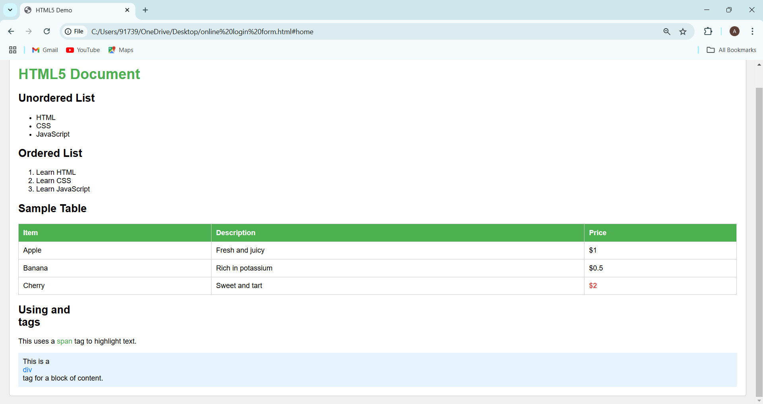

8) Design a catalogue page should contain the details of all the books available in the web site in a table: The details should contain the following: 1. Snap shot of Cover Page. 2. Author Name. 3. Publisher. 4. Price. 5. Add to cart button.

<!DOCTYPE html>

<html lang="en">

<head>

<meta charset="UTF-8">

<meta name="viewport" content="width=device-width, initial-scale=1.0">

<title>Book Catalog</title>

<style>

body {

font-family: Arial, sans-serif;

margin: 20px;

background-color: #f9f9f9;

}

h1 {

text-align: center;

color: #333;

}

table {

width: 100%;

border-collapse: collapse;

margin-top: 20px;

}

th, td {

border: 1px solid #ddd;

padding: 10px;

text-align: center;

}

th {

background-color: #4CAF50;

color: white;

}

img {

max-width: 100px; /* Set a maximum width for images */

}

button {

background-color: #4CAF50;

color: white;

border: none;

padding: 10px;

cursor: pointer;

}

button:hover {

background-color: #45a049; /* Change color on hover */

}

</style>

</head>

<body>

<h1>Book Catalog</h1>

<table>

<thead>

<tr>

<th>Cover</th>

<th>Author</th>

<th>Publisher</th>

<th>Price</th>

<th>Add to Cart</th>

</tr>

</thead>

<tbody>

<tr>

<td><img src="cover1.jpg" alt="Book Cover 1"></td>

<td>Author 1</td>

<td>Publisher 1</td>

<td>$19.99</td>

<td><button>Add to Cart</button></td>

</tr>

<tr>

<td><img src="cover2.jpg" alt="Book Cover 2"></td>

<td>Author 2</td>

<td>Publisher 2</td>

<td>$25.99</td>

<td><button>Add to Cart</button></td>

</tr>

<tr>

<td><img src="cover3.jpg" alt="Book Cover 3"></td>

<td>Author 3</td>

<td>Publisher 3</td>

<td>$15.50</td>

<td><button>Add to Cart</button></td>

</tr>

<tr>

<td><img src="cover4.jpg" alt="Book Cover 4"></td>

<td>Author 4</td>

<td>Publisher 4</td>

<td>$22.00</td>

<td><button>Add to Cart</button></td>

</tr>

</tbody>

</table>

</body>

</html>

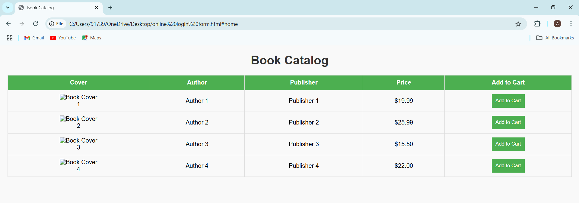

9) . Write JavaScript programs on Event Handling a. Open a Window from the current window b. Change colour of background at each click of button or refresh of a page

a) <!DOCTYPE html>

<html lang="en">

<head>

<meta charset="UTF-8">

<meta name="viewport" content="width=device-width, initial-scale=1.0">

<title>Open Window Example</title>

<script>

function openNewWindow() {

window.open('https://www.example.com', '_blank', 'width=600,height=400');

}

</script>

</head>

<body>

<h1>Open a New Window</h1>

<button onclick="openNewWindow()">Open Window</button>

</body>

</html>

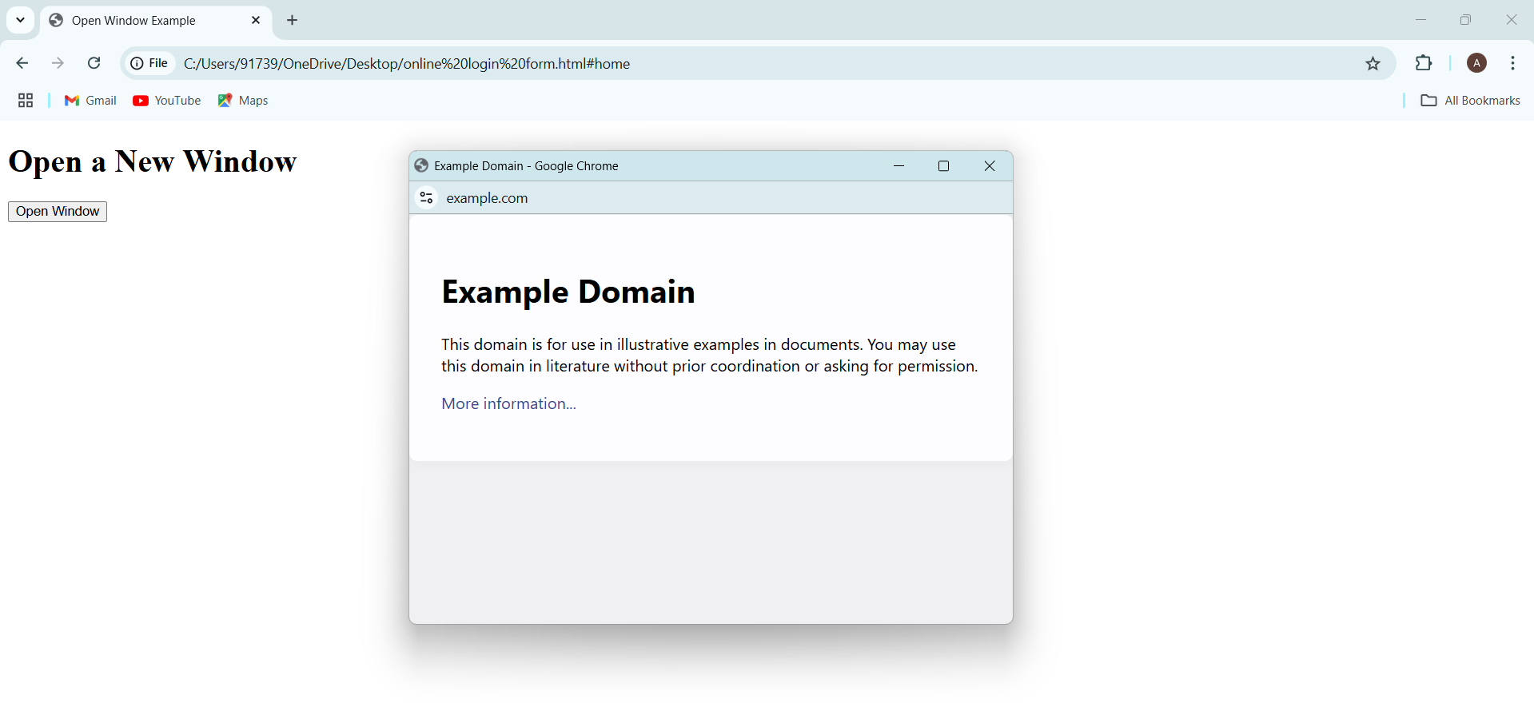

b) <!DOCTYPE html>

<html lang="en">

<head>

<meta charset="UTF-8">

<meta name="viewport" content="width=device-width, initial-scale=1.0">

<title>Change Background Color</title>

<script>

// Array of colors

const colors = ['#FF5733', '#33FF57', '#3357FF', '#F1C40F', '#8E44AD'];

// Function to change background color

function changeBackgroundColor() {

// Get a random color from the array

const randomColor = colors[Math.floor(Math.random() * colors.length)];

document.body.style.backgroundColor = randomColor;

}

// Change color on page load

window.onload = changeBackgroundColor;

</script>

</head>

<body>

<h1>Change Background Color</h1>

<button onclick="changeBackgroundColor()">Change Color</button>

</body>

</htm>

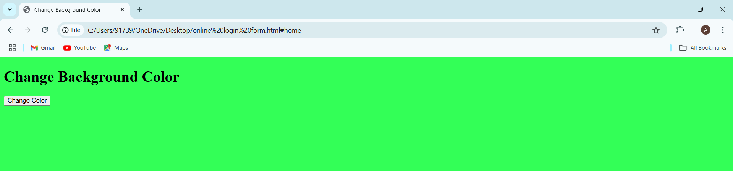

10) Write an XML file which will display the Book information which includes the following: 1) Title of the book 2) Author Name 3) ISBN number 4) Publisher name 5) Edition 6) Price a.Write a Document Type Definition (DTD) to validate the above XML file.

<?xml version="1.0" encoding="UTF-8"?>

<?xml-stylesheet type="text/css" href="library.css" ?>

<?DOCTYPE catalogue SYSTEM "book.dtd"?>

<catalogue>

<book>

<title>c</title>

<author>Balaguruswamy</author>

<isbn>1234</isbn>

<publisher>pearson</publisher>

<edition>4</edition>

<price>$50</price>

</book>

<book>

<title>c++</title>

<author>Balaguruswamy</author>

<isbn>123</isbn>

<publisher>pearson</publisher>

<edition>3</edition>

<price>$55</price>

</book>

<book>

<title>java</title>

<author>Brett spell</author>

<isbn>12</isbn>

<publisher>Apress</publisher>

<edition>2</edition>

<price>$45</price>

</book>

</catalogue>

**Dtd File:**

<!ELEMENT catalogue (book)*>

<!ELEMENT book (title,author,isbn,publisher,edition,price)>

<!ELEMENT title (#PCDATA)>

<!ELEMENT author (#PCDATA)>

<!ELEMENT isbn (#PCDATA)>

<!ELEMENT publisher (#PCDATA)>

<!ELEMENT edition (#PCDATA)>

<!ELEMENT price (#PCDATA)>

Library.css

catalogue

{

font-family:arial;

color:blue;

font-size:16pt

}

book

{

font-family:times new roman;

color:blue;

table-layout:auto;

font-size:14pt

}

title

{

font-family:arial;

color:green;

margin-left:20pt;

font-size:12pt

}

author

{

font-family:arial;

color:magenta

}

publisher,edition,isbn,price

{

display:block;

font-family:arial;

color:black;

font-size:10pt;

margin-left:40pt

}

