Task1:

* You have to make instrument dropdown list on navbar right end.

Now, There are some xml files in Music folder. If you open xml file, you can see music-note and some instrument names.

For example: flute, piano, …

So, your task is to make instrument dropdown list with related selected xml fime.

Here, to important, according to selected xml file, instrument drop down list have to change.

Because only, instrument names on xml file have to insert in dropdown list.

Therefore, according to different xml file, instrument dropdown list have to be changed.

* If you open xml file, you can see number in music-box.

For example: 8, 15,21…

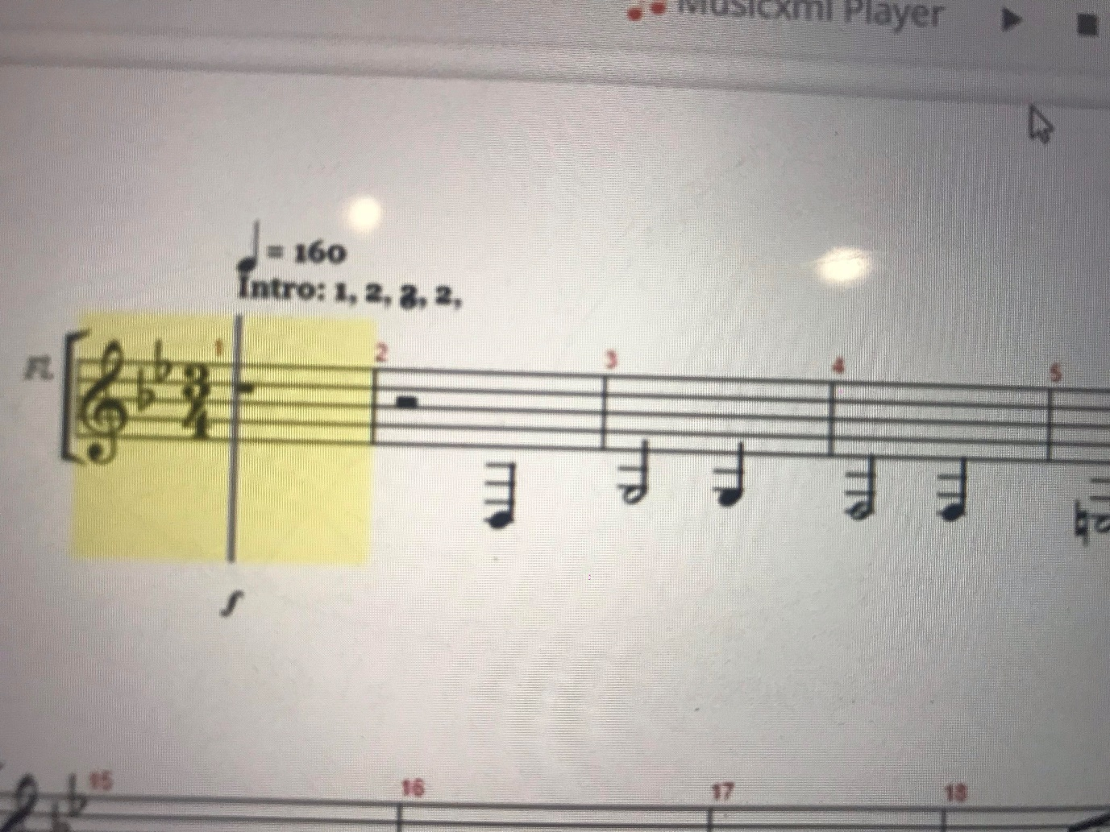

You have to insert all numbers such as music-box number on music-box.

Color have to be a red.

Now, there is some numbers on xml file.

For example: 1,2,3,4,5,6,7,8…(This is unique number)

I will see to you video file about this.

* autoscroll the webpage when the music caret moves onto a new line (tracking the caret).

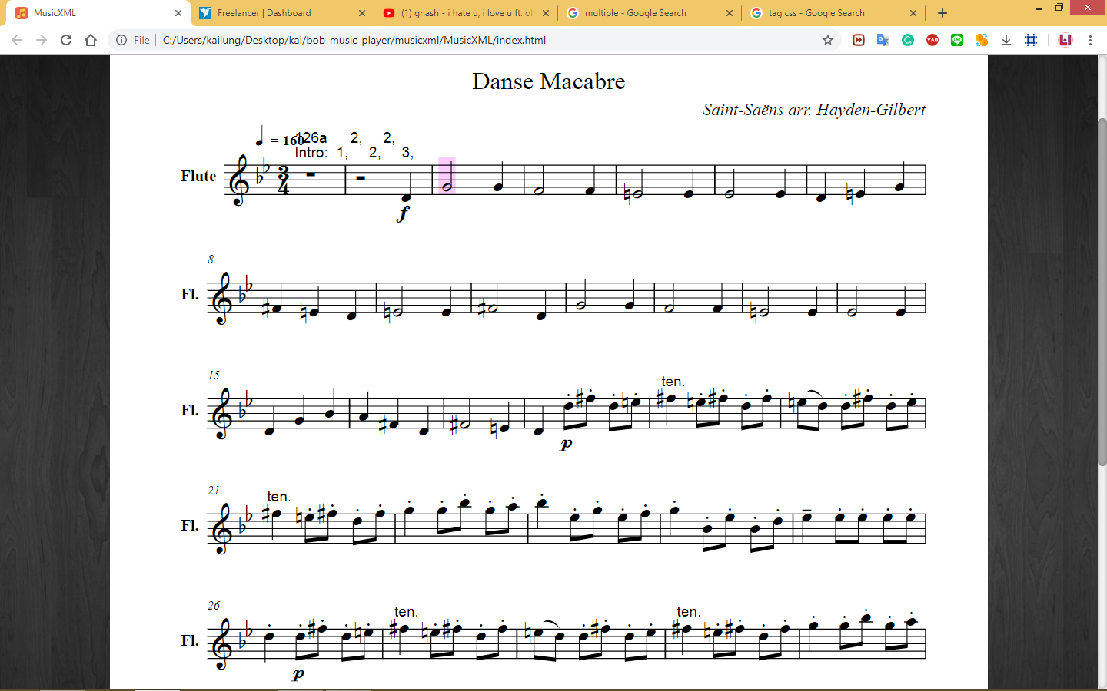

Currently this

if (n.vce==0 && pn){

$("rect:eq(1)").attr("id", "newId");

var element = document.getElementById("newId");

element.scrollIntoView();

}

is implemented in xmlplay.js, but the problem is rect (caret) is deleted and randomly created (check it out in chrome inspect), so rect:eq(1) is not necessarily the caret of the first instrument. One way to distinguish the carets is to use y attribute of each caret and also the y attribute of each instrument name that’s inside a text tag. If you arrange carets and text tag in ascending order in terms of y attribute u can easily match them. This is my current idea.(reference for you)

Now if user play music, tracing about all instruments on seleted xml file is run.

I want like this:

If user select any instrument on dropdown list, only tracking about selected instrument have to be run(keep autoscroll).

Task2

* include other instrument sound.

The instruments is on selected xm file.

Currently it seems to only have piano

If user select music play button, user have to be listen all instrument sounds on

selected xml file.

User have to listen all instrument sounds at same time.

As a result, mixed sounds of all instruments on xml file.