Additions:

**DatabaseInterface – Model** : This class will start and create the SQLite database when called. Methods are included to add data from other classes (incomplete implementation)

When called it will make all the initial tables if they are not there

//sample from https://www.journaldev.com/9438/android-sqlite-database-example-tutorial

//http://www.androidtutorialshub.com/android-login-and-register-with-sqlite-database-tutorial/

**accountCreationActivity – Controller:** This class will now call Database interface and create the initial a user entry by using the USER object from the User – model class

User user = new User(username, password, firstName, lastName);  
dbInterface.createUser(user);

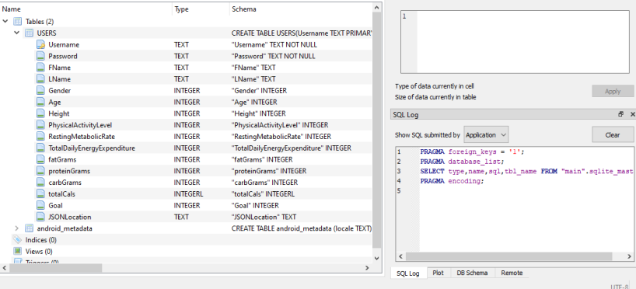

**Log in as an implementation – 30-40% done.**  The database is complete and it will accept data. The problem become when we need to make persistent data across the app by using shared preferences again. Using shared preferences for the username would make pointing at the right Username PK super easy. Not enough time to finish this. Additionally this would break Victoria’s profile view and cart view at our current state.

**Information “Fragments”**

**//https://www.youtube.com/watch?v=Bsm-BlXo2SI Simple Dialog with 1 Button - Android Studio Tutorial**

**Basically these are mini “activities” that will show as a pop up.**

**Example**

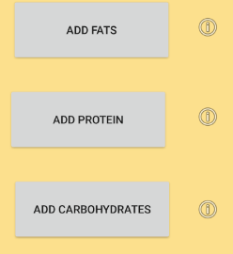

**Onclick**



**Current Fragments**

bodyInfoFragment – links to body info actvitiy

goalFragment – links to goal activity

fats+protein+carb fragment – all link to Food type nav activity