The MTU Security and Privacy (SnP) Lab Hosts MiCUP Scholars during Summer 2022

During Summer 2022, the MTU SnP lab (led by Prof. Bo Chen) hosted DeAndre' Neal, an undergraduate student from Wayne County Community College District, Detroit, Michigan, through the MiCUP program. DeAndre' has been working on exploring the applications of blockchain technology. Especially, he has been investigating how to utilize the blockchain technique to enable NFT (non-fungible token), which is an important component of the newly emerging metaverse.

The MiCUP program evolved from the King-Chavez-Parks Initiative that Michigan's Department of Labor and Economic Growth established in 2000 to give the state's most educationally disadvantaged citizens an opportunity to complete college degrees, preferably in STEM fields, and obtain employment. The MiCUP Transfer Transition Program began in 2000 as the MiCUP Unlock Your Future Program. Michigan Tech received a five-year grant in 2006 and a six-year grant in 2011. In 2017, the King-Chavez-Parks Initiative awarded Michigan Tech a six-year grant to continue this shared goal.

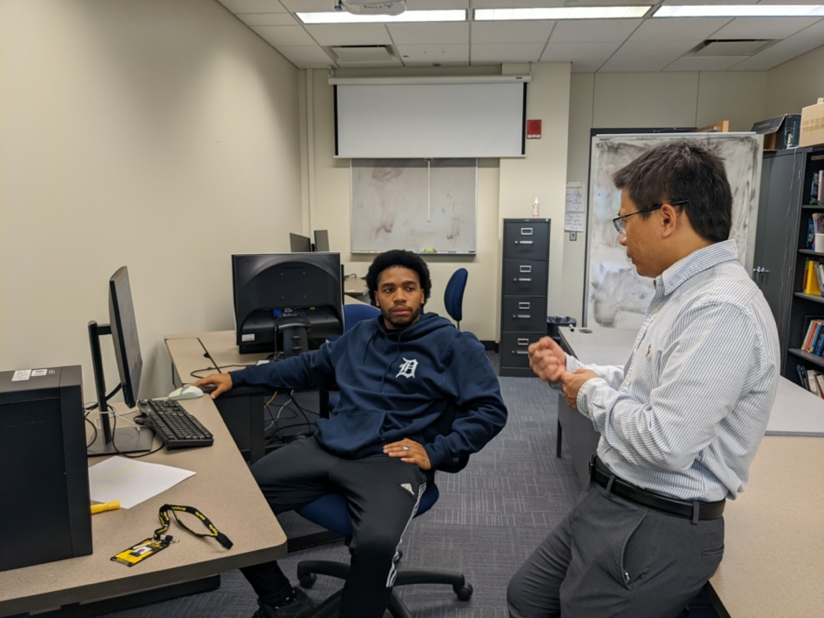
Prof. Bo Chen (right) discussed with DeAndre' (left) about blockchain

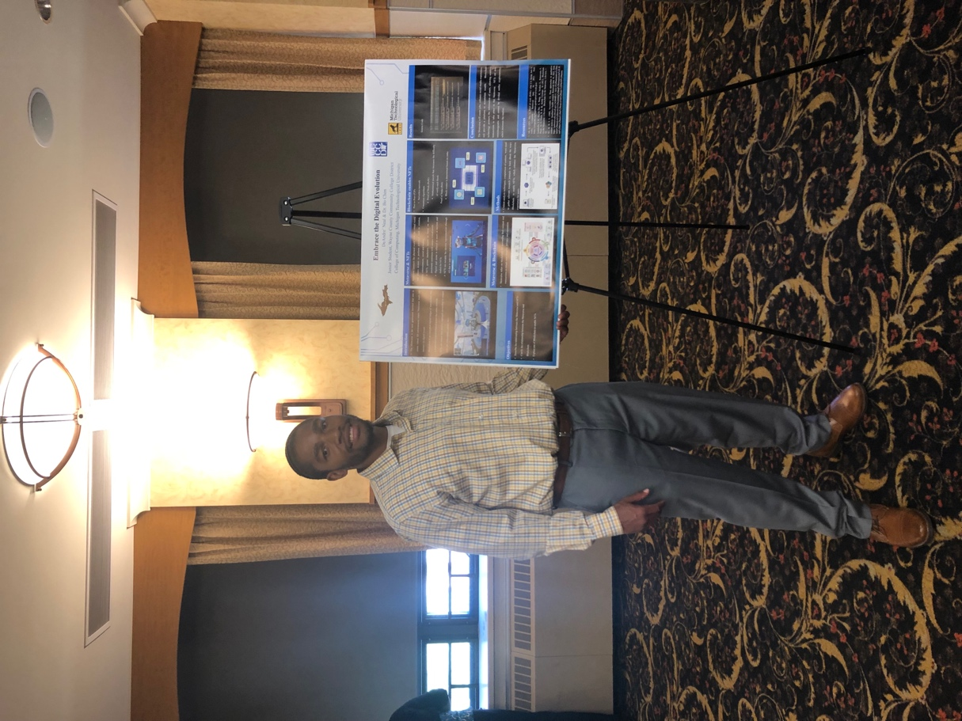
DeAndre' presented his research project

