User Guide for DMR and IQD Automation Framework

Steps to setup the framework

Minimum java8 is required

Verify the java installation by hitting following command in the command line

**Java –version**

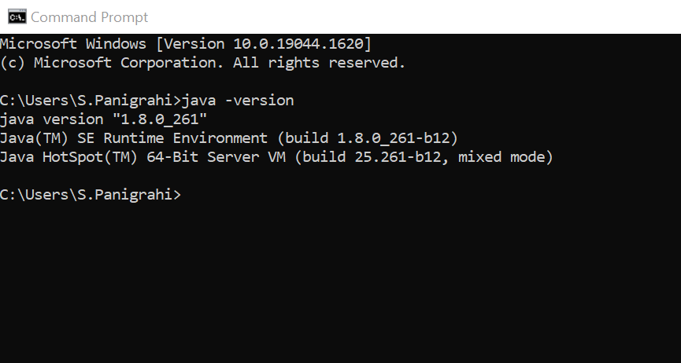

Set JAVA path in the environment variable

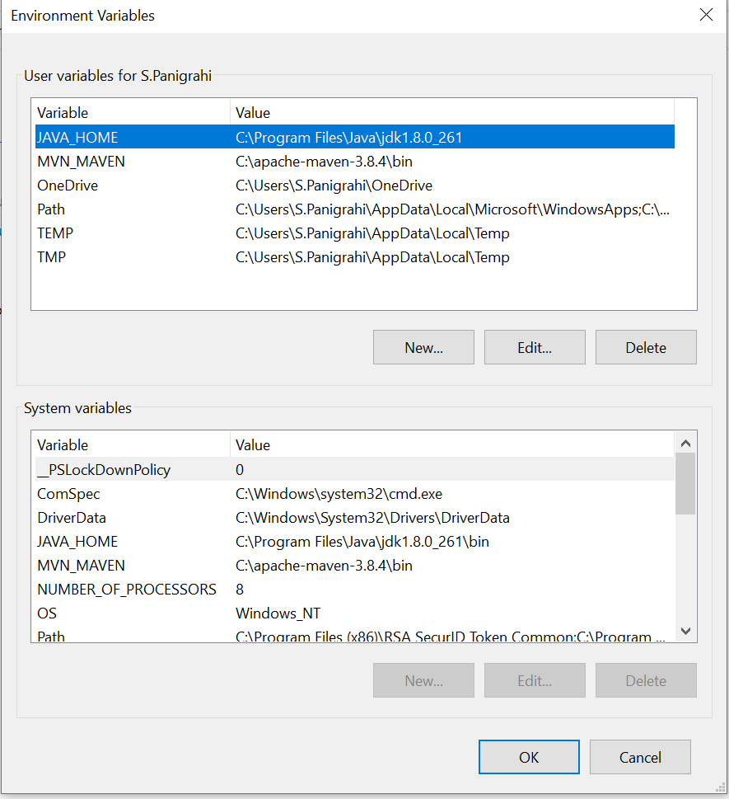

Download and install Apache maven

<https://dlcdn.apache.org/maven/maven-3/3.8.5/binaries/apache-maven-3.8.5-bin.zip>

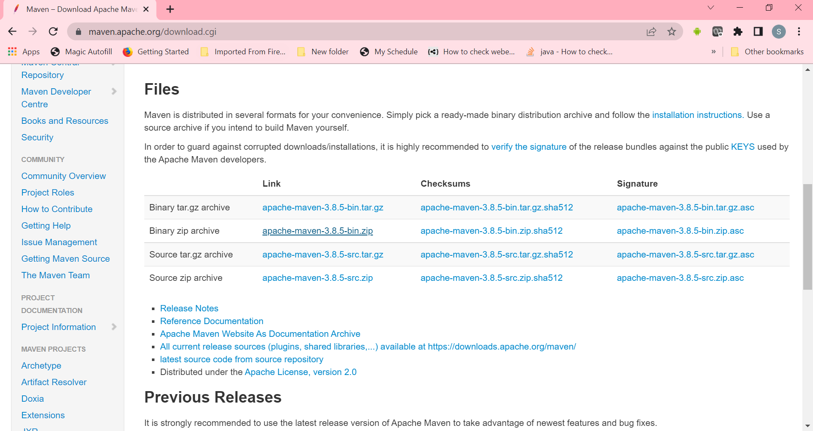

Set Maven path in environment variable

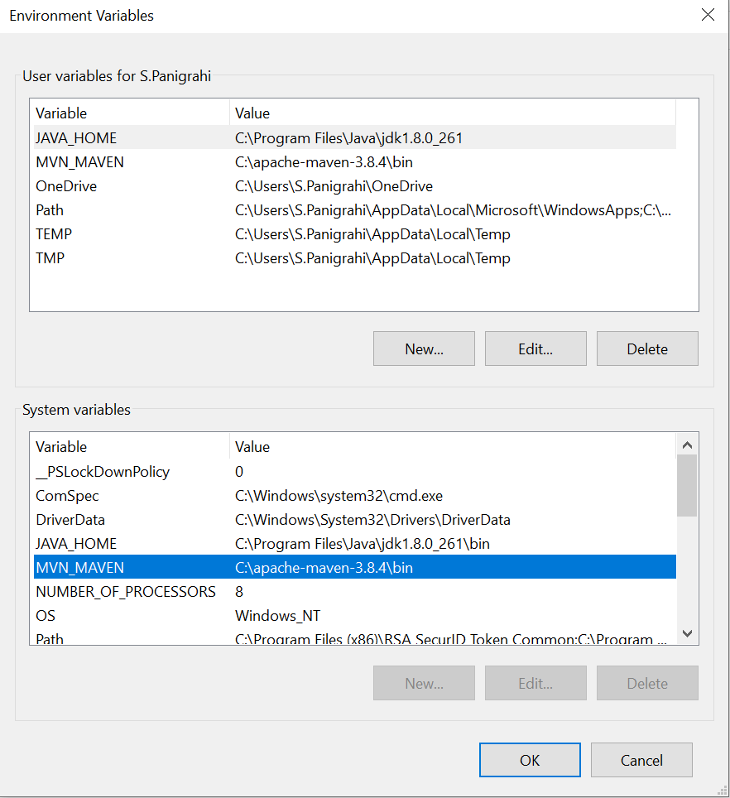

Download and install eclipse

Install Cucumber plugin from eclipse market place

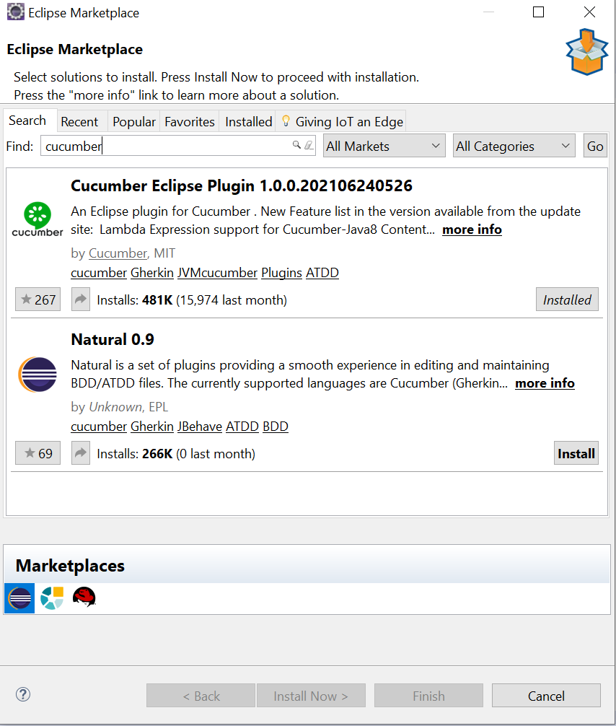

Install TestNG from eclipse market place

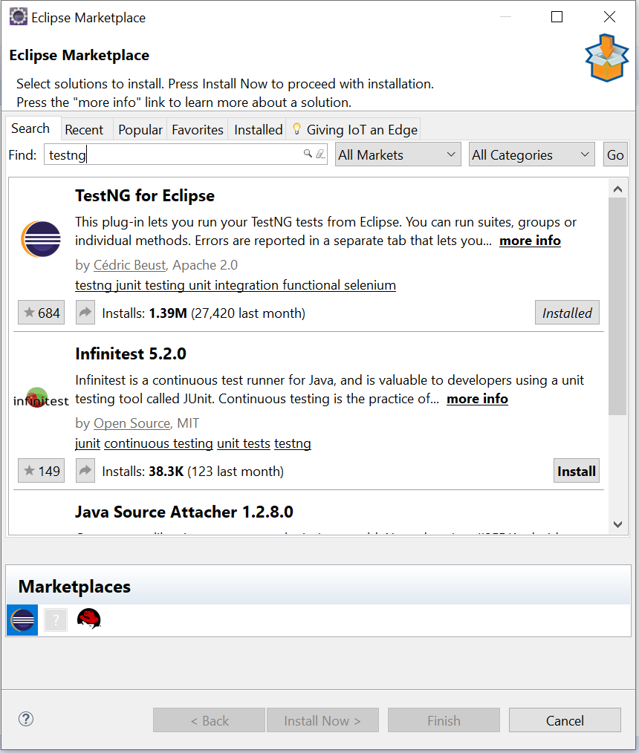

Make sure TestNG libraries are added into java build path

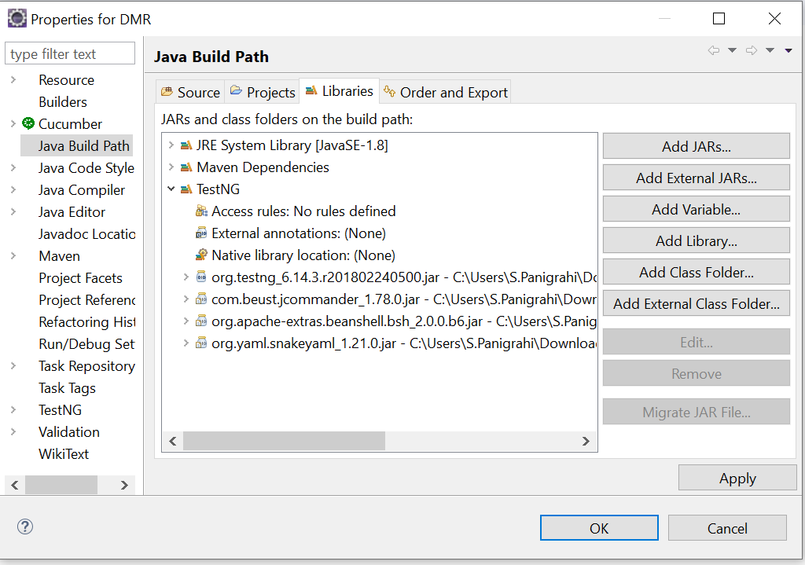

Run the Framework through Runner class using TestNG

