**Task 4:**

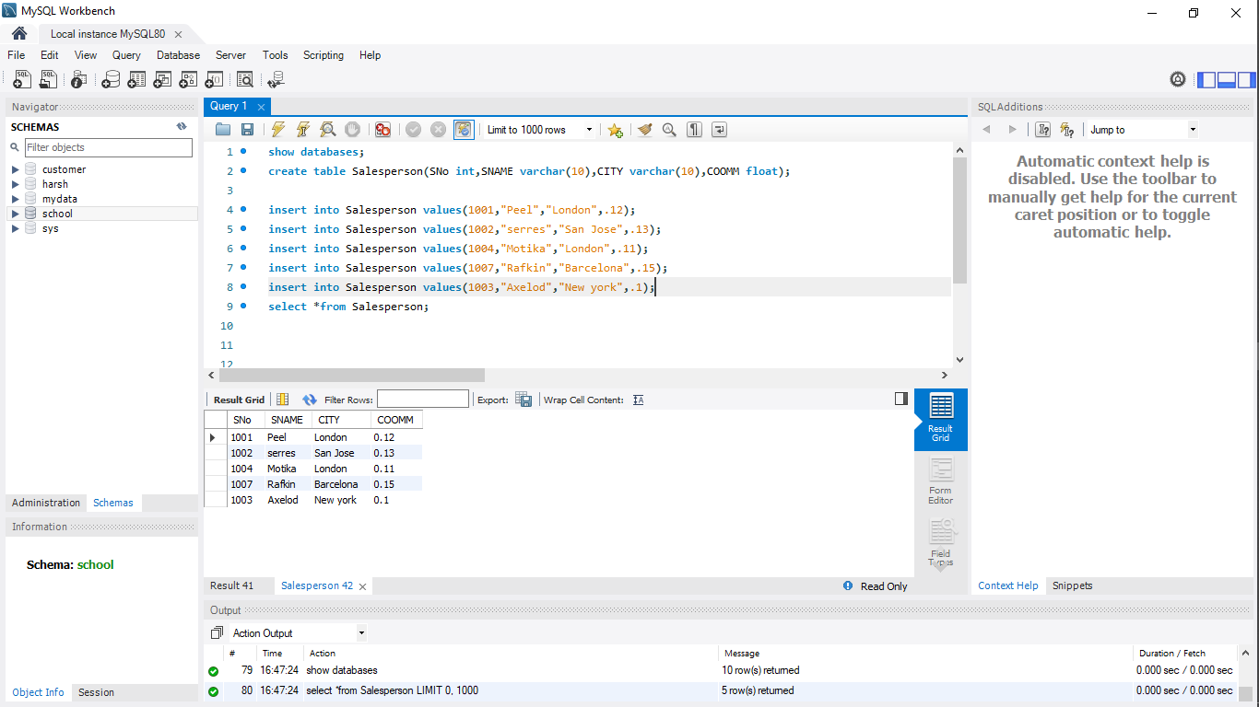

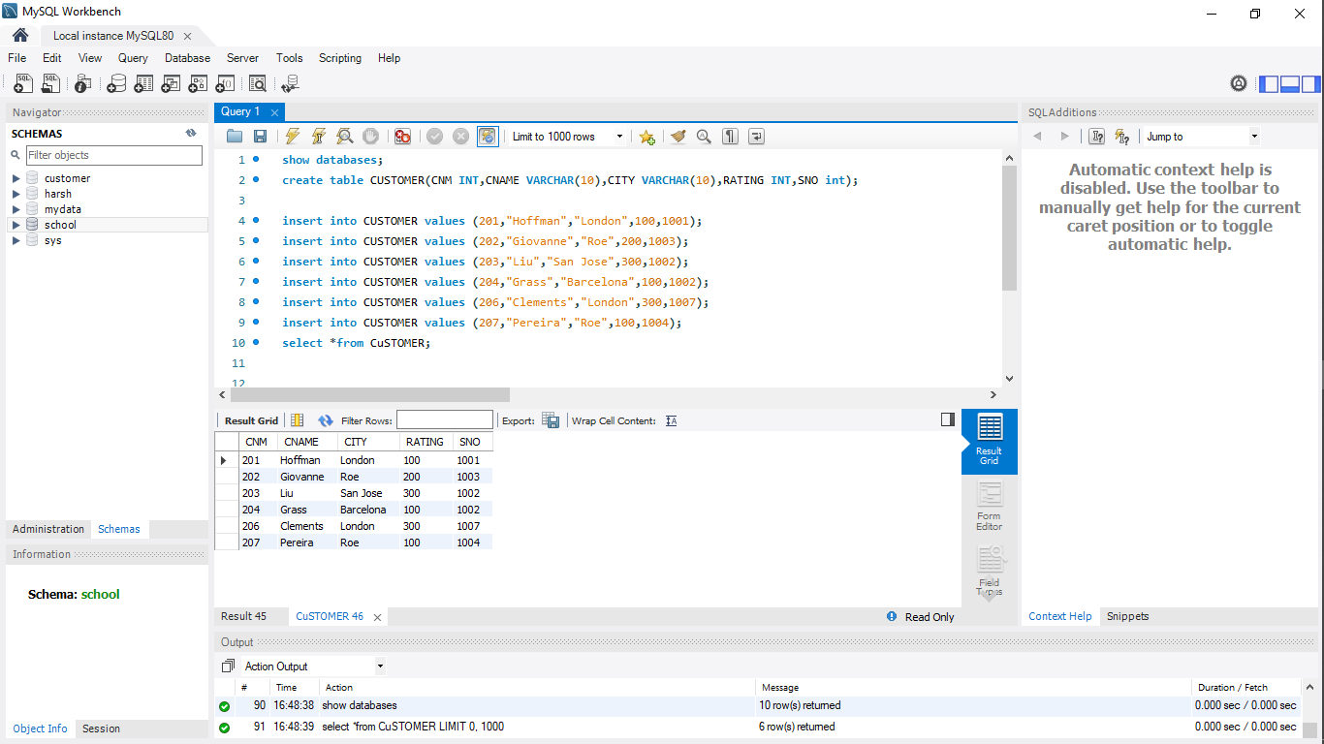

**a) All orders for more than $1000.**

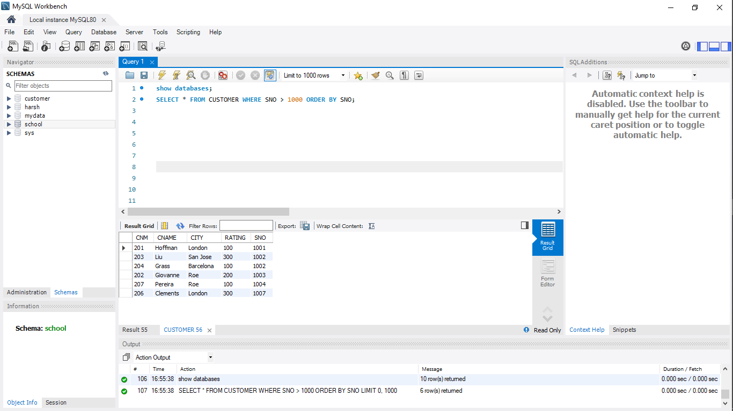

**b) Names and cities of all salespeople in London with commission above 0.12**

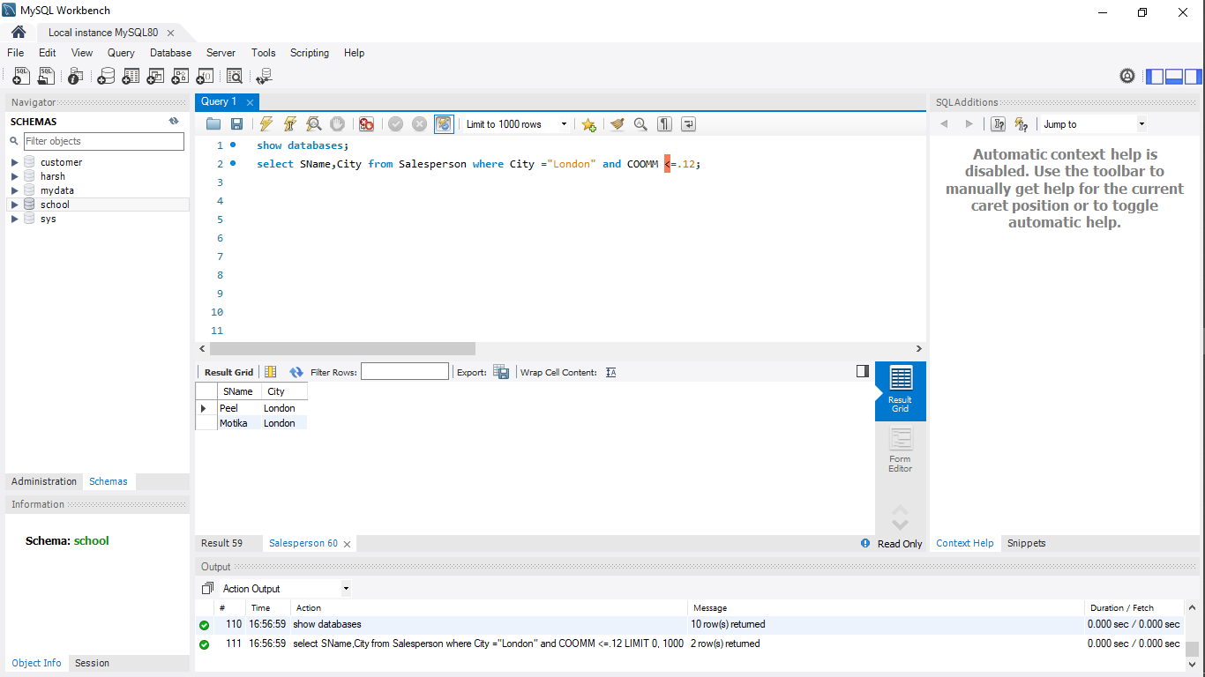

**c) All salespeople either in Barcelona or in London**

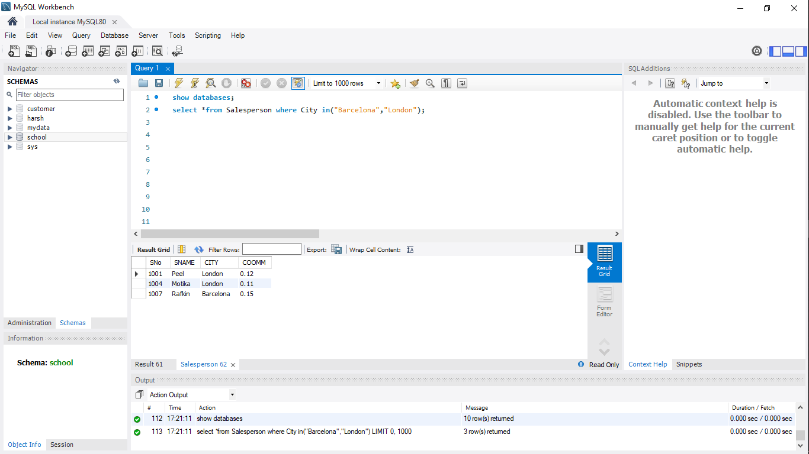

**d) All salespeople with commission between 0.10 and 0.12. (Boundary values should be excluded).**

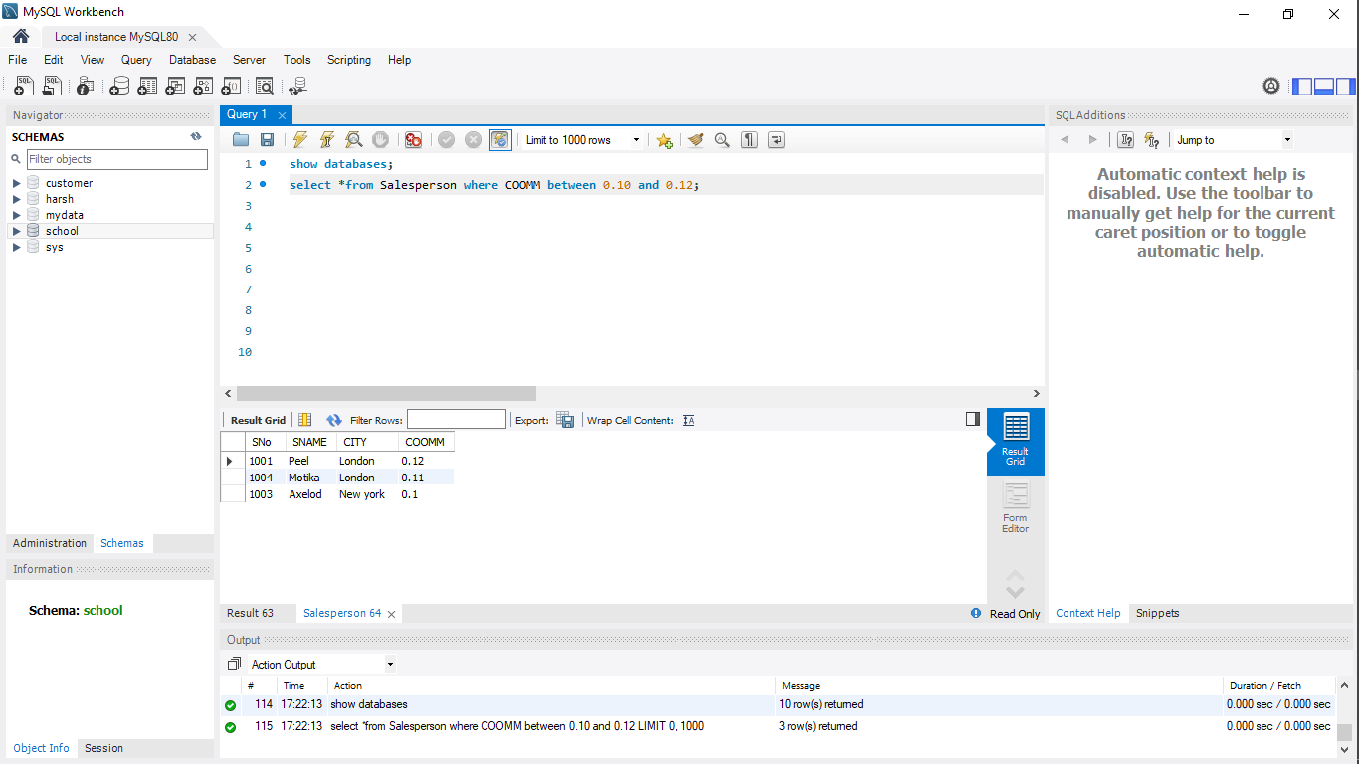

**e) All customers excluding those with rating <= 100 unless they are located in Rome**

