A) Timeline
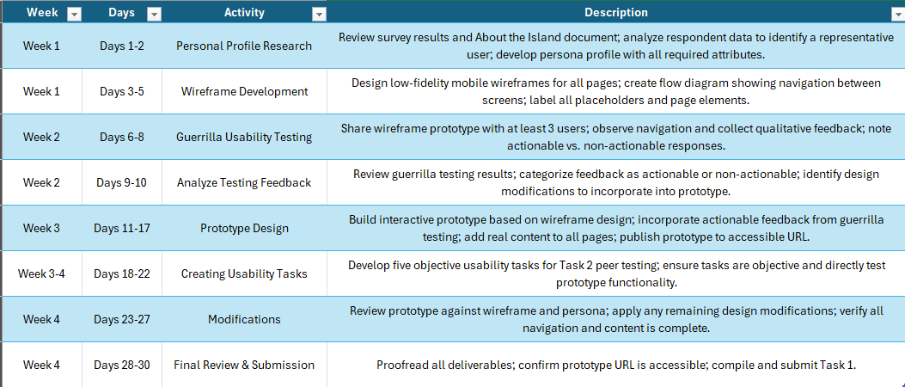


B) Persona: Karen Brouchard
Age: 42
Country: Toronto, Canada
Arrives by: Cruise Ship
Travel Party: Karen, spouse, and four children
Visit Status: First Time
Trip Duration: 5 days
Transportation: Public Transportation
Annual Income: $75,000
Local Attractions: Interested
Accommodations: Hotel
Photo by Alena Darmel, Pexels.
“We only have five days. I need to know what’s worth doing and how to get there fast.”
Karen is a 42-year-old office administrator from Toronto, Canada. She is traveling to Taniti for the first time with her husband and four children (ages 7, 10, 13, and 16) as part of a cruise itinerary. The family has 5 days at the port and wants to make the most of their time on the island. Karen is the family trip planner and researches destinations in advance so she can hit the ground running.
Goals
- Quickly find out what family-friendly attractions are available on the island.
- Understand public transportation routes for ease of getting around.
- Identify hotel options near the cruise terminal or main attractions.
- Plan activities that work for the whole family.

Frustrations
- Websites that are hard to navigate on a phone while on the go.
- Finding out too late that an activity isn’t suitable for kids.
- Unclear or missing information about public transportation options.
- Too much text with no easy way to scan for what matters.

C) Flow Diagram & Wireframe
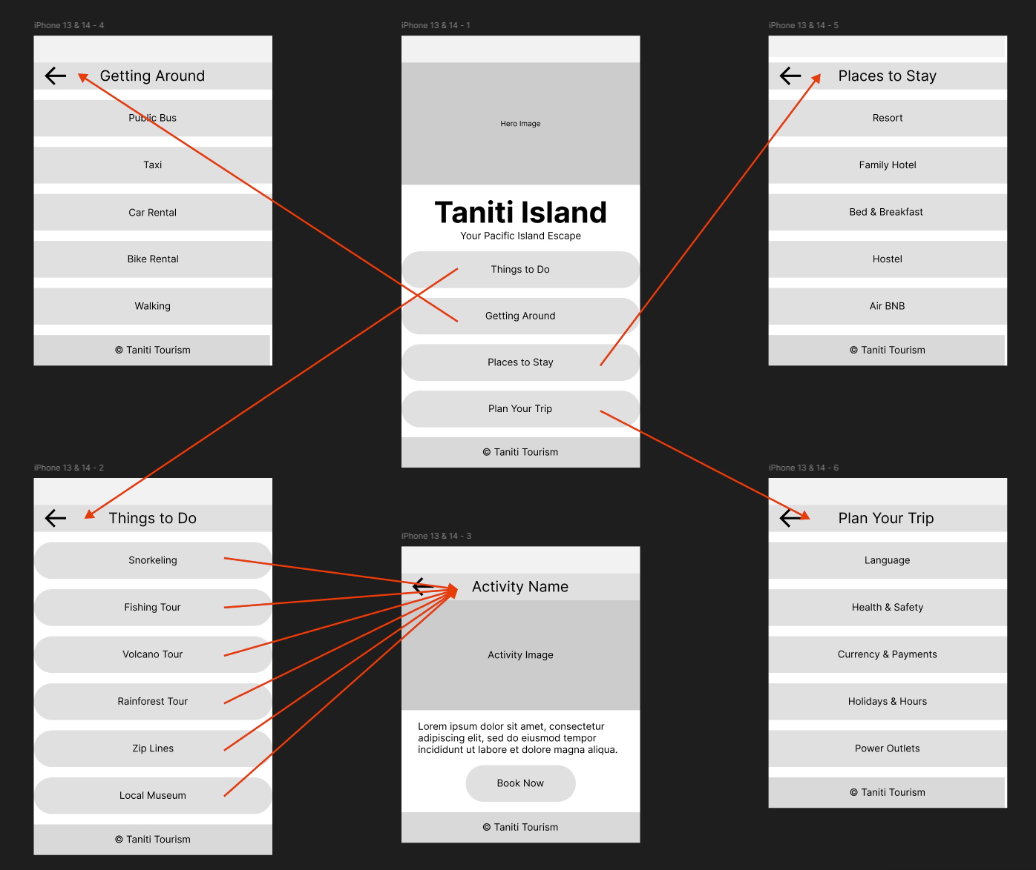
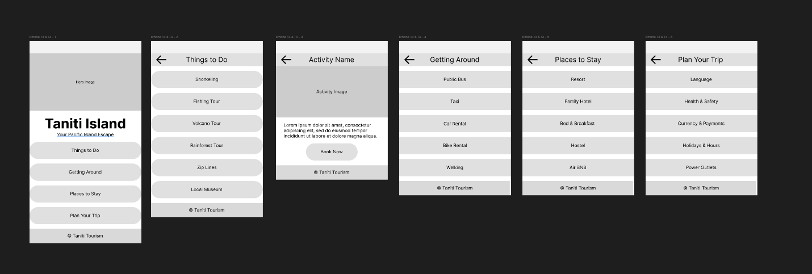
D) Guerrilla Usability Testing
1) Navigate to the Things to Do page and select an activity to view its details.
2) Navigate to the Getting Around page and identify a transportation option suitable for traveling from the cruise dock to Taniti City.
3) Navigate to the Places to Stay page and identify a lodging option suitable for a family of six.
4) Navigate to the Plan Your Trip page and locate the accepted forms of currency on the island.
5) From any page other than the Home screen, navigate back to the Home screen.
D1) Feedback Summary
User 1:
Not Actionable, Easy to navigate to all pages.
Not Actionable, Lots of options for activities, hotels, and transportation.
User 2:
Actionable, Book now button does not do anything.
Not Actionable, Looks unfinished, no pictures.
Not Actionable, all activity cards link to the same page.
Not Actionable, Not enough information, just labels.
User 3:
Actionable wasn’t sure if activity names were clickable.
Actionable, Back arrow was small and hard to tap.
Actionable, Places to Stay did not indicate which options are suitable for large groups.
Not Actionable, Currency information was easy to find.
Not Actionable, Easy to find transportation options.

D2) Incorporation of Feedback
Three actionable items were identified from guerrilla testing and incorporated into the prototype design:
1. Book Now button had no response: The prototype was updated so that tapping Book Now displays a confirmation message: “Thank you! A booking representative will contact you shortly.”
2. Activity cards are not clearly clickable: A chevron indicator (>) was added to the right side of each activity card to signal that the items are interactive.
3. Places to Stay did not indicate suitability for large groups: Each lodging description was updated to include notes on capacity and group suitability, allowing users such as families of six to identify appropriate options quickly.
4. The back arrow was small and hard to tap: The back navigation button was enlarged.
Non-actionable feedback was not incorporated because it reflected the expected limitations of a lo-fi wireframe rather than design flaws. Placeholder images, minimal content, and template-style navigation are intentional at this stage and are addressed in the full prototype.

E) Prototype URL
https://snperry85.github.io/taniti_prototype/

F) 5 Usability Tasks
1) Navigate to the Things to Do page and select an activity to view its details.
2) Navigate to the Getting Around page and identify a transportation option suitable for traveling from the cruise dock to Taniti City.
3) Navigate to the Places to Stay page and identify a lodging option suitable for a family of six.
4) Navigate to the Plan Your Trip page and locate the accepted forms of currency on the island.
5) From any page other than the Home screen, navigate back to the Home screen.

G) Sources
Taniti Island Tourism. (n.d.). About the island. WGU D479 course materials.
Darmel, A. (n.d.) Woman in beige business suit sitting on table while holding laptop [Photograph]. Pexels. https://www.pexels.com/photo/woman-in-beige-busness-suit-sitting-on-table-while-holding-laptop-8133906/

