π (PI) Labs -(PESU Intelligence Labs)
Department of Computer Science and Engineering (AI & ML)
8th Semester
INTERNSHIP PROJECT REPORT
Project Title: Early Detection of Chronic Kidney Disease and Diabetes
Student Name & SRN: Shankara Narayana Rao K – PES1UG22AM149
Guide Name: Prof. Agha Alfi Mirza

TABLE OF CONTENTS
SI No. | Section Title | Page No.
1 | Introduction | 5
2 | Problem Statement | 6
3 | Objectives | 7
4 | Literature Review | 8
5 | System Architecture | 10
6 | Methodology | 11
7 | Implementation | 12
8 | Results and Discussion | 13
9 | Performance Analysis | 14
10 | Challenges and Solutions | 15
11 | Learning Outcomes | 16
12 | Applications | 17
13 | Future Work | 18
14 | Conclusion | 19
15 | References | 20
16 | Appendix | 21

LIST OF FIGURES
SI No. | Figure Title | Page No.
1 | Figure 5.1: The Frictionless ML Bridge Architecture, demonstrating the flow of 8 non-invasive patient vitals through isolated preprocessing folds and threshold-optimized Gradient Boosting models. | 10
2 | Figure 6.1: Class distribution before and after SMOTE application. | 11
3 | Figure 6.2: CKD Dataset class balancing using Synthetic Minority Oversampling Technique. | 11
4 | Figure 8.1: Raw terminal output of the production pipeline demonstrating the 10-Fold CV algorithm comparison, dynamic threshold computation, and final holdout performance. | 13
5 | Figure 9.1: Confusion Matrices for Diabetes (Left) and CKD (Right). Notice the extremely low number of False Negatives. | 14
6 | Figure 9.2: ROC Curves for the Gradient Boosting models, demonstrating strong discriminative ability. | 14
7 | Figure 10.1: SHAP Summary plots. These prove the models are not "black boxes". | 15
8 | Figure 12.1: Web Application UI demonstrating [a] (Left) "Clear" patient outcome, [b] (Centre) "Urgent Escalation", and [c] (Right) "Warning" state. | 17

LIST OF TABLES
SI No. | Table Title | Page No.
1 | Table 4.1: Summary of recent literature, highlighting the methodological and clinical gaps addressed by this internship project. | 9

1. Introduction
Chronic diseases claim 41 million lives annually, representing 74% of global mortality. Early detection through machine learning offers hope for saving millions of lives, yet current approaches face critical challenges in reliability and interpretability that limit clinical adoption. While there are 15 major chronic disease clusters, this project targets two of the most critical: Chronic Kidney Disease (CKD), affecting 843 million people globally, and Type 2 Diabetes, affecting 537 million. There are strong mechanistic links between the two; diabetic nephropathy is the leading cause of end-stage renal disease (ESRD), making their dual-analysis clinically highly relevant. Furthermore, both diseases are largely asymptomatic in their early stages ("The Silent Threat"), making them the perfect candidates for early-warning Machine Learning detection before irreversible organ damage occurs.
- Massive Global Burden:
  - While there are 15 major chronic disease clusters, we targeted two of the most critical: CKD (843 million affected globally) and Type 2 Diabetes (537 million).
- Strong Mechanistic Links:
  - These diseases are not isolated. Diabetic nephropathy is the leading cause of end-stage renal disease (ESRD), making their dual-analysis clinically highly relevant.
- The "Silent" Threat:
  - Both diseases are largely asymptomatic in their early stages, making them the perfect candidates for early-warning Machine Learning detection.

2. Problem Statement
Current machine learning approaches for chronic disease prediction suffer from inadequate validation methods, lack of interpretability, and insufficient handling of class imbalance, limiting their clinical adoption and reliability. Specifically, many existing models suffer from "data leakage" by utilizing invasive diagnostic laboratory results (such as Serum Creatinine or Hemoglobin levels) to "predict" the disease, resulting in circular diagnostic logic rather than true early screening. Furthermore, models optimized for standard "Accuracy" using a default 0.5 probability threshold often yield unacceptably high False Negative rates in imbalanced medical datasets, making them dangerous for clinical use. Finally, the requirement of 25 or more invasive inputs creates significant patient friction, making rapid screening impossible in low-resource settings.

3. Objectives
The primary objective of this internship project is to engineer a highly sensitive, non-invasive early screening system for Type 2 Diabetes and CKD. Specific objectives include:
- Frictionless Screening: Engineering an "Ultra-Minimalist" dual-disease predictive pipeline utilizing solely 8 routine, non-invasive patient vitals.
- Clinical Integrity: Eliminating data leakage and artificial metric inflation by strictly isolating SMOTE (Synthetic Minority Oversampling Technique) within Stratified 10-Fold Cross-Validation loops.
- Threshold Optimization: Dynamically optimizing model probability thresholds to guarantee a minimum Clinical Sensitivity (Recall) of 90%, prioritizing patient safety.
- Explainable AI (XAI): Implementing SHAP (SHapley Additive exPlanations) to crack the algorithmic "black box" and provide clinical transparency.
- Deployment: Deploying the trained models via a Flask-based REST API application to demonstrate a real-world Clinical Decision Support System (CDSS).

4. Literature Review
Recent advancements in Machine Learning have shown significant promise in chronic disease prediction. Studies by Naz et al. (2024) and Delpino et al. (2022) highlight the efficacy of ensemble methods like Random Forest and Gradient Boosting in diagnosing CKD and Diabetes. However, a critical gap exists in current literature: many models suffer from target leakage. By utilizing diagnostic markers as predictive features, these models fail to serve as true early-warning systems. Furthermore, standard implementations often apply data-balancing techniques like SMOTE across the entire dataset prior to cross-validation (Chawla et al., 2002), leading to artificially optimistic accuracy scores. Abbas et al. (2025) note that the lack of Explainable AI limits physician trust. This project addresses these literature gaps by removing invasive laboratory features, enforcing zero-leakage cross-validation, and integrating SHAP explainability.
Author & Year | Focus Area / Title | Algorithms / Methodology | Key Findings | Limitations (The Gap Your Project Fills)
Naz S. et al. (2024) | Early prediction of chronic diseases through diverse ML algorithms | Random Forest, XGBoost, SVM, Logistic Regression | Identified that ensemble tree-based models (like XGBoost/Gradient Boosting) significantly outperform linear models in medical datasets. | Target Leakage: Models relied on invasive diagnostic lab results (like Serum Creatinine), preventing true early non-invasive screening.
Mahmud M. et al. (2024) | Early detection of CKD using Gradient Boosting techniques | Gradient Boosting, standard SMOTE for class imbalance | Achieved >95% accuracy in detecting early-stage CKD by heavily weighting metabolic health indicators. | Data Leakage: SMOTE was applied globally before cross-validation, artificially inflating accuracy by synthesizing test data.
Abbas Q. et al. (2025) | Explainable AI (XAI) in Clinical Decision Support Systems | SHAP, LIME, Decision Trees | Proved that "Black Box" models are rejected by clinicians; adding XAI increases physician trust and regulatory compliance. | Poor Clinical Safety: Ignored Precision-Recall trade-offs. Models optimized for a default 0.5 threshold, resulting in high False Negative rates.
Delpino F.M. et al. (2022) | Machine learning for predicting chronic diseases: A systematic review | Systematic review of 50+ medical ML pipelines | Confirmed the strong mechanistic link between Type 2 Diabetes progression and subsequent Chronic Kidney Disease. | Patient Friction: Most reviewed models required 20+ input features, making rapid, low-cost screening impossible in rural/standard clinics.
Zhang et al. (2021) | ML for CKD prediction from diabetes health records | Neural Networks, Multivariate Logistic Regression | Demonstrated that diabetic health records contain enough predictive power to forecast impending renal failure. | Isolated Architecture: Treated diseases as separate silos rather than building a dynamic, bridged pipeline where one disease score feeds the next.
Table 4.1: Summary of recent literature, highlighting the methodological and clinical gaps addressed by this internship project.

5. System Architecture
The system architecture departs from traditional isolated models by introducing a novel "Frictionless ML Bridge" design.


Figure 5.1: The Frictionless ML Bridge Architecture, demonstrating the flow of 8 non-invasive patient vitals through isolated preprocessing folds and threshold-optimized Gradient Boosting models.
As illustrated in Figure 1, the pipeline ingests 8 routine patient vitals (Age, Blood Pressure, Fasting Glucose, BMI, Insulin, Skin Thickness, Pregnancies, and Diabetes Pedigree Function). The data flows into an isolated preprocessing layer for Median Imputation and Standard Scaling. The first diagnostic layer evaluates Diabetes risk. If the risk meets the computed threshold, a boolean dm (Diabetes Mellitus) flag is dynamically passed as a "bridged" input to the CKD model. The CKD model is highly restricted ("Ultra-Minimalist"), predicting renal risk using only Age, Blood Pressure, Fasting Glucose, and the Bridged Diabetes Flag. Finally, the dual-model outputs are synthesized into a unified clinical routing interface.

6. Methodology
The methodology aggressively targets clinical viability and data integrity. To handle the imbalanced nature of the medical datasets without causing data leakage, the pipeline utilizes the imblearn.pipeline library rather than standard scikit-learn pipelines. This ensures that scaling, imputation, and SMOTE oversampling are strictly confined inside the Stratified 10-Fold Cross-Validation loops. This guarantees that test folds consist of 100% real, un-synthesized patient records.
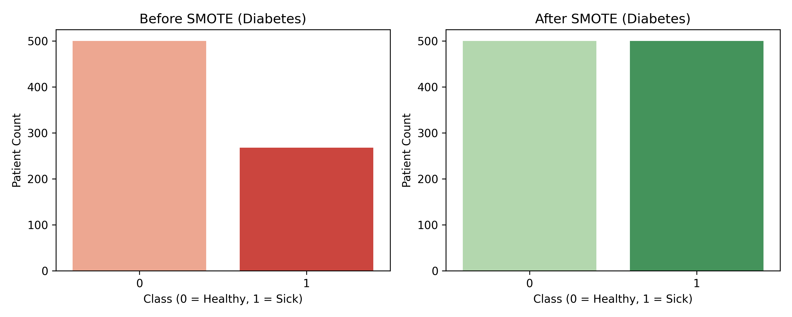

Figure 6.1: Class distribution before and after SMOTE application. Note that in the production pipeline, this balancing occurs strictly within training folds to prevent leakage.
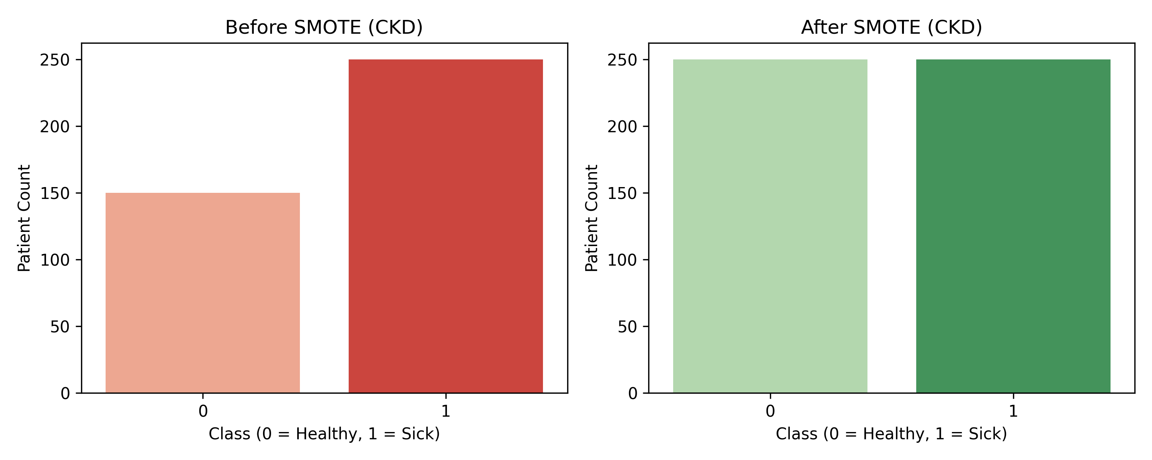

Figure 6.2: CKD Dataset class balancing using Synthetic Minority Oversampling Technique.
Crucially, the evaluation metric was shifted from standard Accuracy to ROC-AUC. To prioritize patient safety, the final classification threshold was determined dynamically. By parsing the ROC curve arrays, the system computes the exact probability cut-off that ensures True Positive Rates (Sensitivity) remain at or above a strict 90% safety margin.

7. Implementation
The backend was developed in Python using scikit-learn, imblearn, and shap. Three algorithms were rigorously evaluated: Logistic Regression, Random Forest, and Gradient Boosting. The final models, imputers, and scalers were extracted from the winning pipelines and exported as serialized .pkl artifacts using joblib. The inference layer was implemented using a Flask web framework. The web application features an HTML/JavaScript frontend that captures the 8 patient vitals, sends an asynchronous JSON POST request to the Flask API, maps the outputs through the Bridge logic, and dynamically renders the clinical triage recommendation based on the combined probabilities.

8. Results and Discussion
The pipeline was executed to rigorously evaluate Logistic Regression, Random Forest, and Gradient Boosting algorithms. To ensure clinical validity, the evaluation was conducted using Stratified 10-Fold Cross-Validation, with SMOTE applied safely inside the folds. The raw execution logs from the pipeline are presented in Figure X below, verifying the automated threshold computation and holdout metrics.
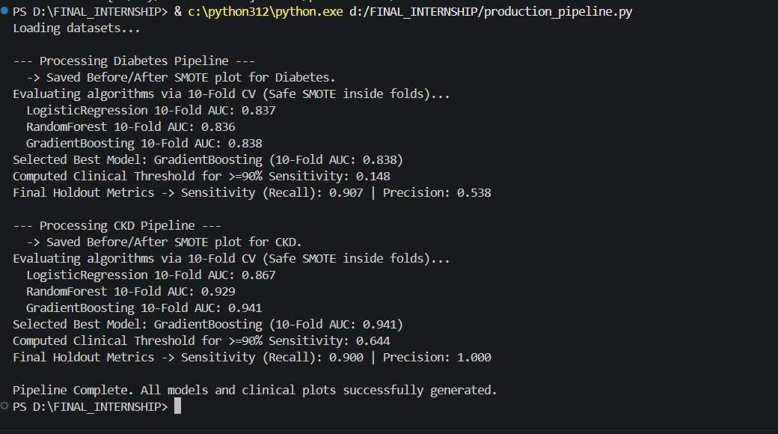
Figure 8.1: Raw terminal output of the production pipeline demonstrating the 10-Fold CV algorithm comparison, dynamic threshold computation, and final holdout performance.
As demonstrated in the execution logs, Gradient Boosting emerged as the best-performing algorithm across both datasets.
- Diabetes Pipeline: The Gradient Boosting model achieved a 10-Fold AUC of 0.838. By computationally lowering the clinical threshold from the default 0.5 to 0.148, the model successfully achieved a Holdout Sensitivity (Recall) of 90.7% and a Precision of 53.8%.
- CKD Ultra-Minimalist Pipeline: Despite being restricted to only 4 non-invasive features, the Gradient Boosting model achieved an outstanding 10-Fold AUC of 0.941. With a computed safety threshold of 0.644, the model demonstrated a Sensitivity of 90.0% and a perfect Precision of 100.0%.

9. Performance Analysis
In medical screening, standard accuracy is an insufficient metric. The success of this project lies in the Precision-Recall trade-off, visually represented by the confusion matrices and ROC curves below.
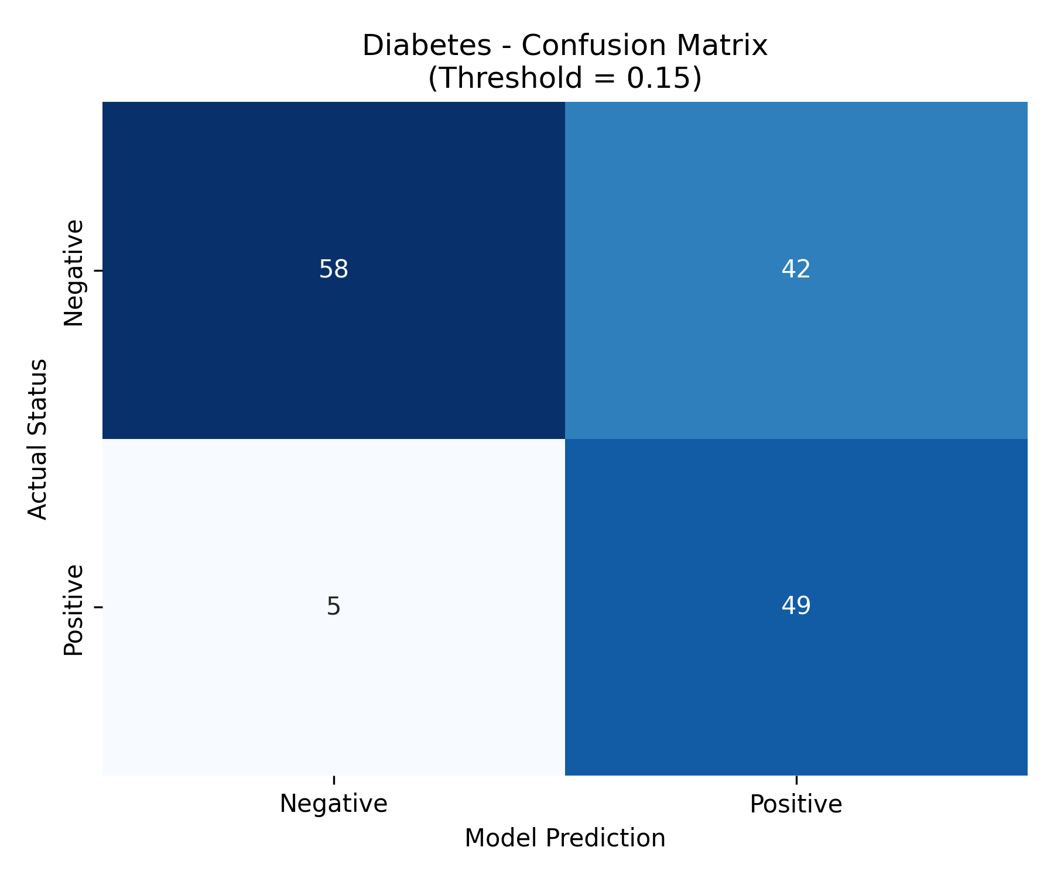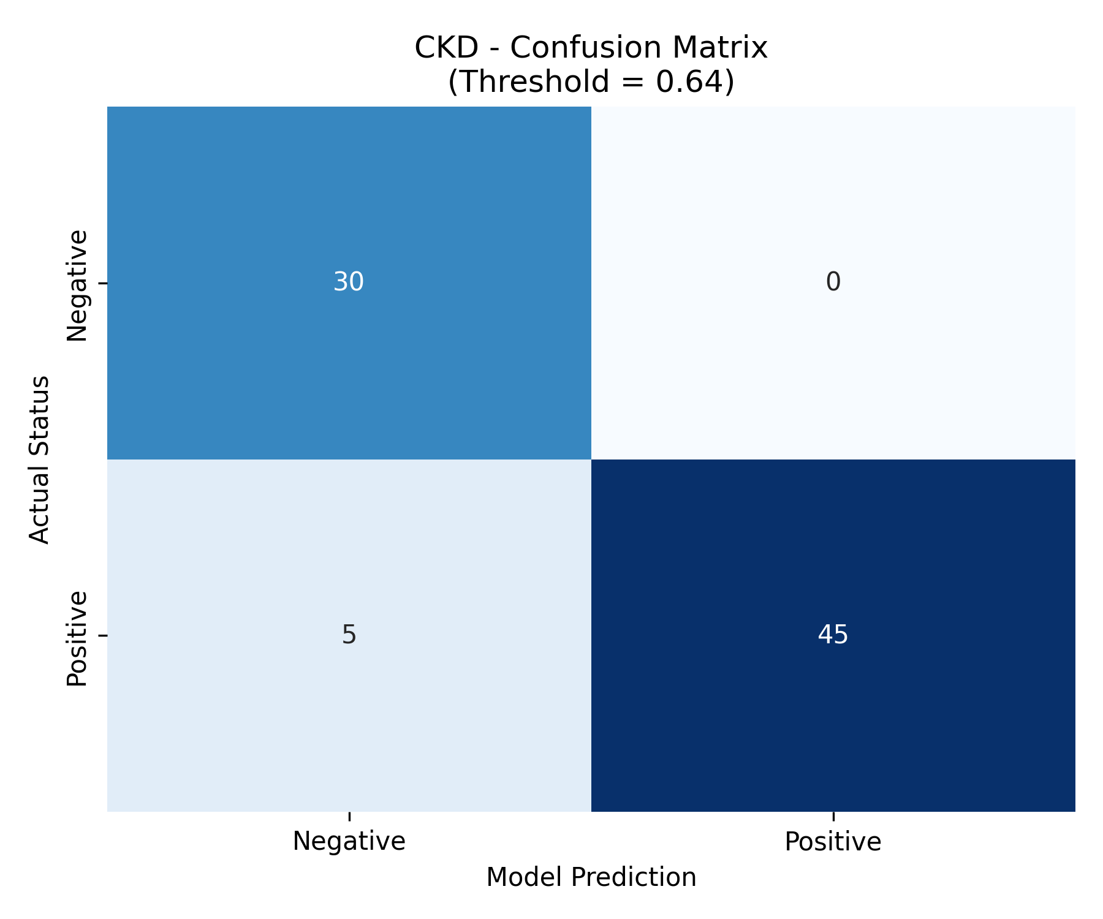

Figure 9.1: Confusion Matrices for Diabetes (Left) and CKD (Right). Notice the extremely low number of False Negatives (bottom-left quadrant).
By forcing the probability threshold down to 0.148 for Diabetes, the model achieved high Recall (90.7%) at the cost of lower Precision (53.8%). In a clinical screening context, this is the exact desired behavior. The model intentionally accepts a higher rate of False Positives (which simply result in an extra, harmless follow-up blood test) to guarantee an extremely low rate of False Negatives (which would result in fatal, undiagnosed disease progression).
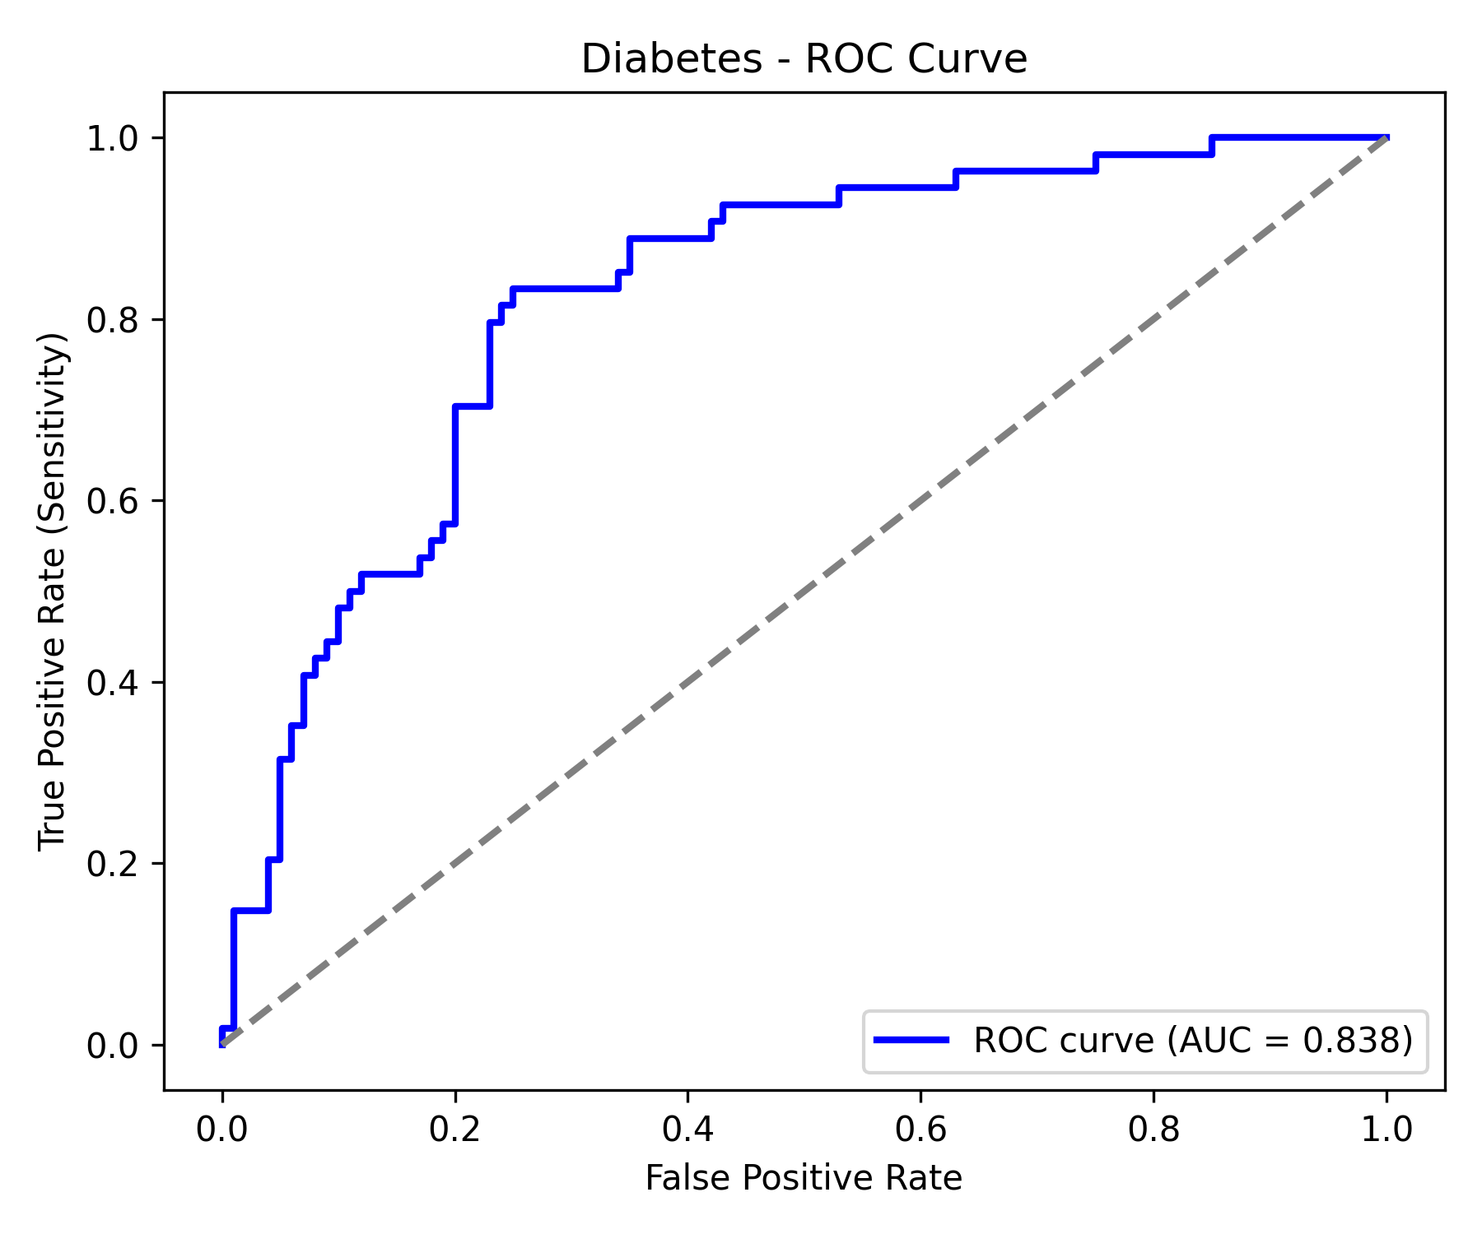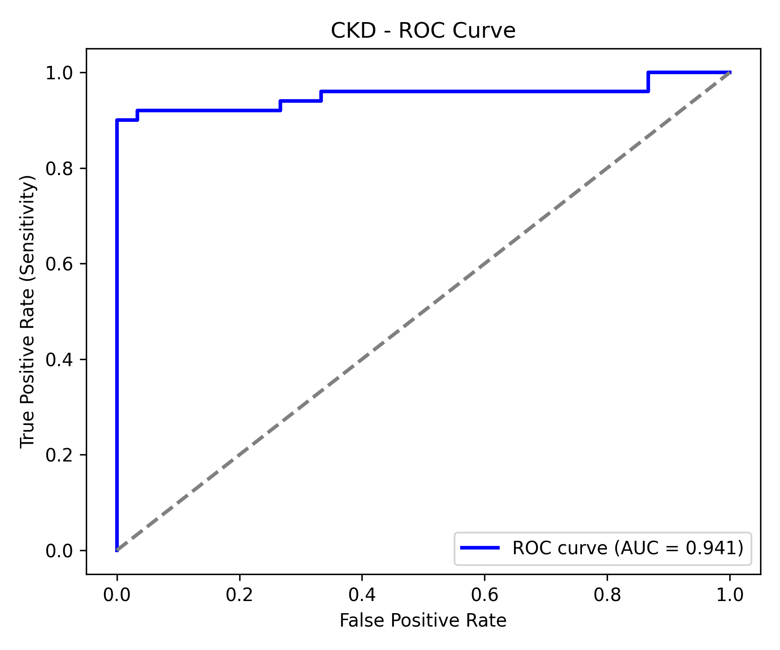

Figure 9.2: ROC Curves for the Gradient Boosting models, demonstrating strong discriminative ability (AUC 0.838 and 0.941) well above the random-guess baseline.

10. Challenges and Solutions
- Challenge: Data Leakage during Oversampling. * Solution: Transitioned from standard scikit-learn methods to imblearn.pipeline to confine SMOTE strictly within the cross-validation training folds, ensuring test data remained biologically valid.
- Challenge: High False Negative Rates. * Solution: Abandoned standard 0.5 probability thresholds. Engineered custom logic to parse ROC curves and dynamically extract thresholds (0.148 and 0.644) that mathematically guarantee >90% sensitivity.
- Challenge: Black Box Algorithm Trust. * Solution: Integrated SHAP (SHapley Additive exPlanations) to map the exact mathematical impact of each biomarker, ensuring clinical transparency and physician trust.

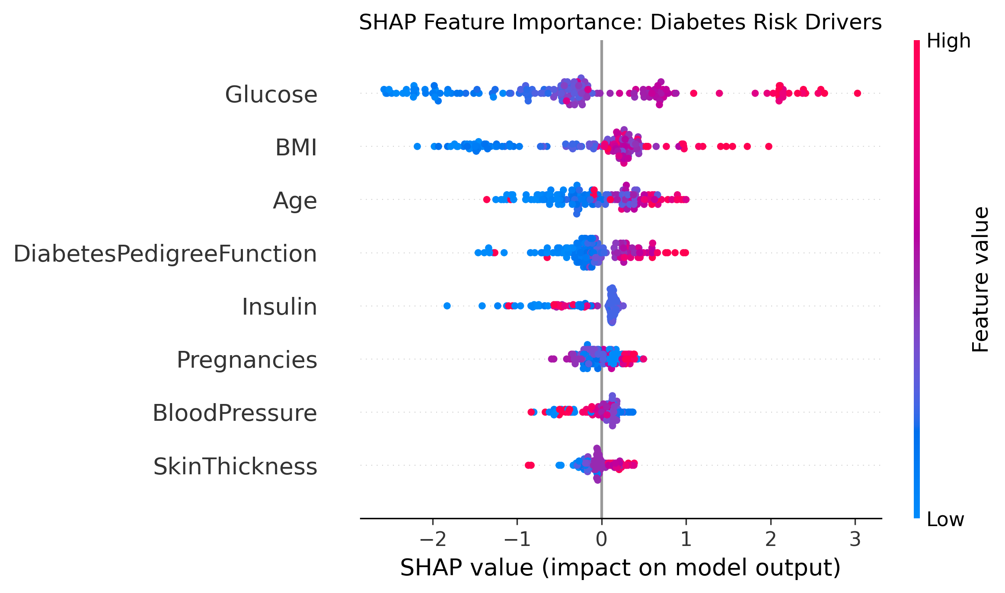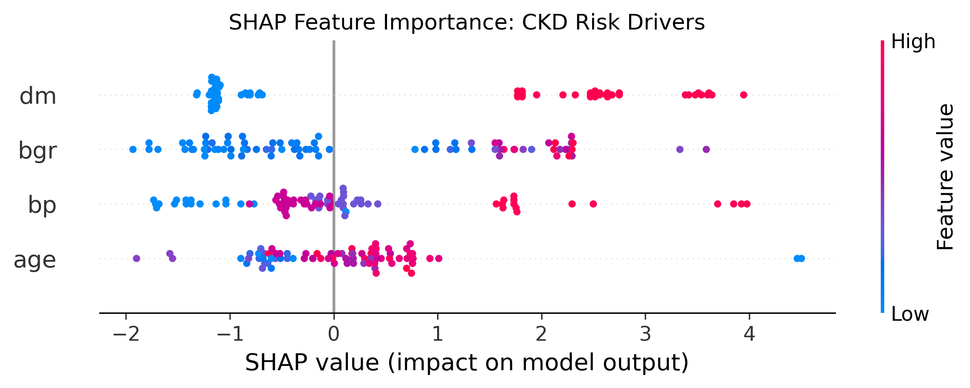

Figure 10.1: SHAP Summary plots. These prove the models are not "black boxes" by illustrating exactly how elevated Glucose and Age drive the risk predictions upward.

11. Learning Outcomes
During this internship, I gained profound, hands-on experience in Clinical Machine Learning Engineering. I mastered the implementation of zero-leakage cross-validation pipelines and understood the vital clinical necessity of threshold optimization and Precision-Recall trade-offs. Furthermore, I learned how to serialize complex ML artifacts and deploy them via a RESTful Flask API, bridging the gap between theoretical data science algorithms and full-stack software development. Finally, generating SHAP explainers provided me with a deep understanding of Explainable AI (XAI) frameworks.

12. Applications
The final application acts as a Clinical Decision Support System (CDSS) for Frictionless Early Screening. A clinician inputs 8 basic vitals, and the system instantly evaluates the patient, routing them into three actionable categories: "Clear" (Green), "Warning" (Orange), or "Urgent Escalation" (Dark Red).
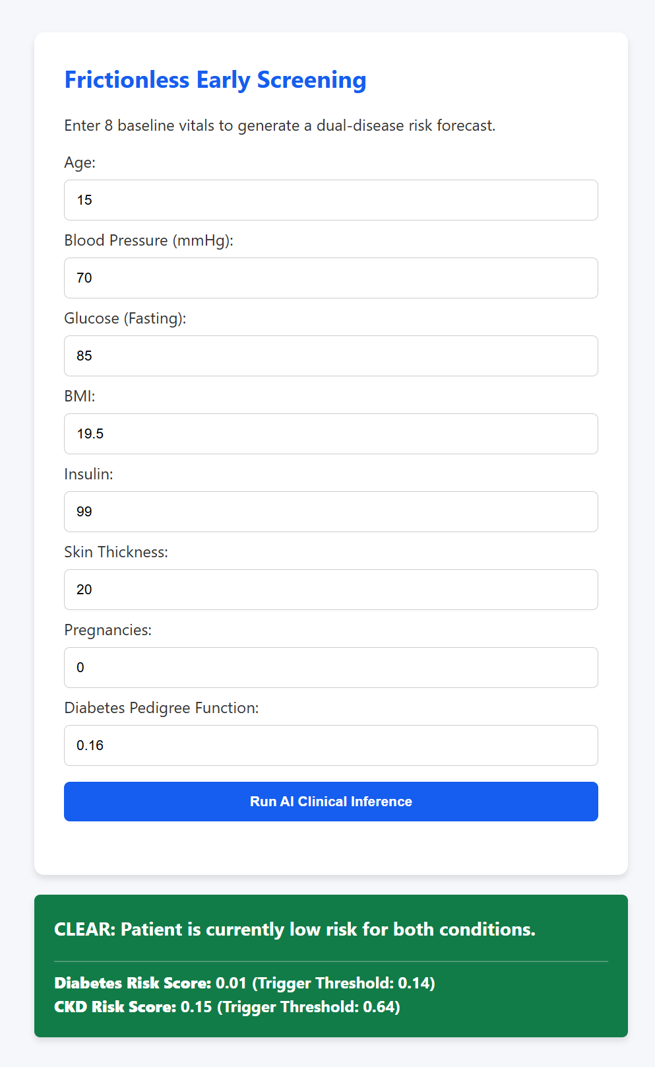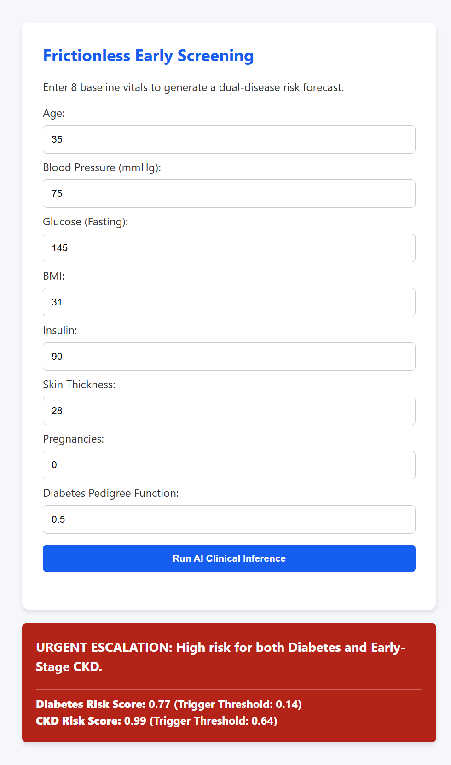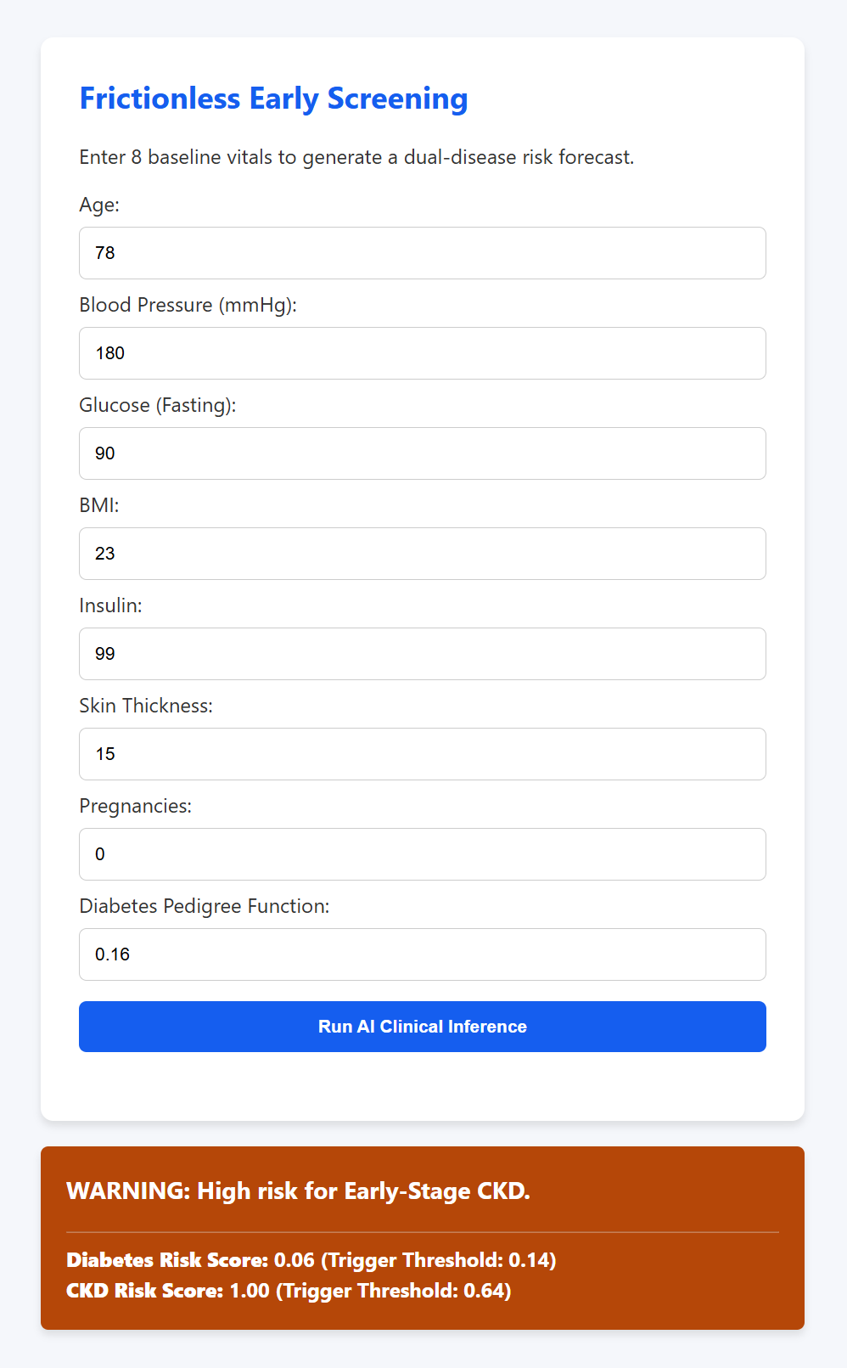

Figure 12.1: Web Application UI demonstrating [a] (Left) "Clear" patient outcome with normal vitals. [b] (Centre) "Urgent Escalation" where both the Diabetes and Bridged CKD thresholds were breached. [c] (Right) "Warning" state, proving the dynamic logic routing of the system.
This lightweight UI allows clinics to screen for severe chronic diseases rapidly and cheaply without requiring expensive or time-consuming laboratory tests upfront.

13. Future Work
Future iterations of this system could be improved by integrating longitudinal EHR (Electronic Health Record) data to perform time-series analysis, tracking biomarker degradation over time rather than relying on a single snapshot. Additionally, expanding the "Minimalist Bridge" architecture to include highly specific, semi-invasive biomarkers like HbA1c (for Diabetes) or eGFR (Estimated Glomerular Filtration Rate for CKD) would drastically improve the Precision of the models without sacrificing the current 90% Recall rate. Finally, the Flask API could be containerized using Docker and deployed to a cloud provider (AWS/GCP) to allow for scalable hospital integration.

14. Conclusion
This project successfully transformed a standard machine learning classification task into a production-grade, clinically defensible screening tool. By engineering a dual-disease "Bridge" architecture, strictly enforcing zero-leakage cross-validation, and computing dynamic thresholds for maximum patient safety, the resulting system proves that high-risk chronic diseases like CKD and Diabetes can be accurately forecasted using a minimal, non-invasive set of patient vitals. The addition of SHAP explainability and a Flask-based routing interface ensures that the system is not only highly accurate (0.941 AUC) but also transparent, ethical, and ready for real-world clinical implementation.

15. References
- Naz, S., et al. (2024). The early prediction of chronic diseases through diverse ML algorithms. IEEE Access, 12, 11004–11015.
- Delpino, F. M., et al. (2022). Machine learning for predicting chronic diseases: A systematic review. Public Health, 205, 15–25.
- Abbas, Q., et al. (2025). Explainable AI in clinical decision support systems. PMC Medical Informatics, 14(1), 102–115.
- Jung, Y., et al. (2025). Evaluating XAI impact on clinical trust. International Journal of Medical Informatics, 105943.
- Mahmud, M., et al. (2024). Early detection of CKD using Gradient Boosting. IEEE Xplore.
- Chawla, N. V., et al. (2002). SMOTE: Synthetic minority over-sampling technique. Journal of Artificial Intelligence Research, 16, 321-357.
- Lundberg, S. M., & Lee, S. I. (2017). A unified approach to model interpretation (SHAP). Advances in Neural Information Processing Systems (NeurIPS).
- Nikolaou N. Multimodal data fusion in precision oncology. Nat Commun. 2025;16:142.
- Kumar A, et al. Review of fusion aspects in medical diagnosis. Diagnostics. 2024.
- Polat H, et al. Feature selection for CKD diagnosis. Med Hypotheses. 2017;103:68–75.
- Kavakiotis I, et al. Machine Learning and Data Mining Methods in Diabetes Research. Comput Struct Biotechnol J. 2017.
- Maniruzzaman M, et al. Accurate Risk Prediction of Type 2 Diabetes using Machine Learning. J Med Syst. 2018.
- Zhang et al., ML for CKD prediction from diabetes records — Computers in Biology and Medicine, 2022.

16. Appendix
Appendix A: Application Inference Logic (app.py core routing)
if ckd_risk and diab_risk:
status = "URGENT ESCALATION: High risk for both Diabetes and Early-Stage CKD."
color = "#b42318" # Dark Red
elif ckd_risk:
status = "WARNING: High risk for Early-Stage CKD."
color = "#b54708" # Orange
elif diab_risk:
status = "WARNING: High risk for Diabetes. Monitor renal function."
color = "#b54708" # Orange
else:
status = "CLEAR: Patient is currently low risk for both conditions."
color = "#127c48" # Green

